Mathematics B-day 2023
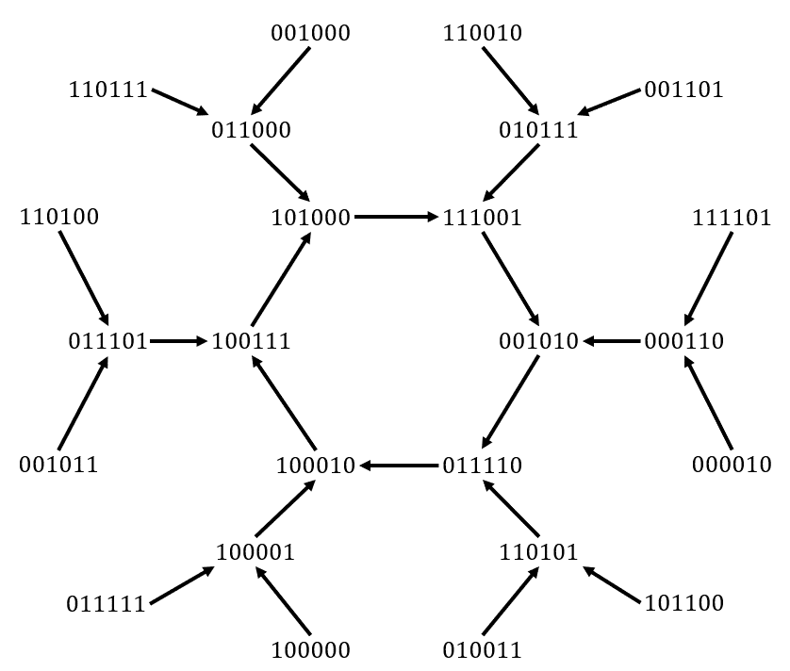

Make the difference!





Introduction

About the assignment
Sometimes a whole world is hidden behind a simple mathematical recipe. Today you explore such a wonderful world with very simple access. Start with a sequence of numbers and create a new sequence by taking the differences between them. It seems like you would soon be done talking about it, but nothing could be further from the truth.

Structure of the day
This Mathematics B day assignment consists of introductory tasks and additional, in-depth tasks. Unlike normal math lessons, you certainly don't have to solve all the problems. There are problems ranging from easy to difficult, and to help you get started, there are suggestions on how to tackle some problems. It's normal that you won't get everything done, but at least show in the report what you've tried and how far you've come—for example, based on the suggestions. If you have spent enough time on the introductory problems, choose one or more of the final studies to delve deeper into a topic. With success on these last problems, your team can distinguish itself even more!

Working in teams
The special thing about the mathematics B-day is that you do mathematics as a team. Perhaps it makes sense to make a plan and divide tasks. Let each team member do what he/she is good at. Give everyone the space to contribute with ideas and elaborations. You can work individually on different or the same problems at the same time and then come together again to discuss and evaluate. For some problems, it is useful to study some different examples. That work can then be nicely divided.

Supplies
Today you need the following: a pen, sufficient (scrap) paper, this assignment, a computer or laptop to prepare your report, and spreadsheet software (Excel or Google spreadsheets) or Python. We want to discourage the use of the internet; If you do so, be sure to include a source reference (URL) in the report. Use of ChatGTP or similar is not permitted.

What do you hand in?
You work on a digital report during the day. Don't start too late; you hand it in at 4:00 PM sharp. In this report, you describe your results and reasoning. Tell your own, clear and convincing story. We appreciate well-written, clear, precise, complete, carefully formulated, and certainly original, creative and lyrical reports.
Tips:
- It can be useful to start writing parts of the final report in the morning.
- Be understandable: make sure that the text is readable for someone who did not participate in the Mathematics B day (but who has sufficient knowledge of mathematics), without having read the assignment. You should not literally copy the tasks from the assignment into the report. Instead, make it an ongoing, creative story.
- Explorations and reasoning are the heart of the Mathematics B-day. If you provide substantiation, explanations, or explanations, try to do so with mathematical arguments as much as possible. The more precise your reasoning is and the more details your reasoning provides, the better. If you still have doubts about something, you can also indicate this in the report: “we suspect that…”.
- Use figures to illustrate your ideas. For example, use copies of drawings you have made (screenshots or photos of figures on paper).
Both the mathematical content of the report and the way it is written count in the assessment!

Introductory problems
Suppose you have a finite sequence of integer positive numbers: $7, 5, 1, 10$. You can then create a new sequence by taking the differences between consecutive numbers: $7-5=2; 1-5=-4; 1-10=-9; 10-7=3$, and then taking the absolute value: $2, 4, 9, 3$. So the last number is the difference between the last and the first number. We call this the difference step. You can then apply the difference step to this new sequence: you then get $2-4=-2; 4-9=-5; 9-3=6; 3-2=1$, and therefore $2, 5, 6, 1$. And one more time: then you get the sequence $3, 1, 5, 1$. You can conveniently write down the sequences below each other:
$$\begin{matrix}7 & 5 & 1 & 10 \\ 2 & 4 & 9 & 3 \\ 2 & 5 & 6 & 1 \\ 3 & 1 & 5 & 1\end{matrix}$$
We call this a series of sequences. Such a series can be as long as you want by applying the difference step again and again.

Problem 1 (Just trying it out)
- Examine how the sequence progresses $7, 5, 1, 10$ when you repeatedly apply the difference step.

- Investigate this with sufficient many other sequences of four natural numbers (i.e., from the set 0, 1, 2,…, etc.) and formulate a conjecture about what happens if you perform the difference step often enough.
Above we looked at a sequence of four numbers, or sequences of length 4; we note $n=4$. You can repeatedly apply the difference step to sequences of any length, including length 3, for example
3 | 9 | 1
6 | 8 | 2
2 | 6 | 4
4 | 2 | 2
2 | 0 | 2
2 | 2 | 0

- Examine enough sequences of length 3 and formulate a conjecture about what will happen if you perform the difference step often enough.
You may have come across a sequence that, after a number of different steps, ended up with a sequence with only zeros. We then say that the sequence vanishes. For example, the sequence $4, 9$ (of length 2) vanishes:
4 | 9
5 | 5
0 | 0
- Prove that every sequence of length 2 vanishes in two steps.

You have probably also come across series that ended in a series of sequences that repeated themselves over and over again. We then say that the sequence eventually becomes cyclic.
the sequence $3, 9, 1$ above eventually becomes cyclic: sequence 2, 2, 0 continues as
2 | 2 | 0
0 | 2 | 2
2 | 0 | 2
2 | 2 | 0
0 | 2 | 2
2 | 0 | 2
etc.

Problem 2 (Stretching the life of a sequence)
For the next assignment, you may use the provided spreadsheet (ask your teacher for the file). You can also write your own (Python) program for this.
- Challenge: find a sequence of length $n=3$ that takes as many steps as possible to vanish or become cyclic. You may use the numbers 1 to 100. Explain why it can't take more steps than you found.

- Do the same for $n=4$.

Problem 3 (Vanishing or becoming cyclic)
If you compare the largest number in a sequence before the difference step with the largest number in the sequence after the difference step, it will remain the same or become smaller. For example:
6 | 8 | 0 | 2
2 | 8 | 2 | 4 | Same
6 | 6 | 2 | 2 | Smaller
0 | 4 | 0 | 4 | Smaller
4 | 4 | 4 | 4 | Same
0 | 0 | 0 | 0 | Smaller

- Explain why the numbers in a sequence do not increase with a difference step.
You are now going to prove that a sequence must vanish or become cyclic in a finite number of difference steps. This is done via a proof “by contradiction”: this means that you prove that the converse is false. So we first assume that a given sequence does not vanish and does not become cyclic. Then no sequence may appear more than once in the entire endless series.
- Why should no sequence appear more than once in the entire endless series?
So there have to be infinitely many different sequences in the series (after all, the series goes on endlessly). But that is impossible. For example, suppose the largest number in the sequence of length 4 is 12. Then the largest number that appears in the entire series of sequences is also 12, because of part a. But there are only finitely many sequences of length 4 with the largest number 12 ( check it out; calculate how many possibilities).
- Generalize this reasoning to explain that there can only be a finite number of different sequences in the series.
We have now reached a contradiction (so the proof is done!), because on the one hand, the series must contain an infinite number of different sequences, but on the other hand, according to part c, we only have finitely many candidates for that.

Problem 4 (Zeroes and one one)
We will now look at special sequences of somewhat greater length.
Start with a sequence of 7 zeros and a one like below:
0 | 0 | 0 | 0 | 0 | 0 | 0 | 1

- Do the difference steps until it vanishes.

- Examine sequences of the form 0 0 … 0 1 ($n-1$ zeros followed by a one) for $n>1$. For which values of $n$ does it vanish and for which values does it become cyclic? Formulate a general conjecture.

There is a kind of repetition effect with some sequences. First look at $n=2$
0 | 1
1 | 1
The three colored parts are all the same. This pattern is the building block of the next series of sequences at $n=4$:
0 | 0 | 0 | 1
0 | 0 | 1 | 1
0 | 1 | 0 | 1
1 | 1 | 1 | 1
And the pattern repeats in blue, red and green. You see the same thing happen with $n=8$:
0 | 0 | 0 | 0 | 0 | 0 | 0 | 1
0 | 0 | 0 | 0 | 0 | 0 | 1 | 1
0 | 0 | 0 | 0 | 0 | 1 | 0 | 1
0 | 0 | 0 | 0 | 1 | 1 | 1 | 1
0 | 0 | 0 | 1 | 0 | 0 | 0 | 1
0 | 0 | 1 | 1 | 0 | 0 | 1 | 1
0 | 1 | 0 | 1 | 0 | 1 | 0 | 1
1 | 1 | 1 | 1 | 1 | 1 | 1 | 1

- In part b you gave values for $n$ which you suspect the sequence $0, 0, …, 0, 1$will end. Prove this conjecture.

- What can you say about sequences of the form 0,0, …, 0, $k$( $n-1$ zeros followed by a positive integer $k$, not necessarily 1)?

Problem 5 (Phase 1 and 2)
When a sequence becomes cyclic, you come across a special moment in such a sequence. From that moment on, the sequence consists only of zero and one other number. For example:
2 | 4 | 6 | 0 | 0
2 | 2 | 6 | 0 | 2
0 | 4 | 6 | 2 | 0
4 | 2 | 4 | 2 | 0
2 | 2 | 2 | 2 | 4
0 | 0 | 0 | 2 | 2 | From here!
0 | 0 | 2 | 0 | 2
0 | 2 | 2 | 2 | 2
2 | 0 | 0 | 0 | 2

- Explain why a sequence containing only zero and one other number, say $a$, (such as $0, 5, 0, 5, 5, 0$) changes under the difference step into a sequence again containing only zeros and that one number$a.$
As long as the sequences in a series contain more than two different numbers, it is in phase 1. If it switches to sequences with only 0, $a$ then it is in phase 2. In part a, you explained that you cannot go from phase 2 back to phase 1. Conversely, it seems that phase 1 always turns into phase 2.
- Investigate whether each sequence in phase 1 ultimately ends up in phase 2. If so, provide reasons why; if not, give a counterexample.

Problem 6 (A step back)
Does the sequence 6, 3, 2, 5 have a predecessor? That is, can the sequence be the result of a difference step? In this case the answer is: yes! For example, start with the number 7. Then the second number must $7±6$be, and so on. For example, you arrive at the predecessor 7, 13, 10, 12.
- Can you still find a predecessor of 6, 3, 2, 5? Describe all predecessors of 6, 3, 2, 5.
If you want to reason in general with sequences, it is useful to use subscripts: $a_{1}, a_{2}, a_{3},…, a_{n}$for a sequence of length $n$. For example, in the sequence 6, 3, 2, 5 you have $a_{1}=6$, $a_{2}=3$, $a_{3}=2$ and $a_{4}=5.$
In general, it turns out that a sequence $a_{1}, a_{2}, a_{3}, a_{4}$has a predecessor, just as long as there is a choice of $±$-signs such that
$$±a_{1}±a_{2}±a_{3}±a_{4}=0.$$
Indeed, this applies to the sequence 6, 3, 2, 5: $6-3+2-5=0$.
- Investigate why a sequence $a_{1}, a_{2}, a_{3}, a_{4}$has a predecessor, exactly if there is a choice of $±$-signs such that
$$±a_{1}±a_{2}±a_{3}±a_{4}=0.$$

- Generalize the statement and your reasoning from part b to sequences of length $n$.

In Problem 1 you probably noticed that sequences of length 3 never vanish, unless they consist of three of the same numbers. For example, 4, 5, 6 and 3, 3, 8 do not vanish, while 2, 2, 2 and 9, 9, 9 do. Check!
- Prove that sequences of length 3 never vanish, unless they consist of three of the same numbers.

- What do you expect for other sequences of odd length? Give arguments.

Own research
We invite you to choose one (or more) of the topics below for your research.
As a reminder: the research report consists of an introduction to difference sequences based on your findings in basic problems 1 to 6. This is followed by your approach and results in at least one of the studies that you choose from the options below.

Study 1: Vanishing sequences
There is much to discover and investigate about vanishing sequences. Here are some choices:
- In Problem 3 you saw that sequences of length 2 always vanish. You probably also suspect that sequences of length four always vanish. Prove that sequences of length 4 always vanish.
- How long it takes for a sequence of four numbers to vanish depends on the numbers you start with. Investigate the relationship between the starting numbers and the number of steps it takes until a sequence of length 4 has vanished.
- Examine the regularity in the lengths $n$, whereby all sequences vanish.
Hint:
- For the first choice: use your findings from Problem 4 and the idea from the box below.
Addition sequences
For initial research, you may want to use the following idea. You cannot simply add two series of the same size

$\left(\begin{matrix}2 & 2 & 0 \\ 0 & 2 & 2 \\ 2 & 0 & 2\end{matrix}\right)+\left(\begin{matrix}0 & 1 & 0 \\ 1 & 1 & 0 \\ 0 & 1 & 1\end{matrix}\right)=\left(\begin{matrix}2 & 3 & 0 \\ 0 & 3 & 2 \\ 2 & 1 & 3\end{matrix}\right)$, but $\left(\begin{matrix}2 & 3 & 0 \\ 0 & 3 & 2 \\ 2 & 1 & 3\end{matrix}\right)$ is not a series of sequences!

If you limit yourself to sequences with only 0 and $a$ (i.e. in phase 2), and adjust the addition rules, then it is possible. The rules then become $0⊕0=0;$ $a⊕0=a;$ $0⊕a=a$and $a⊕a=0$. You then get, for example

$$\left(\begin{matrix}2 & 2 & 0 \\ 0 & 2 & 2 \\ 2 & 0 & 2\end{matrix}\right)⊕\left(\begin{matrix}0 & 2 & 0 \\ 2 & 2 & 0 \\ 0 & 2 & 2\end{matrix}\right)=\left(\begin{matrix}2 & 0 & 0 \\ 2 & 0 & 2 \\ 2 & 2 & 0\end{matrix}\right),$$

and the latter is indeed another series of sequences!
You may use this result. If you also want to prove this, you only have to look at what is happening “locally”, for example:

$$\left(\begin{matrix}… & … & … & … \\ … & a & 0 & … \\ … & a & … & … \\ … & … & … & …\end{matrix}\right)⊕\left(\begin{matrix}… & … & … & … \\ … & 0 & a & … \\ … & a & … & … \\ … & … & … & …\end{matrix}\right)= ?$$

Study 2: Zero trees
In this study we focus on the sequences in phase 2. For convenience, we assume that the non-zero number is 1. We can then make a diagram of sequences and arrows, where the arrows each represent the difference step. If we limit ourselves to all sequences of zeros and ones that culminate in the zero sequence (sequence with only zeros), then that diagram is called the zero tree . Before $n=2$ and $n=4$ it looks like this:
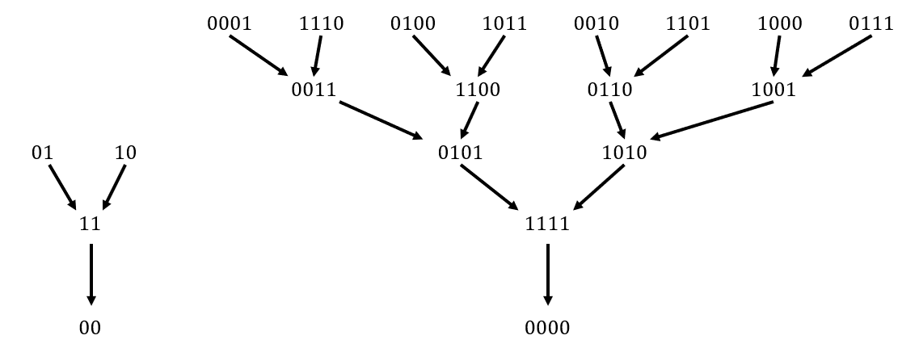
Here all sequences are in the zero tree. This is not the case for length three, but there is still a small zero tree:
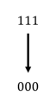
The height of a tree is the number of arrows you encounter when you go from one of the top sequences along the arrows to the zero sequence (bottom). For each value of $n$ there is a null tree, but the height varies. For example, for $n=2$ the height is 2, for $n=3$ the height is 1, and for $n=4$ the height is 4.
Examine the regularity in the height of the zero tree.

Hints
- Explain why every non-zero sequence in the zero tree has exactly zero or two predecessors.
- Use your findings from Problem 4.
- Problem 6 explains what a predecessor of a sequence is. Explain that a sequence of zeros and ones has a predecessor only if there is an even number of ones.
- Use the idea from the box below.

Repetition of sequences
You might be able to use the following idea for this research. If you have a series of sequences of length 3, like
1 | 0 | 0
1 | 0 | 1
1 | 1 | 0
Then you can make a series of sequences of length 6 or 9 from this by repeating the sequences .
1 | 0 | 0 | 1 | 0 | 0 |  |  | 1 | 0 | 0 | 1 | 0 | 0 | 1 | 0 | 0
1 | 0 | 1 | 1 | 0 | 1 |  |  | 1 | 0 | 1 | 1 | 0 | 1 | 1 | 0 | 1
1 | 1 | 0 | 1 | 1 | 0 |  |  | 1 | 1 | 0 | 1 | 1 | 0 | 1 | 1 | 0

This idea can be generalized. Explain in your report why it works.

Study 3: Flowcharts and snowflakes
In this study (as in the previous one) we concentrate on the sequences in phase 2. For convenience, we assume that the non-zero number is 1. You can then make a flowchart of how the sequences fit together. It $n=3$ looks like this:
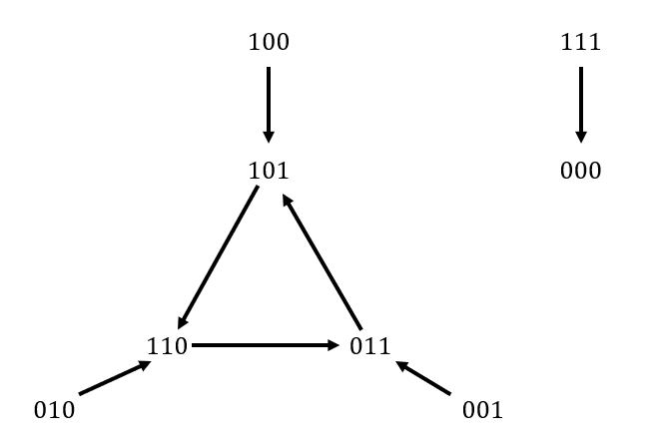
On the left you see a kind of snowflake and on the right you only see the transition from $1, 1, 1$to $0, 0, 0$. It turns out that you should see this as a small tree (see study 2). You will also $n=6$ encounter a snowflake in front, but larger (see below). A snowflake consists of a circuit in the middle (below a hexagon), with each sequence located at a corner (e.g. 101000) having a tree attached to it. The number of different sequences in the circuit determines the order of the snowflake. So the snowflake below has order 6 and the one above has order 3.

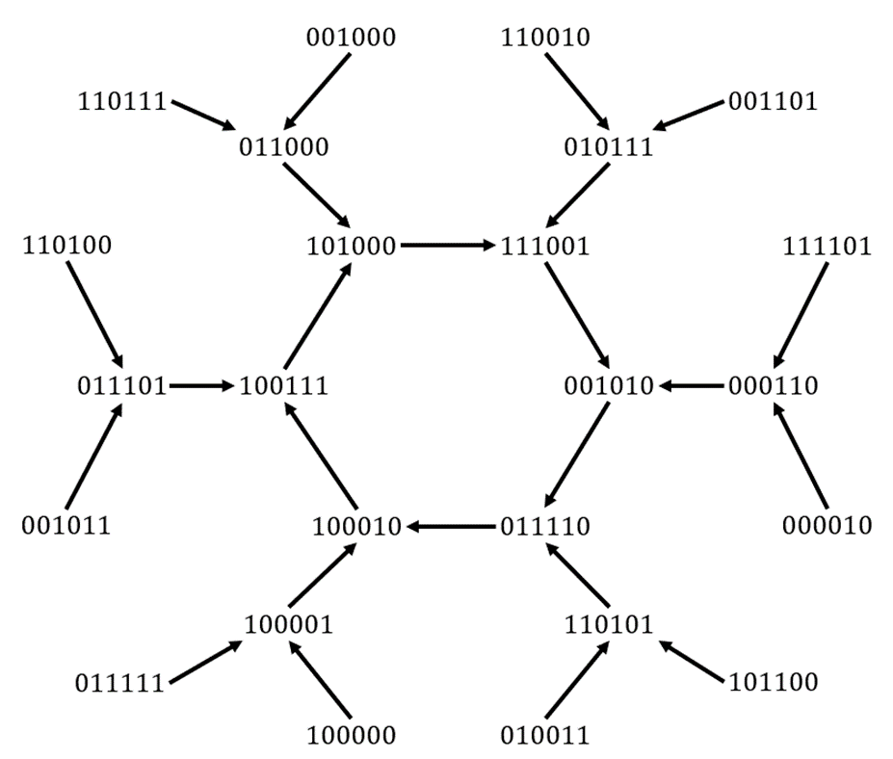
of two more snowflakes in addition to the zero tree and the snowflake above. Which ones? There are exactly $2^{6}=64$ sequences with only zeroes and ones. Can you find them all in the flowchart?
In general it is a mystery how many snowflakes there are at a given length and what the order of those snowflakes is. For example, the flowchart for sequences of length nine appears to consist of the zero tree (with height 2), four snowflakes of order 63 and one snowflake of order 3. In total there are $2^{9}=512$ sequences of zeros and ones. There are 63 of these $63×2=126$in each snowflake of order 63. And six sequences in that of order 3. Together with the two sequences in the zero tree, the sum is then correct: $512=2+4×126+6$.
For different values of length $n$, investigate what the complete flowchart of sequences with only zeros and ones looks like. What can you say about the number of snowflakes? What can you say about the order of those snowflakes? Do you see patterns?
Hints:
- Both $n=3$ and $n=6$have a snowflake of order 3. That is not a “coincidence”. Explain that if a circuit of length $k$ occurs in sequences of length $n$, a circuit of length also $k$occurs in sequences where the length is a multiple of $n$. The idea of repeating sequences is also useful here (see the box in Study 2).
- Extra: What do you notice when you compare the height of the trees attached to the circuit of a snowflake with the height of the zero tree (see study 2) for different values of $n$?
- With the help of generators you can easily describe and search for circuits in snowflakes. See the box below.
Producers
A circuit of length 15 occurs when $n=5$. That's not entirely "coincidental" either. Look at the series:
0 | 0 | 0 | 1 | 1
0 | 0 | 1 | 0 | 1
0 | 1 | 1 | 1 | 1
1 | 0 | 0 | 0 | 1
If you look at it cyclically, the 1 1 in 0 0 0 1 1 has shifted one to the right after four steps. This then repeats five times: after four more steps you have 1 1 0 0 0 and so on; and that forms the circuit. You can think of 1 1 as a generator of the circuit. You come across this more often: for example, in the flowchart of sequences of length 17 there is a snowflake of order 255, produced by 1 1. And this works even more generally. You can describe a circuit in the flowchart by giving it a generator. For example, the four snowflakes are $n=9$ represented by 11, 1001, 10111 and 11101.

That is, ignore the minus signs.
If we ask you to formulate a conjecture (and this will happen more often later), you do not have to know for sure whether what you write is true. Write down something in your report about your search to arrive at your conjecture.
Extinction is actually a special case of becoming cyclic: the row of zeros repeats itself
If you start with that kind of sequence, then of course there is no transition.
In preparation for this study, it is useful to read the introduction to Study 2.

