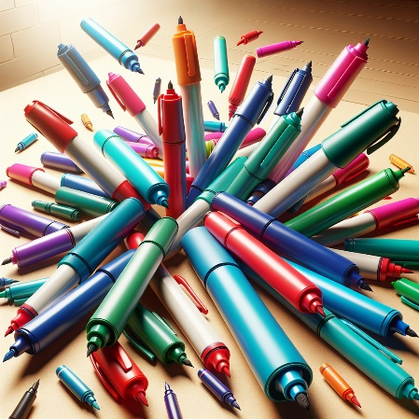
Quarterly Problem
- Green Edition -
What to do with used markers?

→

Brainstorm-Box
Find out about recycle of markers in other countries. Are there any companies that offer marker recycling services?
We often use markers in our daily life, especially at school. But there is one big problem – markers aren’t refillable. After markers run out of ink, they are usually thrown away without thinking twice. For most makers the reservoir, which holds ink inside of a marker, is made out of polyester, while the body of a marker is made out of plastic. Therefore, they aren’t biodegradable and it is not possible to recycle a marker as one piece.

Do your research and find what are some environment-friendly solutions where to put used markers.

The following questions may help you:
1. How many markers does your school use monthly/yearly?
2. What materials are commonly used to make markers?
3. How can unsorted used markers pose risks or harm?
4. Where should used markers be disposed of properly?
5. Do the benefits of markers outweigh their negative impacts?
6. What alternative options can replace markers?
7. What's the environmental impact of discarded markers on ecosystems and water sources?
8. What health risks come with prolonged marker exposure in high-use environments?


© Egle Jasute, Vilnius University, 2024, CC-BY-NC-SA 4.0 Licence grantet
Picture Source: Flowgpt

Whose method is the most accurate?
Focus on phrasing your approach in a clear and comprehensible way.
Also state what foundation you have used for your estimations.

