Mathematics B-day 2022

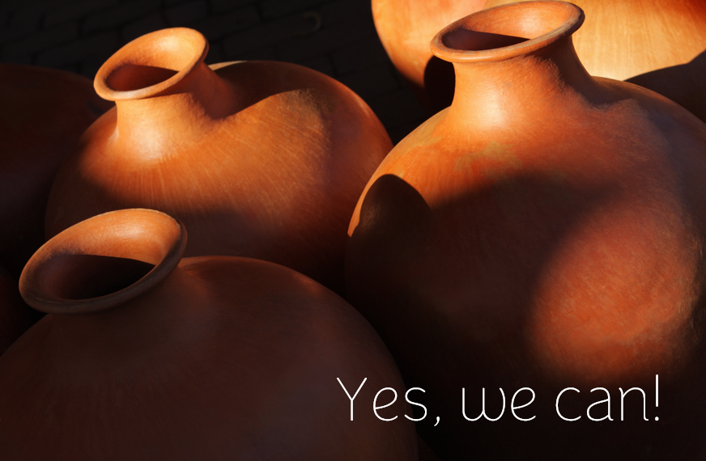



# Introduction

## About the assignment

In a famous 1998 commercial, people go on the ice after a Frisian says: “It kin net”. After they fall through, it turns out that he meant "it’s not possible" rather than "it’s just possible". This year's assignment is equally about whether it is possible or not, and water and jugs play a starring role. The assignment challenges you to investigate with a team. However, don't be afraid of cold feet and dive in. We assume you won't fall through the ice. Yes, you can do it!

## Structure of the day

This Mathematics B-day assignment consists of introductory tasks and additional, in-depth problems. Unlike in normal math lessons, you certainly don't have to solve all the problems in the Math B-day. If you get stuck with a problem or don't have enough time, you can let it rest or even skip it completely. To help you on your way, there are suggestions with some of the problems. Problems range from easy to hard, so it's okay if you don't get everything done; but **at least show in the report what you have tried and how far you have come – for example by using the suggestions**. After you have spent enough time on the introductory problems, choose one or more of the additional problems to delve deeper into a topic. With a success on these last problems, your team can distinguish itself even more!

## Working in teams

The special thing about the Mathematics B-day is that you do mathematics as a team. It may be a good idea to make a schedule and a division of tasks. Let everyone do what they are good at. Give everyone space to contribute with ideas and elaborations. You can all work on different tasks at the same time, or work together on a problem, and then come together again to discuss and evaluate. For some problems it is useful to study some different examples. That is something that can easily be divided with your team.

## Supplies

Today, you will need: a pen, enough (scrap) paper, this assignment, and a computer or laptop to prepare your report, and possibly spreadsheet software or Python. We want to discourage the use of the internet; if you do use online sources, include a citation in your report (url).

## What to hand in?

You will work on a digital report during the day. Don't start too late with that. You must hand it in at 16:00. In it, you describe your results and reasoning. Tell your own, clear and convincing story. We appreciate well-written, clear, precise, complete, carefully formulated, and certainly original, creative and lyrical reports.

Tips:

* It can be useful to start writing out your results in the morning already.
* *Be understandable*: make sure that the text is legible for someone who did not take part in the Mathematics B-day (but who does have sufficient understanding of mathematics), *without having read the assignment*. You do not have to literally copy the problems from the assignment in the report. Instead, make it a creative running story.
* Explorations and reasoning are at the core of the Mathematics B-day. If you If you provide substantiations, explanations or clarifications, try to do so using *mathematical arguments* as much as possible. If you are still unsure of something, you can say so in the report: “We suspect that…”
* Use figures to illustrate your ideas. For example, use copies of pictures you have made (screen captures or photos of figures on paper).

Both the mathematical content of the report and the way it is written will count in the assessment!

# Introductory problems

### Problem 1 (It’s (im)possible)

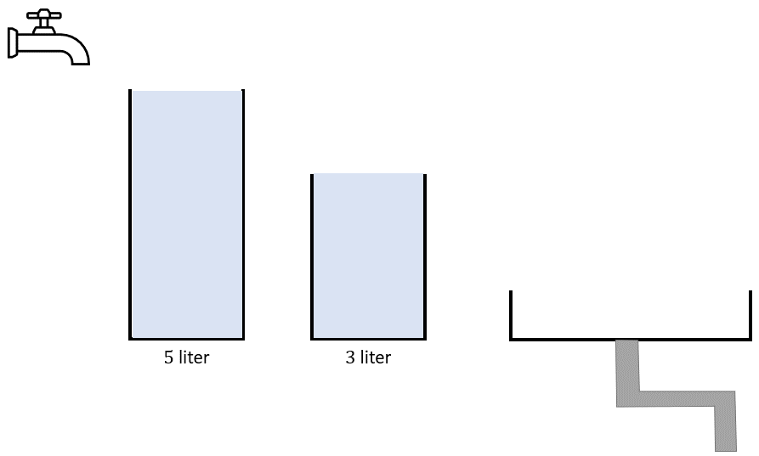

Figure 1. Two jugs, a tap, and a sink

Suppose you have two empty jugs, a five-litre jug and a three litre one, a tap and a sink from which the water drains immediately (see Figure 1). The following actions are allowed:

1. Emptying a whole jug in the sink
2. Filling a jug completely under the tap
3. Pouring water from one jug into the other until that jug is completely empty or the other completely full
4. Investigate if you can measure out four litres like this, in other words, if you can fill a jug with exactly four litres like that. Explain your intermediate steps in the report.
5. Investigate if you can measure out four litres using the following sizes of jugs:
   * 8 litre and 3 litre
   * 7 litre and 3 litre
   * 6 litre and 3 litre

Explain in the report how you investigated this. You can use charts in which you keep track of how many litres of water there is in which jug in which condition, as is shown below for the case of 8 and 3 litre jugs:

|  |  |
| --- | --- |
| $$↲$$ | Fill the 3l jug |
| $$↲$$ | Pour out into the other jug |

|  |  |  |
| --- | --- | --- |
| condition | 8 litre | 3 litre |
| 0 | 0 | 0 |
| 1 | 0 | 3 |
| 2 | 3 | 0 |
| … | … | … |

### Problem 2 (number of efficient solutions)

We go back to the situation with two jugs of five and three litres. You can measure out four litres in more than one way. Of course, you can first fill and empty your five-litre jug ten times to create an extra way, but that is inefficient.

To be precise, it is inefficient to:

1. Reverse an action you performed previously (if you can)
2. Empty a partially filled pitcher into the sink
3. Further fill a partly filled jug from the tap
4. Go on once the target amount is reached

So, the following steps are all inefficient for respectively rules i, ii, i, iii:

|  |  |  |  |  |  |  |  |  |  |  |  |  |  |  |  |  |  |  |  |  |  |  |  |  |  |  |  |  |  |  |  |  |  |
| --- | --- | --- | --- | --- | --- | --- | --- | --- | --- | --- | --- | --- | --- | --- | --- | --- | --- | --- | --- | --- | --- | --- | --- | --- | --- | --- | --- | --- | --- | --- | --- | --- | --- |
| |  |  | | --- | --- | | 5 litre | 3 litre | | 2 | 3 | | 5 | 0 | | 2 | 3 | | |  |  | | --- | --- | | 5 litre | 3 litre | | 2 | 3 | | 0 | 3 | | |  |  | | --- | --- | | 5 litre | 3 litre | | 0 | 0 | | 5 | 0 | | 5 | 3 | | 0 | 3 | | |  |  | | --- | --- | | 5 litre | 3 litre | | 2 | 3 | | 5 | 3 | |

1. Explain why ii and iii are inefficient.

So, working inefficiently, there are infinite ways to get to four litres. Working efficiently there are quite a few less.

Note the content of the 5-litre jug with $x$ and that of the 3-litre jug with $y$. A *step* means a transition from a state to the next state; that is to say filling, emptying, or pouring into a jug. The steps that go with the table below can be graphically represented as a path in a system of axes (see Figure 2)

|  |  |  |
| --- | --- | --- |
| State | 5 litre $$x$$ | 3 litre $$y$$ |
| 0 | 0 | 0 |
| 1 | 5 | 0 |
| 2 | 2 | 3 |
| 3 | 2 | 0 |

1. The above “rules” against inefficient actions dictate that the red path can only be extended in one way. Explain how and why.
2. Use this illustration to investigate how many efficient ways there are to measure out four litres using a 3 and a 5-litre jug (starting with two empty jugs). Explain what you are doing and what your arguments are.

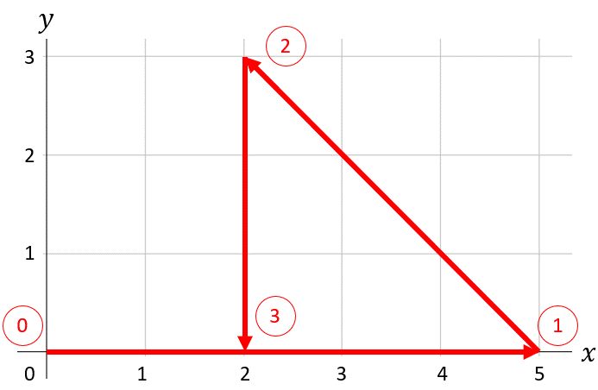

FiguRE 2. Four states and three steps (Red arrows) of the pouring process

|  |
| --- |
| Extra: exploration[1] You can change the illustration in Figure 2 a bit more.    Figure 3. The pouring process as a single arrow  Copies of the previous grid have been placed against each other (see Figure 3). After all, due to efficiency, it is always clear whether a full jug should be emptied or an empty one filled. Can you reconstruct the six steps in the arrow above (a total of three pour over, fill twice, empty once)? In this picture, filling and emptying is more implicit (if you are intersecting a number line), with the advantage that we can just look at a straight line/arrow, instead of zigzagging lines. Can you also show another efficient solution in the figure? |

### Problem 3 (You can also use)

You can also translate the problem into algebra. Let's take another look at the pouring process where we start by filling the 5-litre jug and after a number of steps end with 4 litres in the 5-litre jug.

1. Show, by following what happens step by step, that the contents of either jug in any state can be written in the form 5*k*+3*l*, where *k* and *l* (in each state different) are **whole** numbers.

That we can end up with 4 litres in the 5-litre jug means that there are whole numbers *k* and *l* such that 4=5k+3*l*.

1. What values do you get for the *k* and *l* in this equation in the above manner?
2. Can you connect these values to the steps you took in the pouring process (i.e., the number of fills, empties, and pours)?
3. Can you relate the values of *k* and *l* to an equation for the line in Figure 3?
4. Can you find any other values of *k* and *l* such that equation 4=5*k*+3*l* is satisfied? Are they also related to the pouring process?
5. Now examine all this more generally for the pouring process with a 5-litre jug and a 3-litre jug:
   * investigate target amounts other than 4 litres;
   * investigate the influence of the starting step;
   * investigate in which jar the target amount occurs first.

If necessary, use the table below.

|  |  |  |  |  |  |  |  |  |
| --- | --- | --- | --- | --- | --- | --- | --- | --- |
| Amount to be measured out | Possible? | Least number of steps | Number of times poured over | Number of times filled | Number of times emptied | *k* | *l* | In which jug? |
| 0 | yes | 0 | 0 | 0 | 0 | 0 | 0 | both |
| 1 |  |  |  |  |  |  |  |  |
| 2 |  |  |  |  |  |  |  |  |
| 3 | yes | 1 | 0 | 1 | 0 | 0 | 1 | 3 |
| 4 |  |  |  |  |  |  |  |  |
| 5 | yes | 1 | 0 | 1 | 0 | 1 | 0 | 5 |

### Problem 4

Suppose that you have both an $m$ litre jug and an $n$ litre jug, with $m$ and $n$ positive whole numbers. The question that already arose in problem 1 is which amounts $h$ can or cannot be measured out, generally speaking.

1. Investigate that question for jugs of $m=4$ and $n=6$ litre.
2. Investigate that question for jugs of $m=7$ and $n=2022$ litre.
3. Investigate that question in general and formulate a hypothesis. Provide arguments to support your hypothesis.

Suggestions:

* Make charts like for Problem 3, part f
* Use a graph for this like in Problem 2
* Try a sufficient variation of $m$ and $n$ until you see a pattern
* Continue to think about: what causes these patterns?

Like above, you can make an equation in general for an amount $h$:

$$h=m k-n l$$

1. What can you see about the number of pour overs in relation to $k$ and $l$ in the equation? And the number of fills? And the number of emptyings? Formulate a hypothesis for this. Provide arguments to support your hypothesis.

### Problem 5 (from jugs to billiards)

If you skew the grid in Figure 2 a bit, you get the same but in a triangular grid of equilateral triangles. The great thing is that steps then follow each other like reflections against the edge, like the trajectory of a billiard ball over a parallelogram-shaped billiard table.

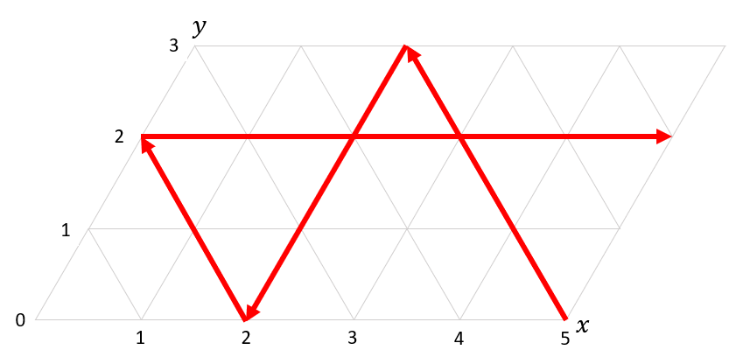

Figure 4. the pouring process as arrows in a triangular grid

If you complete the track above (please do so), you'll see that that one track hits almost all grid points, before ending in (0,3). Only points (0,0) and (5,3) are skipped. As with problem 4, we can now vary the dimensions of the billiard table: call the dimensions *m* and *n*. We look at trajectories of balls across the triangular grid. The vertices (*m*,0) and (0,*n*) can at most serve as the start or end point of a track; and the vertices (0,0) and (*m*,*n*) cannot be reached and do not take part. Investigate how the number of tracks depends on *m* and *n*.

Suggestions:

* Investigate enough concrete examples
* Describe what is happening and why
* Look for patterns
* Formulate a hypothesis
* Give arguments for why that hypothesis might be true
* If your hypothesis turns out not to be true, then give a counterexample in your report: also interesting.

# Optional problems

We invite you to choose one (or more) of the problems below, that are a more in-depth look at the introductory problems

### Problem 6 (generalisation)

Suppose you have three jugs available.

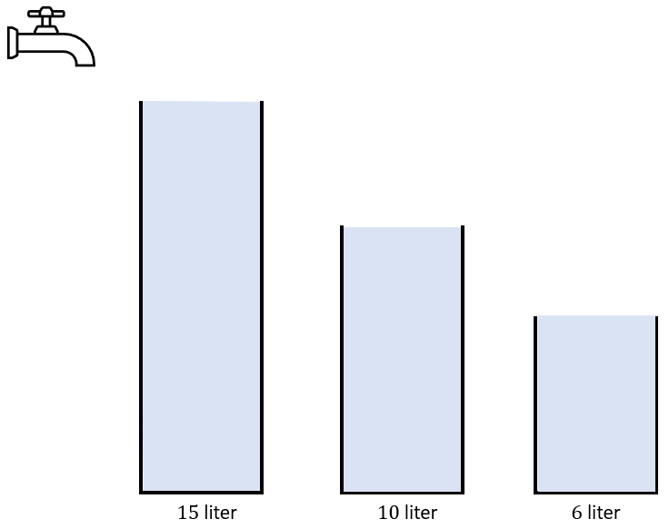

Figure 5. What can you do with three jugs?

1. Investigate the case of jugs of 6, 10, and 15 litre (see Figure 5). Can you measure out 1 litre with them?
2. Can you use a visual model for this? Explain.
3. How many efficient ways are there to measure out 1 litre? Pay attention: you may have to change your definition of the word “efficient”!
4. Investigate which amounts can or cannot be measured out for a $k$ litre jug, an $m$ litre jug, and an $n$ litre jug together, with $k, m$ and $n$ positive whole numbers, and formulate a hypothesis. Give arguments to support your hypothesis.
5. What can you say about the number of efficient solutions in this general case?
6. Further generalise the problem and your solution. What about four, five or even more jugs?

### Problem 7 ($π$-jug)

Suppose that you have two jugs. A 5 litre one and a $π$ litre one.

1. Explain why you cannot exactly measure out any of 1, 2, 3, or 4 litre amounts.
2. Investigate how close you can get to 1 litre. Can you do better than $2π-5?$ Explain well in your report what you came up with. Don’t be satisfied too quickly. Can you think of a clever way? If necessary, use Python, spreadsheet software or something like that.

### Problem 8 (billiards)

In this part you design your own billiard tables on triangular grids. The corners of the billiard table lie on grid points and the sides on grid lines. The ball only rolls over grid lines inside the green border.

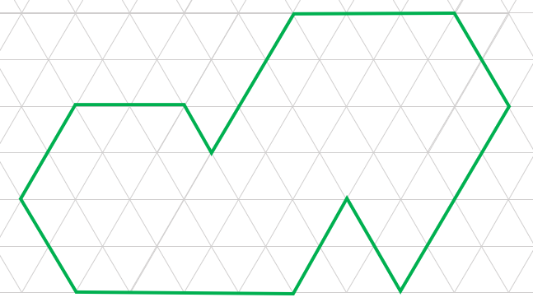

Figure 6. a Billiard on a triangular grid

We need to discuss the corners of such a billiard table. Vertices with acute angles cannot be reached along grid lines at all. Corners with a blunt angle can be reached, but then you can't tell in which direction the ball will bounce. We therefore only use those vertices as the start or end point of a trajectory. For example:

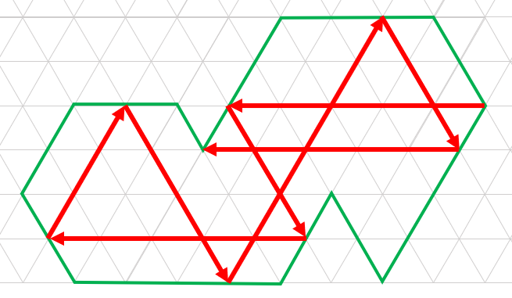

Figure 7. Example of a track that begins and ends in a corner vertex

In problem 5 you searched for a formula for the number of tracks for a parallelogram-shaped billiard table of *m* by *n*.

1. Can you also find such a formula for triangular billiards with equal sides of length *n*? Can you design any other classes of billiard shapes whose number of tracks you can calculate with an equation?

The degree of a corner vertex is the number of directions in which a track can arrive (or depart) at that point.

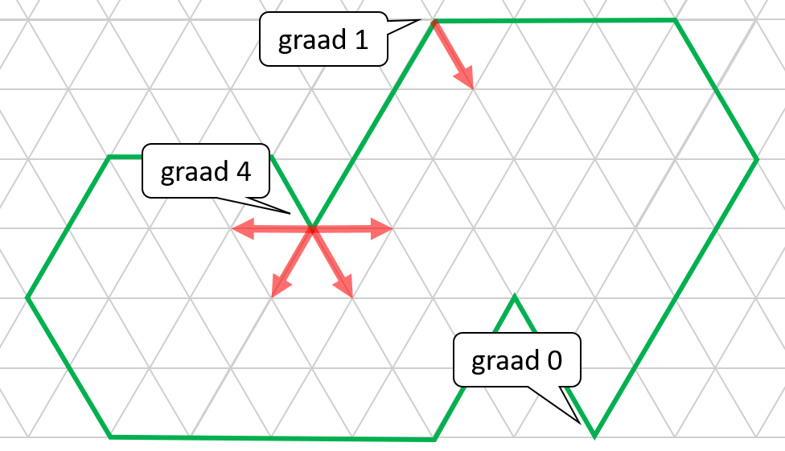

Figure 8. the degree of vertices on the billiard

1. What can you say about the sum of all degrees of the vertices of a billiard table? And about the relationship between the number of tracks and the sum of the degrees? What can you say about the degree of the vertices in your designs in part a and the relation to the corresponding equations?

1. Answers to an exploration do not have to be included in the report.