STEMkey Module 3 |  | Measurement

Worksheets

This Worksheet document is based on the work within the project “Teaching standard STEM topics with a key competence approach (STEMkey)”. Coordination: Prof. Dr. Katja Maaß, International Centre for STEM Education (ICSE) at the University of Education Freiburg, Germany. Partners: Charles University, Constantine the Philosopher University, Haceteppe University, Institute of Education of the University of Lisbon, Norwegian University of Science and Technology, University of Innsbruck, University of Maribor, University of Nicosia, Faculty of Science of the University of Zagreb, Utrecht University, Vilnius University.

The project STEMkey has received co-funding by the Erasmus+ programme of the European Union under Grant Agreement Number 2O2O-I-DEO1-KA203.005671. Neither the European Union/European Commission nor the German Academic Exchange Service DAAD are responsible for the content or liable for any losses or damage resulting of the use of these resources.

© STEMkey project (grant no. 2O2O-I-DEO1-KA203.005671) 2020-2023, lead contributions for STEMkey Module 3 by Utrecht University. CC-NC-SA 4.0 license granted.

Worksheet 1.1A
Individually
- Find out the height of the building or room you are in.
- Identify 1 meter rope from a ball of rope without measuring. Check how close you were.
- Describe various (average or top) speeds with different scales for distance and time (e.g. walking, bicycling, plant growth, snails and cheetahs.

In pairs:
- Compare your strategies for problems 1, 2 and 3. What reference points did you use?

Worksheet 1.1B (optional)
In pairs solve one or more of these Fermi problems. Note your strategies and the reference points you used. This activity can be organized as a contest with time restrictions and a jury and measuring tools for evaluating findings of each of the groups.
Estimate the weight of a bag potatoes | Estimate the weight of one standard concrete foot pavement tile. | How many rolls of toilet paper would you need to put an elephant in a mummy suit?
What is the content of an average shopping cart? | Could the amount of coffee and tea you drink annually fill an average bath tub? | Which grows faster: your hair or your nails?
Visualize the length of 5 meter. | 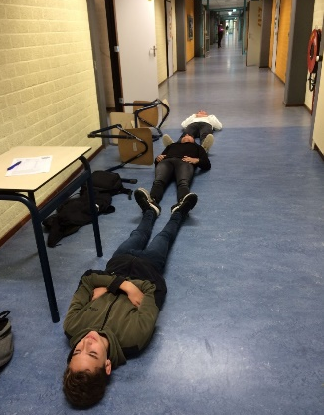 | [In the picture on the left three students managed to create ‘exactly according to our measuring tape’ a length of 5 meter]

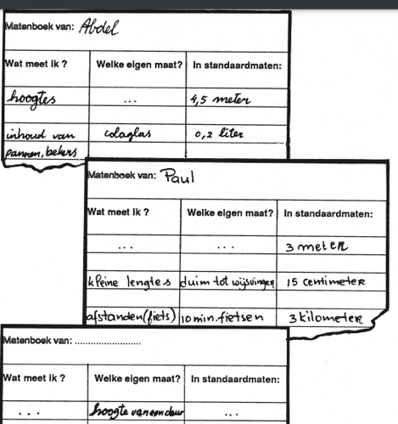
Worksheet 1.1C
On the right you see examples (in Dutch) of personal measurement guides.

Make your own measurement reference guide.
Reference measurement guide of: ………

What quantity do I measure? | What is my personal reference point? | What is the size in standard units?

Worksheet 1.2A
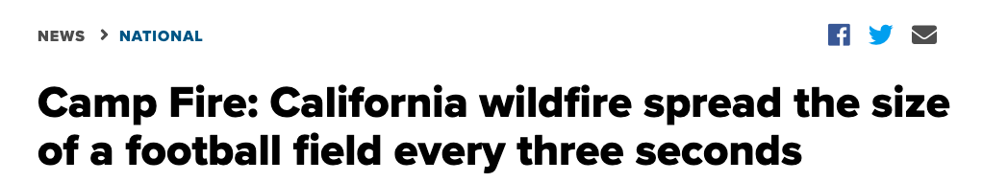
- What does this heading tell you about the fire? How long before your city-park would be all on fire?
- Football fields or pitches are often used to create awareness for the area of tropical rainforests. Why? What is the area of a football field? How many football fields can cover your province?
- Investigate the area of a cricket field and compare it with a football field. What do you prefer to use as a reference for large areas? Why?
- What other personal reference point do you use for area? For example for estimating the area of a living room? The area of a garden? The area of a table? The area of your city? Your country?
- Do you use references of area (as a whole) or rather references of length when estimating or comparing area?

Alternative source: https://www.theguardian.com/environment/2020/jun/02/football-pitch-area-tropical-rainforest-lost-every-six-seconds

Worksheet 1.2B circles
Explain the sizes of the shapes in this 1,5 m. society:
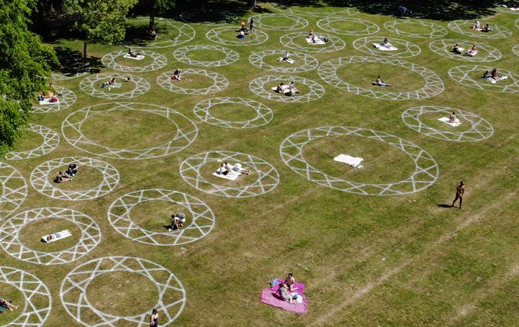
Photo credits: William Hoogteyling

Worksheet 1.3A
Study the task “Keeping distance” (https://www.fisme.science.uu.nl/toepassingen/28931/ ) and create a lesson plan for the task that outlines how to introduce the task to your students in a classroom, how much time they can have to work on the task and how to share findings, how to validate the results and how to conclude the lesson with what kind of summary of lessons learnt about estimation and about reference points.

Worksheet 1.3B
Below you see results of a task for students: “create a keeping 1,5 m distance poster”. Study the four posters of the students below. What are similarities and differences? How did different groups interpret the task?
Design a follow up activity to have students reflect on the use of reference points.

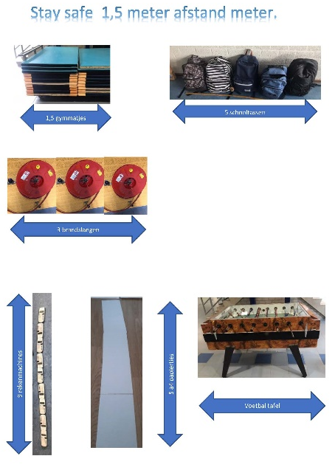 | 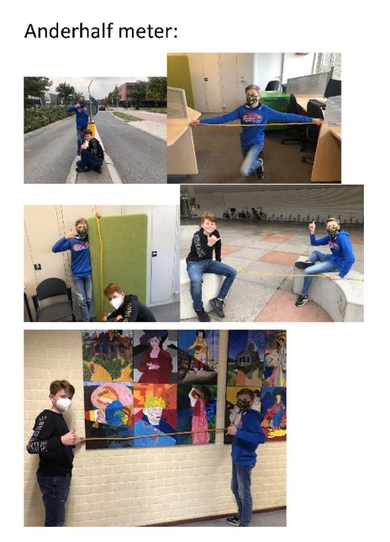
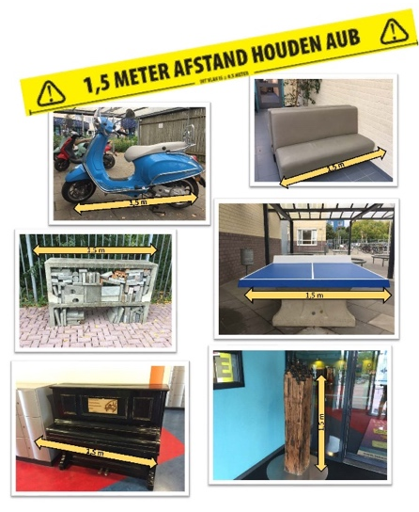 | 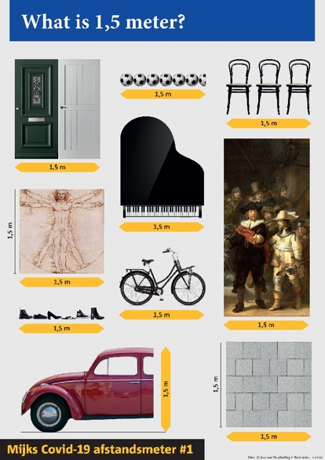

Worksheet 1.3C
The giant ship Ever Given blocked the Suez canal.
Create a lesson plan for your students with use of the following internet resources:
https://evergiven-everywhere.glitch.me/
http://overlapmaps.com/
Possible questions for students: Is that ship bigger than our school? What do you mean with bigger? Is it higher? Longer than the school? Area? Volume, or will all containers from the ship fit in the school?
And next: What information is needed to answer these questions?
Depending on the time available you can have students collect information, or act as a wiki-teacher, or immediately provide measures.
Reflect on estimations, sketches and calculations needed or performed. And show a glitch.me picture of the Ever Given next to the school.

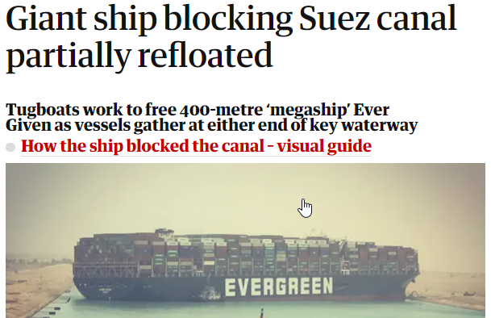
https://www.theguardian.com/world/2021/mar/24/huge-container-ship-blocks-suez-canal-evergreen

Worksheet 3.3

Beau-fort | Description | Wind speed | Wave height | Sea conditions | Land conditions
0 | Calm | < 2 km/h | 0 m | Sea like a mirror | Smoke rises vertically.
1 | Light air | 2–5 km/h | 0–0.3 m | Ripples with appearance of scales are formed | Direction shown by smoke drift but not by wind vanes.
3 | Gentle breeze | 12–19 km/h | 0.6–1.2 m | Large wavelets; crests begin to break; foam of glassy appearance; perhaps scattered white horses | Leaves and small twigs in constant motion; light flags extended.
5 | Fresh breeze | 29–38 km/h | 2–3 m | Moderate waves taking a more pronounced long form; chance of some spray | Small trees in leaf begin to sway.
7 | High wind,  near gale | 50–61 km/h | 4–5.5 m | Sea heaps up and white foam from breaking waves | Whole trees in motion; inconvenience felt when walking against the wind.
9 | Strong gale | 75–88 km/h | 7–10 m | High waves; dense streaks of foam along the direction of the wind; sea begins to roll; spray affects visibility | Slight structural damage (chimney pots and slates removed).
12 | Hurricane force | ≥ 118 km/h | ≥ 16.5 m | The air is filled with foam and spray; sea is completely white with driving spray; visibility very seriously affected | Devastation.

