The border of the Utrecht region
The dimension of a winding line

Part 0 – dimension 1

Measure the line segment below with each strip and always note in the table the length in the number of whole strips.
Notice: Really measure the line segment, you may only use whole strips.

name of the strip | Number of whole strips
8 units
4 units
2 units
1 units
1/2 units
1/4 units
1/8 units

Question 1a. What do you notice?

Question 1b. What is the length of the line segment?

Question 1c: Show from your measurements that the length of the line segment does not depend on the unit of measurement.
This means: the dimension of the line segment is 1:
- If you enlarge the line segment by a factor of 2, you get a line segment into which the original line segment fits 21 times.
- If you enlarge the line segment by a factor of 3 you get a line segment into which the original line segment fits 31 times.
- Etc.
Question 2: Using a few examples from the table, show that your line segment has dimension 1.
Maybe this all sounds familiar.
Voor kronkelige lijnstukken is er echter wat anders aan de hand. Daar kan namelijk de lengte van het lijnstuk wel afhangen van de maateenheid en dat heeft gevolgen voor de dimensie.

Part 1 – Measure the border of the Utrecht region

Look closely at Utrecht's provincial border. That is a sinuous line  You can see a pattern of inlets and bulges.  As you zoom in on that border, you see more and more details and you can measure the length of the border more and more precisely. It then looks like the perimeter (the county border) is getting bigger and bigger. What is that actually like? | 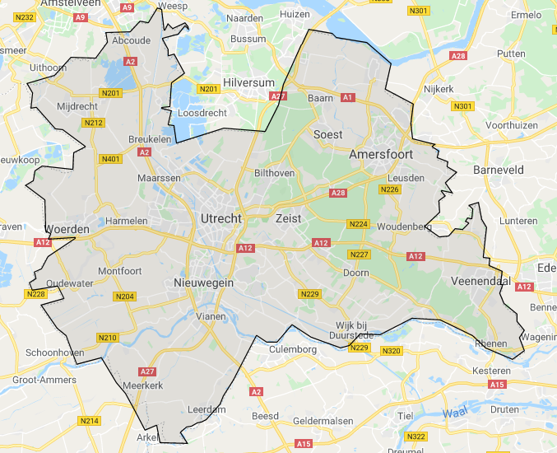

Measurement
Measure the perimeter of the province of Utrecht on the large map with the different measuring strips. Start with the longest strips (of 40 km).
- Always place the strips of the same length as best you can along the border of the province.
- Do not bend or fold the strips.
- Count the number of whole strips and calculate the length in km.
- Length = number x unit of measurement
- Fill in the table

Measure unit strip | Number | Length
strip 40 km

strip 30 km

strip 20 km

strip 10 km

strip 5 km

Question 3a: What do you see? Explain

Question 3b: Using a few examples from the table, show whether the boundary line of Utrecht has dimension 1.

Question 4: Find out the ratio between the measured length and the factor by which you reduce the strip.

Part 2 – measuring a fractal

You can see here a fractal, which is a mathematical structure whose pattern keeps repeating as you zoom in. So the border of Utrecht looks a bit like such a fractal.

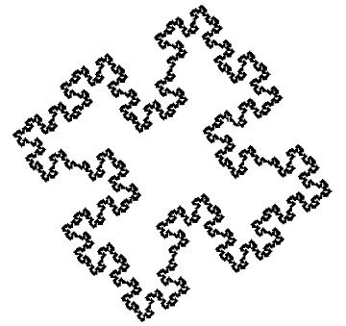

You can also measure the length of this fractal with a smaller and smaller strip. Use the strips from task 0 to measure the length and enter the results in the table again.

Name of the strip | Numb. of whole strips | Length in units
8 units
4 units
2 units
1 units
1/2 units
1/4 units
1/8 units

Question 5a: What do you see? Explain

Question 5b: Using a few examples from the table, show whether the fractal has dimension 1.

Question 6: Find out the ratio between the measured length and the factor by which you reduce the strip.

Question 7: Compare the factor with that of borderline of the province of Utrecht.

Part 3 – More about the fractal - broken dimensions

This fractal was created in a special way. The shape was devised by Italian mathematician Peano. You start with a square:
In it, replace each of the four sides with a line of the following shape. The line segments below are 4 times as short as the side of the square.
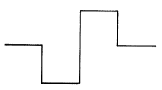

You get:  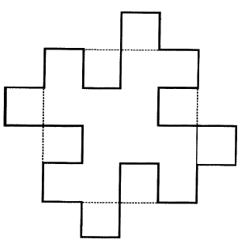  For clarity, the old square is still drawn in.  In the new figure, again replace all straight line segments with line segments of the shape:  These line segments are again four times smaller. You get the figure on the right. You can go on like this indefinitely. | 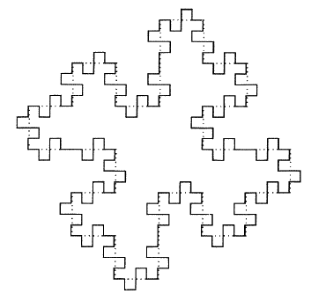
We can now also measure the length (circumference) of the fractal with measuring strips that become 4 times smaller each time. So you can measure more and more precisely.

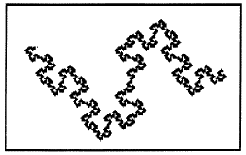 | 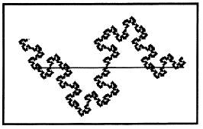 | 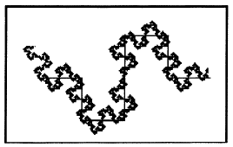
Part of the fractal | Measured with a 'rough' measure | And then with a smaller measure( eight times smaller).

The approximation of the length already gets a lot better with a smaller unit of measurement (a smaller measuring strip). Here you can see the table that fits this fractal.
Strip (units) | Number of strips | Length in units  (measure) | $$\frac{1}{measure unit}$$
1 | 1 |  | 1
$$\frac{1}{4}$$ | 8 |  | 4
$$\frac{1}{16}$$ | 64 |  | 16
$$\frac{1}{64}$$ | 512 |  | 64
$$\frac{1}{256}$$ | 4096 |  | 256

Now we will investigate the relationship between the length and the unit of measurement for this fractal.

Question 8: Find out the ratio between the measured length and the factor by which you reduce the strip.

Question 9: Compare the factor with that of borderline of the province of Utrecht and of the factor at question 6.

Question 10: Does this fractal have dimension 1? That means: does the rule apply:
Length = number x (measure unit)¹

More general:
measurement = number x (measure unit)^{dimension}
Or: number = measurement/(measure unit)^{dimension}

Question 11: Use this line and the table above to find the dimension of the fractal's length.

Question 12: In the same way as for question 10, now find the dimension of the boundary line of Utrecht.

Part 4 – extra – more fractals and broken dimensions

Investigate the dimension of the blue line segment in fractal below called Koch's snowflake.
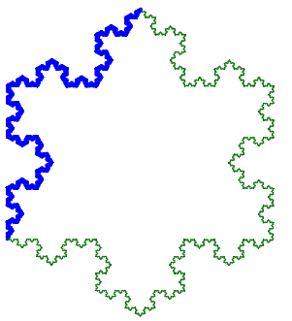

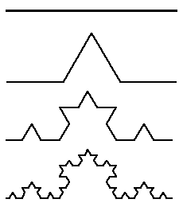
You make this line segment:
- Divide a line segment of length 1 into 3 equal parts.
- On the middle part, draw an equilateral triangle.
Omit the middle part.
- Now repeat the division for each line segment of the new figure.
- And so on.

To measure (fit) the length of the blue line segment, always use a strip that is 3 times smaller than the previous one. You probably don't really need to measure now, but you can 'conveniently count'.
Again, use a table to fill in your results.
Strip  measure unit | Number of strips | Length  (measurement)
1
$$\frac{1}{3}$$
$$\frac{1}{9}$$
$$\frac{1}{27}$$
$$\frac{1}{81}$$
$$\frac{1}{243}$$

Again, use the rule about dimensions

measurement = number x (measure unit)^{dimension}
Or: number = measurement/(measure unit)^{dimension}

