JUST MAKE A THROW



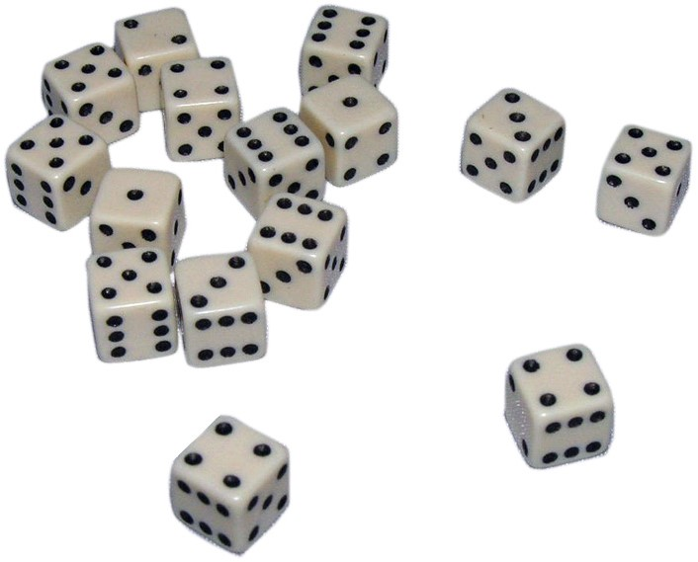

Alympiad final

March 13-14, 2020

Garderen, the Netherlands

# Colophon

The Mathematics Alympiad (Wiskunde Alympiade) is an initiative of the Freudenthal Institute, Utrecht University. The Alympiad committee is responsible for the organisation of the Alympiad and for creating the assignment.

The committee members are:

**Marcel Daems**

Gymnasium Sorghvliet, Den Haag

**Eric van Dijk**

Lorentz Casimir Lyceum, Eindhoven

**Tom Goris**

Fontys Lerarenopleiding, Tilburg

**Dédé de Haan**

Freudenthal Instituut, Utrecht

**Senta Haas**

Städtisches Gymnasium Hennef, Hennef, Deutschland

**Kim Kaspers**

Murmellius Gymnasium, Alkmaar

**Johan van de Leur**

Mathematisch Instituut, Universiteit Utrecht

**Matthias Lippert**

Bezirksregierung Köln, Deutschland

**Ruud Stolwijk**

CITO, Arnhem, Vrijeschool Zutphen VO, Zutphen

**Monica Wijers**

Freudenthal Instituut, Utrecht

Secretarial support:

**Mariozee Wintermans**

Freudenthal Instituut, Utrecht

The Alympiad is supported by contributions from:

Ministerie van Onderwijs, Cultuur en Wetenschap

CASIO, Amstelveen

Fontys Lerarenopleiding, Tilburg

# INSTRUCTIONS FINAL ROUND MATHEMATICS A-LYMPIAD 2020

IN ADVANCE:

* First read the full text of the assignment so you will know what you have to do this weekend.
* Check whether you can open the data on the memory stick.
* The following file is included on the stick: the assignment: Finale Alympiade2020 (in Dutch, English and German) including three appendices.
* Divide tasks when possible

TIME MANAGEMENT:

* Keep an eye on the time when you are working on the different parts.
* You have to hand in a report *and* prepare a presentation. More information about the the presentation will follow during the weekend.
* Plan in advance who will start work on what and when.
* Saturday afternoon, before lunch, at 12.30 h, you must hand in the memory stick with the result (as one single document).

HANDING IN:

* Saturday afternoon 12.30 at the latest: the memory stick with the assignment.
  + Hand in the assignment as **one single** document, preferably in pdf.
  + Try whether you can open the pdf on several different computers.
  + The jury will receive digital copies of the handed-in file, so you can make use of colour in your assignment.
  + Each team is responsible for the technical quality (legibility and processability) of the file it hands in.

JUDGING:

* Put all your findings in a clear report that can be read independently (i.e. without having to look at the assignment). The focus is on the final assignment and its reasoning and argumentation.
* These are some of the points the jury will focus on in judging the assignment:
  + The elaboration and reporting for assignment 1 to 4 and the final assignment;
  + how complete the answers for the various parts are;
  + the use of mathematics;
  + the argumentation that is used and justification of choices that have been made;
  + the depth to which the various assignments have been answered;
  + how the whole is presented: form, coherence, readability, illustrations etc.;
  + originality and creativity.

Have fun and good luck

# First this…

Lego bricks are thrown a number of times per table. These can fall on the table in different ways: on their side, with the "studs" up and with the "studs" down. Every table keeps track of how often each method occurs. These numbers are noted on a sheet of paper and handed to the organization. It will become clear later on what role these data play during this final weekend.  
Each team will receive a set of "normal" and a set of "special" dice.

# Introduction…

You have probably played Yahtzee or another dice game, and thought about your choice of throwing the dice again or not. What does such a choice depend on? In this assignment, you will examine a few dice games and investigate different scoring systems and their effect on the attractiveness of the game.

**Assignment 1: No six**

**Game ‘No six’**

Rule: In each round you may throw one die as often as you like, but you have to stop once you throw a six.

*Scoring system A*

You get no points when you throw a six. If you stop before you throw a six, your score will be determined as follows: if you stop after the first turn, you get the number of pips you threw last. If you stop after the second turn, you get twice the number of pips you threw last. If you stop after the third turn, you get three times the number of pips you threw last, etc. You count your scores.

*Scoring system B*

You get no points when you throw a six. If you stop before you throw a six, all throws you made until then will be added up.

1. Play this game for a large number of rounds with both scoring systems and keep good track of how the game goes.

Arie plays the game and has made the following throws in the first six rounds:

5-2-4-2-1-4.

1. Calculate the chance that Arie will be better off if he makes another throw for both scoring systems.
2. With which scoring systems is the chance of a high score in general the highest? Distinguish between risk-avoiding players and players who are happy to have a gamble. Support your answer with examples and calculations. You may of course make use of the answer from a. and b.

**Assignment 2: Sum-product**

**Game ‘Sum-product’**

**Rule:** You throw two dice in every round and may throw a maximum of three times.

***Scoring system A***

Your score is the sum of the pips in the last throw.

***Scoring system B***

Your score is the product of the pips in the last throw.

Play the game ‘Sum-product’ for a large number of rounds with both scoring systems and keep good track of how the game goes.

With which scoring systems is the chance of a high score in general the highest? Distinguish between risk-avoiding players and players who are happy to have a gamble. Support your answer with examples and calculations.

**Assignment 3: More of the same**

**Game ‘More of the same’**

**Rules:** You throw five dice and may throw a maximum of three times. For each throw, you may choose whether to leave some dice and don’t carry them over to the next throw. When you determine the score you first check whether you threw a certain number of pips more than once.

|  |  |  |
| --- | --- | --- |
| Score table | *Scoring system A* | *Scoring system B* |
| None the same | Total pips | Total pips |
| 2 the same | 5 points + total pips | 5 times the number of pips of the double die |
| 3 the same | 10 points + total pips | No points |
| 4 the same | 15 points + total pips | 15 times the number of pips of the quadruple die |
| 5 the same | 20 points + total pips | No points |

Play the game ‘More of the same’ for a large number of rounds with 5 normal dice according to both scoring systems and keep good track of how the game goes.

1. 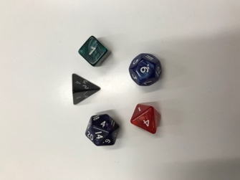With which scoring systems is the chance of a high score in general the highest? Distinguish between risk-avoiding players and players who are happy to have a gamble. Support your answer with examples and calculations.
2. Play the game ‘More of the same’ with the five ‘special’ dice you got from the organisation (see the photo). Now also investigate the effects of the scoring systems.
3. What are the differences and similarities between the games? Which game do you find more attractive and why? Support your answer with examples and calculations.

**Assignment 4: other elements …**

You have indicated for all games which scoring system has the greatest chance of a high score in general. That is of course not the only element that makes a game attractive to play.

Which other elements in the rules and the scoring system make it an attractive game to play? Explain your answer.

# Final assignment…

On Friday morning we threw Lego bricks. You will receive the table with the results of the throws on Friday evening.  
You are going to design a game with the following rules:  
**Rules:**

* Make a throw with 6 ‘dice’: you must use 2 Lego bricks, 2 ‘normal’ dice and 2 ‘special’ dice.
* You must leave at least one die after each throw; it may no longer be thrown (so a turn is over after a maximum of six throws).

Design an attractive multi-player game, with a scoring system, within these rules. Make sure that the explanation of the game (before you start playing) is short - and that the game itself is not too long either, of course!

Explain in your report why this is an interesting game. Discuss both the scoring system and other factors. Make use of your experiences from the previous assignments. In your report, also explain why you chose these particular 2 "special" dice (after all, you could choose from 5).

# Conclusion…

In the conclusion (on Saturday afternoon after lunch) (some of) the games you designed are played using the associated scoring systems. Therefore, ensure that the rules / scoring systems are clearly written down.