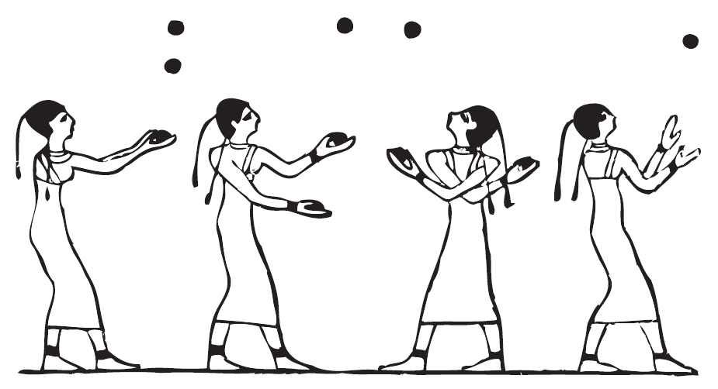

Mathematics B-day 2020



# Introduction

## About the assignment

You have probably tried to juggle yourselves. Two balls is still doable, but after that it quickly gets more difficult, and the number of possible ways to throw the balls also increases quickly. Today it will turn out that there is a surprising amount of beautiful mathematics behind juggling. The ball is in your court!

## Structure of the day

This Mathematics B-day assignment consists of introductory and final assignments. Try to keep half of the day for the final assignment; so, don't spend too long on the morning session. Unlike normal maths lessons, you certainly do not have to do all the assignments for the Math B-day (this includes the introductory assignments). If you cannot do an assignment or you do not have enough time, you can skip it, or perhaps only include in your report the part that did work. There are many introductory assignments ranging from easy to difficult, so it is not surprising if you cannot get everything done.

## Working in teams

The special thing about the Math B-day is that you do mathematics in a team, like at a football match. It might be a good idea to make a schedule and a division of tasks. Let everyone do what they are best at. Give everyone room to contribute with ideas and elaborations.

## Necessities

Today you will need: a pen, enough (scrap) paper, scissors, tape, a stapler or paperclips to attach pieces of paper to each other, this assignment and a computer or laptop to prepare your report. Use of the internet is allowed (clearly state the source url in the report), but we do not encourage it.

## What to hand in?

During the day you will work on a digital report. Don't start on the report too late. You must hand it in at 16:00. In it, you describe your results and reasoning. This concerns in particular the research from the final assignment. Tell your own clear and convincing story. We value well-written, clear, precise, complete, carefully formulated, and certainly original, creative and lyrical reports.

Tips:

* Plan your time and divide the tasks among the team members. It can be useful to start writing out your preliminary exercises in the morning.
* *Be understandable*: make sure that your work is legible for someone who has not participated in the Mathematics B-day (but has sufficient understanding of maths), without having read the assignment.
* If you provide substantiation, explanations or clarification, try to do so with *mathematical arguments* as much as possible.
* Use *figures* to illustrate your ideas. For example, use copies of pictures you have made (screen captures or photos of figures on paper).
* Make a *schedule and distribute the tasks* among the group.

Both the mathematical content of the report and the way in which it is written count in the assessment!

# Basic assignments

# Watch the YouTube video *The Beauty and Mathematics of Juggling* | Alexander Leymann | TEDxDresden: <https://www.youtube.com/watch?v=ELvedTUcjPo>. If necessary, turn on the translation.

# You can watch the video completely during the morning, but for the introduction it is enough to watch up to minute 8.

# Assignments 1 to 8 are the minimum you need to understand the final problems.

Throwing patterns

# Questions 1 to 4 are about the video. You do not have to include the answers to these questions 1 to 4 literally in the report

# Today we will follow the same rules as in the video: so, in short: while juggling there is always a regular pulse ("beat"), and balls are only caught on that pulse and immediately thrown again, alternating with the left- and the right hand, but never simultaneously.

1. Alexander mentions a **3-throw** (in the video at 1:50).

How do you describe a 3-throw in your own words? And what is an $n$**-throw** (video 2:08) for $n>0$?

1. In which hand does the ball land on an $n$-throw with the left hand, if $n$ is even? And for an odd $n$? Why? (video: 5:10)
2. Alexander gives as an example the **throwing pattern 4, 4, 1**  (video 5:38)**.**

a How many balls does he use?

b What does the green ball do in sequence?

c Copy the diagram he uses.

1. Alexander also gives as an example the **throwing pattern 5, 3, 1** (video 6:04)**.**

a How many balls does he use?

b What does the green ball do in sequence?  
c Copy the diagram he uses.

There are some moments that no ball is landing or being thrown. Such a moment we call a **0-throw** – don’t confuse this with holding the ball for one beat; that does not happen in this notation. A throwing pattern like 5, 3, 1 tells you every time what to do with a ball that you catch, and so leads to an infinitely long **juggling session**, in this case …, 5, 3, 1, 5, 3, 1, 5,3, 1, …, in which a certain pattern repeats itself. We therefore call the number of numbers in the throwing pattern the **period**.

Alexander mentions three agreements for throwing patterns/juggling sessions (starting at 6:38):

1. A throwing pattern represents a sequence of throws that repeats itself, so 5,3,1 represents the juggling session…, 3,1,5,3,1,5,3,1,5,….
2. You catch alternately left, then right, then left, then right, etc. So not with left and right at the same time.
3. You never catch and / or throw two balls with one hand.

We emphatically add to that:

1. Every ball you catch on a beat is immediately thrown again (in the same beat). Balls therefore do not stay in the hand for several beats.
2. Balls cannot just disappear in a juggling session.
3. You cannot just add balls in a juggling session.

It therefore appears from lines v and vi that the throwing pattern says nothing about the beginning and the end of a juggling trick - which practically always shows only a finite part of a juggling session.

For jugglers, a throwing pattern is an important aid for discovering and communicating how to juggle. We will further investigate these throwing patterns in the basic assignments.

Switching and throwing diagrams

Questions 5 to 8 help you to practice throwing patterns and the pictures you can make with them. You do not have to include the answers to these exercises in your report literally.

In the video you saw pictures of a finite part of a juggling session, in which the repeating pattern can be seen in its entirety at least once. We call such a picture a **switch diagram**.

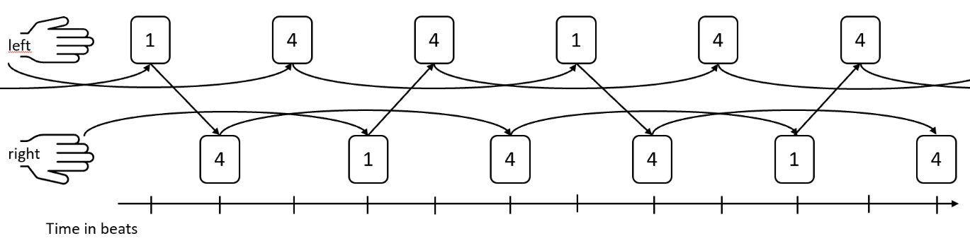

You read the diagram from left to right, with the time regularly increasing. Each curved arrow represents a throw. Each square represents a moment that a ball can be caught and then thrown again: top is left, bottom is right. The box states which type of throw it is. The “1”'s represent a 1-throw with the left that lands in the right hand a beat later. The “4”'s represent a 4-throw, landing in the same hand that threw four beats later.

1. Which throwing pattern does this switch diagram show? And the diagram below?

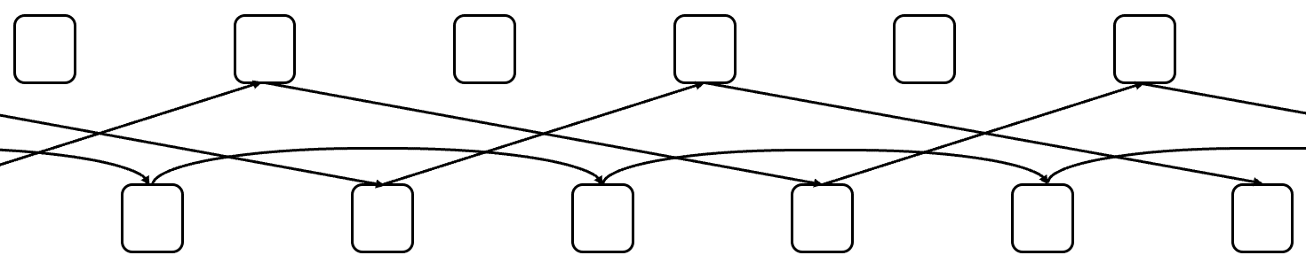

1. Here you can see a number of throwing patterns. Which ones result in the same juggling session?

5,3,1 5 1,5,3 5,5,5 5,3,1,3 6,1,6,5,7 1,6,6,5,7 5,7,1,6,6

1. Draw a switch diagram for the throwing pattern 4,4,1,3.

A throwing pattern that can be described by one number (such as 5) is called a **basic throwing pattern**.

You can simplify the switch diagram a bit more. The left / right distinction might be useful if you're really going to juggle, but for mathematical reasoning, you can put the dots all next to each other - just keep in mind that left and right take turns doing something.

You will then get a **throwing diagram**.

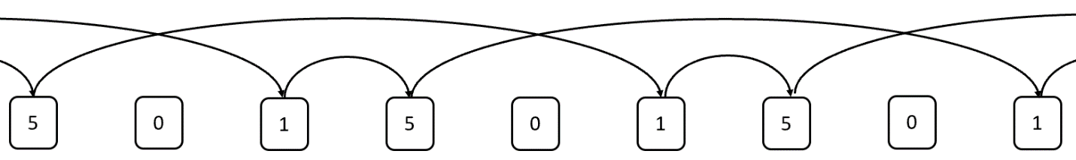

1. Draw the throwing diagram for the throwing pattern 4,5,3,0,3.

Is a row a throwing pattern?

Not every sequence of numbers is a throwing pattern that leads to a juggling session. In exercises 10 to 16 you will investigate how you can use a calculation to determine whether a sequence of numbers is a throwing pattern.

To check whether a sequence of numbers is a throwing pattern, you can first use the throwing diagram.

1. a. Use throwing diagrams to determine **whether** 4,4,3,1 and 3,3,4,0,5 are throwing patterns.

b. Explain exactly how you use the throwing chart to determine whether a sequence of numbers is a throwing pattern and why it works.

Making a drawing is handy, but what about a row like 300,3,3 (leaving aside whether you could throw that high)? Then you would want to be able to determine whether this is a throwing pattern by calculating alone.

c. First try 6,3,3. Is it a throwing pattern? How do you tell?

d. Make a start with making a throwing diagram for 300,3,3. Use this to see what kind of calculation you need to make to see if 300,3,3 is a throwing pattern.  
  
e. How do you determine whether 300,12,3 is a throwing pattern?

f. And how do you determine whether 300,400,500 is a throwing pattern?

1. a. Investigate a general mechanism with which you can discover whether a row is a throwing pattern by just calculating and comparing numbers. Describe your research in your report and, of course, the mechanism, if you found it.  
     
   b. Illustrate your mechanism with the examples 4,4,3,1 and 4,4,4,5,3.  
     
   c. Explain why this control mechanism works.

Making and adapting throwing patterns

You have the basic throwing patterns $n$ for integer positive numbers $n$.

Other throwing patterns do not come out of the blue. Would there be a way to create a new throwing pattern? In the following exercises you will investigate a number of possibilities. You can include your findings in your report.

Below, there are four ways to adjust throwing patterns.

1. Suppose you have a throwing pattern, say 5,3,1. Add 4 to each number. Then you get 9.7.5. Is that another throwing pattern?
2. II. Suppose you have a throwing pattern, say 5,3,1. Add (or subtract) a period to one of the throws. For example, you can add the period 3 to 1. Then you get 5,3,4; or you can subtract the period 3 from 5. Then you get 2,3,1. Are those throwing patterns again? We call this method **periodicity**.
3. You can also **rotate** a throwing pattern: that means that each number moves one spot and the last becomes the first. For example, 7,5,6,2,5 becomes 5,7,5,6,2.

Reversing two numbers in throwing pattern usually does not produce another throwing pattern. For example, 5,3,1 could become 5,1,3 (and the latter is not a throwing pattern).

1. Reverse two numbers, then add 1 to the first of the reversed numbers and subtract 1 from the second - for example, 5.3,1 becomes 5.1 + 1,3-1 is 5.2,2. We call this the **swapping trick**.
2. Investigate for each of the methods I to IV under which conditions they do make a new throwing pattern from a throwing pattern, and why. Also investigate what the methods do with the number of balls needed for the juggling session. Include your findings in your report.

If you perform the swapping trick twice with two numbers in the same position, you are back to square one: for example, 5,3,1 goes to 5,2,2 and then back to 5,3,1.

The number of balls you need cannot be read implicitly from the throwing pattern.

1. Research how you can calculate the required number of balls from the numbers in a throwing pattern. Briefly describe in your report how you approached your research, what the outcome was, and substantiate your claim(s).

Finding all throwing patterns

In assignments 14 to 17 you will research a way to find all possible throwing patterns. You can include your findings from these assignments in your report.

As you will recall, basic throwing patterns are the ones that repeat a type of throw over and over, for example 3,3,3,3,3,..., briefly written as 3.

**Claim A**: Any throwing pattern can be changed to a basic pattern by rotating and swapping.

1. Take 4,5,3,0,3. How do you know in advance which basic throwing pattern you will be working towards? Why? Work towards that.
2. Investigate whether Claim A is true. If so, explain why (proof). If not, provide a counterexample. Also briefly describe how you approached your research. Note: Even if you do not find a definitive answer with your research, be sure to write down what you did and tried.

**Claim B:** Any throwing pattern can be made from a basic throwing pattern by rotating and swapping.

1. Investigate whether Claim B is true. If so, explain why (proof). If not, provide a counterexample. Also briefly describe how you approached your research.
2. Provide an overview of all throwing patterns with a maximum period of 3 and only 0, 1, 2, 3, 4, and 5 throws. Explain how you came to your overview in a systematic way, and why you are sure you have them all.

# 

# Final assignments

Option 1: train station

A (small) station has one platform. Trains depart from this station on a number of routes of different length, returning to the station after 20, 30, 50 minutes respectively. For safety and flow, the platform can process one train every 10 minutes – that is, the train arrives and departs. For the sake of convenience, assume that no time is lost with that.

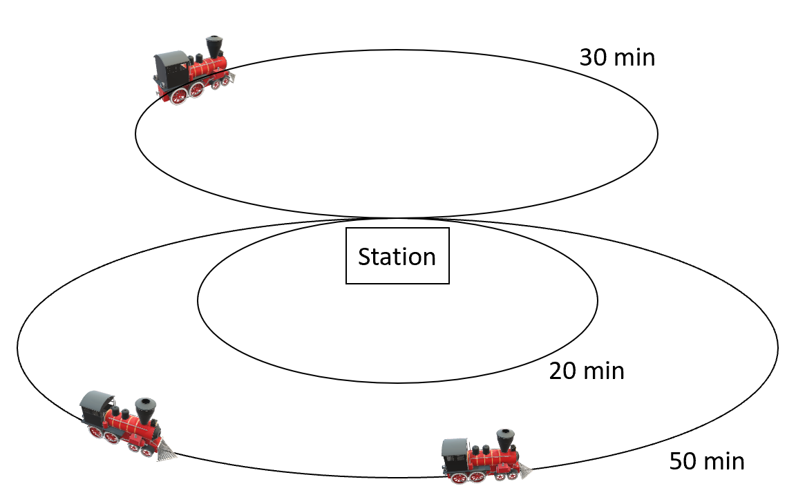

A timetable is a schedule of departure times for the trains, so that all routes are completed at least once before repetition occurs.

1. Explain the relationship between this situation and juggling throwing diagrams / throwing patterns as precisely as possible. How is it the same and how is it different?
2. Design a timetable using what you wrote in question 1. Do you see more possibilities? What are the considerations for choosing one timetable over another?

One additional route of 80 minutes is added.

1. Design a timetable. Do you see more possibilities? What are the considerations for choosing one timetable over another?

For the sake of convenience, we now assume that the platform can process a train every minute and we note the route lengths with integer positive numbers $t_{1}, t_{2}, t_{3},…, t_{n}$

**Claim:** There is a timetable for every combination of routes with length $t_{1}, t_{2}, t_{3},…, t_{n}$.

1. Is this claim true? If so, please explain. If not, please provide an example showing this.

Suppose you have two routes: $t_{1}=2$ en $t_{2}=5$.

1. Investigate for which positive integers $k$ there is a timetable with $k$ trains for these two routes ( $t_{1}=2$ en $t_{2}=5$).

You can investigate this for any finite combination of trajectories with length $t_{1}, t_{2}, t_{3},…, t_{n}$.

1. So, in general: what can you say about the possible number of trains $k$ with which you can make a timetable? Research this issue. Suggestions: is there an upper limit for the number of trains? Are certain numbers of trains always possible? Is it easier to answer for certain combinations of routes?

A timetable with a period of 1437 minutes is not practical. Suppose you want a timetable with the shortest possible period.

1. Investigate the problem to get as short a period as possible. What can you say about that? Explain using examples and / or general statements with substantiation.

Option 2: Juggling graph

In the morning you researched and made throwing patterns. The disadvantage of this juggling model is that it does not involve switching between patterns. A good juggler makes smooth transitions from one pattern to the next, so that the act does not get boring. That is why in this assignment option we look at another model that can describe this.

Let us assume a beginner throws with two balls and has only mastered the 0,1,2 and 3 throws. So, just like in the morning, we work with a "beat" and the same juggling rules apply. The model consists of *states* and *transitions*.

A state is a sequence of 0's and 1's, for example 011, and is associated with a particular beat. The first 0 or 1 indicates whether or not you have a ball in hand on the beat in question. Furthermore, a 1 in the $k$-th position means that a ball lands in the hand after a $k-1$ count and a 0 means that no ball will land during a $k-1$ count. Only throws that have already been made are considered. In the state on a certain beat, throws made on that beat or later will not be counted yet.

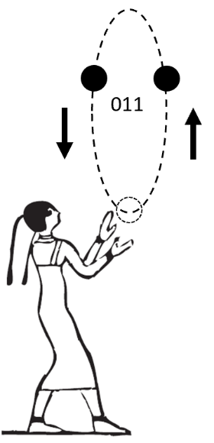 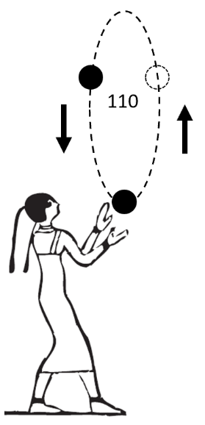 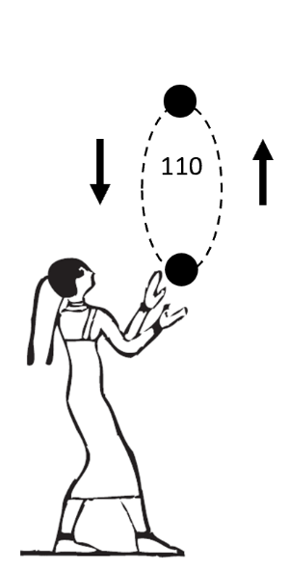

A state alone does not determine a throwing pattern. Of course, the state changes every beat and those are the transitions mentioned earlier. State 011 (left figure) changes to state 110 with a 0 throw (middle figure). But in state 110 you can do a 2-throw or a 3-throw. With a 2-throw, the new state is 110 again - but the picture (figure on the right) is a bit different, because the last 2-throw has a lower curve than the 3-throw in the previous pictures.

Next, you can make an overview of all states with two balls and only 0-,1- , 2- and 3-throws. That corresponds to all rows with 2 ones and 1 zero. There are only three: 011, 101, 110. You can then summarize the possible states and transitions in a diagram, where the rectangles contain the states and the arrows represent the transitions.

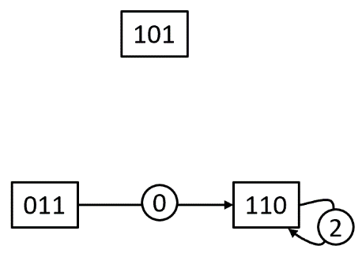

1. Complete the diagram with arrows for all possible transitions between states

This diagram is called the **juggling graph**.

1. Make the complete juggling graph for two balls and 0-, 1-, 2-, 3-, 4-throws.

Below is the juggling graph for three balls and 0-, 1-, 2-, 3-, 4-, 5-throws. You can see, for example, that there are three transitions from 10110.

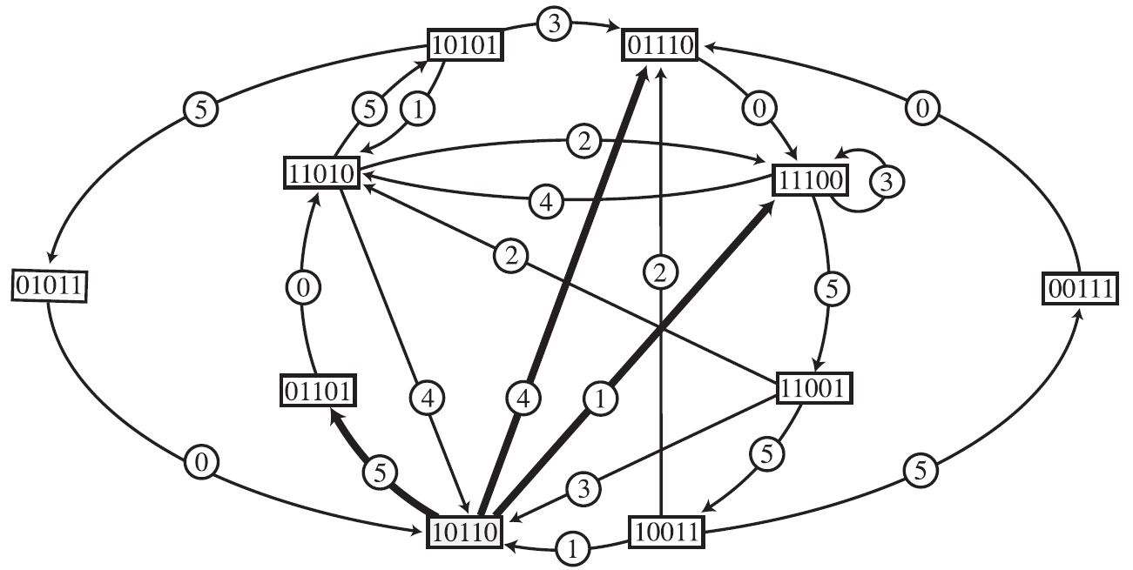

1. Explore the connection between throwing patterns and juggling graphs. How can you make throwing patterns using the juggling graphs?
2. Investigate how to find *all* throwing patterns with a fixed number of balls and a maximum throwing height in a systematic way with the help of the juggling graph.

Suppose you do allow the juggler to catch and throw two balls at a time, so with left and right at the same time.

1. Investigate how the juggling graph model can be adapted for this. Indicate in the report which choices you make in this regard. Also give one or more examples.

Option 3: non-periodic juggling patterns

This assignment is slightly shorter and can possibly be combined with part of another optional assignment.

You can maintain all the juggling patterns that we have seen indefinitely, but they can still be described very briefly. This is because they are periodic: after a fixed period, everything repeats itself. However, there are also rows of numbers that you can continue indefinitely WITHOUT any repetition and that you can still describe in finite words thanks to a different regularity that is included, for example:

Row A: 1, 3, 6, 10, 15, 21, 28, ...

Row B: 2, 3, 3, 2, 3, 2, 2, 3, 3, 2, 2, 3, 2, 3, 3, 2, ....

Such rows, in which no period can be found, are called non-periodic. Neither Row A nor Row B are juggling patterns, but non-periodic juggling patterns do exist.

1. Make an infinite, non-periodic juggling pattern. Explain how you found it and why it works. The rules are:

* The row must be juggleable
* There must be a regularity in the list that can be explained to someone who knows nothing about juggling
* You must minimize balls 'from nothing', that is, a ball that is handed in or falls down from your head like in the video. That is allowed, but a finite number of times.
* There must be no period after which everything repeats itself exactly the same The more interesting the row the better.

1. Calculate how many balls are needed for your juggling pattern in the previous section
2. Provide a method for creating, adjusting, and / or combining infinite, non-periodic juggling patterns.

Non-periodic sequences can be unlimited (like row A), which means that there is no limit to how big the numbers become if you keep going long enough, or limited like row B. Both possibilities occur also for non-periodic juggling patterns. You can choose which of the two types of rows you want to make (or both). Although in real life you may not be able to throw higher than the distance to the moon, for this assignment that is not a problem!