The art of security
Introduction
A museum for modern art will organise a large exhibition with the work of a number of important artists. The museum is currently working on the preparations for the exhibition and encounters a problem relating to security.
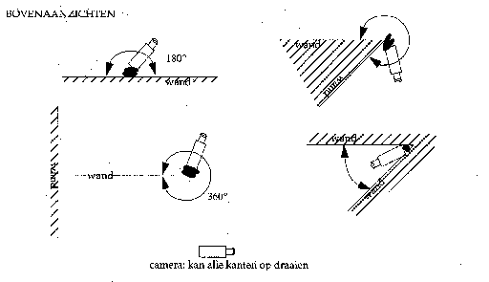
A new security system
The current security system using video cameras does not satisfy the needs required by an exhibition of this scale. Among other things the cameras do not move around quickly enough (to bring a different corner into the picture), but the main objection is that the current system cannot cover the entire area of the museum. A new security system must be purchased in order to be able to organise the exhibition.
The camera type that will be purchased has already been found. This camera can rotate so quickly (in all directions) and then focus, that you can assume that this camera will secure the entire surrounding area see figure below). All the walls in the museum extend from floor to ceiling.
A downside to this camera is the rather high purchase price. Therefore it is necessary to have a thorough examination into where the cameras have to be placed so a minimum of cameras is needed.
In the appendix you will find a plan of the museum. The museum has a top view shaped like a triangle. The grey area consists of the entrance, toilets, wardrobe and offices. In this area it is unnecessary to replace the current cameras. So, the new security system is solely needed for the non-grey area.
Task 1
Come up with a plan for the setting of the cameras on the plan in the appendix in which a minimum of cameras is needed to secure the exhibition area. Describe the system you have used in placing the cameras. Indicate where the cameras need to be placed and demonstrate that the entire area of the museum is secured.
The exhibition contains a little under a hundred paintings. To portray these properly (with a fair interval between paintings) at least 280 meters of wall is needed, but: the more walls, the better. In the plan some walls are in bold print. These are supporting walls, all the other walls can be removed. Since the new security system is extremely expensive, the organisation wants to cut back in costs. In cutting back on costs there is the possibility of reducing the number of cameras, but it is also an option to remove the non- supporting walls. Removing a wall costs €500,- per meter. A video camera costs €10,000.
Task 2
How can you cut back on costs by removing walls (think of the minimum amount of meters of wall that you need!)? So: How can you use as few cameras as possible, while removing the smallest amount of walls, but with all walls still being guarded? Make a proposition and calculate the savings.
After this exhibition the interior of the museum will be changed radically. First, all non- supporting walls will be removed, only the supporting walls will remain standing. As the new interior design of the museum will be used for a longer period of time and for several exhibitions, an architectural firm will be involved. The architectural firm will be assigned to place the interior walls in such a way that it will create 150 meters of wall besides the already existing supporting walls. On top of that, six cameras should suffice for security while the area is still arranged appealingly.
Task 3
A number of security firms are requested to submit their proposals meeting the aforementioned requirements. You are one of those security firms, and are keen on bringing in the task. Naturally, it will not enhance your competitiveness when you only meet the minimum requirements. Write a proposal for the board of the museum (including a working drawing and a brief accompanying letter).

Appendix

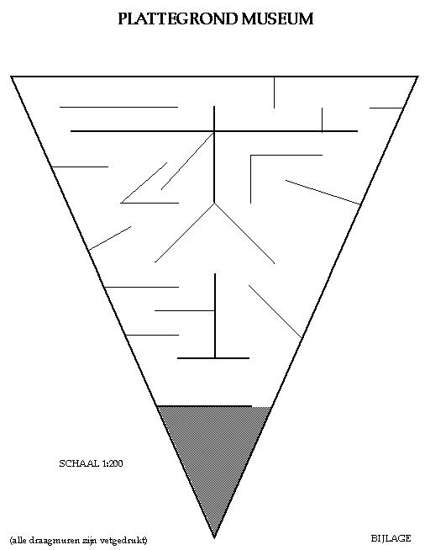
Museum Plan
scale

All supporting walls are in bold print.

