Teacher guide: Drug concentration
http://www.fisme.science.uu.nl/toepassingen/22038

This activity is designed for 16 year old students (grade 10) as introduction to difference equations in mathematics. It is an activity for two lessons.

A sample lesson plan
Lesson 1
10 minutes: create groups & introduce the problem and the working plan and distribute the task
10 minutes: students work in groups on the task
10 minutes: discuss with the whole class whether all groups have an idea how to start and how to proceed. Exchange strategies and make sure that everybody has an idea what is expected.
15 minutes: students work on the task, finish calculations and prepare the building blocks for their flyer.
Lesson 2
20 minutes: students finish their flyer
20 minutes: presentations of a few examples
10 minutes: reflection on the task (and positioning it in further work)

A doctor presents the following details about the use of a specific drug:
- An average of 25% of the drug leaves your body by secretion during a day.
- The drug is effective after a certain level is reached.
- Therefore it takes a few days before the drug that you take every day is effective.
- Do not skip a day.
- It can be unwise to compensate a day when you forgot the drug with a double dose the next day.

N.B. These details are a simplification of reality.

Investigation
- Use calculations to investigate how the level of the drug changes when someone starts taking the drug in a daily dose of 1500 mg with for instance three times 500 mg.
- Are the consequences of skipping a day and/or of taking a double dose really so dramatic?
- Can each drug level be reached? Explain your answer.

Product
Design a flyer for patients with answers to the above questions. Include graphs and/or tables to illustrate the progress of the drug level over several days.

Suggestions
The task can be extended by asking students what happens when you vary the daily dose and/or the percentage by which the drug leaves your body. What is the effect on the resulting (converging) drug level? Such questions can also be used to differentiate within a class and to challenge high achievers.

Example student work
The illustrations below show parts of solutions of students. They illustrate the kind of reasoning of the students with repeated calculations using tables and graphs. This work can be used for the introduction of difference equations. As you can also see, with similar information students reached quite different results. This is important for reflecting on the relevancy for understanding such mathematical processes in the world of work.
Solution 3 shows the work of a small group (in Dutch) that really prepared a kind of flyer. The teacher of these students highly valued the reality character in the task

Solution 1
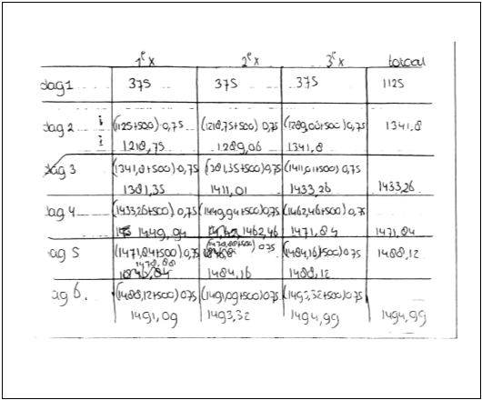

Solution 2
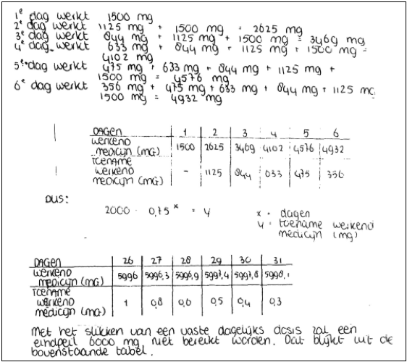

Solution 3
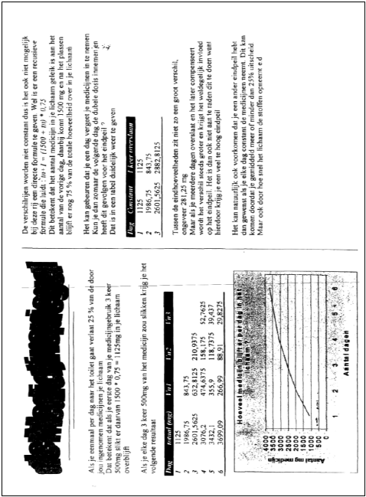

Source
Mathematics and Science for Life

www.mascil-project.eu

Dutch project 'Profi ', 'discrete analyse' (1997). Vervolgopdracht is verwerkt in pakketje DDM (1998, 2e experimentele versie):
http://www.fisme.science.uu.nl/toepassingen/00669/
Also published in: Wageningse methode VWO4, deel 2 (p. 23, versie 2000)

Dutch version (medicijnspiegel):
http://www.fisme.science.uu.nl/toepassingen/28001/

