Renovating a flat
Students can relate to this task based in the construction and skilled craftsworker professions. A flat needs renovating and the amount of material the painter needs for the job must be estimated. The question is posed authentically and it is also relevant and appealing to students. The reasoning behind doing the calculation is immediately clear. The task is well-suited for use in the context of area calculation. It is also underdetermined: Everyday knowledge is used to make assumptions and estimate quantity.

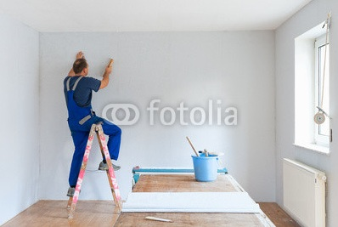
A painter has been given the job of completely re-painting the interior of a flat in white. The floor plan of the flat is below. How many buckets of paint will the painter need for the job if 1 litre of paint is enough for 6-8 m² of wall area?

Foto: Superingo, de.fotalia.com
Plan: http://www.jeder-qm-du.de
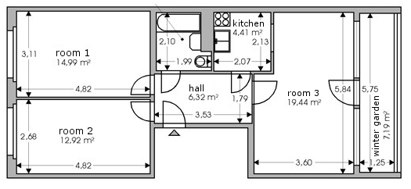

TAGS
Discipline and curriculum area:
Mathematics; Strand: Counting and understanding number
Educational level:
Lower Secondary (ISCED 2), Age: 11 and up (Year 6)

Mathematical prerequisites:
Knowledge about calculating area, ability to read floor plans, spacial visualisation skills
Inquiry-based learning:
This is an underdetermined task. Common, everyday knowledge is used to make assumptions and estimate quantities.
Connection to the world of work:
This is an authentic task taken from the construction sector and part of a house painter’s job.
Class time needed:
Circa one class lesson. This task is suitable for group work. The necessary calculations can be divided amongst the group members to save time and promote efficient work methods.

possible solution
Assumptions: The height of the walls and the window dimensions are not provided on the floor plan. Wall height can be assumed to be 2. 5 meters, and the doors and windows in rooms 1 and 2 each can be assumed to have an area of approximately 2 m². It is also assumed, that the walls will need two coats of paint.
In order to estimate the area that needs painting, it is sufficient to use rounded off numbers. The estimates for the wall surfaces to be painted in each room can be estimated on a per room basis. For example, in room 1, calculate the wall measurements of 3 x 2.50 m and 5 x 2.50 m. This results in an equation of:
$2 x(2 x \left(3 m+5 m\right)x 2.5 m-2 x 2 m^{2})=72 m^{2}$. In the same way, the areas that need painting in the other rooms can be estimated: Circa $67 m^{2}$ in room 2, circa $32 m^{2}$ each in the kitchen, bath and hall.
With room 3, only three walls need to be estimated, two walls with the dimensions 3.50 m x 2.50 m and one with 6 m x 2.50 m, which results in an area for painting of about $61 m^{2}$.
All in total, this results in an area that needs painting of about $\left(72+67+3 x 32+61\right){ m}^{2}=296 m^{2}≈300 m^{2}$ . If 1 litre of paint covers about an area of $7 m^{2}$ , then one needs approximately 43 litres of paint. The painter will need five, 10-litre buckets of paint for the walls.
If the ceilings will also be painted white, then the painter will, of course, need more paint. The paint needed for the ceilings can be calculated approximately with: $2 x \left(15+13+4+4+6+20\right) m^{2}=124 m^{2}$ . That is about 18 litres, or two more 10-litre buckets. If it is assumed that applying the second coat requires less paint – perhaps half as much as for the first coat – then the painter can do the job for sure with six, 10-litre buckets of paint – and maybe need only five.

Possible problems
- The students use the floor area of the rooms for their calculations instead of the wall areas. A suggestion for solving or avoiding this problem is to have simple sketches of the walls prepared.
- The students forget to consider the windows and doors. Here as well, simple sketches can be of assistance.

Practical experiences from teaching and suggestions
This task was tested in a German middle school with students in Year 6, ages 11 to 12.
To introduce this task, you might want to have a short class discussion about students' own homes (number of rooms, colour(s) of walls/doors, number of windows etc.) A follow-up task could be students sketching a simple floor plan of their own home – and calculating how much paint they would need to redecorate their own room – or even their entire home interior (or the classroom).

