Manual Chocolate Chip Mining
http://www.fisme.science.uu.nl/toepassingen/22016

Requirements (group)
Each group of students will need:
- 2 chocolate chip biscuits (which should be stored in a refrigerator or other cool place before use)
- clean containers, e.g. margarine tubs, or yoghurt pots
- access to a variety of equipment and materials such as:
  - knife
  - spatula
  - sieve or strainer
  - water bath
  - a balance
  - measuring cylinder
  - oven
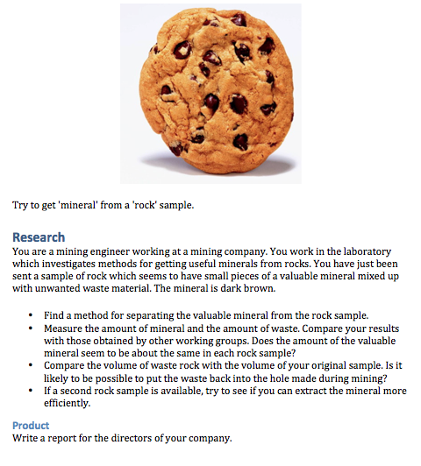

Background
This is an activity for students age 15 years, and consists of one or 2 lessons. Students will work in groups.
Students will need to be explicitly encouraged to record all data (quantities, etc.) and process these in tables, and possibly graphs.

Source
Mathematics and Science for Life

www.mascil-project.eu

SATIS , Science and Technology in Society (UK) (1984). Task 1001, only part 1.

