Working as an architect: parking in the basement
In designing a block of apartments the architect has to work out how to distribute parking places in the design of the basement car--‐park.

The diagram shows a plan drawn to scale of the area available. All measurements are in metres.

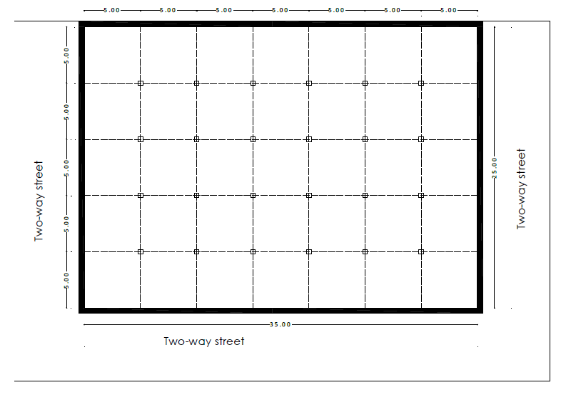

Some constraints:

- There are to be two parking places for disabled people.
- There are to be six parking places for motorbikes.
- There has to be a 5m x 5m stairwell.
- There needs to be a ramp by which cars enter and exit. The maximum gradient of the ramp is to be 25%.

Find a good design for this situation.

