(Re)Design Guidelines
Guidelines for teachers for developing IBST-oriented classroom materials for science and mathematics using workplace contexts

Connecting inquiry-based learning (IBL)
in mathematics and science
to the World of Work (WoW)

version 0.96
Date: 4-6-2014

Colophon
Title | MaScil WP3 – Guidelines  Guidelines for teachers for developing IBST-oriented classroom materials for science and mathematics using workplace contexts from industry
Coordinator | University of Education Freiburg  Prof. Dr. Katja Maaß
Website | www.mascil-project.eu
Authors | Michiel Doorman, Sabine Fechner, Vincent Jonker, Monica Wijers

Versions
20140604 | 0.96
20140512 | 0.91
20140428 | 0.9
20140320 | 0.8
20140312 | 0.7
20140306 | 0.6
20140224 | 0.5
20131204 | 0.4
20131031 | 0.3
20131023 | 0.2
20130715 | 0.1

Table of Contents
Colophon 2
Table of Contents 2
Introduction 3
The mascil Framework 3
Guidelines for (re)designing IBST tasks connected to the World of Work 6
Characteristics of tasks for IBST 6
Characteristics of tasks that connect to the World of Work 8
Guidelines for redesigning 11
Examples 12
Format for designing materials 17
Theoretical background 18
References 19

Introduction
In this document we describe guidelines for teachers and teacher trainers for (re)designing IBST-oriented classroom materials using rich, vocational workplace contexts. This document is supposed to help teachers and teacher trainers to understand why and how mascil tasks support IBL and how they connect to workplace contexts (the World of Work, WoW). In addition, it shows how teachers can select and adapt mascil tasks or other tasks (textbook, projects, etc.) to their needs and those of their students for promoting IBL and connecting to WoW contexts.
Mascil aims to promote a widespread use of inquiry-based science teaching (IBST) in primary and secondary schools. The major innovation of mascil is to connect IBST in school with the World of Work, making science more meaningful for young European students and motivating their interest in careers in science and technology. To achieve these aims, mascil collects and publishes examples of classroom materials for inquiry in rich vocational contexts in close collaboration with all mascil partners (see: www.mascil-project.eu).

The mascil Framework
Inquiry based learning (IBL) aims to develop and foster inquiring minds and attitudes that are vital in enabling students to face and manage uncertain and quickly changing futures. Fundamentally, IBL is based on students adopting an active, questioning approach. This approach is central to the mascil project. In the mascil Diagram we summarize the aspects of IBL and the connections to World of Work that constitute our framework for (re)designing classroom tasks (Figure 1).

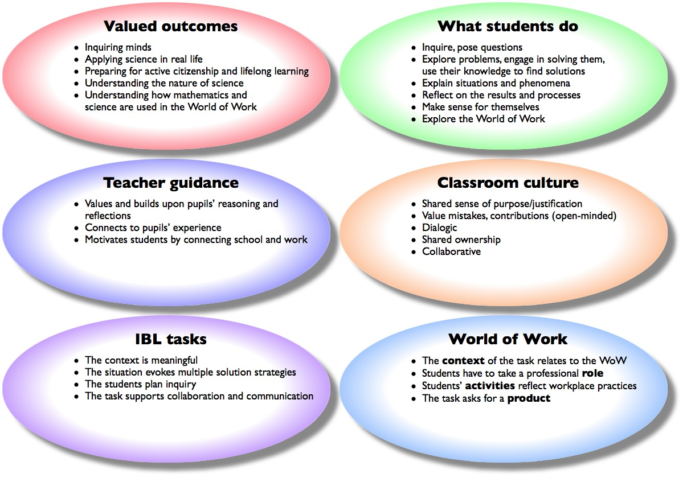
Figure 1: The mascil Framework

Some of the characteristics in this framework apply to values and goals of teaching and learning processes in science and mathematics education. The ‘IBL tasks’ and the ‘World of Work’ characteristics apply directly to the tasks (materials) used in classrooms. These will be discussed in this document.

In the cloud ‘IBL tasks’ we distinguish four criteria for tasks that support inquiry-based learning¹. When students learn by inquiry they explore situations, pose questions, plan investigations, experiment systematically, interpret and evaluate, and collaborate and communicate results. These processes are supported by tasks that are cast in – for students – meaningful situations. It might even be the case that such a situation is presented to students without mentioning the main problem that needs to be solved. This meaningfulness allows them to question the situation and to think of ways to tackle possible problems without using standard solution procedures.
When students connect the task to a standard solution procedure, their processes of inquiry will be limited. Consequently, the task should have the potential to evoke multiple solution strategies. This is a characteristic of tasks that is highly dependent on the learning history and achievement level of the students that work with the task.
The task does not guide the students along the inquiry process by providing all sub-questions that need to be answered for solving the main problem. The task allows students to (initially) plan or think of the process of inquiry by themselves.
Finally, the task supports collaboration and communication, for instance by providing information of how to distribute work, or by including the need for a presentation of results.

In the cloud ‘World of Work' four dimensions of how tasks can be connected to the World of Work are presented: Context, Role, Activity and Product.
The context in which the task is set relates to the WoW. This relation can be very strong if an (authentic) practice from the WoW is used as the rich context for learning. It should provide a clear purpose and a need to know.
The relation between the context and the WoW may also be weak, if for example the task is set in the context of the WoW, but this context is just a ‘superficial wrapping’ of the task, and does not remain important when working on the task.
The activities students do in the task are related to authentic practices from the WoW. The activities can be more or less similar to activities actually carried out by workers in the workplace. Also, the ways of working reflect characteristics of daily work, for example teamwork, division of labour/tasks etc. The activities should have a clear purpose, involve authentic problems and reveal how mathematics and science are used. The focus in the activities is on students using mathematics and science in ways and in contexts related to the WoW. If students’ activities are very similar to typical problems in textbooks for mathematics and science, the connection between activities and WoW is weak.
Within the task students are placed in a professional role fitting the context of the task. In some sense students step out of their role as a student.
The outcome of the task is a product made by the students in their role as professionals, meant for an appropriate audience. The product is similar to real products from the WoW.

For a task to be strongly connected to the WoW, its relation to the WoW on the dimensions context, role, activities and products should be explicit, well aligned and clear to the students. Not every task will have a similar emphasis on each of these four dimensions, but for a strong connection with the WoW these dimensions need to be taken into account in the actual (re)design of tasks for students.

Guidelines for (re)designing IBST tasks connected to the World of Work
The point of departure for designing mascil tasks consists of the national curricula for the science disciplines and mathematics. It is important that the tasks fit the goals of the curriculum and that appropriate content knowledge is addressed. As discussed in the theoretical background, using contexts and authentic practices in IBST does not cause a decrease in content knowledge and understanding if the tasks are carefully designed.

Characteristics of tasks for IBST
First of all, the tasks that teachers give to the students have a major influence in determining the learning that takes place. In this section we describe guidelines for (re)designing tasks that promote inquiry-based learning. However, the resulting written task does not per se promote inquiry by students, since teachers may present an ‘IBL’ task in a closed and structured way, thus removing the IBL characteristics. The reverse is also true: some teachers
may present a task that can be seen as closed and non-IBL in a way that promotes inquiry. Taking this into consideration, tasks for IBST will have the following characteristics:

Tasks support inquiry by students
To provide students with optimal opportunities for exploration, tasks should not be too structured in advance. In many textbooks for mathematics and science, tasks are divided into smaller sub-tasks to guide students smoothly along all possible problems they might confront. In IBST it is the student who gets the opportunity to think of how the problem can be structured and divided into smaller problems. This fosters inquiry by students and ownership of the problems that need to be solved to fulfill the task. The PRIMAS project formulates advice for teachers on how to deal with unstructured problems (see Table 1).

IBL Teaching strategies | Suggested questions
Allow students time to understand the problem and engage with it  Discourage students from rushing in too quickly or from asking you to help too soon. | - Take your time, don't rush.  - What do you know?  - What are you trying to do?  - What is fixed? What can be changed?  - Don't ask for help too quickly – try to think it out between you.
Offer strategic rather than technical hints  Avoid simplifying problems for students by breaking it down into steps. | - How could you get started on this problem?  - What have you tried so far?  - Can you try a specific example?  - How can you be systematic here?  - Can you think of a helpful representation?
Encourage students to consider alternative methods and approaches  Encourage students to compare their own methods. | - Is there another way of doing this?  - Describe your method to the rest of the group  - Which of these two methods do you prefer and why?
Encourage explanation  Make students do the reasoning, and encourage them to explain to one another. | - Can you explain your method?  - Can you explain that again differently?  - Can you put what Sarah just said into your own words?  - Can you write that down?
Model thinking and powerful methods  When students have done all they can, they will learn from being shown a powerful, elegant approach. If this is done at the beginning, however, they will simply imitate the method and not appreciate why it was needed. | - Now I'm going to try this problem myself, thinking aloud.  - I might make some mistakes here – try to spot them for me.  - This is one way of improving the solution.
Table 1: Tips for dealing with unstructured problems

Tasks allow for multiple solution strategies
It is important that students learn to think about what they already know and what they do not know. Questions (posed by the teacher or the textbook) often point at one solution or address only a specific aspect of the problem. In IBST the question is posed in a relevant and rich problem situation that is meaningful for the students. What is meaningful for the students depends on their learning history and their familiarity with the context. The richness of the problem refers to a problem that does not evoke one method for solving it. Part of the job for students is to clarify the question and to find a procedure for answering it. In this process, students try to model and solve the problem using representations, relationships or ideas. Such activities are important for students to foster creativity and experience modeling cycles. Tips for supporting student-led inquiry from the PRIMAS project are:
- Introduce the situation first, then ask students to identify problems
- Stimulate simplifications and representations of the problem
- Review the representations students use
- Let students further analyze and solve the problem(s)
- Stimulate students to communicate and reflect on their different approaches
- Review the processes that students have been through

Tasks stimulate collaboration and communication
In IBST the tasks stimulate collaborative work and ask for answers, solutions or products that are communicated with others through, for instance, reports, presentations or posters. These products also enhance the connection to the World of Work (see fourth characteristic in next section). For such products it is important that students are aware of the inquiry-related goals of the task in a mathematics or science classroom (e.g. to become more able to explore, plan, experiment, evaluate, collaborate, …). These goals can be communicated in advance or through organizing (peer) feedback on products or presentations; for example by presenting and discussing well-prepared sample work from other students or by asking students to assess each other’s work to identify, make explicit and use inquiry-related criteria for evaluation.

Characteristics of tasks that connect to the World of Work
Tasks that fit the aims of mascil are tasks that (i) connect to curricular content goals, (ii) support IBL and (iii) are set in rich vocational contexts. The connection to the World of Work is ensured by the following characteristic: students are given a professional role, as 'workers' in a workplace, and they perform activities that are similar to activities actually done by workers. These activities have a clear purpose and reveal how mathematics and science are used in work settings. A product for an audience is the result. These characteristics, that also guide the design process, are illustrated below in more detail.

Rich vocational contexts
Rich vocational contexts give students insights into the usefulness (purpose and utility) of mathematics and science in the WoW. The mathematics or science in the task should of course also fit your curricular goals. To find suitable rich vocational contexts several actions can be undertaken. Before you start you may orient yourself by:
- Asking your students what types of profession they are interested in;
- Finding out if any contexts related to the WoW are already used in your teaching materials;
- Using the mascil framework (Figure 1 and 2) to get a better understanding about the dimensions of both IBL and WoW.
To find out in what ways mathematics and science are used in workplaces, you may want to:
- Talk to professionals in your personal network
- Talk to or visit a vocational teacher at your school or in your region
- Read journals for professionals
- Visit websites of companies and look for educational materials
- Visit a specific workplace

Once you have found a suitable context and identified authentic practices to use, you can start to (re)design teaching materials. This is a cyclic process in which context, underlying content knowledge and possible student activities influence each other. You may want to:
- Provide students with the opportunity to explore the professional context of the task: what are typical activities, tools, data, language outcomes, products, problems of this workplace? This may be done e.g. by showing as part of the task a video or photos or artefacts from the workplace, inviting professionals to the classroom, having students visit a workplace or a website of a company;
- Use the activities from the authentic practice (and the related mathematical and scientific concepts) as a starting point and as the backbone for the design;
- Use artefacts and tools from the workplace in the design;
- Make adaptations (e.g. simplify, model, build in scaffolds) to make the authentic practice accessible for students. Beware of losing coherence and authenticity when re-contextualising, it may lead to contrived instead of authentic activities.

Giving students a professional role
In the teaching materials, try to give students a professional role that fits the context of the task, not only to ensure engagement with the task, but also to have students experience the purpose of the activities they perform.
- This role can be very specific (e.g. an architect) or more general (e.g. a scientist). A job description, the workplace setting or a specification of the work to be done, may be described in the task.
- You may want to have the ways student work on the task reflect the ways of working of professionals e.g. working in teams, division of labour, working within constraints, using authentic artefacts like tools, instruments and data.
- Note: Make the professional role as concrete and specific as possible. For example, if an activity fulfils all requirements of inquiry learning, we could argue that the role of researcher is prominent in this activity. This is a professional role and so the relation to WoW seems to be strong. For students however this relation may not be as clear as we think. The professional role in this case is often not a specific type of researcher. The same is true for ‘engineer’ in a design activity. In the teaching materials you may therefore decide to provide students with background materials and resources about this profession.

Have students perform workplace activities
Your task may contain several activities that students need to carry out. When designing these activities consider the following:
- Make solving an authentic workplace problem, using known concepts, skills and procedures from mathematics and science, the central activity in the design. All the other activities need to have a purpose with respect to this central problem;
- Have student activities be similar to (or analogies of) actions, processes or procedures used in workplaces. Some simplification or scaffolding may be needed, but beware of losing authenticity and the open, inquiry based character of the task.
- Make sure that the activities fit the context and the role.
- Use workplace language where possible and connect this to the disciplinary language;
- Present activities in such a way that they provide students with valuable opportunities to use knowledge of mathematics and science in the way it is applied in professional settings. You may use authentic artefacts like research briefs, memos, schemes or task descriptions to present the activities in an authentic way.

Targeting products connected to the World of Work
When designing the task, work towards a concrete product as outcome. This reflects the nature of workplaces, which generate explicit final products. The product can take many shapes, for example, it may be an object or a report or an advice. Consider the following:
- The intended product should fit the context, role and activities;
- Make sure that the product has an audience for whom the product is useful. If the audience is not immediately clear from the activities, make explicit for the students who the audience is. A clear audience, as part of the community of practice, will help define the product and its specifications;
- Have students include an appendix, a brief, a memo or a log in which they show or explain the way they used math or science (the process) to address and solve the problem;
- Include suggestions and/or instruments for reflecting on and evaluating process and product. An example of such a list of criteria can be found in figure 2.

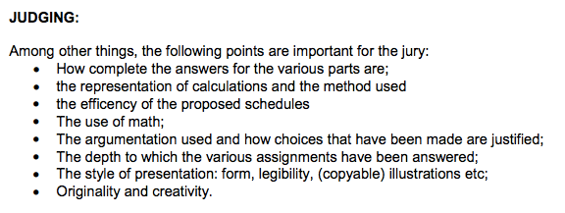

Figure 2: An example of a list of criteria to evaluate process and product

Guidelines for redesigning

Redesigning a structured textbook task
Often, it is not necessary to start from scratch when designing tasks that fit the characteristics of mascil. An easy-to-find starting point is a textbook problem situated in a (rich vocational) context. The activities presented to the
students will in that case be typical textbook problems: highly structured, closed, divided in sub-problems, with a lot of guidance. If this is the case you may keep the setting (the context), but change the activities. This can be done by opening them up, stating a purpose, describing a meaningful situation that ‘naturally’ incorporates and evokes questions, or starting with an authentic overarching problem in order to support inquiry-based learning.

Connecting an IBL task to the World of Work
The starting point for a mascil task may also be an existing IBL task for mathematics or science that is not yet related to the World of Work. In this case it is often possible to add contextual information from the WoW, to formulate activities for the students that are related to similar authentic practices from the WoW, to give students a professional role and to define an appropriate product.

Guidelines for (re)design
- From a structured (textbook) task to a task supporting IBL
  - Look for the ‘relevant and meaningful (for the students) problem’ within the context. Take this as the focal point for redesign
  - Create opportunities for students to become owner of the problem and a solution strategy (the problem gives rise to multiple strategies)
  - Skip sub-questions and have students plan or be involved in planning the inquiry
  - Scaffold students’ inquiry process (e.g. with a lesson plan including an introduction of the problem situation and process support)
  - Provide guidelines about the final evaluation
- Connect to the WoW
  - Explore the context and try to relate this to the WoW
Note: be aware that it is not always possible to connect an existing task to a practice from the WoW in an authentic way.
  - Think of a workplace practitioner and a workplace activity that fit the task (as a backbone for the (re)design)
  - Use artefacts, tools and language from the workplace where possible and adapt and connect this to disciplinary use
  - Make the professional role as concrete as possible
  - Determine a product connecting to the WoW for an audience
- Stimulate collaboration and communication
  - Ask for products that can be presented or discussed
  - Make sure the task asks for collaborative work (e.g. sharing of responsibilities)
  - Organize peer feedback

Finally, be aware of the changing role of the task in the learning process of the students. In addition to content-related goals, the new task aims to develop process skills. In some cases this might be at the cost of attention for content knowledge. In other cases it might offer opportunities to deepen content knowledge, or to better assess students’ abilities.

Examples

Calculating Body Mass Index
This example shows two versions of a task. The first one is a highly structured version of the task that guides the students along all the steps needed to discover the mathematics behind a Body Mass Index calculator. The sub-questions ‘do the thinking’ for you. In the second version of the task, structuring is the responsibility of the students.

First version of Body Mask Index (highly structured)

Second version of Body Mask Index (structure is responsibility for student)

Drug Concentration

These two versions of a similar task show how a task can be redesigned to support IBL and to connect to the World of Work. The second version of the task does not provide the sub-questions that guide the students along the solution process. In addition, it asks for a clear product that provides a purpose and connects to a workplace practice. The flyer can be used to have the students give each other feedback on the result of the activity.

A structured version of the task | A version for IBL and connecting the task to the WoW
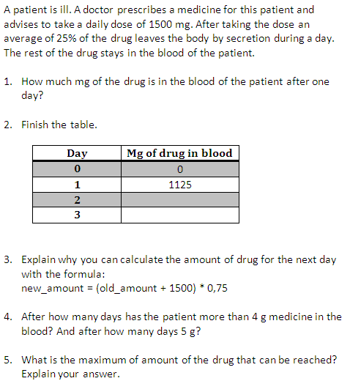 | 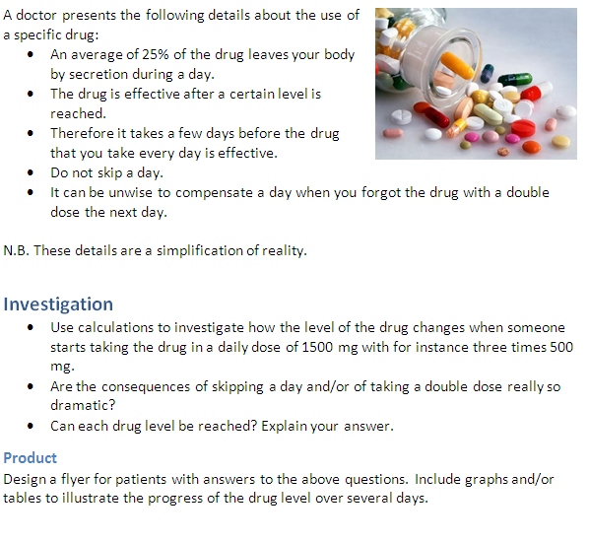

The second version gives less information about how the students will arrive at a final product. Teachers need to think in advance on how to scaffold their inquiry process. An example lesson plan for the IBL activity is:

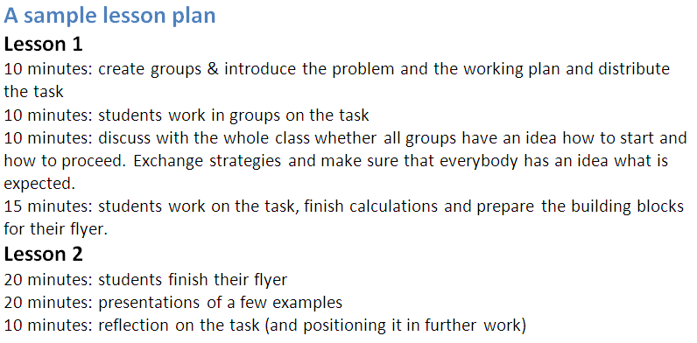

Brine
This example provides three versions of a task that show how a structured version of a task can be redesigned into a task supporting IBL by deleting the sub-tasks and having the students themselves think of the equipment that can be used. Finally, the alternative introduction of the task shows how it can be connected to the World of Work by including a workplace practice, providing a practitioner’s role and asking for a clear product.

Structured version of the Brines task | A version of the Brines task supporting IBL
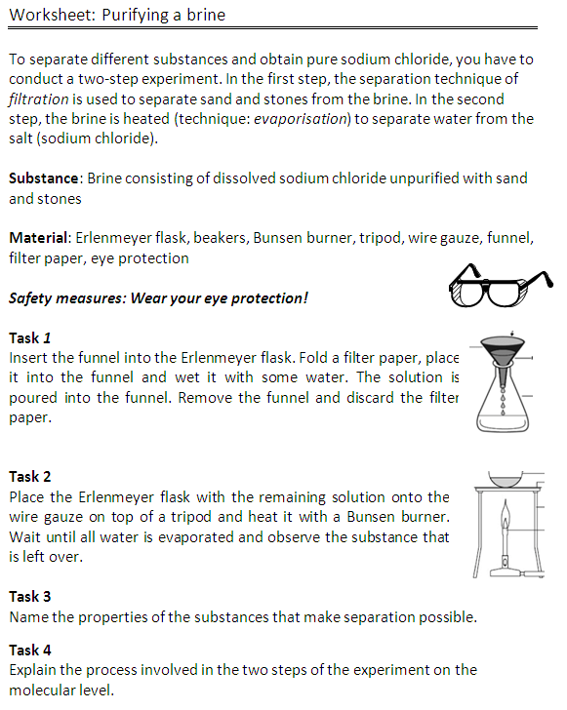 | 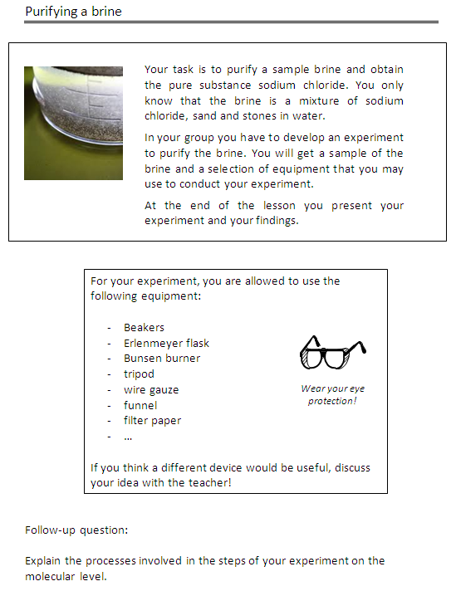

An introduction to the Brines task that connects it to the WoW
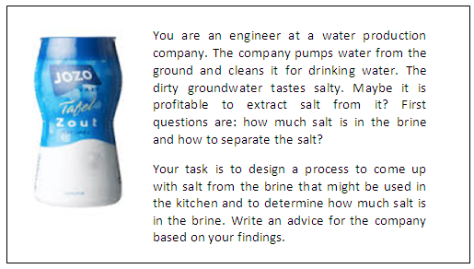

Format for designing materials
Tasks need to have an attractiv layout and format. In WP6/WP1 a proposal has been made for a mascil template for tasks (Figure 3). This format will be delivered (on the mascil website) to be used for designing materials within the mascil project.
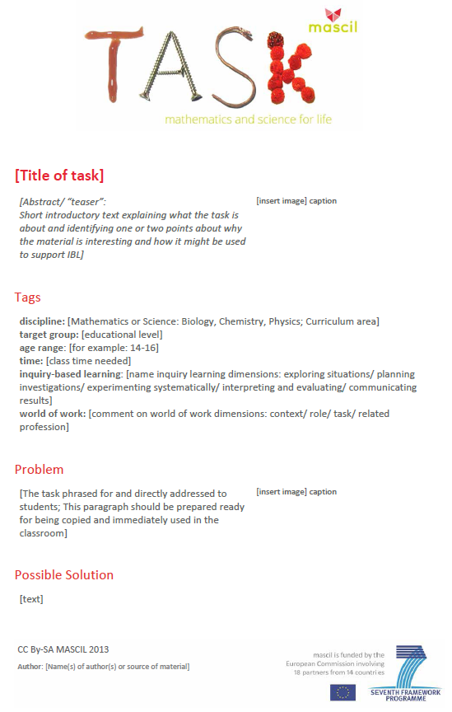
Figure 3: An example template for task-design within the mascil project

Theoretical background
The first chapters were written to support the teacher in his daily work. In the current chapter 'Theoretical background' we show that the underlying ideas are grounded in research and relate to the framework that emerged from an analysis of the mascil (Mathematics and Science for Life) task collection.

Inquiry-based learning (IBL) is defined as being inductive, student-centred and focused on creativity and collaboration (Doorman, 2011). IBL aims to develop and foster inquiring minds and attitudes that are vital for students to face and manage uncertain futures. Fundamentally, IBL is based on students adopting an active, questioning approach. The problems they address are supposed to be experienced as real, they inquire and pose questions themselves, explore problem situations and evaluate results. Learning is driven by open questions and multiple-solution strategies.
Although this model of IBL is student-centred, the learning process is guided and scaffolded by teachers and classroom materials (Hmelo-Silver, Duncan & Chinn, 2007). Our model should not be confused with that of minimally guided discovery methods, where the teacher simply presents tasks and expects learners to explore and discover ideas for themselves (Kirschner, Sweller & Clark, 2006). IBL asks for teachers being proactive: they support and encourage students who are struggling, make constructive use of students’ prior knowledge, challenge students through probing questions, manage small group and whole class discussions, encourage discussing alternative viewpoints and help students to make connections between their ideas (Crawford, 2000). This is quite an effort and cannot be expected from teachers in every lesson. A message that teachers should therefore take to heart is:
You don’t need to change everything. IBL is not a completely different educational practice, but an essential ingredient of good education.

IBL is seen to be effective in both primary and secondary education in increasing children’s interest and attainment levels as well as in stimulating teacher motivation (Rocard, 2007; Furtak, Seidel, Iverson & Briggs, 2012; Schroeder et al. 2007). IBL motivates students and enhances learning outcomes.
In order to enforce the benefits of IBL and make science and mathematics more meaningful to students rich vocational contexts will be used in mascil tasks, to connect mathematics and science to the WoW. Research supports the use of contexts in science teaching. Context-based science education does not lead to a decrease in the development of understanding of science, and has considerable benefits in terms of attitudes to school science and of abilities in solving context-based problems (Bennett, Lubben & Hogarth, 2007). The WoW introduces contexts that can be presented as authentic practices, which Gilbert (2006) sees as the most promising model for context-based science education (Prins, 2010; Dierdorp et al., 2010). Research findings show that students experience and understand the functionality, purpose and utility of disciplinary knowledge in the workplace (Ainley, Pratt & Hansen, 2006; Dierdorp, 2010; Mazereeuw, 2013). For this to happen however, it is important that tasks are carefully designed and fit the goals of the curriculum. In the context of work the use of science and mathematics emerges from the activities and tasks of the workplace (Hoyles & Noss, 2010). Therefore the teaching materials should reflect authentic practices and experiences related to the World of Work. Finally, the use of rich vocational contexts asks a lot from teachers. They have to master contextual knowledge and skills as well as connecting content-context knowledge and skills. We do not want to suggest that every lesson should be cast in a vocational context, but the starting point for mascil is that these contexts are also an important ingredient of good education.

References
National Research Council (1996). National science education standards. Washington D.C.: National Academy Press.
Ainley, J., Pratt, D., & Hansen, A. (2006). Connecting engagement and focus in pedagogic task design. British Educational Research Journal, 32(1), 23-38. doi: 10.1080/01411920500401971
Banchi, H., & Bell, R. (2007). The many levels of inquiry. Science and Children, 46(2), 26-29.
Bell, T., Urhahne, D., Schanze, S., & Ploetzner, R. (2010). Collaborative Inquiry Learning: Models, tools, and challenges. International Journal of Science Education, 32(3), 349-377.
Bennett, J., Lubben, F., & Hogarth, S. (2007). Bringing science to life: a synthesis of the research evidence on the effects of context-based and STS approaches to science teaching. Science Education, 91 (3), 347-370.
Colburn, A. (2000). An Inquiry Primer. Science Scope, 23, 42-44.
Crawford, B. A. (1999). Is it realistic to expect a preservice teacher to create an inquiry-based classroom? Journal of Science Teacher Education, 10(3), 175-199. doi: 10.1023/A:1009422728845
Csikszentmihalyi, M., & Schneider, B. (2000). Becoming adult: How teenagers prepare for work (Vol. First). New York: Basic Books.
Dierdorp, A., Bakker, A., Van Maanen, J., & Eijkelhof, H. M. C. (2010). Educational versions of authentic practices as contexts to teach statistical modeling. Paper presented at the ICOTS 8, Ljubljana, Slovenia.
Doorman, M. (2009). PRIMAS WP3 – Materials: Teaching and professional development materials for IBL (version 2). Netherlands: PRIMAS project.
Gilbert, J. (2006). On the nature of 'context' in chemical education. International Journal of Science Education, 28(9), 957-976.
Hakkarainen, K. (2003). Progressive inquiry in a computer‐supported biology class. Journal of Research in Science Teaching, 40(10), 1072-1088. doi: 10.1002/tea.10121
Hoyles, C., Noss, R., Kent, P., & Bakker, A. (2010). Improving mathematics at work: The need for techno-mathematical literacies. London: Routledge.
King, D., & Ritchie, S. M. (2012). Learning science through real-world contexts. In B. J. Fraser, K. Tobin & C. J. McRobbie (Eds.), Second International Handbook of Science Education (Vol. 24, pp. 69-79). Rotterdam: Springer Netherlands.
Kirschner, P., Sweller, J., & Clark, R. E. (2006). Why minimal guidance during instruction does not work: an analysis of the failure of constructivist, discovery, problem-based, experiential, and inquiry-based teaching. Educational Psychologist, 41(2), 75-86.
Louca, L. T. S. M., & Tzialli, D. (2010). Implementing a Lesson Plan Vs. Attending to Student Inquiry: The Struggle of a Student-Teacher During Teaching Science. International Society of the Learning Sciences, 1, 604-611.
Mazereeuw, M. (2013). The functionality of biological knowledge in the workplace. Integrating school and workplace learning about reproduction. Utrecht University, Utrecht. Retrieved from http://www.fisme.science.uu.nl/toepassingen/20080 (FIsme Scientific Library 80).
Prins, G. T., Bulte, A. M. W., Driel, van, J. H., & Pilot, A. (2008).Selection of Authentic modelling practices as contexts for chemistry education. International Journal of Science Education, 30(14), 1867-1890.
Prins, G. T. (2010). Teaching and learning of modelling in chemistry education. Authentic practices as contexts for learning. Utrecht University, Utrecht. Retrieved from http://www.fisme.science.uu.nl/toepassingen/20063/ (FIsme Scientific Library 63)
Rocard, M. (2007). Science Education Now: A Renewed Pedagogy for the Future of Europe (pp. 20). Brussel: High Level Group on Science Education, Directorate General for Research, Science, Economy and Science, European Commission.
Roth, W.-M. (1997). Graphing: Cognitive ability or practice? Science Education, 81(1), 91-106. doi: 10.1002/(SICI)1098-237X(199701)81:1<91::AID-SCE5>3.0.CO;2-X
Roth, W.M., van Eijck, M., Reis, G., & Hsu, P.L. (2008). Authentic science revisited: In praise of diversity, heterogeneity, hybridity. Rotterdam: Sense publishers.
Teichler, U. (1999). Higher education policy and the world of work: Changing conditions and challenges. Higher Education Policy, 12(4), 285-312. doi: 10.1016/S0952-8733(99)00019-7.

A more detailed description can be found in Deliverable 1 and on the mascil website.
Source: http://www.primas-project.eu/artikel/en/1044/Tackling+unstructured+problems/
Source: http://www.primas-project.eu/artikel/en/1260/Student-led+inquiry/
This relates to the characteristic ‘stimulation, collaboration and communication’ that is discussed in the previous paragraph.
Copied from the mascil problem 'Container logistics': http://www.fisme.science.uu.nl/toepassingen/00810/
This type of tasks can be found on the PRIMAS site www.primas-project.eu
Drawn from the PRIMAS project: http://www.primas-project.eu/artikel/en/1044/Tackling+unstructured+problems/
Drawn from mascil task ‘Drug Concentration' www.fisme.science.uu.nl/toepassingen/22038
Drawn from mascil task ‘Brines’: www.fisme.science.uu.nl/toepassingen/28121/
See mascil deliverable 3.1 on www.mascil-project.eu

