|  |
| --- |
| **Worksheet 2: Simultaneity**  **Answers** |
| **Names:** |

|  |
| --- |
| **Thought experiment** |

A beam of light is emitted from a train travelling at constant velocity along a platform. The speed of light is measured inside the train and on the platform.

Complete the following sentence. In the reference frame of the platform, the speed of light is

* higher than in the train’s reference frame
* **same** as in the train’s reference frame
* lower than in the train’s reference frame

Comment on your answer below.

|  |
| --- |
| According to the light postulate, the speed of light is the same in any inertial reference frame. The reference frames of the train and the platform are both inertial. So in the reference frame of the platform, the speed of light is the same as in the reference frame of the train. |

|  |
| --- |
| **Simulation activity** |



**Task 1**

According to the light postulate, the speed of light is the same in every inertial reference frame. In this task, you will explore the consequences of this postulate. Scan the QR code to see an example of the simulation.

Perform the following steps:

1. Select two trees from the left column and place them 5 squares to the left and right of the yellow dot. Place two birds in the middle of the screen (you can find the icons by clicking on the  icon). Finally, place a car below the trees. A screenshot of a video game

   Description automatically generated
2. Select the birds and give them a horizontal velocity of 3 m/s and -3 m/s relative to the yellow dot.
3. Give the car a horizontal velocity of 5 m/s relative to the yellow dot.

We define two events:

Event A: the bird traveling to the left hits the left tree

Event B: the bird traveling to the right hits the right tree

1. Run the simulation and verify that events A and B are **simultaneous** in the reference frame of the yellow dot.
2. Make a prediction: in the car's reference frame, events A and B are

* **Simultaneous**
* Not simultaneous

1. Comment on your prediction below.

|  |
| --- |
| The time interval between two events is the same in each reference frame (see Worksheet 1). Therefore, if two events are simultaneous in one reference frame, they will be simultaneous in all reference frames. |

1. Verify your answer through a simulation.
2. Revisit the explanation of your prediction. What would you like to change about this now that you have observed the simulation?

|  |
| --- |
| Answer as you see fit. |

1. What general conclusion can you draw about the simultaneity of events in different reference frames?

|  |
| --- |
| The simultaneity of two events is independent of the chosen reference frame. |

**Task 2**

In this assignment, you are going to recreate the previous simulation, but with light beams instead of birds. You can scan the QR code to see an example of the simulation.

Perform the following steps:

1. Create a new simulation.

1. Select a laser by clicking on the  icon in the left-hand column and place it on the yellow dot. The scale of the coordinate system automatically changes from meters to light seconds (1 light second is the distance light travels in 1 second, so 1 ls = 3.00 - 108 m).
2. In the laser's pop-up menu, you can specify in which direction(s) the laser will emit light. Press the arrows on your keyboard to make sure the laser only emits light to the left and the right.
3. Place two satellites 5 squares away to the left and right of the laser.
4. Place a spaceship below and give it a velocity of 40% of the speed of light. You can enter this velocity as "**0.4c**".

We define two events:

Event A: the light beam traveling to the left reaches the left satellite

Event B: the light beam traveling to the right reaches the right satellite

1. Run the simulation and verify that events A and B are **simultaneous** in the reference frame of the yellow dot.
2. Make a prediction: in the spaceship's reference frame, events A and B are

* Simultaneous
* **Not simultaneous**

1. Comment on your prediction below.

|  |
| --- |
| We express the three events in the rocket's inertial reference frame.  The distance between event A and B1 is greater than the distance between event A and B2 (because both satellites move to the left). However, the speed of light is the same in both directions. As a result, the light will reach the right satellite first and then the left satellite. So the events are not simultaneous in the reference frame of the rocket. |

1. Verify your answer using a simulation.
2. Revisit back the explanation of your prediction. What would you like to change about this now that you have observed the simulation?

|  |
| --- |
| Answer as you see fit. |

1. What general conclusion can you draw about the simultaneity of events in different reference frames? What has changed from your conclusion in the previous task?

|  |
| --- |
| The simultaneity of two events depends on the chosen reference frame.  This conclusion is different from the conclusion in the previous task. This shows the difference between relativistic mechanics (by Einstein) and non-relativistic mechanics (by Newton, among others). |

**End of simulation activity**

|  |
| --- |
| **Check questions** |

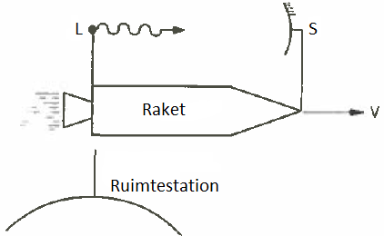

1. A rocket travels at a velocity of 0.*75c* past a space station. A laser (L) and a mirror (S) are placed on the rocket. When the rocket passes the space station, the laser emits a light pulse. The light pulse is by the mirror and travels back to the laser. See Figure 1. In the rocket's reference frame, the outward journey of the light pulse (from L to S) takes as long as the return journey (from S to L).

Figure 1

Explain whether the outward and return journey of the light pulse require the same amount of time in the reference frame of the space station.

|  |
| --- |
| We define three events:  A: the light is emitted by the laser (L)  B: the light reaches the mirror (S)  C: the light reaches the laser (L)  We express these events in the space station's inertial reference frame.  The distance between event A and B will be greater than the distance between event B and C (because the laser and mirror are both moving to the right). However, the speed of light is the same in both directions. As a result, the outward journey will take longer than the return journey. |

1. There are two volcanoes - Taupo and Tongariro - 150 km apart. At the centre of the two volcanoes is a seismologist (S) and at the base of Taupo is an assistant (A). A rocket flies over Taupo towards Tongariro at a velocity of 0.*5c*. See figure 2.

In the seismologist's reference frame, the two volcanoes erupt simultaneously.

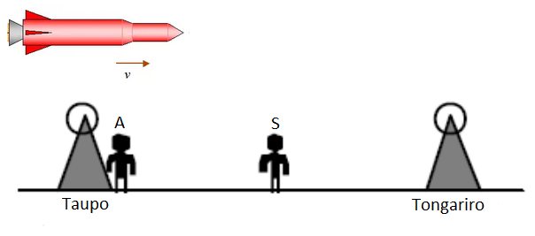

Figure 2

Explain whether volcanoes also erupt simultaneously in the assistant's reference frame.

|  |
| --- |
| The assistant and the seismologist share a reference frame (see Worksheet 1). They therefore measure the same positions and times of events. So the volcanoes also erupt simultaneously in the assistant's reference frame. |

1. When the seismologist receives the light from Taupo's eruption, she raises her left hand. When she receives the light from the eruption of Tongariro, she raises her right hand. So, in her own reference frame, she raises her hands simultaneously.

Explain whether the seismologist raises her hands simultaneously in the reference frame of the rocket.

|  |
| --- |
| The moment when the seismologist receives light from the Taupo and Tongariro eruptions is one event (because this event occurs at one position at one time). Events occur in all reference frames (see Worksheet 1). So it is also measured in the rocket's reference frame. So in the rocket's reference frame, the seismologist also raises her hands simultaneously. |

1. Explain whether the seismologist receives the light from the two volcanic eruptions simultaneously in the rocket's reference frame.

|  |
| --- |
| The seismologist raises both hands when she receives the light from the two volcanic eruptions simultaneously. In the reference frame of the rocket, the seismologist raises her hands simultaneously (see question 3). So the seismologist receives the light from the volcanic eruptions simultaneously in the reference frame of the rocket. |

1. Explain whether the volcanoes erupt simultaneously in the reference frame of the rocket.

|  |
| --- |
| We define three events:  A1: the light is emitted by the left volcano (Taupo)  A2: light is emitted from the right volcano (Tongariro)  B: the light reaches the seismologist  We express these events in the rocket's inertial reference frame. In this reference frame, both volcanoes and the seismologist move to the left. As a result, the distance between event A1 and B is smaller than the distance between event A2 and B. However, the speed of light is the same in both directions. As a result, events A1 and A2 cannot be simultaneous. Thus, in the rocket's reference frame, the volcanoes do not erupt simultaneously. |

1. If you answered in question 5 that volcanoes do not erupt simultaneously in the rocket's reference frame, which volcano erupts first?

|  |
| --- |
| The distance between event A1 and B is smaller than the distance between event A1 and B (see question 5). So the duration between A1 and B will be shorter than the duration between A2 and B. In the rocket's reference frame, therefore, A2 will happen first (Tongariro erupts) and then A1 (Taupo erupts). |

**End of check questions**