Title | Can the earth feed us?  Part of: A healthy multicultural meal for your school
Subject(s) | Biology
Learning goal(s) | Students practice the use of scientific knowledge in discussions about socioscientific issues.
Time | 30 minutes
IBL | The activity asks for IBL: It is an open problem, students need to explore the information and formulate sound arguments.
Achievement | Collaborating on an open and rich task allows for diversity in the ways of working as well as in the level of achievement.
Context | Food is a rich context, close to students’ own daily lives. The world food situation may be somewhat more abstract, but students will likely be able to reasons about 'eating meat'.
Culture | What we eat is partly dependent on where we live and on the cultural heritage. In a culturally diverse classroom/school students may have different eating habits, rules and tastes.
Fundamental Values | Respect – getting to know and respect different eating habits, tastes and dishes.
SSI/RRI | Hunger; food shortage; the costs of meat (in terms of grain); animal welfare. See activity: Can the earth feed us?
Background | When discussing a socioscientific issue in the science classroom, students will meet different discourses. The students are expected to move between, for example, everyday discourse, societal discourse and science discourse. The students are also expected to move between different types of knowledge (school subjects), values and emotions, since socioscientific issues are complex. This student task “Can the Earth feed us – do we have enough food?” also presents the students with dilemmas about social justice and scarce resources as well as what they like to eat and what they should eat.

Lesson outline
Orientation
- Have students read the texts and discuss problems 1-3 in pairs.
Discussion
- Have a whole class discussion
Debate
- Finish with a debate about problem 4.

Text: Can the Earth feed us? – Do we have enough food?

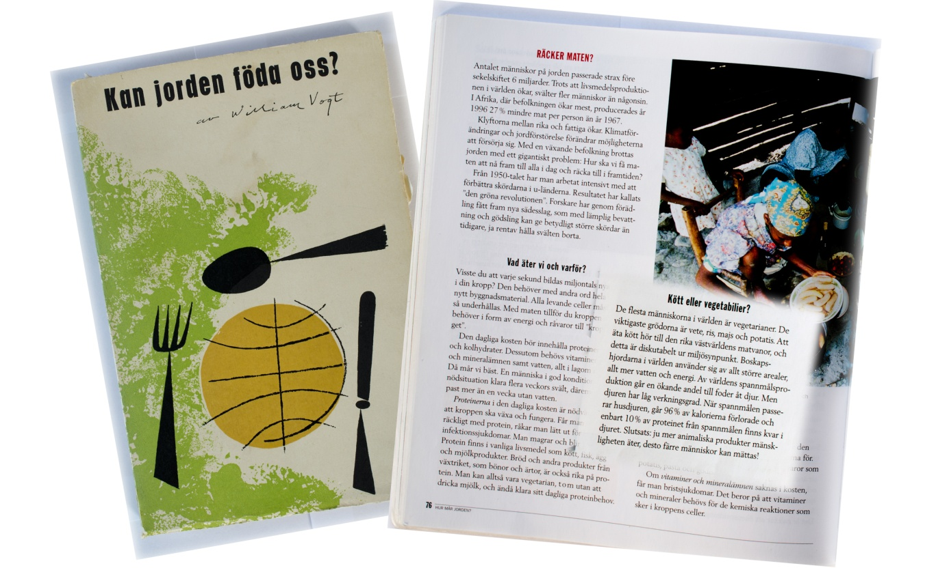

1948 the American ecologist William Vogt wrote the book: Can the earth feed us? The author was concerned that the global population was so big that they were right next to the border to have an adequate food supply. He argued that we need to stem population growth, otherwise there would be a disaster.
It is 72 years ago William Vogt wrote this. At that time the world's population was about 2 billion. We are now 6.48 billion.

The question of human's food supply is still under discussion. In the textbook, Medan Jorden Snurrar, for Natural Science A is a chapter called: Enough food? When the textbook was written, the number of people on earth has passed 6 billion. Below is quoted a paragraph from the chapter.

"Meat or vegetables
Most people in the world are vegetarians. The main crops are wheat, rice, corn and potatoes. Eating meat is one of the rich Western diets, and this is questionable from an environmental perspective. Cattle herds in the world use larger and larger land-areas, more water and energy. An increasing proportion of the world's cereal production is used to feed animals. But the animals have a low efficiency. When the grain is passing pets, is 96% of the calories lost and only 10% of the protein from the grain remains in the animal. Conclusion: the more animal products mankind eats, the less people can be satisfied "(Medan Jorden Snurrar, 2000, page 77)
Problems

1. Discuss the paragraph, meat or vegetables together and try to come up with / understand what the authors mean.

2. The authors state that it is questionable from an environmental point to eat meat. Discuss if / why it is questionable from an environmental perspective, based on your knowledge in for example ecology and environment.

3. Is the conclusion coherent: "The more animal products mankind eats, the less people can be satisfied!"?
Discuss.

4. Imagine that a political party in the Town has suggested that it should be served more vegetarian food in the Towns schools, for environmental reasons.
You are now a participant in the Towns city council and shall decide in the issue. First consider what you as an individual think. Then have a discussion / debate on the issue to finally come up with a decision.

Source: parrise project, https://www.parrise.eu/

