Title | Fishery
Subject(s) | Physics, Biology & Chemistry
Learning goal(s) | • Understand what sound waves are and how they travel  • Connect biological consequences to physical changes  • Understand how chemical characteristics attribute to physical phenomena
Time | One or two lessons (circa 50 minutes) depending on teacher how to use the assignment(s)
IBL | The activity asks for IBL:  As a teacher you will need to decide how organize the collaborative work, and how to share/communicate the various strategies and whether to offer more structure, guidance and help.
Achievement | See guideline for teachers next to worksheet. There are multiple in depth theories that can be added for students in search of more challenges. For the students struggling with the theory there are some worksheets added to recap the information
Context | The context is very real and recent, but maybe not very relevant to the day-to-day business of the students. Still it is easy to understand why this is a problem that needs a solution and it is different context in which sound waves are usually explained to the students.
Culture | Encourage students to find their own solution strategies. Appreciate and acknowledge diverse solutions and take that opportunity to discuss characteristics of the solutions to afford whole class progress.
Fundamental Values | Collaborative work, valuing each other’s reasoning in group work, feel part of an inquiring community (belonging).
SSI/RRI | Nobel and the discovery of nitroglycerine, how scientific discoveries can be used for "evil" purposes.

Lesson outline
Orientation
- Introduce the context, maybe show some pictures/video of fish, refer to the classroom aquarium/display for example. Or maybe have a group discussion on fishing boats (and form small groups).
Working in groups and whole class discussion
- Have students work for about 10 minutes on the first activity.
- Discuss questions and answers briefly with the whole class to make sure all groups are heard.
- Optional: present students with the soundwave theory
Introduce the new Context
- Show one of the videos to the whole class, let the students comment on the video before starting on the group task.
- Give all students/groups time (circa 15 minutes) to design their own drawing (maybe keep some extra worksheets ready to be handed out in case of “emergency”) and work on the diving deeper exercises.
Evaluate the outcomes with the whole class. In case of an “interactive” whiteboard let some students draw their answers and discuss with the other groups. If wanted follow up with for example an extra task, or a student-assignment (dopler effect or recap exercise) to prepare for next lesson.
- Discover the Chemistry behind the blast (videos on Nobel and some fun explosions from "slowmo guys".
Discuss SSI about the scientific discoveries and how they can turn into something dangerous, unintended by the scientist who made the discovery.
- Develop a sustainable alternative for the local fishermen.
A creative activity which you could stretch out in time and maybe even let the students present in "science fair" or classroom presentations.

Fishery
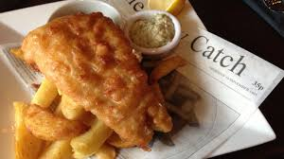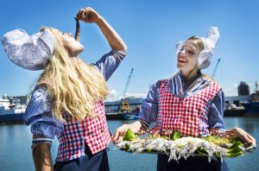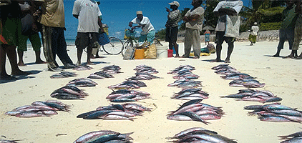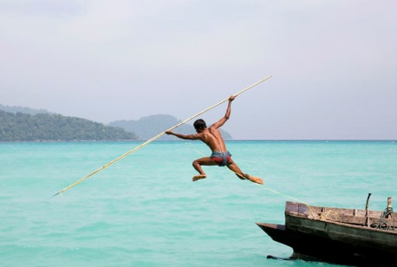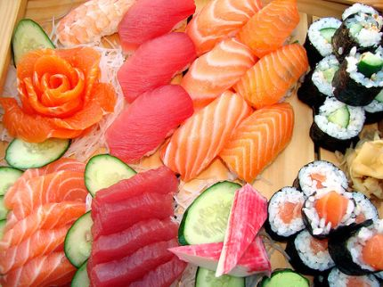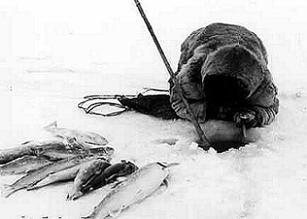

The ocean is one of Earth's most valuable natural resources. It provides food in the form of fish and shellfish—about 200 billion pounds of fish are caught each year.
For millions of years the oceans serve as an important food source for all life on earth. By human kind the oceans have been fished for thousands of years and are an integral part of human society. Fish have been important to the world economy for all of these years, starting with the Viking trade of cod and then continuing with fisheries like those found in Lofoten, Europe, Italy, Portugal, Spain and India. Fisheries are still enormously important to the economy and wellbeing of communities.
The word fisheries refers to all of the fishing activities in the ocean, whether they are to obtain fish for the commercial fishing industry, for recreation or to obtain ornamental (aquarium) fish or even fish oil. Fisheries are usually designated to certain ecological distribution regions like the salmon fishery in Alaska, the Eastern Pacific tuna fishery or the Lofoten island cod fishery. Due to the relative abundance of fish on the continental shelf, fisheries are usually marine and not freshwater.

Activity 1
Discuss in small groups (max 4) and collect your answers. Sometimes this means you have to give an average answer (or describe the range) for your collective group answer.
- How many times a week do you eat fish?
- Are there any other products you might use that are derived from fish/ocean creatures?
- Can you think of other cultures were fish or fisheries might be a very important aspect of daily life?
- How would you try to catch fish …..
- Within a radius of 10 kilometers from your school?
- In other areas of your country?
- Do you think it will be different from other places in the world?

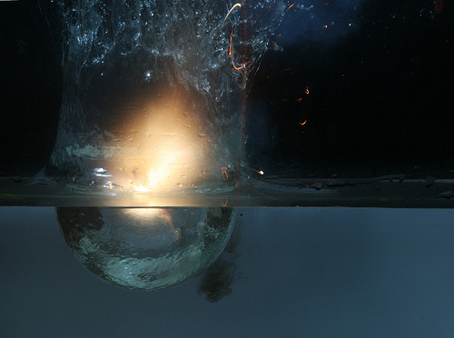
Activity 2 - Dynamite fishing
Take a look at one of the videos on dynamite fishing in Tanzania.
Dynamite fishing (Dutch subtitles): https://www.youtube.com/watch?v=n75prj6hyus
English: https://www.youtube.com/watch?v=gOyusJVKxvc
In different parts of the world (take a look at the map below) this method of fishing is carried out. Can you locate Tanzania on the map? what about your own country?
Which physics (physical) mechanism is responsible for the death of the fish when the fishermen use dynamite?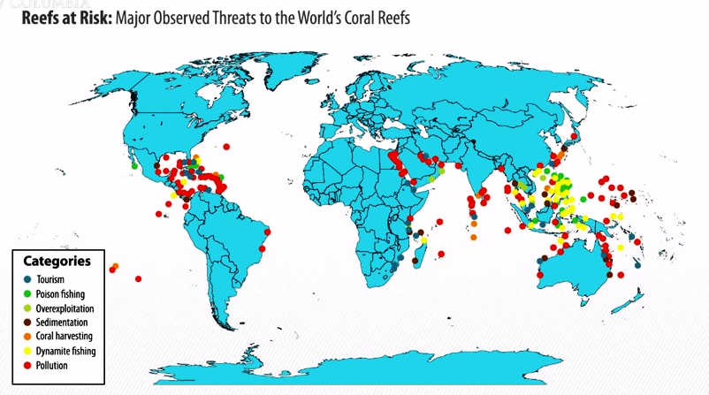
Figure...: Distribution map of threatened coral reefs source https://www.researchgate.net/figure/221910402_fig3_Fig-3-Main-causes-for-reef-destruction-tourism-poison-fishing-overexploitation

Can you think of other harmful consequences of this fishing method?

Activity 2.1 - Exploring the blast (in pairs or max groups of three)
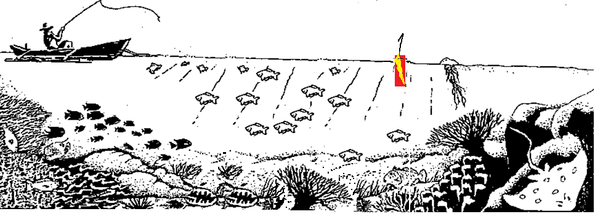
Look at the schematical drawing of the coral reef below. Let’s use our imagination and show what happens to the organisms in the picture if the piece of dynamite would come to explode. Which organisms will be hit first? Who will die and who would you expect will stay alive? Sketch this into the drawing.
Figure …: Schematical drawing of coral reef to be used in activity 2.1

Using the same method as in the previous exercise now look at our next picture. First decide what will happen to the fish and coral reef if the dynamite will detonate at the site above the reef. Draw your findings in the picture. Next consider what will happen if the boat would travel about 1500 meters away from the reef and will detonate the dynamite there. Again draw the blast wave into the picture, how far do you think it will travel? Will it have any effect on the damselfish or coral reef from this distance?

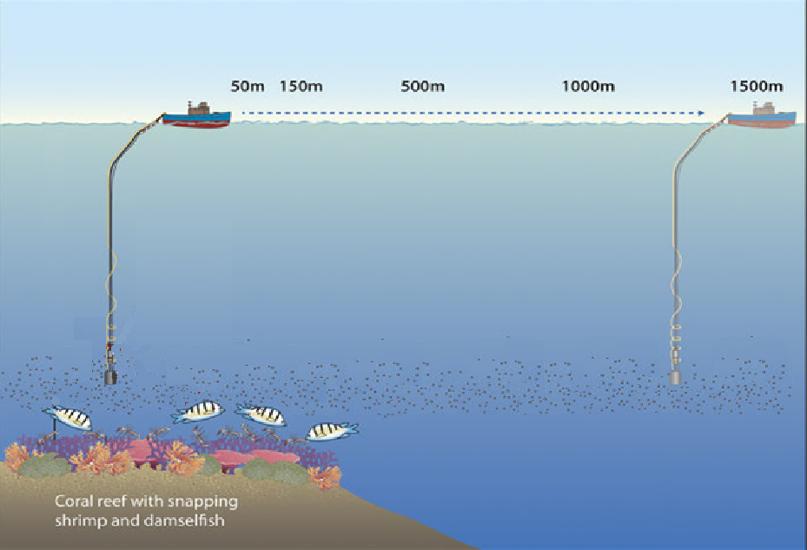
Figure …: Schematical drawing of coral reef with different blast distances to be used in activity 2

Activity 2.2 - “Diving deeper”
You might find the following exercises more challenging.
- Why does is it kill fish in a certain(specific) area? Which factors define that area?
- Which other organisms are killed by the blast and why? Is there also a perimeter to the area in which they are affected? And is that the same as for the fish? (why or why not)

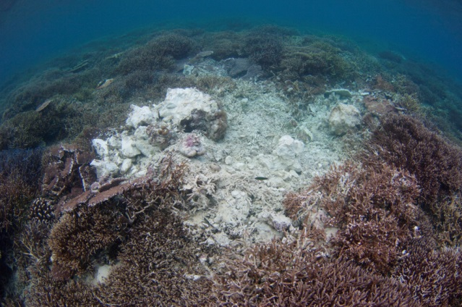
Figure..: Fish bomb damage, Timba Timba Island, Darvel Bay, Sabah.

Activity 3 - An explosive chemistry
Where does dynamite come from and how does it work? Which chemical characteristics of dynamite what makes it perfect for underwater use? Watch the online science video of "How stuff works" about dynamite:
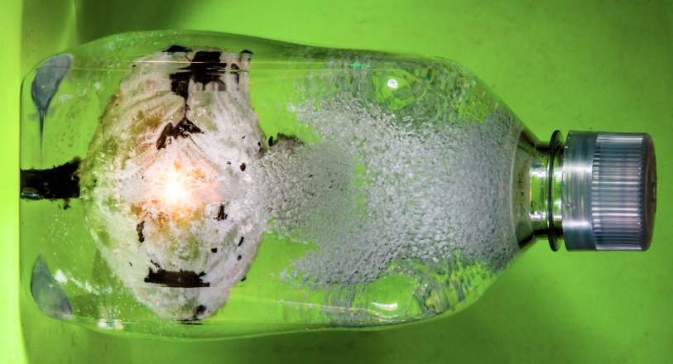
https://science.howstuffworks.com/question397.htm
Which substance makes it possible for dynamite to explode under water?

Who invented/discovered this chemical compound? Was he happy or sad about this discovery? And wat did he do after he made the discovery?

Take a look at the next video on underwater explosions from the Slow mo guys:
https://www.youtube.com/watch?v=E5rGFZWQfzk
Can you answer their question at the end of their video? What do you think happens after the initial blast?

Activity 4 - Blast from the past or Future?
So now we know how dynamite fishing works and why it is so destructive to the ecosystem. But why do the fishermen in Tanzania and other parts of the world still use this method if it is so bad, illegal and dangerous?

Design for the future:
How can you help the fishermen to stop these activities and switch to a more sustainable way of fishing/living? Think about their needs (food, money, care for their childeren) and try to be creative in the possibilities of their surroundings. Can you think of other ways to use what they have to gain food, money or support for their families?
Which steps are necessary to preserve the coral reefs? Can the local fishermen help with the preservation and maybe even gain from this? How will you get the locals involved in your plan?
Be as creative as you would like, you can write, draw, make a movie, design a prototype etc.

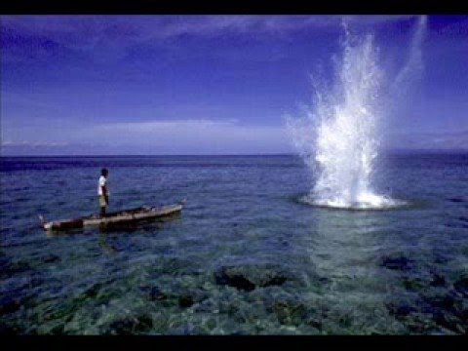

Information for the teacher
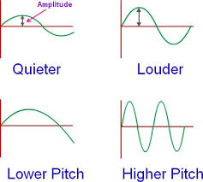
The goal of this exercise is that the students are able to make the connection of the object emitting the sound waves and how they travel (should we add the difference in air and water? Explain in lesson). There are different objectives possible when you use this lesson. Maybe you want to use this as an introduction, maybe you want to use this as an evaluation on the theory explained in the lesson. (see example exercises)
Activity 2:
Let the students show they are able to make the connection visible in the context of dynamite fishing by drawing the soundwaves and how they travel from the point of explosion through the surrounding waters.
To make it more interactive if you have an interactive (white)board you can project the picture and invite several students to draw it on the board when discussing the results.
To enhance difficulty of the activity or to create achievement diversity:
Let them calculate the speed of the pressurewave from the blast site to …. (the fish, the boat, coral on opposite site)
Introduce the Doppler effect to high achievers (maybe let them make an explanatory video about it)
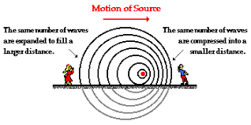For excelling students.
Activity 3: (In pairs or as classroom activity)
Where does dynamite come from and how does it work? Which chemical characteristics of dynamite what makes it perfect for underwater use: creates it’s own O₂ = oxidiser (Nitroglycerine) so you only need a detonator not oxygen.

Activity 4 - Blast from the past or Future?
- Let the students design different ideas for the fishermen to make a sustainable living with the fish and coral reefs.
- Decide on group size (individual or groups?)
- Let them be as creative as possible, they can design fishing rods, diving excursions in marine reservations or schooling materials for the natives. It is important that in their design that they do not just ban the use of dynamite fishing (it is already illegal) they should come up with something that will persuade the fishermen to contemplate other (sustainable) sources of income.

Extra materials:
There are a lot of dynamite fishing games for smart phone and computers that can be found online.
This would make great fun as a starter, end of the lesson treats or the occasional fun kind of homework 😉
https://handy-games.com/en/games/super-dynamite-fishing/

http://marinebio.org/oceans/ocean-resources/

