Breaks at School
You will be working on a large open problem in a group of three or four students. The intention is that you can present a report as the result of your work by the end of the day. Below there is a checklist with points of attention.

Method |  | check
- First read the entire task and think of:
  - the approach
  - the division of tasks
  - the time schedule (and set one up!)
- cooperation: consult each other regularly to see whether you are still on the right track and if you are still following the planning;
Remember that you will need time at the end of the day to create a coherent piece.
- do not be satisfied too quickly. Try out several variants of the tasks and process these in your report.
- answers may be given in a variety of ways: with pictures, in words, etc.
- always support your choices with arguments and describe your work method;
- make a real report, so do not just provide a list with answers to the questions, ensure that it is a logical story!
Tip: Calculations and graphs can often be placed in an appendix.
- ensure that your report can be read independently of the task; without having the actual questions in the task.
- remember to include page numbers.
- mention the names of the team members on the cover page.

The assessment
This task is not about the ‘one correct answer'; there is not one single correct answer, but several possibilities. In the assessment, we mainly pay attention to:
- A clear description of your work method;
- a good foundation of your choices and results;
- your approach to the task and whether your use of maths and calculations has been correct, useful and clear;
- the coherence of the report/paper (is it a proper report?) which can be read as an independent report, without having to use the task.

Have fun and success!

Breaks at school

Introduction
From your own experience, you know that you cannot just continue working and pay the same amount of attention without any breaks. Every now and then you need to eat and drink something, you get tired and after a while your concentration slackens. When doing your homework, you will gradually lose your concentration and as such will learn less. Less work will be finished and your so-called ‘learning effectiveness’ – that is the percentage of time that you effectively work or learn – has decreased. In the preparation of a test you cannot continue for hours at an end without a break. E.g. studying words works better when you repeat it often for short periods of time instead of working on it for a longer period of time.
So, breaks are necessary, but…how can these breaks be organized in the most effective way? Few, but longer breaks, or many short breaks, or a mixture of these? So, the question is: what does your optimal schedule look like?

Starting tasks

Starting task A – calculation in clock hours
The following global image of the relationship between the learning efficiency and the number of clock hours that one is studying/working successively has evolved out of experience and research. This graph is more detailed in appendix 1.

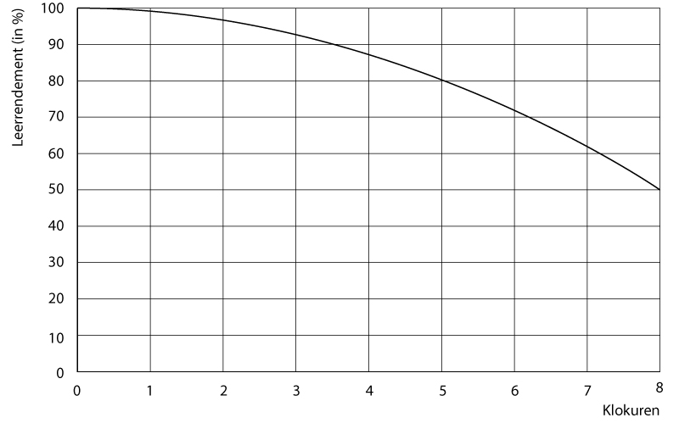
The longer you study successively, the lower your learning efficiency. In the graph you could e.g. read that after eight hours of uninterrupted, so without a break, studying, your efficiency has dropped with 50%.
It is also known that taking a break enhances the learning efficiency. Shortly after a break, the learning efficiency of a pupil is higher than just before the break. In other words: the learning efficiency has returned to a previous, higher level. Research has come up with the following rule-of-thumb:

After a break within the first four hours of studying time (this is the unadulterated studying time) the learning efficiency is back on the level as it was at the moment of three times the length of the break before the start of that break.

An example will clarify this rule-of-thumb: if someone starts studying at 8:00 and continues until 11:30, then his learning efficiency has decreased with 90% of his maximum. When this person would take a forty minute break, at the end of that break he continues studying with a learning efficiency of
3 x 40 = 120 minutes before 11:30.

Use the graph to determine how high the learning efficiency is at that point.

When pausing after more than four hours of uninterrupted study, the effect will decrease. You will then go back twice the length of the break instead of thrice!

Starting task B – calculation in clock hours
This does not merely apply to the hours of studying, but also to the classes you attend at school, which often have a different length than a clock hour.

Use the graph of the learning efficiency (see appendix 1 for extra graphs) to draw a scale division of the number of lessons on the horizontal axis. Go by the length of the lessons at your school.
Calculate your learning efficiency after the first small break (the morning break), assuming that you started with the first lesson of the day.

Starting task C – the effect of breaks at school
Until now, the learning efficiency has been stated as a percentage. This can also be done in minutes. The maximum of learning efficiency is 100%, so sixty minutes per hour or fifty minutes per lesson of fifty minutes. It can be deduced from the graph that this maximum output is actually unrealistic.
- Estimate the total amount of learning efficiency in minutes on the basis of the graph, after nine lessons of fifty minutes of uninterrupted classes (so without any breaks). Use the graphs in the appendix.
- A Dutch school uses the timetable on the following page. Estimate the total learning efficiency in minutes with the given timetable for a school day of nine lessons. Use what you know of the effect of breaks (see starting task a) and clearly report how you have used the graph.

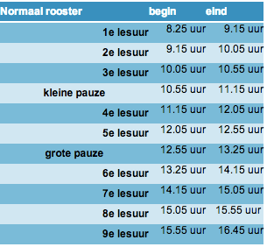
Keywords: normal schedule, start, end, lesson, hour, small break, large break.

Follow-up tasks

To make the calculations regarding the learning efficiency easier, the model has been simplified to a well-fitting straight line. You see the graph of the adjusted linear model below, together with the graph of the original model (these graphs can also be found in Appendix 2).

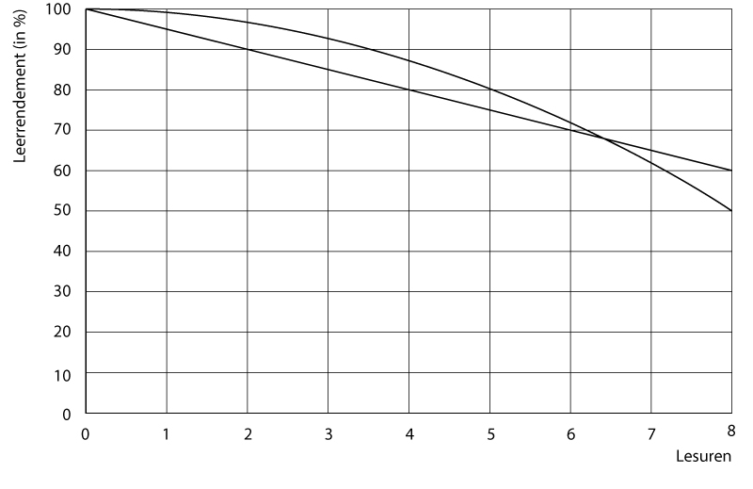
Hours

As you can see, the new model assumes that the learning efficiency – with a continuity of lessons without a break – decreases in a straight line from 100% to 60% in eight hours.
As of now, you will use this simplified linear model with all the tasks.

Follow-up task 1
- Calculate the learning efficiency of a pupil who attends nine uninterrupted lessons of fifty minutes (or studies) using this new model. Use the graphs in Appendix 2.
- Also calculate the learning efficiency of a pupil who attends nine lessons according to the previously provided timetable – so with two breaks. Add your calculations and explanation on the basis of this new graph (see Appendix 2).

Follow-up task 2
Assume that you can divide the two breaks in a number of shorter (but all of the same length) breaks that together take the same amount of time as the two breaks out of the timetable. The division of the break time can be done in a number of ways. Find out if you can let the learning efficiency rise by dividing the break time. How long will you let the breaks last, and when would you plan them? What is the best-realizable learning efficiency?

Final task
The board of your school wants to examine whether it is wise and possible to introduce a new timetable for the coming school year, one with which a higher learning efficiency can be reached.
You are the experts who are going to execute this research. The board asks you to determine the learning efficiency of the current timetable and to work out some new timetables (a minimum of two) that give a maximum result on the learning efficiency.
We will provide you with the following points of attention:
- Other hours, lessons that are briefer or longer and briefer or longer breaks, are all possible, as long as it is arranged as such that the norm of 1040 hours per year will be reached. This means at least 26 hours of lessons per pupil per week;
- each pupil should be able to reach a learning efficiency of at least 1450 minutes per week at school; the higher, the better, of course;
- the school can be open from 8:00 to 18:00.
- per day, there is an obligatory break time of at least 30 minutes included in the timetable;
- most students prefer to have uninterrupted periods of free time.
So rather an extra day (or half a day) off, or all the days shortened. If that is not optional, than most students like to have large periods of break time;
- brain research has shown that students in their puberty start with a maximum learning efficiency of 90% between 8:00 and 10:00, without breaks this declines at the same rate as the linear graph in Appendix 2.

The board expects a clear research report from you with all the propositions for the new timetables and a well-founded advice.
In your report you support the calculations with graphs, you clarify how you have taken the attention points into account, you explain the choices that you have made and describe the pros and cons of the current timetable and the newly-proposed timetables. Remember to add the well-founded advice!

