“Routing school buses” – student handout

Schools have buses for taking pupils to school in many countries. A school bus picks up pupils in the morning and drops them off at the end of the day at designated stops on the bus route. With school buses, total time on the bus is always the most important dimension (pupils have to get to school on time), and there is a known time of travel between any two bus stops. Since children must be picked up at every bus stop, a tour of all the sites (starting and ending at the school) is required.

Since the bus repeats its route every day during the school year, finding an optimal tour is crucial.
You have to solve a problem and should make a map sketch of the particular locality, label roads and bus stops.

- You have to chose one of the roles:
- Role of a planner (for example, school headmaster) should be taken by pupils who need a quick solution (not the best one).
- Role of a mathematician fits those who would like to understand the context of the graph theory and be introduced to several algorithms.
- Role of an information technology specialist also can be chosen for this task: pupils can find algorithms and software to solve some examples of this problem.
- You have to present a tour map of a school bus(es), which has to take students from all the streets in the map (Fig. 1).
- You have to optimize stop stations, and to estimate travelling time.
- Be able to present and argue for your work and to discuss with other students.

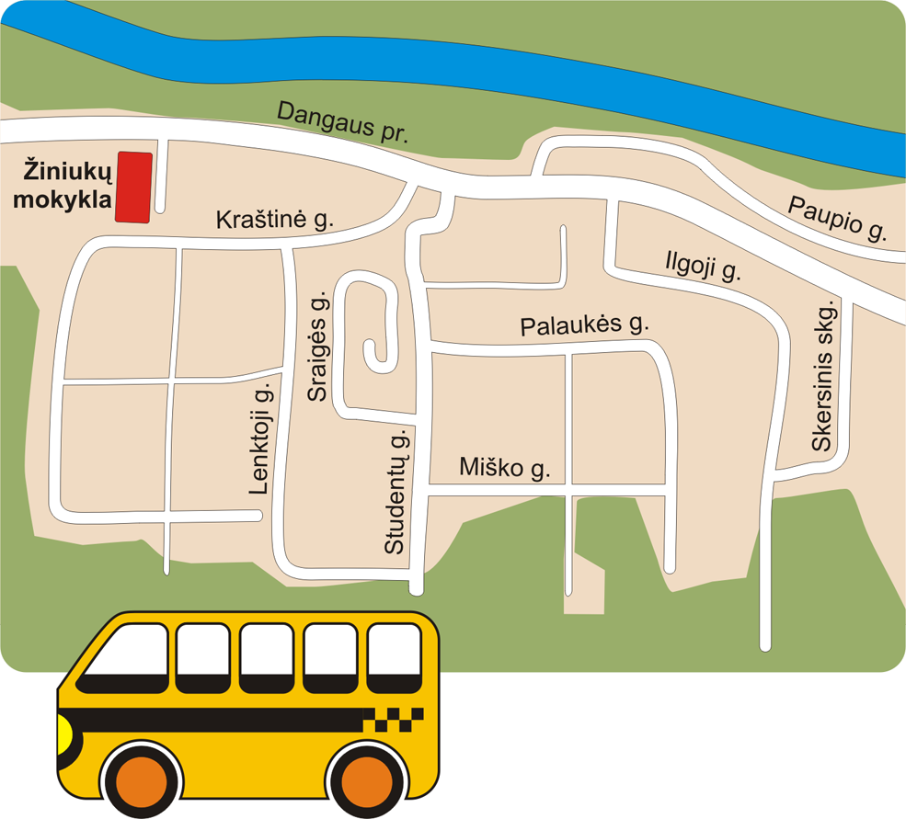
Fig. 1. The map

