“Nesting-box” – student handout

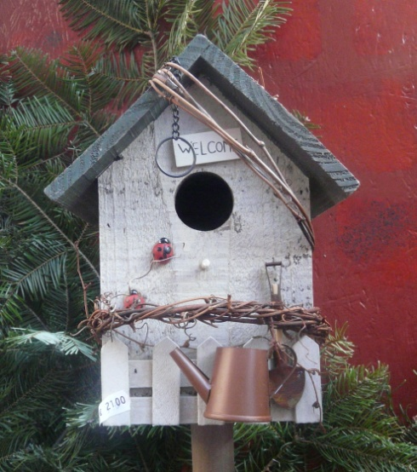
All European countries seek to conserve all bird species by protecting their habitats and, through this, to work for the world's biological diversity and the sustainability of human use of natural resources.
Most of endangered species of birds could disappear without the help of humans. One of the possible ways to help birds is to build nesting-boxes. These small houses for birds could determine if birds can survive in a particular place.
You have to imagine that you are an employer of a company which produces wooden things. The company was asked to build 1000 nesting-boxes for birds. These nesting-boxes will be hung on trees in a particular forest.
Photo by Egle Jasute
- You have to design an original nesting-box for a particular bird species in your place.
- You have to explain what type of birds will live in the box and why it is suitable for your chosen species of birds, where and how it has to be hung.
- You have to calculate how many and what materials you need to build your designed nesting-box.
The work has to be presented on A4 paper sheets. All drawing has to be done to appropriate scale. The instruction of how to build a nesting-box has to be described there. You have to be able to present your work to other students.

You can check for information:
http://senas.birdlife.lt/index.php/gamtos-klase/litetuvos-pauksciai/ (Lithuanian birds)
https://www.youtube.com/watch?v=qMjE-Z6I4WE (video of Lithuanian birds)
http://www.birdlife.lt/inkilai (about nesting-boxes in Lithuanian)
https://www.youtube.com/watch?v=nWg5nL5ROL0&feature=player_embedded (video of how to build nesting-box)

