“Nesting-box” – teacher guide

Abstract
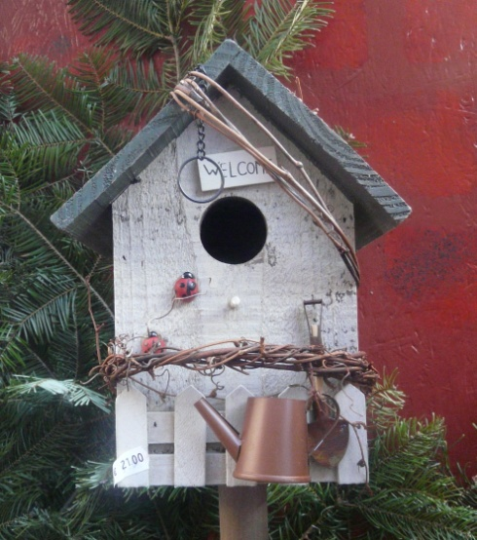
All European countries seek to conserve all bird species by protecting their habitats and, through this, to work for the world's biological diversity and the sustainability of human use of natural resources.
Most of endangered species of birds could disappear without the help of humans. One of the possible ways to help birds is to build nesting-boxes. These small houses for birds could determine if birds can survive in a particular place.
The student works as a carpenter or designer in a company, which produces wooden things. The company was asked to build 1000 nesting-boxes for birds. These nesting-boxes will be hung on trees in a particular forest.
Photo by Egle Jasute

Discipline: Interdisciplinary between Mathematics and Science (Biology), Design & Technology
Duration: 2 lessons for design (90 minutes), and 2-3 lessons for building (90-125 minutes)
Target Group: Upper Primary, Lower Secondary Education
Age range: 10–12 years
WoW context:
The task has a direct connection to the world of work. Students play a certain role, perform typical work activities and create an authentic product. Students work as designers and woodworker. Students understand how mathematics is utilised in the world of work and explore the world of work.
Student task:
All European countries seek to conserve all bird species by protecting their habitats and, through this, to work for the world's biological diversity and the sustainability of human use of natural resources.
Most of endangered species of birds could disappear without the help of humans. One of the possible ways to help birds is to build nesting-boxes. These small houses for birds could determine if birds can survive in a particular place.
You have to imagine that you are an employer of a company which produces wooden things. The company was asked to build 1000 nesting-boxes for birds. These nesting-boxes will be hung on trees in a particular forest.
- You have to design an original nesting-box for a particular bird species in your place.
- You have to explain what birds will live in the box and why it is suitable for your chosen species of birds, where and how it has to be hung.
- You have to calculate how many and what materials you need to build your designed nesting-box.
The work has to be presented on A4 paper sheets. All drawing has to be done to appropriate scale. The instruction of how to build a nesting-box has to be described there. You have to be able to present your work to other students.
Equipment:
The knowledge and information of mathematics and biology is needed to solve this task. For this the information about birds in the appropriate location could be printed for students or the links could be presented.
Teaching notes:
Depending on students’ abilities the task can be a guided inquiry or an open inquiry.
Guided inquiry: the presentation of the task can be started with a discussion about endangered species of birds and what we can to do to help them to survive. The photos and videos of birds can also be shown. The teacher together with students can discuss which species of birds are the most widespread in the area of school and decide on the species of birds which they will design a nesting-box for.
All further steps of the task can be talked over.
Open inquiry: students can be asked to find all the necessary information on the internet and in textbooks, and discuss reasons and ways how to help the birds, what species of birds live in the area of school or students’ living places, what to pay attention at while designing a nesting-box for an appropriate species of birds. Students have to justify why they have chosen to design a nesting-box for a specific species of birds.
Teacher can use online material or videos which are listed in students’ handout:
http://senas.birdlife.lt/index.php/gamtos-klase/litetuvos-pauksciai/ (Lithuanian birds)
https://www.youtube.com/watch?v=qMjE-Z6I4WE (video of Lithuanian birds)
http://www.birdlife.lt/inkilai (about nesting-boxes in Lithuanian)
https://www.youtube.com/watch?v=nWg5nL5ROL0&feature=player_embedded (video of how to build nesting-box)
Lesson plan example:
Lesson 1:
5 min Hand out student tasks; divide students in groups (3-4 persons). Students read information and try to comprehend the task.
10 min Discussion of the task in class; the teacher could show video and pictures of birds; discussion of students’ questions; working out first steps.
35 min Students work on the task (in groups); teacher supports them as an adviser.
Homework: if next lesson is next day/week: to check what birds live near the student’s living place. To write argumentations why particular species were chosen.

Lesson 2:
5 min Short repetition of the task in the class. Joint answering of arising questions, discussion of unclear aspects.
20 min Students work on the task (in groups); teacher supports them as an adviser.
5 min Students summarise their results and write the report.
20 min Groups present their results and discussion.
10 min Students give feedback on the task.

