House insulation - Worksheet

Scenario:
Two neigbours, Antony and Alex, found out that they pay 390 and 850 Euros respectively for house heating over the period November- February. Their houses are built in the same area, they are the same (in terms of arhitecture and area they cover), they get the same hours of sun, and the temperature inside is the same around the clock. Both houses use the same type of heating.
What are your hypotheses about the variation on the amount of money Antony and Alex have to pay? Explain your hypotheses.

Graph 1: Cost per house per month (House 1:Alex, House 2: Antony)

What kind of profession could better help us to understand the variation in costs for Alex and Antony? Explain your answer

Alex and Antony came up with the following hypotheses:
- Hypothesis Α: The type of material that was used to construct the house has an impact
- Hypothesis Β: The type of insulation thaw was used to construct the house has an impact

Part A: Design an experiment to check the first hypothesis, using the materials shown in the table below. Think about the different variables involved, about the data to be collected and describe your experiment below the experiment.
Time  (mins) | Metal | Sterofoam | Glass
 | 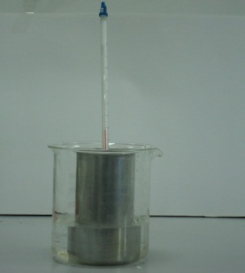 | 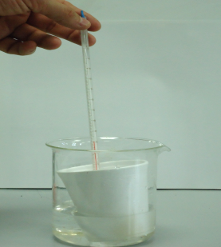 | 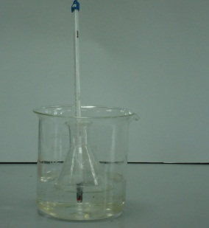
0
0,5
1
1,5
2
2,5
3
3,5
4
4,5
5

Describe your experiment and identify the variables:

Conclusion: Which container «looses» heat faster? Is there a difference between the first minues and the last minutes in your measure? How can the findings help you expain your hypothesis?

Explanation: What can you understand from your findings in terms of the difference in the heating cost between the two houses?

Part B: Design an experiment to check the second hypothesis, using the materials shown in the table below. Think about the different variables involved, about the data to be collected and describe your experiment below the experiment.

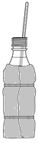
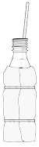
Bottle with no wrapping
Wrapped in styrofoam
Wrapped in air cells

Α) Try out the experiment and collect the following data. Then sketch a graph with all the data.
Time  (min) | Water temperature in unwrapped bottle | Water temperature in bottle wrapped in styrofoam | Water temperature in bottle wrapped in air cells
0
4
8
12

What is your conclusion? Expain by providing evidence. How can these findings help you explain the second hypothesis?

Question 1: Based on the outcomes of your experiments, and using the data below, decide which material is the best.
Criteria | Glass | Styrofoam | Μέταλλο | Glass wrapped in polyester | Metal wrapped in polyester
Toughness | Very good | Bad | Very good | Very good | Very good
Insulation | ………….. | ………….. | ………….. | ………….. | …………..
Cost | €250 000 | €20 000 | €200 000 | €270 000 | €270 000

Question 2: What is your hypothesis on why Antony is paying more on heating? Explain based on evidence. Also provide solutions to his problem.

Practical Application: Using simple materials (e.g. an empty shoe box, styrofoam, plastic, metal container) construct a model of a house in a way that it has very good insulation. After doing so, check the insulation and compare with the other model houses constructed in other groups. Present the outcomes and discuss practices that building enginners and architects use.

The original version of this PoM was designed by Yiannis Karmiotis (Physics Teacher) and was adapted by the Mascil Cyprus group.

