Design of a parking entrance to a basement garage: teacher guide

Abstract
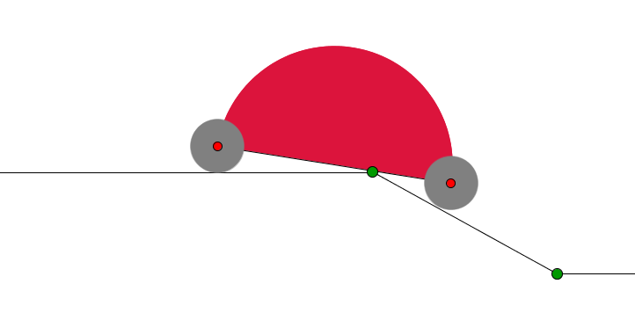
The aim of this task is to facilitate the parking entrance from the street to the basement of different types of cars and other moving objects such as baby carriages, wheelchairs, etc. The natural intention is to make the passage from the street to the basement as short as possible
This task is inspired by (and is a continuation of) the Parking Problem proposed by the UK Mascil team (http://www.mascil-project.eu/classroom-material).
The problem implements mathematical ideas in the context of road construction, car design, architecture, traffic control (speed bumps).
The students are expected to explore a real-life situation by means of paper models and dynamic geometry software. Based on experiments they enhance their intuition for the situation under consideration, formulate and verify conjectures and, finally, find practically acceptable solutions.
Example of lesson plans are at the end of this document.
Potential adjustments to other age groups
Part 1 is suitable for younger students also down to primary, so primary teachers may want to choose only to do only Part 1. Otherwise, the task as a whole can be adjusted by varying the duration of the lessons, for instance extending from two to three lessons (see example of lesson plan).

The task
Part 1: Parking from the street to the basement parking garage
The students are given the task to design a straight-line slope connecting the street and the basement parking garage, as shown in Fig.1, of a newly built house. 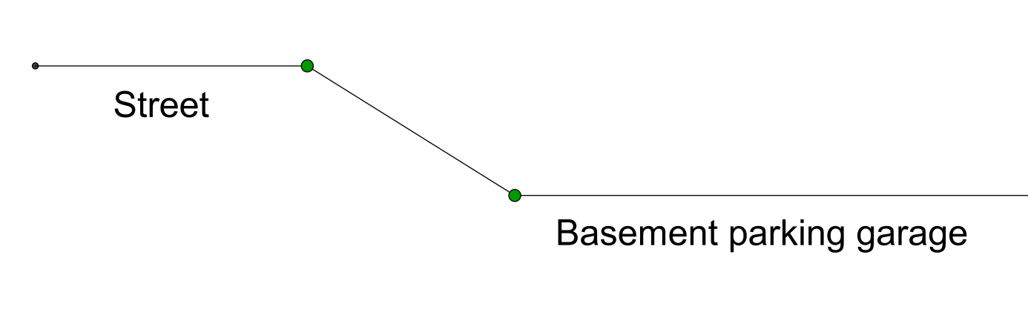
Fig. 1
The aim is to facilitate parking from the street to the basement of different types of cars and other moving objects such as baby carriages, wheelchairs, etc. The natural intention is to make the passage from the street to the basement as short as possible. This could be achieved by making the slop steeper. To understand what kind of difficulties appear when the slope gets steeper the students are invited to experiment with different slopes (drawn on a sheet of paper) and a preliminary prepared 2D paper model of a „turtle-car” as in Fig.2
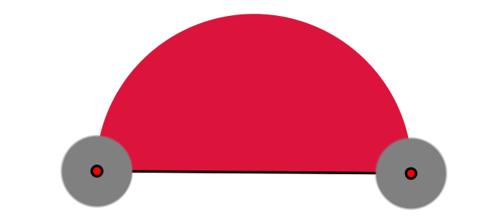
Fig. 2
Here is what could happen:
Fig. 3
The bottom of the turtle-car hits the beginning of the slope and gets damaged.
To increase the opportunities for exploration and experimentation, the students are prompted to use any of the next two Experimental Environments (EE)
http://www.math.bas.bg/omi/cabinet/content/bg/html/d22185.html
http://www.math.bas.bg/omi/cabinet/content/bg/ggb/d22185.ggb

Here the students can vary the length of the turtle-car, the size of the car-wheels and the steepness of the slope. For the second listed EE one has to have GEOGEBRA installed on the computer. This popular and free software is downloadable from http://www.geogebra.org/download . In case some (or both) of the links does not open, one can use the GEOGEBRA file EE1.ggb associated to this material.
Discussion with students:
Questions to consider on what makes parking easier:
- Bigger or smaller wheels?
- Longer or shorter turtle-car?
- Steeper or less steep slope?
How to measure:
- The size of the wheels (the notion of circle and its radius)?
- The length of the car (distance between centers of wheels)?
- The slope (ask students to propose measures for the slope)?

Damage of the car:
- Which parts of the turtle-car will be damaged, if the slope is too steep (front, top, back, bottom)?
- Which is the steepest slope that a given turtle-car can overcome without problems?
- Which is the most vulnerable part of the turtle-car bottom when passing over the slope: front, rear, middle?
(The experiments will show that, if the middle point of the bottom line of the turtle-car passes safely the beginning of the slope, parking is possible.)

Homework: Measure the radius of the wheels of a baby carriage and the car of the parents. Measure the slope of a staircase at home and/or at school. Give the measures both in percentages and in degrees.

Teacher guidance for measuring slope:
There are different measures for the slope.
It is measured in percentages “ % “ and in degrees “ º “.

A traffic sign for the slope and its meaning:

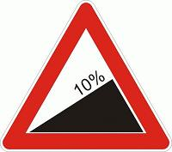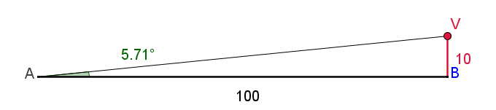
Calculating the slope in percentages %:

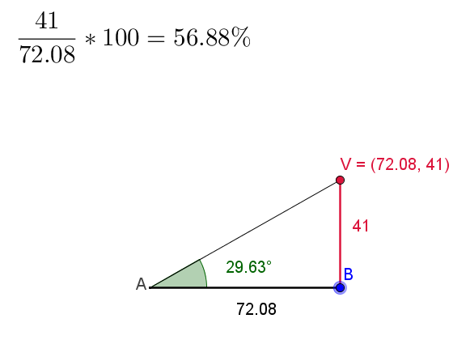

The interplay between slope measured in percentages and in degrees can be explored by many of the following EE:
http://www.math.bas.bg/omi/cabinet/content/bg/html/d22190.html
http://www.math.bas.bg/omi/cabinet/content/bg/ggb/d22190.ggb
http://www.math.bas.bg/omi/cabinet/content/bg/html/d22191.html
http://www.math.bas.bg/omi/cabinet/content/bg/ggb/d22191.ggb

http://www.math.bas.bg/omi/cabinet/content/bg/html/d22192.html
http://www.math.bas.bg/omi/cabinet/content/bg/ggb/d22192.ggb
http://www.math.bas.bg/omi/cabinet/content/bg/html/d22193.html
http://www.math.bas.bg/omi/cabinet/content/bg/ggb/d22193.ggb

http://www.math.bas.bg/omi/cabinet/content/bg/html/d22194.html
http://www.math.bas.bg/omi/cabinet/content/bg/ggb/d22194.ggb

Part 2: Investigating slope

The students investigate slope by working through a set of task.
In the sequel the steepness of the slope will be measured in degrees only. On Fig. 4 a 32º slope is depicted.
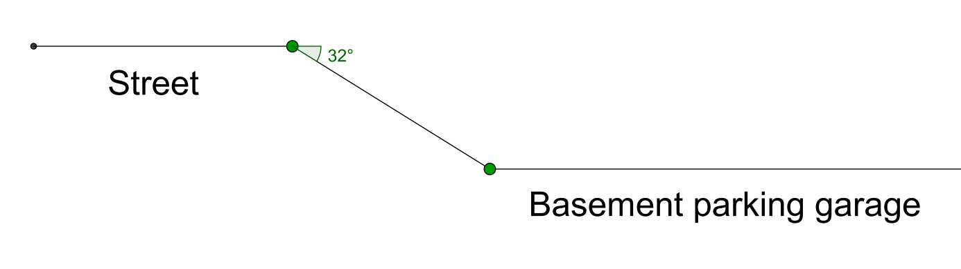
Fig. 4

Teacher guidance for working with the tasks

Task 1. If the wheels of the turtle-car have radius 8 cm and the distance between the centers of the wheels is 72 cm (as shown on Fig. 5), will the turtle-car overcome safely the slope of ?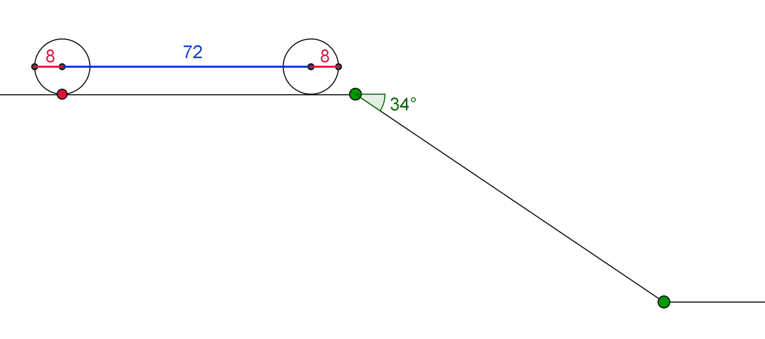
Fig. 5
To explore this and the next several tasks the students can use the associated file EE2.ggb .

Draw the attention of the students to the fact that, if the bottom line of the turtle-car crosses the horizontal line of the street or the inclined line (of the slope), then an orange colored sign „x“ appears at the crossing point. This means the turtle-car cannot overcome the slope and parking is impossible.
Exploration with the help of provided EE and the data from Task 1 shows that the turtle-car cannot overcome the slope and parking in the basement is impossible in this case.
Reducing, with the help of the α-slider, the steepness of the slope to 25º makes the parking possible.
Task 2. There are three turtle-cars with different sizes as shown in the table:

Turtle-car | Radius  of Wheels | Distance between  centers of wheels
TC1 | 8 cm | 72 cm
TC2 | 10 cm | 99 cm
TC3 | 13 cm | 111 cm

What is the steepest slope that could be overcome by all three turtle-cars?
Answer. By means of the provided EE (using the slider for the slope) the students find, for each car separately, the steepest slope for which parking is possible. This gives

Turtle-car | Radius  of Wheels | Distance between  centers of wheels | Steepest slope  for which parking is possible
TC1 | 8 cm | 72 cm | 25 º
TC2 | 10 cm | 99 cm | 23 º
TC3 | 13 cm | 111 cm | 26 º

In order for the three cars to be able to park, one has to take the slope of 23 º.
Another question arising in connection with Task 1 is to increase the size of the wheels of the turtle-car (keeping the length of the turtle-car and the slope unchanged) so that parking becomes possible. For instance, experimenting with the g-slider one finds that, if the radius of the wheels is 12, then parking is possible.

Task 3. If the distance between the centers of the wheels of a turtle-car is 72 cm, what is the minimal radius of the wheels that should be given to the car so that it overcomes the slope of 34º?
Exploring the problem with the EE one finds as an approximation 10.7. The precise number is 36 sin17º which is approximately equal to 10.525 but this need not be revealed to students at this moment. Similar problems could be given for homework.
Still another direction of inquiry is to keep the radius of the wheels and the slope unchanged and to reduce the distance between the centers of the wheels of the turtle-car from Task 1 so that parking becomes possible. For instance, reducing the length to 50 cm (instead of 72 cm) provides a turtle-car that easily overcomes the slope of 34º.

Task 4. Given the radius of the wheels (8 cm) and the slope (), what is the maximal length between the centers of the wheels for which the turtle-car could be parked in the basement?
The exploration with the EE shows that the answer is strictly between 54 cm and 55 cm. The precise answer is 8/sin 17º but there is no need to reveal this to students. A very good approximation is 54.725 cm. In this optimal case the bottom of the turtle-car just touches the beginning of the slope as shown on Fig. 6:
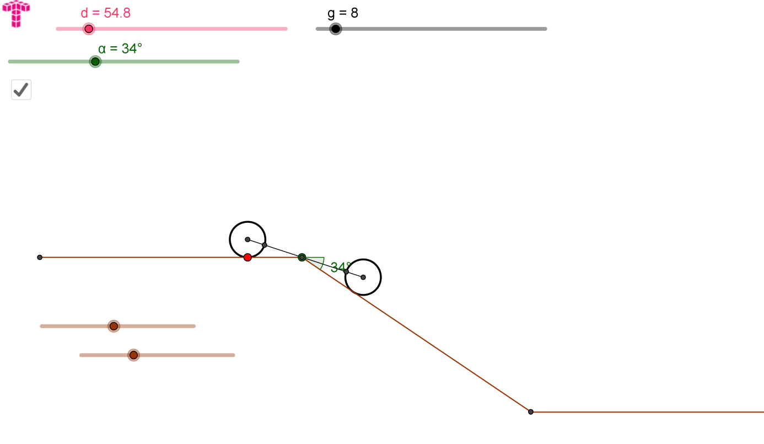
Fig. 6

From now on we will use the term “vertex” for the point at the beginning of the slope.
This is a proper place to ask the students to measure (on Fig. 6, with the help of the tools provided by GEOGEBRA) the distances between the vertex and the centers of the wheels in Fig. 6. This will show that the two distances are approximately equal to each other and, therefore, equal to half of the distance between wheel-centers. Similarly, one can measure the angle between the “turtle-car-line” (the line connecting the centers of the wheels) and the horizontal line, on one hand, and the angle between the turtle-car-line and the line of the slope, on the other. The two angles must be almost equal and, actually, equal to half of the slope angle. This always happens in the “critical situation” (as in Fig. 6) regardless what the radius of wheels is and what the slope angle is. This could be “experimentally discovered” by the students while working on the following task with the help of EE2.ggb .

Task 5. There are wheels of several different sizes as shown in the table below. For each wheel-size find the maximal length of the turtle-car (in terms of the distance between the centers of wheels) that could be parked over a slope of 34º. For this maximal length check if in the process of parking the vertex touches the middle of the turtle-car bottom. At the “moment of touch” measure the angle between the turtle-car bottom and the horizontal line. Fill in the empty boxes in the table.

Radius  of Wheels | Maximal distance  between  centers of wheels  for which parking  is possible | Size of the angle  at the moment  of touch
8 cm
10 cm
13 cm
15 cm

Task 6. (Homework) As Task 4 but with a slope of 40º.
Let us consider a more realistic model of a car as shown on Fig. 7.

Task 7. Is it possible to park the car from Fig. 7 (where all sizes are given in centimeters) over a slope of 28°? Pay attention to the troubles that appear when leaving the slope and entering the basement.
It is advisable to use the dynamic file in:
http://www.math.bas.bg/omi/cabinet/content/bg/html/d22178.html
or (if you have GeoGebra installed) in the link:
http://www.math.bas.bg/omi/cabinet/content/bg/ggb/d22178.ggb
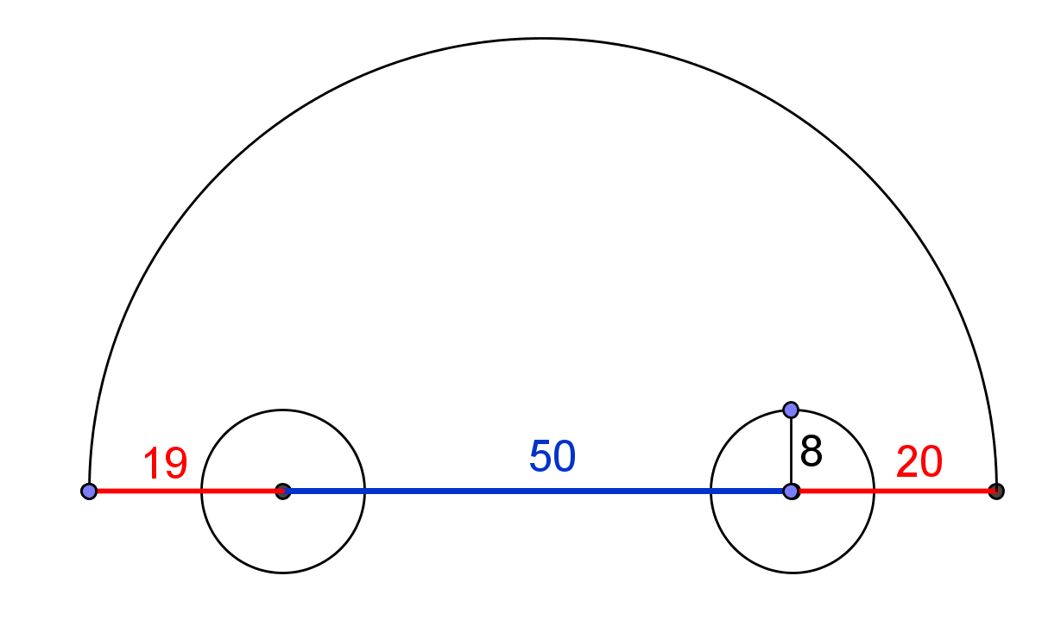
Fig. 7

Task 8. Is it possible to park the car with technical characteristics as in Fig. 8 over a slope of 28°?
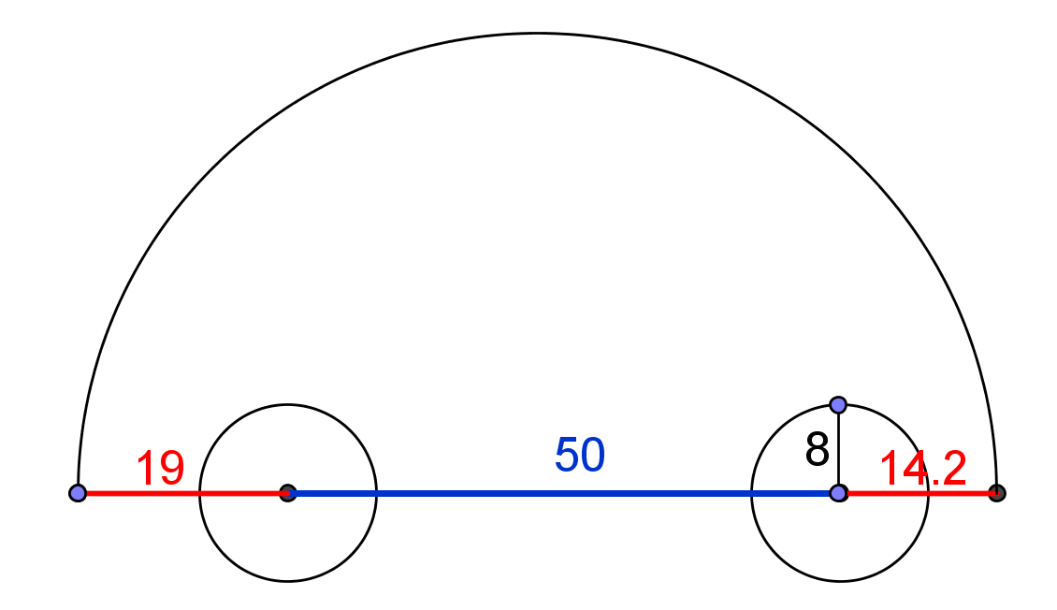
Fig. 8

As a matter of fact, for real cars the “bottom line” is not the one that connects the centers of the wheels. It might be lower as in Fig. 9.
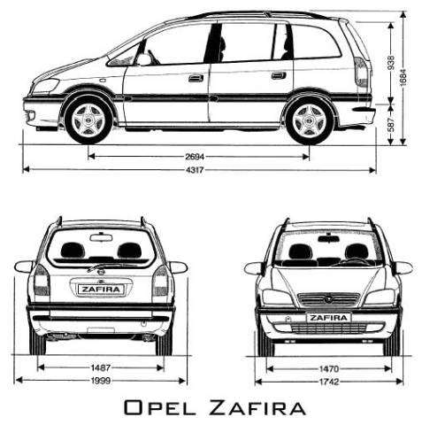
(taken from http://stamm.snimka.bg/automobiles/tehnicheski-shemi.523901.19987698 )
Fig. 9
While exploring the parking problem we have to work with the real distance between the ground and the lowest parts of car chassis. This is the so called “clearance” of the car. Here is what Wikipedia says about it ( http://en.wikipedia.org/wiki/Ride_height):

Ride height (also called ground clearance or simply clearance) is the amount of space between the base of an automobile tire and the underside of the chassis; or, more properly, to the shortest distance between a flat, level surface, and any part of a vehicle other than those parts designed to contact the ground (such as tires, tracks, skis, etc.). Ground clearance is measured with standard vehicle equipment, and for cars, is usually given with no cargo or passengers.
Ground clearance is a critical factor in several important characteristics of a vehicle. For all vehicles, especially cars, variations in clearance represent a trade-off between handling and practicality. A higher ground clearance means that the center of mass of the car is higher, which makes for less precise and more dangerous handling characteristics (most notably, the chance of rollover is higher). However, it also means that the car is more capable of being driven on roads that are not level, without the road scraping against and likely damaging the chassis and underbody. Higher ride heights will typically adversely affect aerodynamic properties. This is why sports cars typically have very low clearances, while off-road vehicles and SUVs have higher ones. Two well-known extremes of each are the Ferrari F40and the Hummer.

Task 9. Find the clearance of the car of your parents and determine the maximal slope over which the car still can be parked in the basement.

Task 10. Construct a speed bump (sleeping policeman) whose height is bigger than the clearance of the car from the previous task and, nevertheless, the car can pass over it without any problem.
More information on Speed bumps (sleeping policemen) may be obtained at http://en.wikipedia.org/wiki/Speed_bump

Consult also “Supercar's Worst Enemy – Speed bump” at https://www.youtube.com/watch?v=GSUU5xOMAU8

ATTACHMENT: Example of lesson plans
Example of lesson plan for Part 1:
5 min Organize your class in small working groups (3-4 students) and introduce the problem. Allow the students some quiet minutes to think about factors that might important to consider with regard to the construction.
5 min Bring the students ideas up front in a five to ten minutes whole class discussion.
Questions to consider on what makes parking easier:
- Bigger or smaller wheels?
- Longer or shorter turtle-car?
- Steeper or less steep slope?

25 min Hand out paper cars to the students for experimenting. Let the students work in groups of 3-4. Walk around and discuss with the groups. Bring in elements for them to consider. Some important questions might be:
How to measure:
- The size of the wheels (the notion of circle and its radius)?
- The length of the car (distance between centers of wheels)?
- The slope (ask students to propose measures for the slope)?

Damage of the car:
- Which parts of the turtle-car will be damaged, if the slope is too steep (front, top, back, bottom)?
- Which is the steepest slope that a given turtle-car can overcome without problems?
- Which is the most vulnerable part of the turtle-car bottom when passing over the slope: front, rear, middle?
(The experiments will show that, if the middle point of the bottom line of the turtle-car passes safely the beginning of the slope, parking is possible.)

If the students have access to Experimental Environments, this can be introduced. Then more time might be necessary.

15 min Let the groups present their work with the problem so far and their hypotheses. Pay attention to the questions given in the previous phases of the lesson.

Homework: Measure the radius of the wheels of a baby carriage and the car of the parents. Measure the slope of a staircase at home and/or at school. Give the measures both in percentages and in degrees.

Example of lesson plan for Part 2 (day one):
10 min Organize your class in small working groups (3-4 students) and introduce the problem. Recall their work with part 1 of the basement parking problem. Hand out copies of the tasks.
35 min Let the students work in groups of 3-4. Walk around and discuss with the groups. Bring in elements for them to consider. See notes below for elements to bring in.
5 min Summarize questions that the students have run into during the lesson. Introduce the homework.

Example of lesson plan for Part 2 (day two):
5 min Organize your class in the same groups as the previous day. Clarify questions from the previous day. Hand out copies of the tasks.
30 min Let the students work with the task. Walk around and discuss with the groups. Bring in elements for them to consider. See notes below for elements to bring in.
15 min Let the student present their work.

