Design of a parking entrance to a basement garage

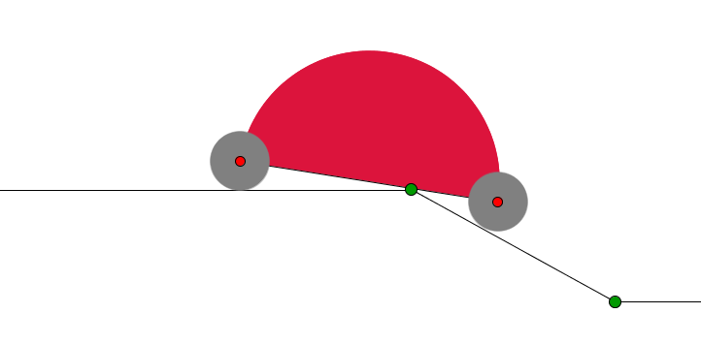
The main problem
You are an architect and your task is to facilitate the parking entrance from the street to the basement-parking garage. For the purpose, you have to design a straight-line slope connecting the street and the basement-parking garage, as shown in Fig.1, of a newly built house.

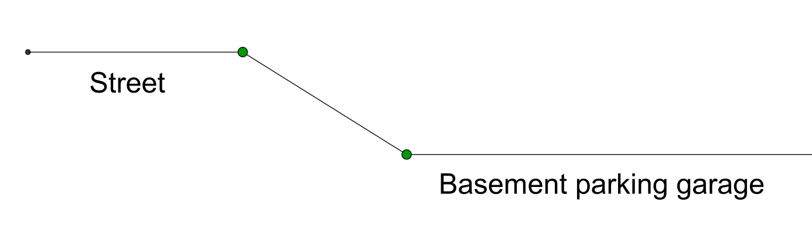
Fig. 1

Task 1. If the wheels of the turtle-car have radius 8 cm and the distance between the centers of the wheels is 72 cm (as shown on Fig. 2), will the turtle-car overcome safely the slope of ?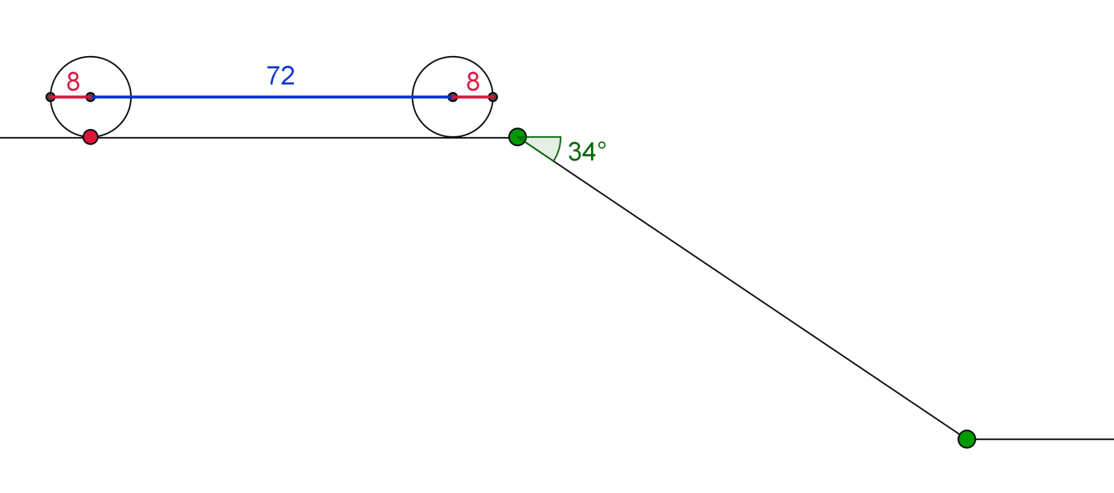

Fig. 2

To explore this and the next several tasks you could use the dynamic file in the link:
http://www.math.bas.bg/omi/cabinet/content/bg/html/d22179.html
or (if you have GeoGebra installed) in the link:
http://www.math.bas.bg/omi/cabinet/content/bg/ggb/d22179.ggb
Task 2. There are three turtle-cars with different sizes as shown in the table:
Turtle-car | Radius  of Wheels | Distance between  centers of wheels
TC1 | 8 cm | 72 cm
TC2 | 10 cm | 99 cm
TC3 | 13 cm | 111 cm

What is the steepest slope that could be overcome by all three turtle-cars?

Task 3. If the distance between the centers of the wheels of a turtle-car is 72 cm, what is the minimal radius of the wheels that should be given to the car so that it overcomes the slope of 34º?

Task 4. Given the radius of the wheels (8 cm) and the slope (), what is the maximal length between the centers of the wheels for which the turtle-car could be parked in the basement?

Task 5. There are wheels of several different sizes as shown in the table below. For each wheel-size find the maximal length of the turtle-car (in terms of the distance between the centers of wheels) that could be parked over a slope of 34º. For this maximal length check if in the process of parking the vertex touches the middle of the turtle-car bottom. At the “moment of touch” measure the angle between the turtle-car bottom and the horizontal line. Fill in the empty boxes in the table.
Radius  of wheels | Maximal distance between  centers of wheels for which parking is possible | Size of the angle at the moment of touch
8 cm
10 cm
13 cm
15 cm

Let us raise the bar now!
Task 6. (Homework) As Task 4 but with a slope of 40º.
Consider a more realistic model of a car as shown on Fig. 3.
Task 7. Is it possible to park the car from Fig. 3 (where all sizes are given in centimeters) over a slope of 28°? Pay attention to the troubles that appear when leaving the slope and entering the basement.
You could use the dynamic file in the link:
http://www.math.bas.bg/omi/cabinet/content/bg/html/d22178.html
or (if you have GeoGebra installed) in the link
http://www.math.bas.bg/omi/cabinet/content/bg/ggb/d22178.ggb

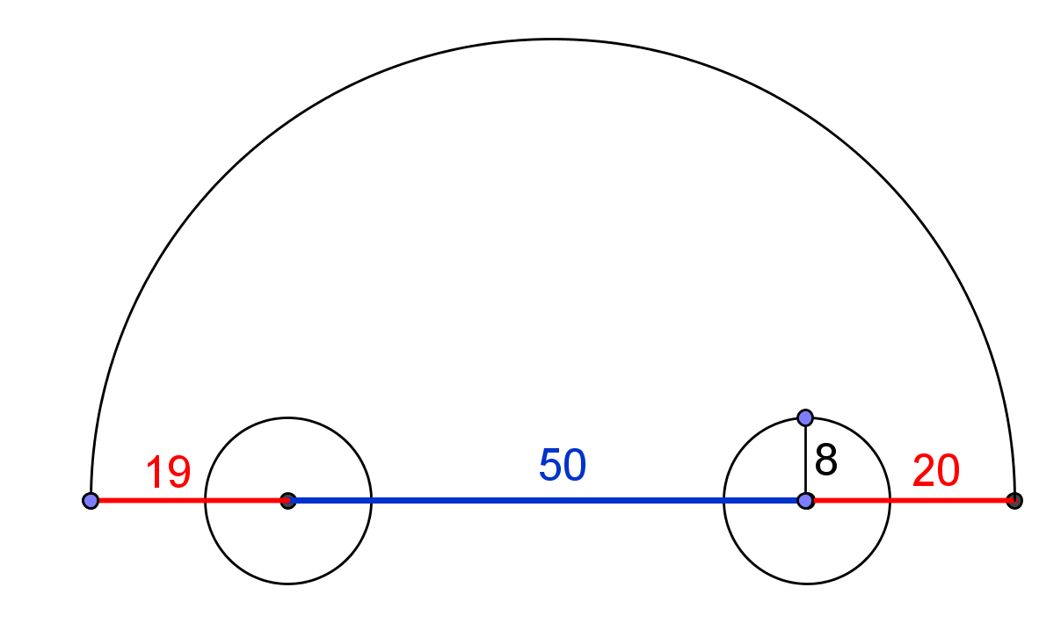
Fig. 3

Task 8. Is it possible to park the car with technical characteristics as in Fig. 4 over a slope of 28°?
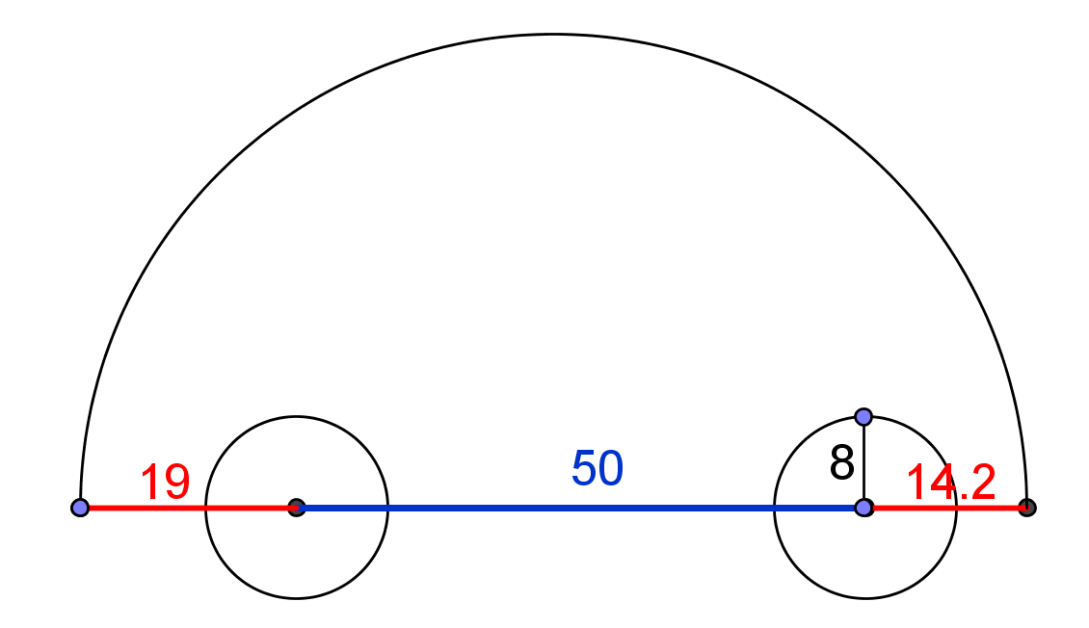
Fig. 4
As a matter of fact, for real cars the “bottom line” is not the one that connects the centers of the wheels. It might be lower as in Fig. 5.
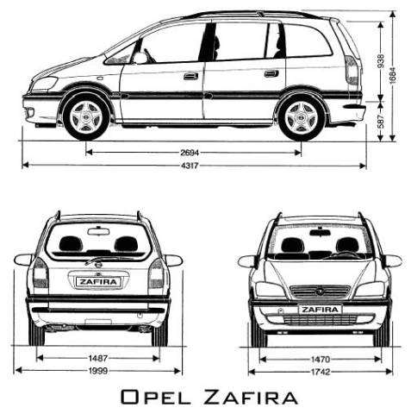

Fig. 5 http://stamm.snimka.bg/automobiles/tehnicheski-shemi.523901.19987698

While exploring the parking problem we have to work with the real distance between the ground and the lowest parts of car chassis. This is the so called “clearance” of the car. Here is what Wikipedia says about it ( http://en.wikipedia.org/wiki/Ride_height):
Ride height (also called ground clearance or simply clearance) is the amount of space between the base of an automobile tire and the underside of the chassis; or, more properly, to the shortest distance between a flat, level surface, and any part of a vehicle other than those parts designed to contact the ground (such as tires, tracks, skis, etc.). Ground clearance is measured with standard vehicle equipment, and for cars, is usually given with no cargo or passengers.
Ground clearance is a critical factor in several important characteristics of a vehicle. For all vehicles, especially cars, variations in clearance represent a trade-off between handling and practicality. A higher ground clearance means that the center of mass of the car is higher, which makes for less precise and more dangerous handling characteristics (most notably, the chance of rollover is higher). However, it also means that the car is more capable of being driven on roads that are not level, without the road scraping against and likely damaging the chassis and underbody. Higher ride heights will typically adversely affect aerodynamic properties. This is why sports cars typically have very low clearances, while off-road vehicles and SUVs have higher ones. Two well-known extremes of each are the Ferrari F40and the Hummer.

Task 9. Find the clearance of the car of your parents and determine the maximal slope over which the car still can be parked in the basement.

Task 10. Construct a speed bump (sleeping policeman) whose height is bigger than the clearance of the car from the previous task and, nevertheless, the car can pass over it without any problem.

You could find more information on Speed bumps (sleeping policemen) at http://en.wikipedia.org/wiki/Speed_bump

Consult also “Supercar's Worst Enemy – Speed bump” at https://www.youtube.com/watch?v=GSUU5xOMAU8

