# Forest and Timber Management Handout for Students

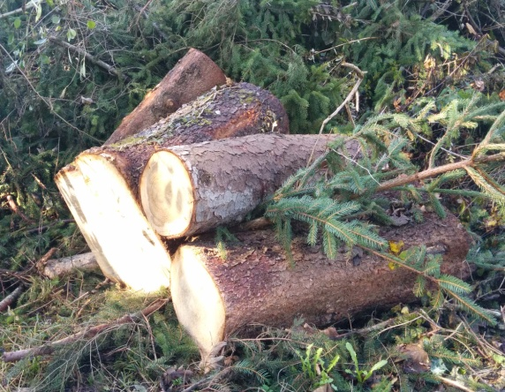You are employees of the Austrian Bundesforste (a company managing natural resources, mainly focusing on forest management, on behalf of the Austrian federal government) and are responsible for the forest and timber management of a privately owned piece of land.

The landlord wishes the deforestation of a forest area as well as the afforestation of a felling site. For this, calculations are necessary.

***mascil****-Team Austria*

* Do some literature studies to collect background information about forests in your area to model the landlord’s land. Investigate the plant and tree diversity, and together with literature studies estimate whether the forest and plant communities are of a pioneer type, an intermediate type or a climax type.
* Table 1 provides the diameters at breast height (DBH) and total height of twenty 60-year-old spruces in the forest area to be deforested.

|  |  |  |  |  |  |  |  |  |  |  |
| --- | --- | --- | --- | --- | --- | --- | --- | --- | --- | --- |
|  | F1 | F2 | F3 | F4 | F5 | F6 | F7 | F8 | F9 | F10 |
| DBH | 15,1 | 15,1 | 15,3 | 15,4 | 15,5 | 16,2 | 16,7 | 16,7 | 17,2 | 17,9 |
| Height | 10,3 | 10,8 | 11,4 | 11,2 | 11,9 | 12,8 | 12,4 | 13,1 | 14,3 | 14,8 |
|  | | | | | | | | | | |
|  | F11 | F12 | F13 | F14 | F15 | F16 | F17 | F18 | F19 | F20 |
| DBH | 18,4 | 19,8 | 19,9 | 20,2 | 20,4 | 21,6 | 22,6 | 23,5 | 23,9 | 24,5 |
| Height | 15,1 | 15,7 | 15,7 | 16,3 | 16,1 | 16,9 | 17,8 | 18,2 | 19,5 | 19,8 |

Table 1 Diameters at breast height (in cm) and height (in m) of 20 spruces (age: 60 years)

Estimate the volume in m³ (cubic meter) of this stand. To do so, use this formula (customary in forest management):

$V=G ∙ H ∙ F$

G is defined as the sum of the tree’s cross section surface at breast height, H as the medium height, and F as the shape number. Depending on the tree growth circumstances, the latter lies between 0,4–0,55. The form number of the respective tree species can be taken from tables. With respect to this stand, the shape number lies between 0,46 and 0,48.

Why is it necessary to multiply with a shape number? What is being calculated when the shape number is left out?

* The felling site, 20m × 100m, is to be afforested with spruces, firs and beeches.  
  How many of the respective trees are necessary for this? The planned distances between the trees can be gathered from table 2.

|  |  |  |
| --- | --- | --- |
| Tree Species | Recommended planting distance between trees | |
| between rows | within rows |
| Spruce (*Picea abies*) | 2,5 × 1,5 | |
| Fir (*Abies alba*) | 2,5 × 1,5 | |
| Common Beech (*Fagus sylvatica*) | 1,5 × 1 | |

Table 2 Recommended planting distance between trees (in m)[1]

* The costs for the young trees are listed in table 3. How much will it cost the landlord to buy trees for the afforestation of the felling site?

|  |  |
| --- | --- |
| Species | age/height (cm) price |
| Fir (*Abies alba*) | 4-years 0,60 |
|  | 5-years 0,65 |
| Spruce (*Picea abies*) | 3-years 0,43 |
|  | 4-years 0,48 |
|  | 5-years 0,55 |
| Common Beech (*Fagus sylvatica*) | 20–40 0,63 |
|  | 30–50 0,74 |
|  | 50–80 0,97 |
|  | 80–120 1,69 |

Table 3 Excerpt of a list of plant prices (in Euros)[2]

The results should be presented in a report, which will be given to the landlord. To inform all future employees, your summarised results should be presented during the next morning meeting.

The results should be followed by discussion, in light of the background information, on how the deforestation/afforestation strategy will affect the forest ecology in the long term. Eventually you can also draw on or connect your discussion to nature conservation policy in your area.

1. Landwirtschaftskammer Oberösterreich. (March 2011). *Landwirtschaftskammer Oberösterreich.* Accessed: 24-October-2014 https://ooe.lko.at/media.php?filename=download%3D%2F2012.11.05%2F1352121762922941.pdf&rn=Standortgerechte_Aufforstung.
2. Landesforstgärten. (2014). *Land Tirol.* Accessed: 23-October-2014 <https://www.tirol.gv.at/fileadmin/themen/umwelt/wald/landesforstgaerten/downloads/preisliste-deutsch.pdf>