Counting people – Teacher guide
Abstract  Children start counting from a very early age  Counting is a key mathematical competency in Early Childhood Education and the first grades of Primary School.  However, counting goes beyond school and it is an essential activity in many professional fields such as biology, ecology, geology, medicine, journalism, sociology…  In contrast with the ‘world of school’ where counting is normally an unproblematic and straightforward activity, in the ‘world of work’ counting can become a really challenging task. In this activity, students will have to devise their own plan for counting the number of people in a big public area.  Discipline: Mathematics  Duration: 2-3 lessons (55 minutes each)  Target Group: Upper Primary or Lower Secondary Education  Age range: 10-12, or 12-14. | 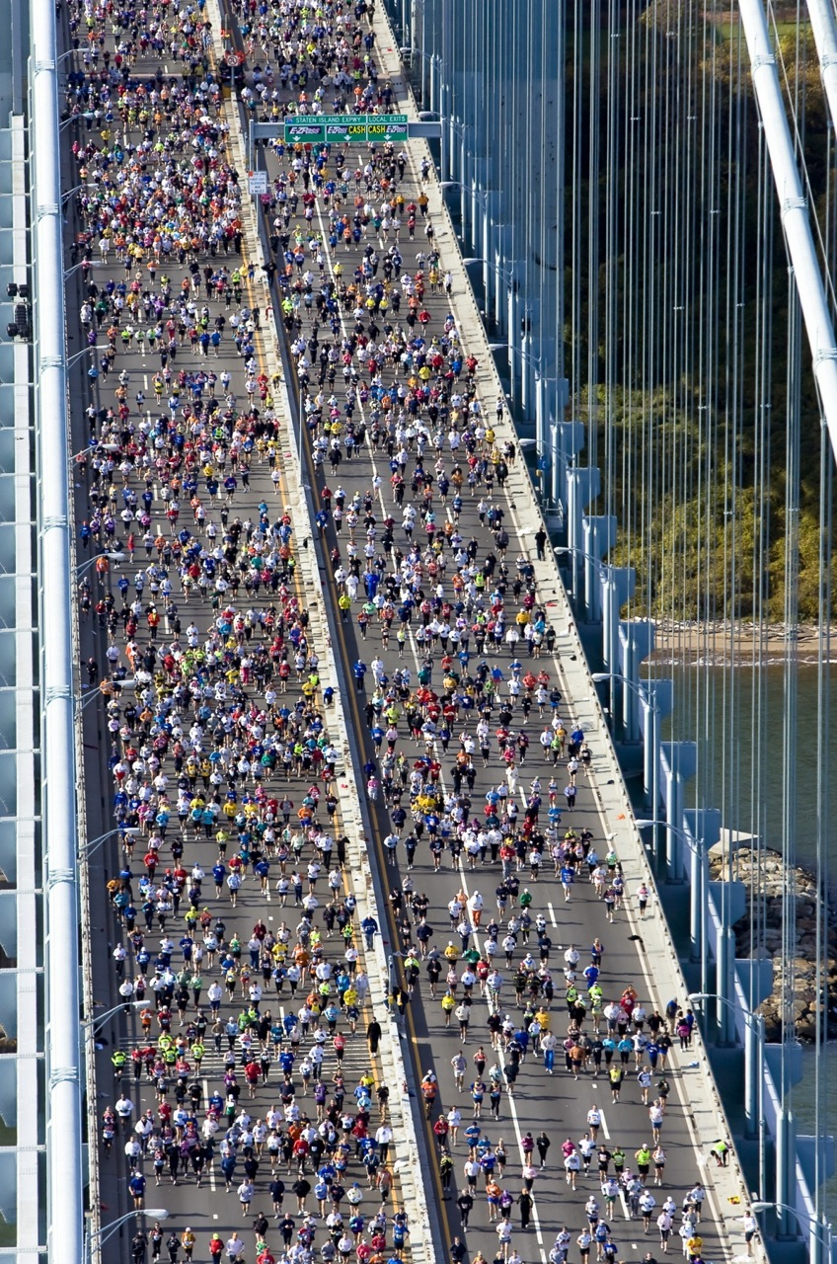  Thanks to Fergal Carr  Shared under the cc-by-2.0 licence

WoW context: journalism
The task presented within our ‘problem of the month section’ can be contextualized in many different professional settings. We have chosen journalism, because when journalists have to inform about a mass concentration, they need to estimate how many people there are, and not just rely on the data provided by the organisers (which normally tend to overestimate) or authorities (which sometimes tend to underestimate).

Student task:
You are a journalist and you have to write a press release about a mass meeting in your city. Organisers and public authorities have offered data about how many people that attended the meeting. However, data do differ significantly. How could you estimate the number of people at the event?

You should:
- Devise a plan to estimate how many people there are in a concentration when a one-to-one counting is not possible.
- Pilot your plan, by estimating how many pupils are playing in the schoolyard during a break.
- Based on your results, optimise your plan if necessary, and conduct a new piloting.
- Write a press release explaining both your method and how it has been used to estimate the number of pupils playing in the schoolyard.

Some comments:
The task could be addressed from a more context-specific scenario. However, it might be difficult to find a mass meeting that takes place nearby your school at the time you are using the task. Additionally, taking students outside school to attend such an event could be problematic. Optionally, we are suggesting that students could estimate pupils in the schoolyard as a means to validate their first proposal. This would offer students an easy way to prove if their initial plan led to a more or less accurate solution, since it is possible to know how many students there are in the schoolyard by asking how many pupils there are in each class.

A good solution for this task encompasses two different aspects: the extension of the public area (the schoolyard, in this case) and an estimation of the space that one person occupies when he or she is standing. Normally, this second aspect is tackled the other way around: how many people can stand together in an area unit (for instance, in a square meter).

For the first one:

- Pupils can go outside to measure the area of the schoolyard.
- Alternatively, an online service based on Google maps (like http://www.gravoplex.com/Planimeter/GMapPlanimeter.html ) could be used.

For the second one, a reasonable estimation is between 1 and 2 people per square meter. But do not give pupils the answer. Instead, encourage them to inquiry.

The latter idea is connected with the concept of density, bringing the need to observe the schoolyard during the breaks in different days, and consider what the density could be. Even if they can use an average density or they should use different density estimations for different parts of the schoolyard. To develop this idea you could invite pupils to circulate around the schoolyard and take pictures in different locations. Alternatively, they could observer the schoolyard from an upper floor of the school building, and take pictures.

Sample lesson plan:

First lesson
5 min | You could start with a whole class debate about ‘counting’. Is it always possible to count a set? Are there cases in which counting could be difficult? Collect students’ ideas and try to draw their attention to situations where counting can be challenging.  Pupils will probably refer to the problem of the size of the collection. But there are other issues. For instance, when the collection is not accessible (like counting the number of leaves in a tree, or microorganisms using a microscope), or when the collection is not static (like counting birds flying in the sky or people moving in the street).
10 min | Introduce the problem (just the first part). You could raise their interest presenting some real data about a demonstration or a mass meeting in your country, in which numbers offered by organisers and those offered by local authorities differed significantly.  Give some time to the pupils to digest the problem individually. Solve any doubt that might emerge.
5 min | Introduce the second part of the problem: ‘Let’s use our schoolyard as a public area, and the break as a mass event’. If we couldn’t count pupils directly, how could we proceed? Give pupils some time to understand the situation. Solve any question that might emerge (be careful, do not give them an answer) and launch the group work phase.  You might consider having prepared bird-eye views of the schoolyard (for instance, from Google Maps) or a plan.
20 min | Group work: pupils work in groups, trying to devise their plan. You circulate around the groups offering strategic advice, without giving them an answer. You should intervene if a group is stuck.
15 min | Each group presents its plan, and explains how they are going to conduct the piloting.

Second lesson
In between the first and the second lesson, you could encourage pupils to observe the schoolyard in the break time during different days, and to collect some data. Taking pictures of the schoolyard in different locations, or from an elevated point (like a window or a balcony in an upper floor) could be helpful.
10 min | Start the lesson by recalling the problem and giving a brief overview of each group’s strategies. If you have the time, you could invite groups to briefly explain their plans.
45 min | Enquiry process: pupils start piloting their plan. Depending on their ideas, they will be measuring the schoolyard (directly or using an online tool), they will be inquiring about the number of people per unit of area, and the density of people in the schoolyard.  Finally, they will be doing their own calculations.  Pay attention to the hypothesis they make about the density of people in the schoolyard. It is important that they follow a realistic approach. Encourage them to experiment with themselves, and to consider that the density might vary from one area to another.  If a group is assuming a very unrealistic hypothesis you might consider intervening. However, it is interesting to let group works, and use the plenary time to draw their attention to this. It is more than likely that very different results will be obtained at the end, which will redirect pupils thinking about the two main variables of the task: hypothesis about people’s density and calculation/estimation of the schoolyard’s area.

If pupils are measuring the schoolyard themselves, they will probably need a third lesson. Depending on the time you can spend in this activity, you could consider using an online tool or even giving them this data. You could also give them a map if they know how to work with scales. However, measuring an irregular real life area is an inquiry activity worth to consider, and very interesting. It could be tackled as a collaborative activity: first, deciding how the schoolyard could be divided into regular shapes; second, each pupil or group takes the responsibility over one of these shapes; finally, they put all their measurements together.
Third lesson
40 min | Group presentations: each group of students presents both their method and their results. Other pupils can make questions and comments.
15 min | Closing the activity: you as the teacher might consider closing the activity offering an overview of students’ different approaches and solutions. Also a final reflection about the whole task and its connections with the ‘world of work’.

Additional comments:
You could explore the same task from the perspective of a different ‘world of work’. For instance, counting cells in a laboratory. The problem is similar, but the technique is different. There are many videos in YouTube that explains the process. For instance, you can have a look at: http://youtu.be/pP0xERLUhyc?list=PLTOMUJtTNzPtTfGf8Yg0HVdPXqEcdOs-Z
Students could try to make sense of the technique and the calculations behind. Even explaining similarities and differences between method like these, and the one that they have created. This activity is quite rich for collaboration between science and mathematics teachers.

