Counting people – Student handout

You are a journalist and you have to write a press release about a mass meeting in your city. Organisers and public authorities have offered data about how many people that attended the meeting. However, data do differ significantly. How could you estimate the number of people at the event?  You should:  - Devise a plan to estimate how many people there are in a concentration when a one-to-one counting is not possible.  - Pilot your plan, by estimating how many pupils are playing in the schoolyard during a break.  - Based on your results, optimize your plan if necessary, and conduct a new piloting.  - Write a press release explaining both your method and how it has been used to estimate the number of pupils playing in the schoolyard. | 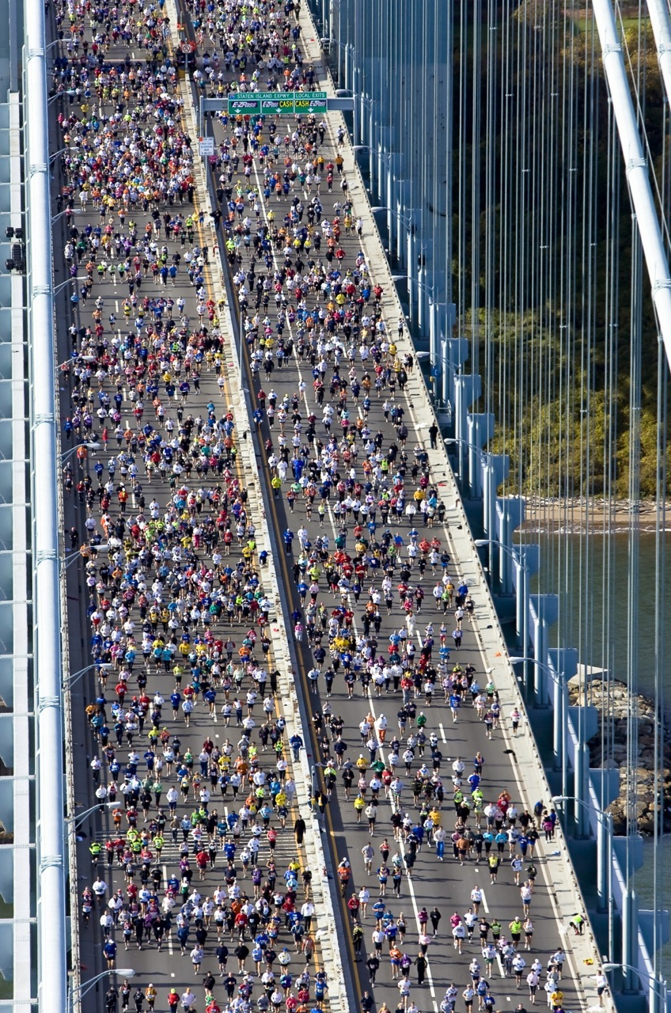  Thanks to Fergal Carr  Shared under the cc-by-2.0 licence

