Bicycle Insurance – teacher guide
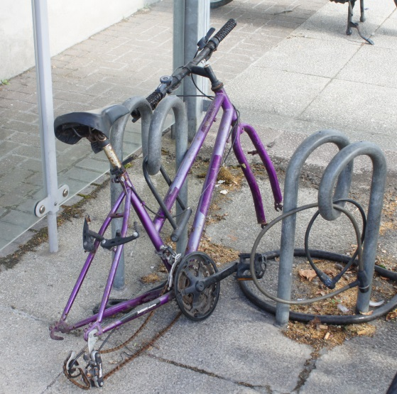
Abstract: The task is to create an instruction for an insurance company on how to calculate a “fair” insurance for a bicycle and a “fair” compensation for a stolen bicycle.
Discipline: mathematics
Age group: 12-16 years
Time: two lessons of 50 minutes each

Preparation: Copies of student worksheet (optional)
Additional material (optional)
Example of lesson plan:
Lesson 1:
5 min Organize your class in small working groups (3-4 students) and introduce the problem. Allow the students some quiet minutes to think about factors that are important to consider with regard to the amount of insurance payment, and factors that can/should affect the level of compensation.
10 min Bring the students ideas up front in a five to ten minutes whole class discussion.
Questions to consider:
- What will it take for the insurance company to make money?
- How much are people willing to pay for a bicycle insurance?
- How often is a bicycle stolen?
- Should all bicycle owners pay the same insurance?
- Should all bicycle owners get the same compensation if their bicycle is stolen?
5 min Use some minutes to clarify/discuss the outcome of the project (the written document). Who should be able to read it? How detailed should it be? How can you convince the insurance company that your advices are good? Can/should the document include graphs, tables, statistics, formulas, text?
25 min Let the students work in groups of 2-4 (handout available, but not necessary). Walk around and discuss with the groups. Bring in elements for them to consider.
5 min Brief discussion of student’s ideas, questions and challenges so far.

Lesson 2:
35 min Students finish their bicycle insurance advises.
15 min Present (all or a few) examples and discuss and compare results.

Teaching notes:
Additional material can be provided, or the students can be encourages to search for information when they feel the need.
Information that can be provided (real or artificial)
- Some statistic of bicycle thefts in the area
- Pricelist for new bicycles

Possible outcomes from the students:
- The insurance payment and the compensation should depend on the value of the bike.
- The value of the bike is dependent of the price and the age
- Different kinds of discrete payment and compensation functions, in form of tables
- Different kinds of continuous payment and compensation functions, of one or more variables (i.e. payment or compensation= (a factor) times (value of bicycle as new) divided by (age of bicycle)).

