Bicycle Insurance
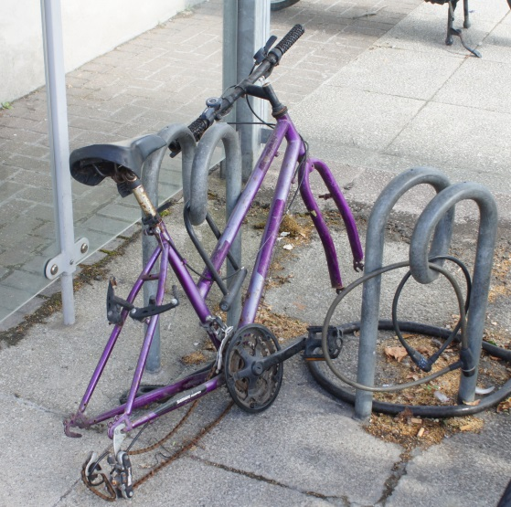
Every now and then a bicycle is stolen. Therefore, it can be convenient to have bicycle insurance. Some friends of yours want to start a small bicycle insurance company, and they come to you for some advices regarding the following issues:
- What can be a convenient (and fair) way to calculate the yearly payment for bicycle insurance?
- What can be a convenient (and fair) way to calculate the compensation for a stolen bicycle?

Your friends assume that the company will have approximately 1000 customers.

Your advices should come in form of a document where you explain the calculations that need to be done, and where you also explain how you came to make these decisions.

