Design your own non-standard bookshelf: Guidelines for teachers
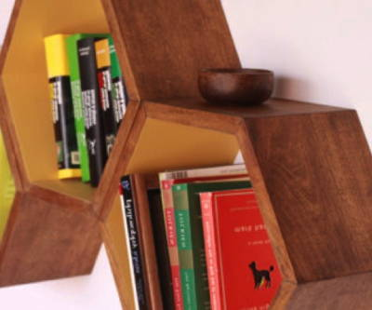
Abstract
The students design a non-rectangular bookshelf for a wall. The design must be feasible with the available tools/possibilities and must contain a detailed plan for realizing the bookshelf. In a less open formulation the bookshelf has to possess several properties: have regular polygonal cells, modular construction, etc.
Discipline: mathematics
Age group: 11-18 years
Time: 100 minutes

Preparation:
- Make copies of the student worksheets
- Materials: paper, scissors, rulers, pairs of compasses
- Optional: computers to investigate regular polygonal shapes

Extra information
The task focuses on two particular aspects in the interior design of a room (home or office), the design itself and the manufacturing part as well, so it is a challenging experience to connect the theoretical design with the technical part. Provides a lot of opportunity to organize how the teacher works with the students (they can design a bookshelf for their classroom, for their home, they can work in pairs to make a design for each other).
it is a great opportunity to focus on how practical demands (like modular construction, reduced number of cuttings, etc.) influence the design, beyond the geometry of the design.

Experiences
A seven minutes video with a classroom experience

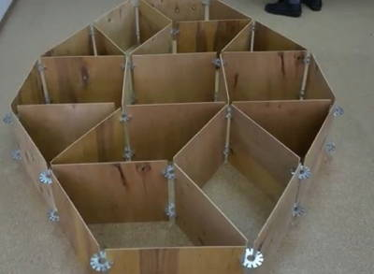

End product: a real bookshelf design, or a bookshelf

Example lesson plan:

First decide whether the given task is to design a non-standard bookshelf that completely
covers a wall of 4m x 2,5m, has a modular construction and is formed by cells having regular polygonal shapes, or that you just ask the student to design a non-rectangular bookshelf.

5 min Organize your class in small working groups (2-3 students) and introduce the problem and the workplace: an interior designer or carpenter. and explain what is expected as a product.
45 min (worksheet) Students start to plan their task. You may decide after some time, to have a brief moment to check and share their ideas. Then the students can continue working.
10 min Present (all or a few) examples and discuss results.
Possible solutions can be related to plane tiling with regular polygons, but the wow aspect is crucial because students must deal with the physical dimensions of the objects (for a mathematical background see http://en.wikipedia.org/wiki/Tiling_by_regular_polygons or Chavey, D. (1989). "Tilings by Regular Polygons—II: A Catalog of Tilings". Computers & Mathematics with Applications 17: 147–165. doi:10.1016/0898-1221(89)90156- 9. ).

