Design your own non-standard bookshelf
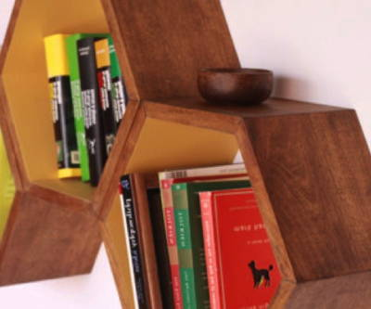

There are two options for the design. Your teacher will let you know which task will be yours.

- Non-standard polygonal bookshelf
Your task is to design your own non-rectangular bookshelf that completely covers a wall of
4m x 2,5m, has a modular construction and is formed by cells having regular polygonal cells.
The design must be feasible with your available tools/possibilities and must contain a detailed plan for realizing the bookshelf.
- Non- rectangular bookshelf
Any design of a non-rectangular bookshelf is allowed. The design must be feasible with your available tools/possibilities and must contain a detailed plan for realizing the bookshelf.

End product: a real bookshelf design, or a bookshelf

