Let us make snowflakes – teacher guide

Planning

10 min Have students work on problems 1 and 2. Then have a whole class discussion about their results.

10 min Students look on the internet for images of snowflakes (Google images snowflakes) and work on problems 3 and 4.
When students have no internet access, you may want to copy and print page 2 of this teacher guide.

20 min Students work on problem 5 and 6 (Students can make a New Year card, poster or a decoration using their designs).

5 min Students share their work in class.

15 min Choose which of the last three problems you would like to assign.
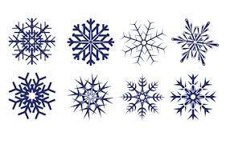
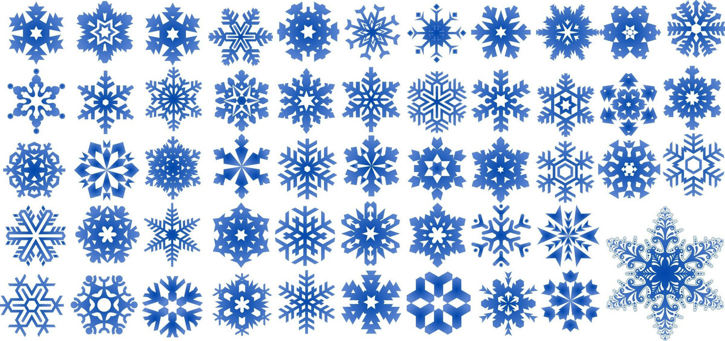
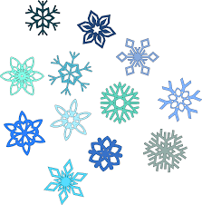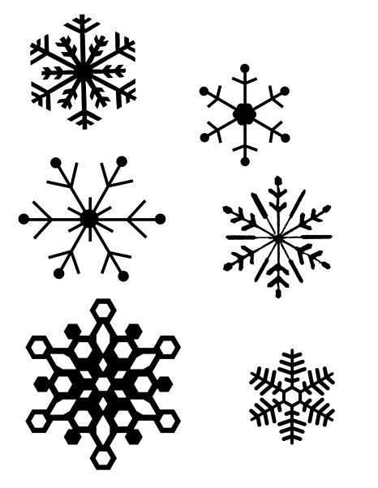

A real snowflake chrystal:

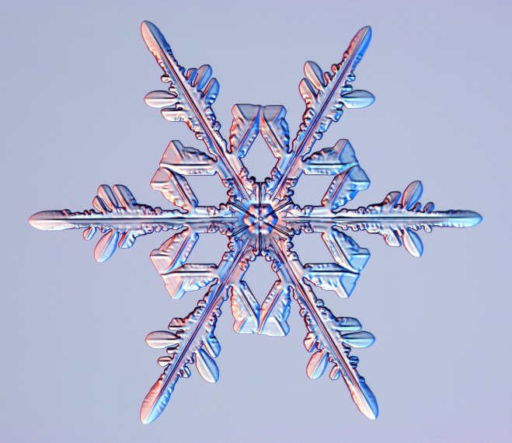
source: http://scijinks.jpl.nasa.gov/snowflakes

