Student task: Purifying a brine

Your task is to purify a sample brine and obtain the pure substance sodium chloride. You only know that the brine is a mixture of sodium chloride, sand and stones in water.
In your group you have to develop an experiment to purify the brine. You will get a sample of the brine and a selection of equipment that you may use to conduct your experiment.

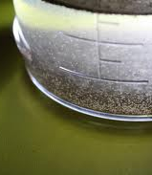

Wear your eye protection!
For your experiment, you are allowed to use the following equipment:

- Beakers
- Erlenmeyer flask
- Bunsen burner
- tripod
- wire gauze
- funnel
- filter paper
- …

If you think a different device would be useful, discuss your idea with the teacher!
Follow-up questions:

- Explain the processes involved in the steps of your experiment on the molecular level.
- Explain how you would separate the substances if different ionic compounds were involved.

