CHOCOLATE CHIP MINING
http://www.fisme.science.uu.nl/toepassingen/22016

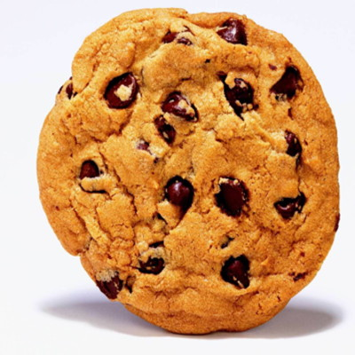

Try to get 'mineral' from a 'rock' sample.

Research
You are a mining engineer working at a mining company. You work in the laboratory which investigates methods for getting useful minerals from rocks. You have just been sent a sample of rock which seems to have small pieces of a valuable mineral mixed up with unwanted waste material. The mineral is dark brown.

- Find a method for separating the valuable mineral from the rock sample.
- Measure the amount of mineral and the amount of waste. Compare your results with those obtained by other working groups. Does the amount of the valuable mineral seem to be about the same in each rock sample?
- Compare the volume of waste rock with the volume of your original sample. Is it likely to be possible to put the waste back into the hole made during mining?
- If a second rock sample is available, try to see if you can extract the mineral more efficiently.

Product
Write a report for the directors of your company.

Source
Mathematics and Science for Life

www.mascil-project.eu

SATIS , Science and Technology in Society (UK) (1984). Task 1001, only part 1.

