Pottery: Helping the archAeologists
Science and mathematics play an important role in restoring ancient artefacts – e.g. in gluing broken pieces of a ceramic plate together, and filling in the gaps. Here you will enter the role of archeologists and explore various tools for creating a model of a broken plate and suggest ways of restoring the original.

- The challenge
A part of a broken ceramic plate, depicted in Fig. 1, has been found in archeological excavation:
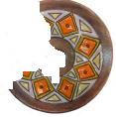
Fig1.
- Warming up
To restore the shape of the plate try to find a pattern which would be helpful:
- AB is a chord of a circle with a center O and radius OC (Fig. 2). The line OM is a perpendicular bisector of AB. Observe what happens when you move the points A and B.
- Formulate your conjecture.
- Change the circle by moving the points O and/or C and verify your conjecture.
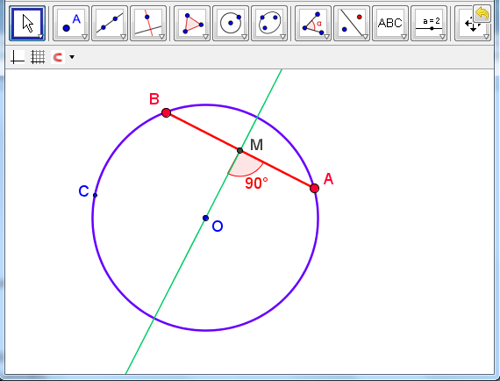
Fig 2. http://www.math.bas.bg/omi/cabinet/content/bg/html/d22100.html
http://www.math.bas.bg/omi/cabinet/content/bg/ggb/d22100.ggb

- If your conjecture seems to be correct, try to prove it.
- After proving it you could use it to restore the plate.
- Then download the dynamic file at http://www.math.bas.bg/omi/cabinet/content/bg/html/d22101.html
http://www.math.bas.bg/omi/cabinet/content/bg/ggb/d22101.ggb

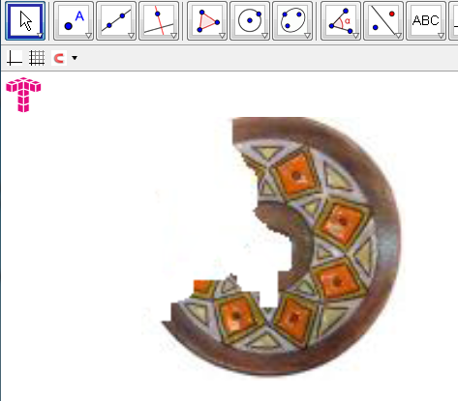
Fig 3.

- Compare your solutions with the solution given there by means of the button for the consecutive steps (Fig. 4).

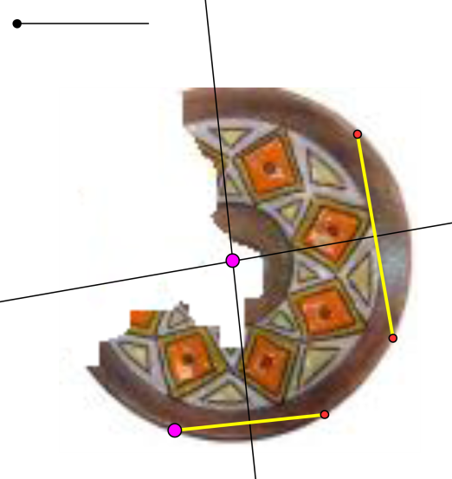

Fig 4. http://www.math.bas.bg/omi/cabinet/content/bg/html/d22102.html
http://www.math.bas.bg/omi/cabinet/content/bg/ggb/d22102.ggb

- Becoming professionals
Restore the shape of other broken plates by a single part using the dynamic file.

- Raising the bar
Make a plan how to restore the decoration of the plate. Discover some patterns. (You could use various IT tools).
Hint: Here are some ideas if we could justify that the craftsmen have used symmetry (rotational symmetry):

- Working with GeoGebra
- Insert a picture of the object twice in the Geogebra file.
  - Construct its reflection across an axis
    - Explore and find an appropriate axis;
    - Use the Geogebra button for a reflection across an axis.
  - Reduce the transparency of the two pictures;
  - If necessary move the points A and B, so as to impose the pictures in a way that could give you an idea about the original.
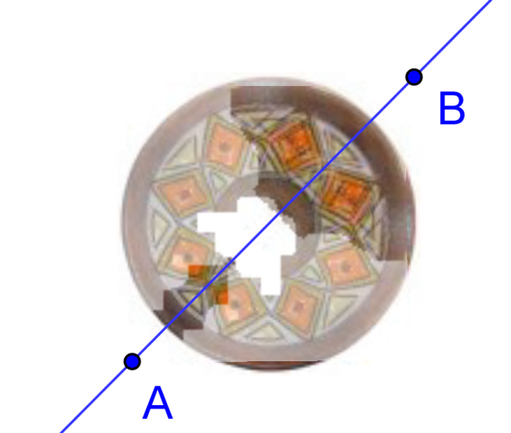
Fig 5. http://www.math.bas.bg/omi/cabinet/content/bg/html/d22103.html
http://www.math.bas.bg/omi/cabinet/content/bg/ggb/d22103.ggb

Alternatively you could use a rotation:
  - Construct the image of the object under rotation (by means of the corresponding button in Geogebra). For the purpose:
    - Think which point to use a center of rotation;
    - Explore and figure out at what angle to rotate the picture.
  - Reduce the transparency of the two pictures;
  - Decide if it is sufficient to use one rotated image or more images under rotation with appropriate angles to complete the decoration.
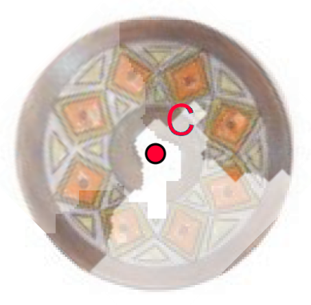
Fig 6.

It is worth mentioning that in some cases more than one copies of the picture are needed which should undergo specific congruencies or compositions of congruencies.

We illustrate the content of the file on Fig. 7 containing a slider k for k-folded symmetry of an object. You could use it as a tool – to insert pictures and observe the effect.

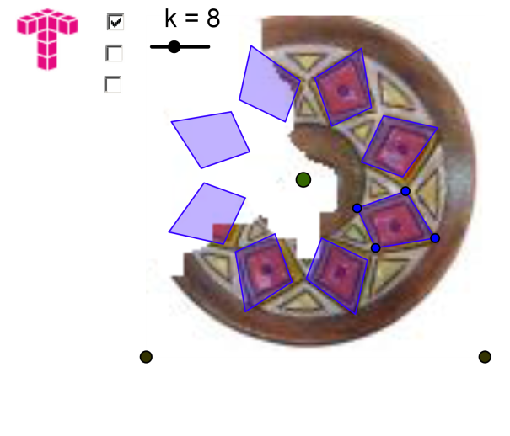
Fig 7. http://www.math.bas.bg/omi/cabinet/content/bg/html/d22104.html
http://www.math.bas.bg/omi/cabinet/content/bg/ggb/d22104.ggb

- Working with a graphic editor (e.g. Paint)
In Fig. 8 you see:
- The image of the broken plate
- A piece of it which is cut out
- The piece being copied, rotated and then brought close enough to get a a possible restored model
- The piece being copied, reflected and then brought close enough to get a possible restored model
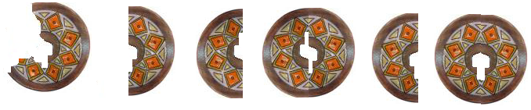
Fig 8.

Now you know what to do if you find just a piece of a plate you have broken But wait, there are other pieces of knowledge you need to make the real restoration.

Task. Prepare a working plan for restoring 2D artefacts based on rotational symmetry.
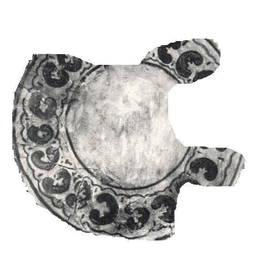
Fig 9.

Chehlarova, T., E. Sendova. Stimulating different intelligences in a congruence context. In: Constructionist approaches to creative learning, thinking and education: Lessons for the 21st century. Proceedings for Constructionism 2010. The 12th EuroLogo conference. 16-20 August, Paris, France. 2010. ISBN 978-80-89186-65-5 (Proc) ISBN 978-80-89186-66-2 (CD)

Remarks:
- In order to work with the dynamic files you need java.
- You could download the above dynamic files as GG files at
http://www.math.bas.bg/omi/cabinet/index.php?lang=en.

- To use them you should have Geogebra installed, e.g. from the address
http://www.geogebra.org/cms/bg/

