# Pottery: Guidelines for teachers

**Abstract**

Science and mathematics play an important role in archeology, for example in restoring ancient artefacts – e.g. in glueing broken pieces of a ceramic plate together, and filling in the gaps with pieces of appropriate form , ensuring that the pattern is restored as well. In this task students explore various geometry-tools for creating a model of a broken plate and they suggest ways of restoring the original.

**Preparation:**

* Make copies of the student worksheets 1, and worksheet 2
* Have Geogebra and/or Paint available on the computers

**Example lesson plan**:

*Lesson 1*

10 min Students are introduced to the workplace of an archeologist where broken pottery is restored. This can be done by showing a video or pictures of this process. These can be found on the internet (YouTube).

15 min **1.** **The challenge:** Hand out worksheet 1 and ask the studentswhat aspects need to be taken into account when restoring this plate by designing the missing fragments. Students discuss and work out their ideas in pairs. Then they share their ideas with another pair of students.  
Then have a class discussion of their ideas and the aspects, focusing on the mathematics (An important insight is that in order to construct the missing parts, you need to find out where the center of the plate is.)

30 min Hand out worksheet 2 (or 3) and have students work on the introductory problems using Geogebra (or Paint)

5 min Discussion of results and questions so far

*Lesson 2*

35 min **Becoming professionals and raising the bar**Students work on the task to prepare a plan for the restoration of the plate in figure 9.

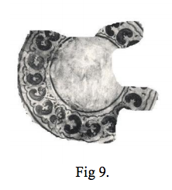

15 min Present and discuss results.

***Working with GeoGebra***

* Insert a picture of the object in the Geogebra file.  
   a. One possible approach is: Construct its **reflection** across an axis
* Explore and find an appropriate axis;
* Use the Geogebra button for a reflection across an axis.

b. Reduce the transparency of one of the two pictures;

c. If necessary move the points A and B, so as to impose the pictures in a way that could give you an idea about the original.

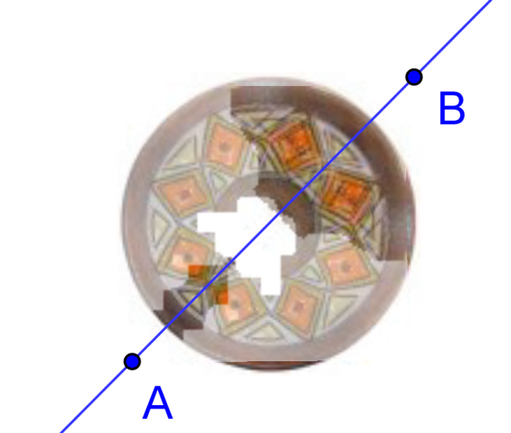

Fig 5. <http://www.math.bas.bg/omi/cabinet/content/bg/html/d22103.html>

<http://www.math.bas.bg/omi/cabinet/content/bg/ggb/d22103.ggb>

* Alternatively you could use a **rotation**.

d. Construct the image of the object under rotation (by means of the corresponding button in Geogebra).   
 - Think which point to use a center of rotation;

- Explore and figure out at what angle to rotate the picture.

e. Reduce the transparency of the two pictures;

f. Decide if it is sufficient to use one rotated image or more images under rotation with appropriate angles to complete the decoration.

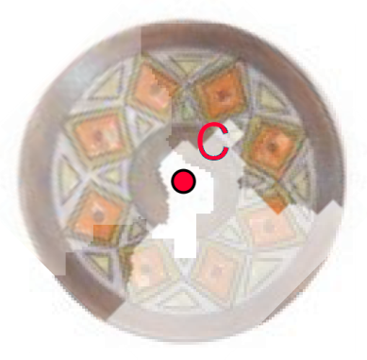

It is worth mentioning that in some cases more than one copies of the picture are needed which should undergo specific congruencies or compositions of congruencies.

***Working with a graphic editor (e.g. Paint)***

Using Paint, the angle of rotation only can be multiples of 90°.

**

In Fig. 8 below you see:

* The image of the broken plate
* A piece of it which is cut out
* The piece being copied, rotated and then brought close enough to get a a possible restored model
* The piece being copied, reflected and then brought close enough to get a possible restored model

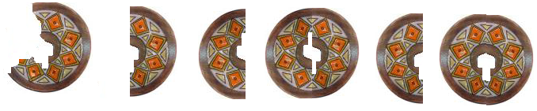

Fig 8.

Now you know what to do if you find just a piece of a plate you have broken ☺

But wait, there are other pieces of knowledge you need to make the real restoration.

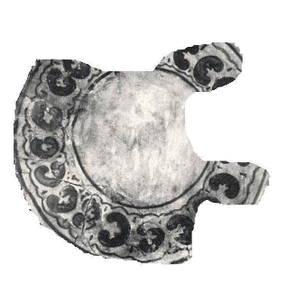**Task.** Prepare a working plan for restoring 2D artefacts based on rotational symmetry.

Fig 9.

## References

Chehlarova, T., E. Sendova. Stimulating different intelligences in a congruence context. In: Constructionist approaches to creative learning, thinking and education: Lessons for the 21st century. Proceedings for Constructionism 2010. The 12th EuroLogo conference. 16-20 August, Paris, France. 2010. ISBN 978-80-89186-65-5 (Proc) ISBN 978-80-89186-66-2 (CD). <http://www.fisme.science.uu.nl/publicaties/literatuur/2010_chehlarova_sendova_constr.pdf>