## ALYMPIAD FINALS 2005 ASSIGNMENT

### Garderen, April 18th and 19th 2005

English

# GUIDE LINES FINAL MATH A-LYMPIADE 2005

**BEFORE YOU START:**

* Read the whole text carefully before you start dividing tasks!
* This assignment consists of four sub assignments.   
  assignment 1 : making the bus network;  
  assignment 2 : designing a timetable;  
  assignment 3 : designing a quality index   
  assignment 4 : testing the network
* Keep assignment 3 in mind, the quality index, while working on the first assignments.

**PRODUCTS:**

# Hand in

A complete report in which you present your plan to the city council, including underpinnings, criteria, argumentation and calculations. The results of the sub assignments need to be integrated in this report.

# Presenting on saturday afternoon

* a poster with the network you designed in sub assignment 1
* the travelling times of sub assignment 4 (you can off course only calculate these in the last 2 hours, after you obtained the additional data from your teacher).

**PLANNING:**

* Try to *finish* the first two assignments in the first 5 hours and elaborate assignment 3 as far as possible.
* The final report is written as an advice to the city council, don’t postpone the start of writing this to the very end...

INTRODUCTION

Amberhavn[1] is a typical European medium-sized old city; an authentic old city centre built around the cathedral, surrounded by more modern districts.

One of the most frequent visited sites is the ‘Old town’ with its beautiful stone wooden houses on the waterfront. This part of amberhavn attracts many tourists who visit amberhavn for a day or two. Amberhavn is surrounded by rivers and canals. Across the water there are four suburbs: Flamburg, Eigenhem, Elave and Fiville.

Amberhavn is one of the oldest university towns in Europe. Part of the university buildings are located in the old town. There is also a large university complex in the south-east of the city. This is where the majority of students follow their lectures. The teaching hospital has an important regional function.

For most Europeans Amberhavn is known as the home town of the European Broadcasting Company. This broadcasting company and its adjacent organisations are housed in a futuric villages of buildings in the north east part of the town. From the moment the broadcasting company chose Amberhavn as its hometown there are many new inhabitants. Many of them settled down in the booming suburb fiville.

In short, Amberhavn is a vibrant city.

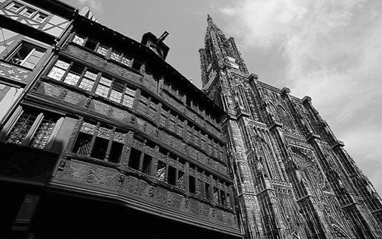 *Amberhavn Cathedral*

*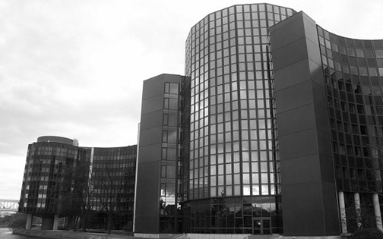 Teaching Hospital*

*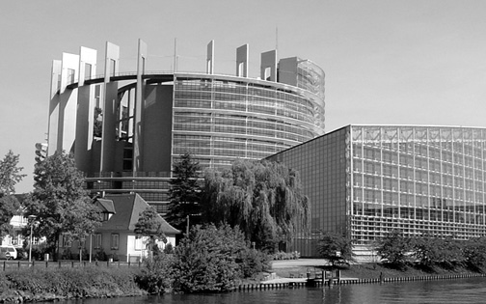 European Broadcasting Company*

As a result of Amberhavn’s vibrancy and growth, it turns out the public transport in the city is no longer functioning optimally.

Amberhavn has one bus company, ABC: the Amberhavn Bus Company. As a result of continuous small changes to the bus routes, the bus services and the time table, over time the local bus network has become so chaotic that hardly anybody can understand it anymore.

The inhabitants of Amberhavn are complaining that the system is only aimed at getting tourists to their destination as soon as possible, outside visitors are complaining that public transport in Amberhavn is so complicated that it’s better to take their own car; which in turn results in complaints from the locals, etc. etc.

Or in other words: Amberhavn 2005 is ready for a completely new bus network.

The Amberhavn city council wants to set up and organise public transport in such a way that both the locals, the people who have to be in Amberhavn for work, study, health, shopping etc. and the tourists are satisfied.

### ASSIGNMENT

Your team is going to create, by order of the local council, a plan for this new bus network. The other teams will also be working on this, and are of course your competitors!

You will also test your own plan, and you have to develop a measure to judge the quality of the plans and to compare them.

You will do this through four sub-assignments.

You will find in attachment several street maps of Amberhavn. All sites of significance are pointed out on this map. The A3 maps can be used as worksheets.

The city council has held a preliminary investigation into the flow of traffic in Amberhavn. Of course there are still many people coming to Amberhavn by car – the following data are relevant for public transport::

* Amberhavn has 60 000 inhabitants.
* The inhabitants of Amberhavn should all be within 10 minutes walking distance from a bus stop.
* Elave, Eigenhem, Fiville and Flamburg have their own bus companies. Of course you can reach these suburbs by bus out of Amberhavn.
* All tourist sights must have a bus stop.
* On weekdays about 2000 people from Fiville and another 2000 from elsewhere outside Amberhavn travel to the European agency by bus.
* On weekdays about 5000 students travel to Amberhavn by train
* There is a constant daily flow of about 2000 people from the city, the suburbs and outside to the teaching hospital by bus.
* On average around 3000 tourists visit the city each day, using public transport.

You have no doubt seen them before, schematic drawings of bus or metro routes in a city. They let you work out quickly which bus you need to get. Here you see an example.

*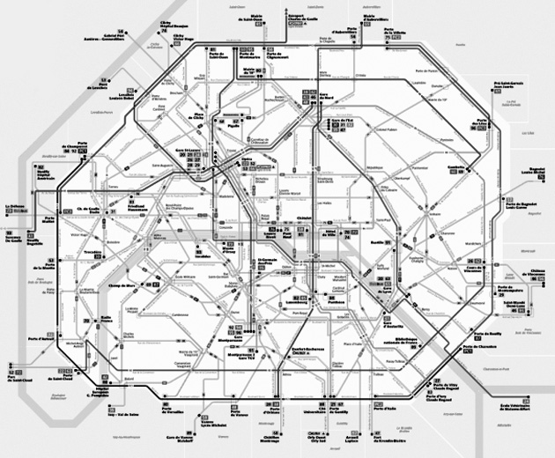 Schematic drawing*

***Assignment 1 The bus network***

*Design a bus network scheme for Amberhavn. The scheme must contain all routes and all stops on those routes.*

*Read all the other three assignments first so you can take them into account while working on the first one. Specially the quality index!*

*For this assignment you can use the A3 street maps of amberhavn.*

*Of course your network must meet all the requirements of the preliminary investigation. Data that are not mentioned have to be assumed. Choices have to be made.*

*These assumptions and choices have to be elaborated in a report about the network.*

*You will present your bus network scheme on Saturday on a poster with a brief motivation.*

A bus network scheme is the first step in designing a complete city bus system. Timetables are also necessary. Many cities have a brochure with the timetable for every route.

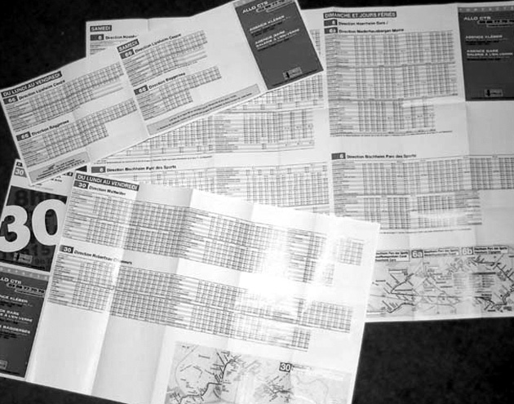

*Bus timetable brochures*

***Assignment 2 The timetable***

*Make a timetable to go with your bus network scheme.*

*The timetable must contain every bus movement in some way. Think of your own way to represent the timetable as compact and clearly as possible. Here, too, you will have to use some assumptions. (Remember the quality index!) Include these in your report as well.*

It’s important for the city council to be able to judge the different proposals on quality. It would be convenient if this could be done quickly, based on a numerical criterion, a so-called ‘quality index’.

How would you measure the quality of the different proposals? Which factors play a part? And how do you weigh them?

***Assignment 3***

*Design your own index as a gauge for the quality of the proposed new networks of bus lines you have designed. Substantiate your choices!*

*Next calculate the value of that index for your own plan. You may use the results of sub-assignment 4 if needed.*

The Amberhavn city council wants to set up and organise public transport in such a way that both the locals, the people who have to be in Amberhavn for work, study, health, shopping etc. and the tourists are satisfied. One of the things that play a part here is *travelling time*.

This is an aspect of the quality of your bus network that we can ‘test’.

On **Saturday morning** you will get from the Alympiade organisation a ‘profile’ of a journey for eight different travellers. The profile will contain information about point of departure, destination, time and optional extra details.

***Assignment 4 The travelling time***

*Determine for each of these 8 travellers the journey time. The sum of all the journey times*

*will be included on the poster you will present on Saturday.*

*You will also include them in your report, including of course the calculations and their foundation, and you will indicate how well you think your proposal performs on the aspect ‘journey times’.*

1. The city of Amberhavn has been made up for this finals assignment.