The module has been developed within the framework of the doctoral research of Adri Dierdorp under the guidance of

soldr. A. Bakker

Prof. dr. J.A. van Maanen

Prof. dr. H.M.C. Eijkelhof

Freudenthal Institute for Science and Mathematics Education, Utrecht University.

The copyright of this module belongs to the Freudenthal Institute for Science and Mathematics education. The materials in this module may be used for educational purposes.  
It is not allowed to use this material for commercial purposes. In developing the module the authors have used material made by third parties. In those cases the authors have mentioned the sources as much as possible.

In retrieving and complying with the rights of texts, illustrations, etc., we have tried to be as accurate as possible. If in spite of this people or authorities think they can assert their rights to parts of the text or illustrations in a module, let them please contact Adri Dierdorp.

**Table of contents**

Part 1. The sports physiologist and statistics

* 1. Measuring a client’s condition
  2. Scatter plots

Part 2. The role of statistics in improving one's condition

* 1. Heart rate and condition
  2. Threshold point
  3. General equations and variation

At school, but certainly in most university studies, you regularly have to do a survey or study. It will often be useful if you can show a relation between two properties (variables). In this module you will learn how to do this and how to represent such a relation mathematically and calculate how strong a correlation is. In many professions people perform statistical tasks that use the statistical techniques from this module to solve science problems. In this module we chose to look at three such professional situations. This module introduces you to statistical techniques that are sometimes used by sports physiologists in improving a client’s condition.

**Connection to school subjects**

What connection does this have what you have learned in school so far? This module is interdisciplinary in character. In this module we will use the theory you have learned in your mathematics, biology, geography and physics lessons, and expand on it.

# Part 1. The sports physiologist and statistics

## fysio3 copy1.1 Measuring a client’s condition

In this chapter you will learn a technique that is regularly used by sports physiologists in supporting clients to improve their condition. Statistics often plays an invisible role in such techniques. Sports physiologists, as well as sports instructors and physiotherapists, regularly make use of ready-made charts for their advice, which means that the statistical foundation is not immediately apparent to the client. The statistical component does become clear when a client wants individualised advice, since that requires more advanced statistical techniques.

In task, the heart rate is important. During physical activity your heartbeat increases. This happens less quickly in people who are fit than in people who are out of shape. In people who are fit the heart rate recovers faster after exertion. This chapter looks at the use of a statistical technique and knowledge about heart rate to be able to improve sportspeople’s physical condition.

Task 1.

Consider how a sports physiologist could support a client in improving his or her condition and why it can be useful to measure your heart rate for that.

|  |
| --- |
|  |

To be able to help someone to improve their condition, a sports physiologist must first know how good or bad that person’s physical condition is. Once he knows that, he can measure it again at the end of a training program and establish whether there has been an improvement.

Although nowadays much more advanced methods are available to sports physiologists, we will first look at a simple measuring test, since it is one we can perform in class ourselves. An experiment now follows to show how a sports physiologist can establish a client’s condition. For this measurement, researchers have developed predictive tests with the aid of statistics. The Ruffier-Dickson test is one such test, which uses heart rate measurement.

**Practicum A: Measuring condition**

Task 2a

Below are the instructions of the Ruffier-Dickson test. Read them first, answer a few question and then collect your date in Task 2.

Form a group of test subjects. You will measure the heart rate of each member of the group a number of times later on; instructions are given below. First read all the instructions!

Heart rate is measured at the wrist. Always use your middle finger (possibly together with your forefinger). The artery is on the side of the thumb. If you find it easier, you can also determine heart rate in a different spot, like for instance the carotid artery.

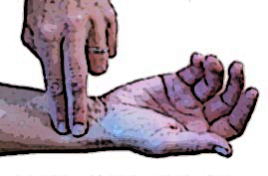

A sports physiologist, sports instructor or physiotherapist will normally use a measuring instrument to establish heart rate.   


Instructie Ruffier-Dickson-test

1. Let the test subject (client) sit quietly for about a minute before you start the measurement.
2. Determine the subject’s heart rate, which we will call resting heart rate *H1*. Let someone else in the group determine the value of *H1*, so the subject does not have to keep an eye on the time.
3. Next, the test subject will make thirty deep knee bends in 45 seconds, keeping the back straight and feet flat on the ground. Touch the ground with your fingertips each time.
4. Immediately after the knee bends, count the number of heartbeats in 15 seconds and convert it to heartbeats in one minute (*H2*).
5. One minute after measuring *H2,* count the number of heartbeats in 15 seconds again and convert it to heartbeats in one minute as well (*H3*).

Task 2b

Write down a number of points of interest that you should pay attention to as a sports physiologist when collecting data with this test.

|  |
| --- |
|  |

When a sports physiologist knows *H1, H2* and *H3* in beats per minute, he can make a prediction about your level of physical fitness.

Task 2c

How might a sports physiologist be able to use *H1*, *H2* and *H3* to predict your

level of physical fitness?

|  |
| --- |
|  |

Task 2d

If you were to repeat the Ruffier-Dickson test for each member of your group, would you expect to find the same values for H1, H2 and H3 each time? Explain your answer! Also indicate how a sports physiologist might deal with this.

|  |
| --- |
|  |

Task 2e

Perform the experiment for each member of your group and collect the data in the table in Appendix B. Complete the table with data from other students in your class.

When *H1, H2* and *H3* are expressed in beats per minute, sports physiologists may also use an equation to calculate an indication for a client’s physical condition, for example the Ruffier-Dickson index. This is often abbreviated as *I.R.D.*, and can be calculated as follows:



|  |  |
| --- | --- |
| ***I.R.D.* measurement** | **condition** |
| *I.R.D*.= 0 | excellent |
|  | very good |
|  | good |
|  | weak |
|  | bad |

Indicator for the level of fitness:

Task 2f

How much does this equation agree with what you wrote down in Task 2b?

Task 2g

Which datum is the most important in the index equation?

Is there something in the equation that makes this apparent?

Task 2h

Do the *I.R.D*.-values that have been measured agree with the sporting qualities of the test subjects? For example, do your fellow students who play a lot of sports have a low *I.R.D*.?

Task 2i

Do you expect a relation between *H1* and *H2* and if so, how will it look?

## 1.2 Scatter plots

To get more insight into a possible relation between *H1* and *H2*, we can use a graph. The graphs we use in statistics to prove this kind of relation are called scatter plots.

Task 2h

Make a graph of all data from all test subjects, setting *H1* on the horizontal axis and *H2* on the vertical axis. So, you draw the point (*H1, H2*) for every person.

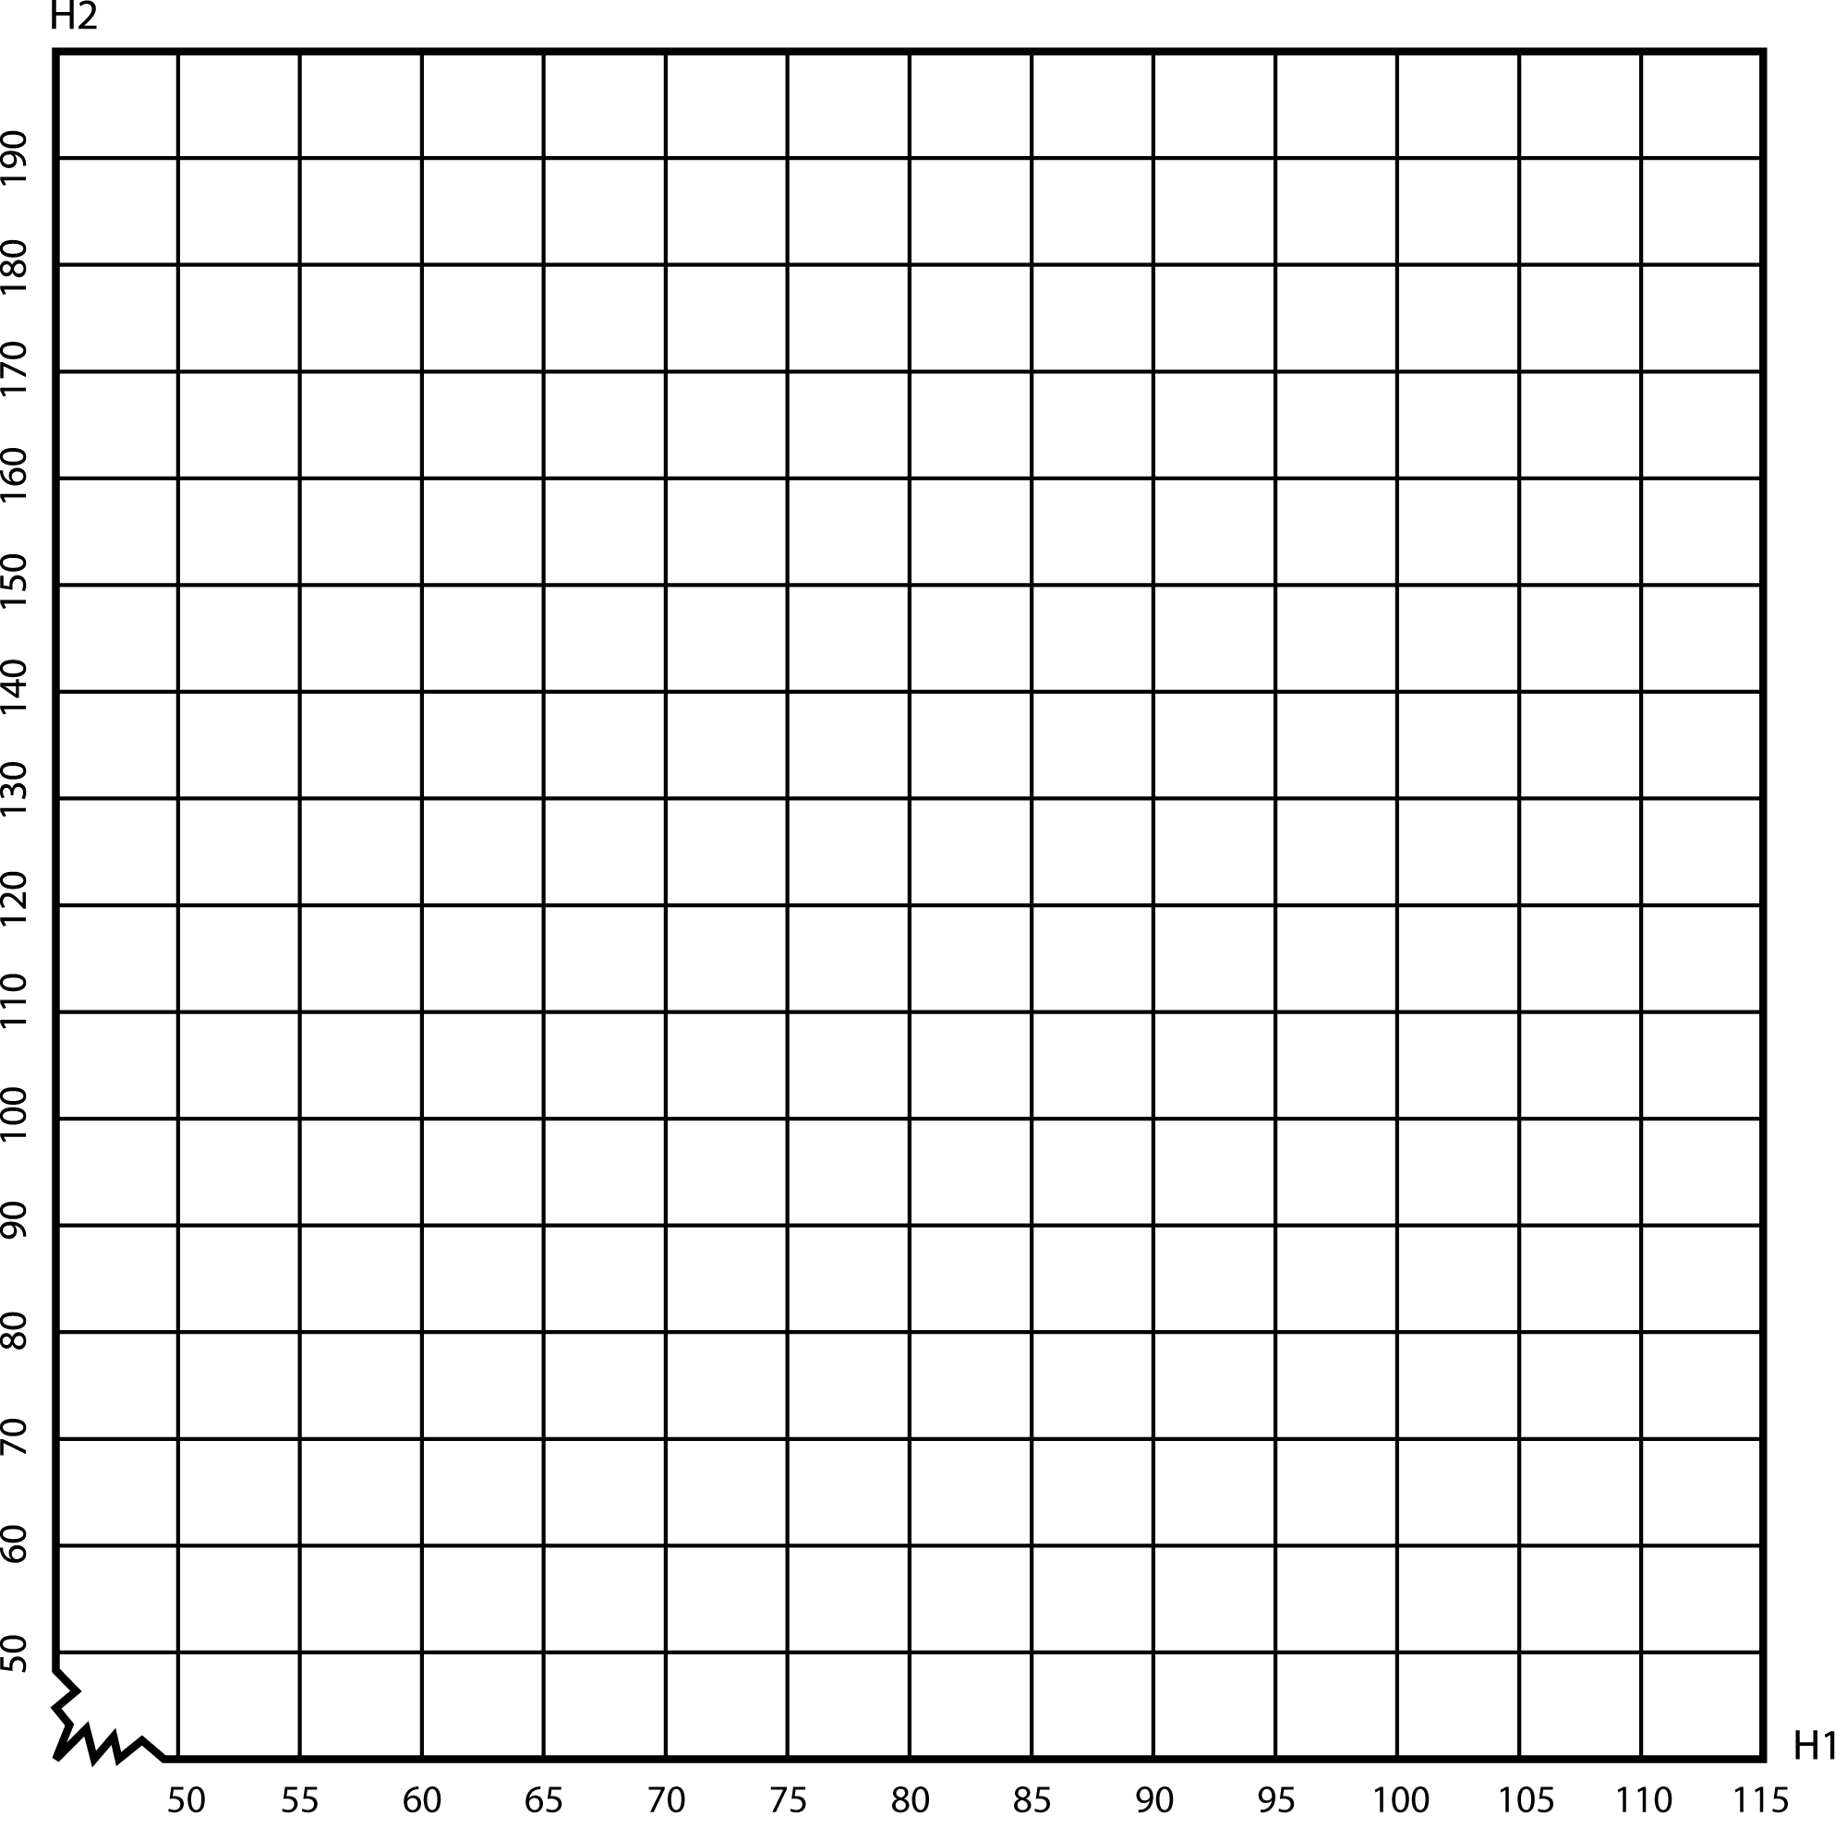

Can you see a relation in the graph between the resting heart rate (*H1*) and the active heart rate (*H2*)? If so, how would you describe this relation?

# Part 2. The role of statistics in improving one’s condition

## 2.1 Heart rate and condition

In determining a measure for condition, the sports physiologist is interested not just in the duration, but also in physical exertion. However, the level of exertion is harder to determine. It can be measured for instance with a heart rate monitor. It has been scientifically proven that at a higher level of exertion the heart rate will be higher also. You measured the heart rate by hand or with a simple meter in practicum A. The sports physiologist has access to much more advanced instruments such as an electrocardiogram or lung function machine.

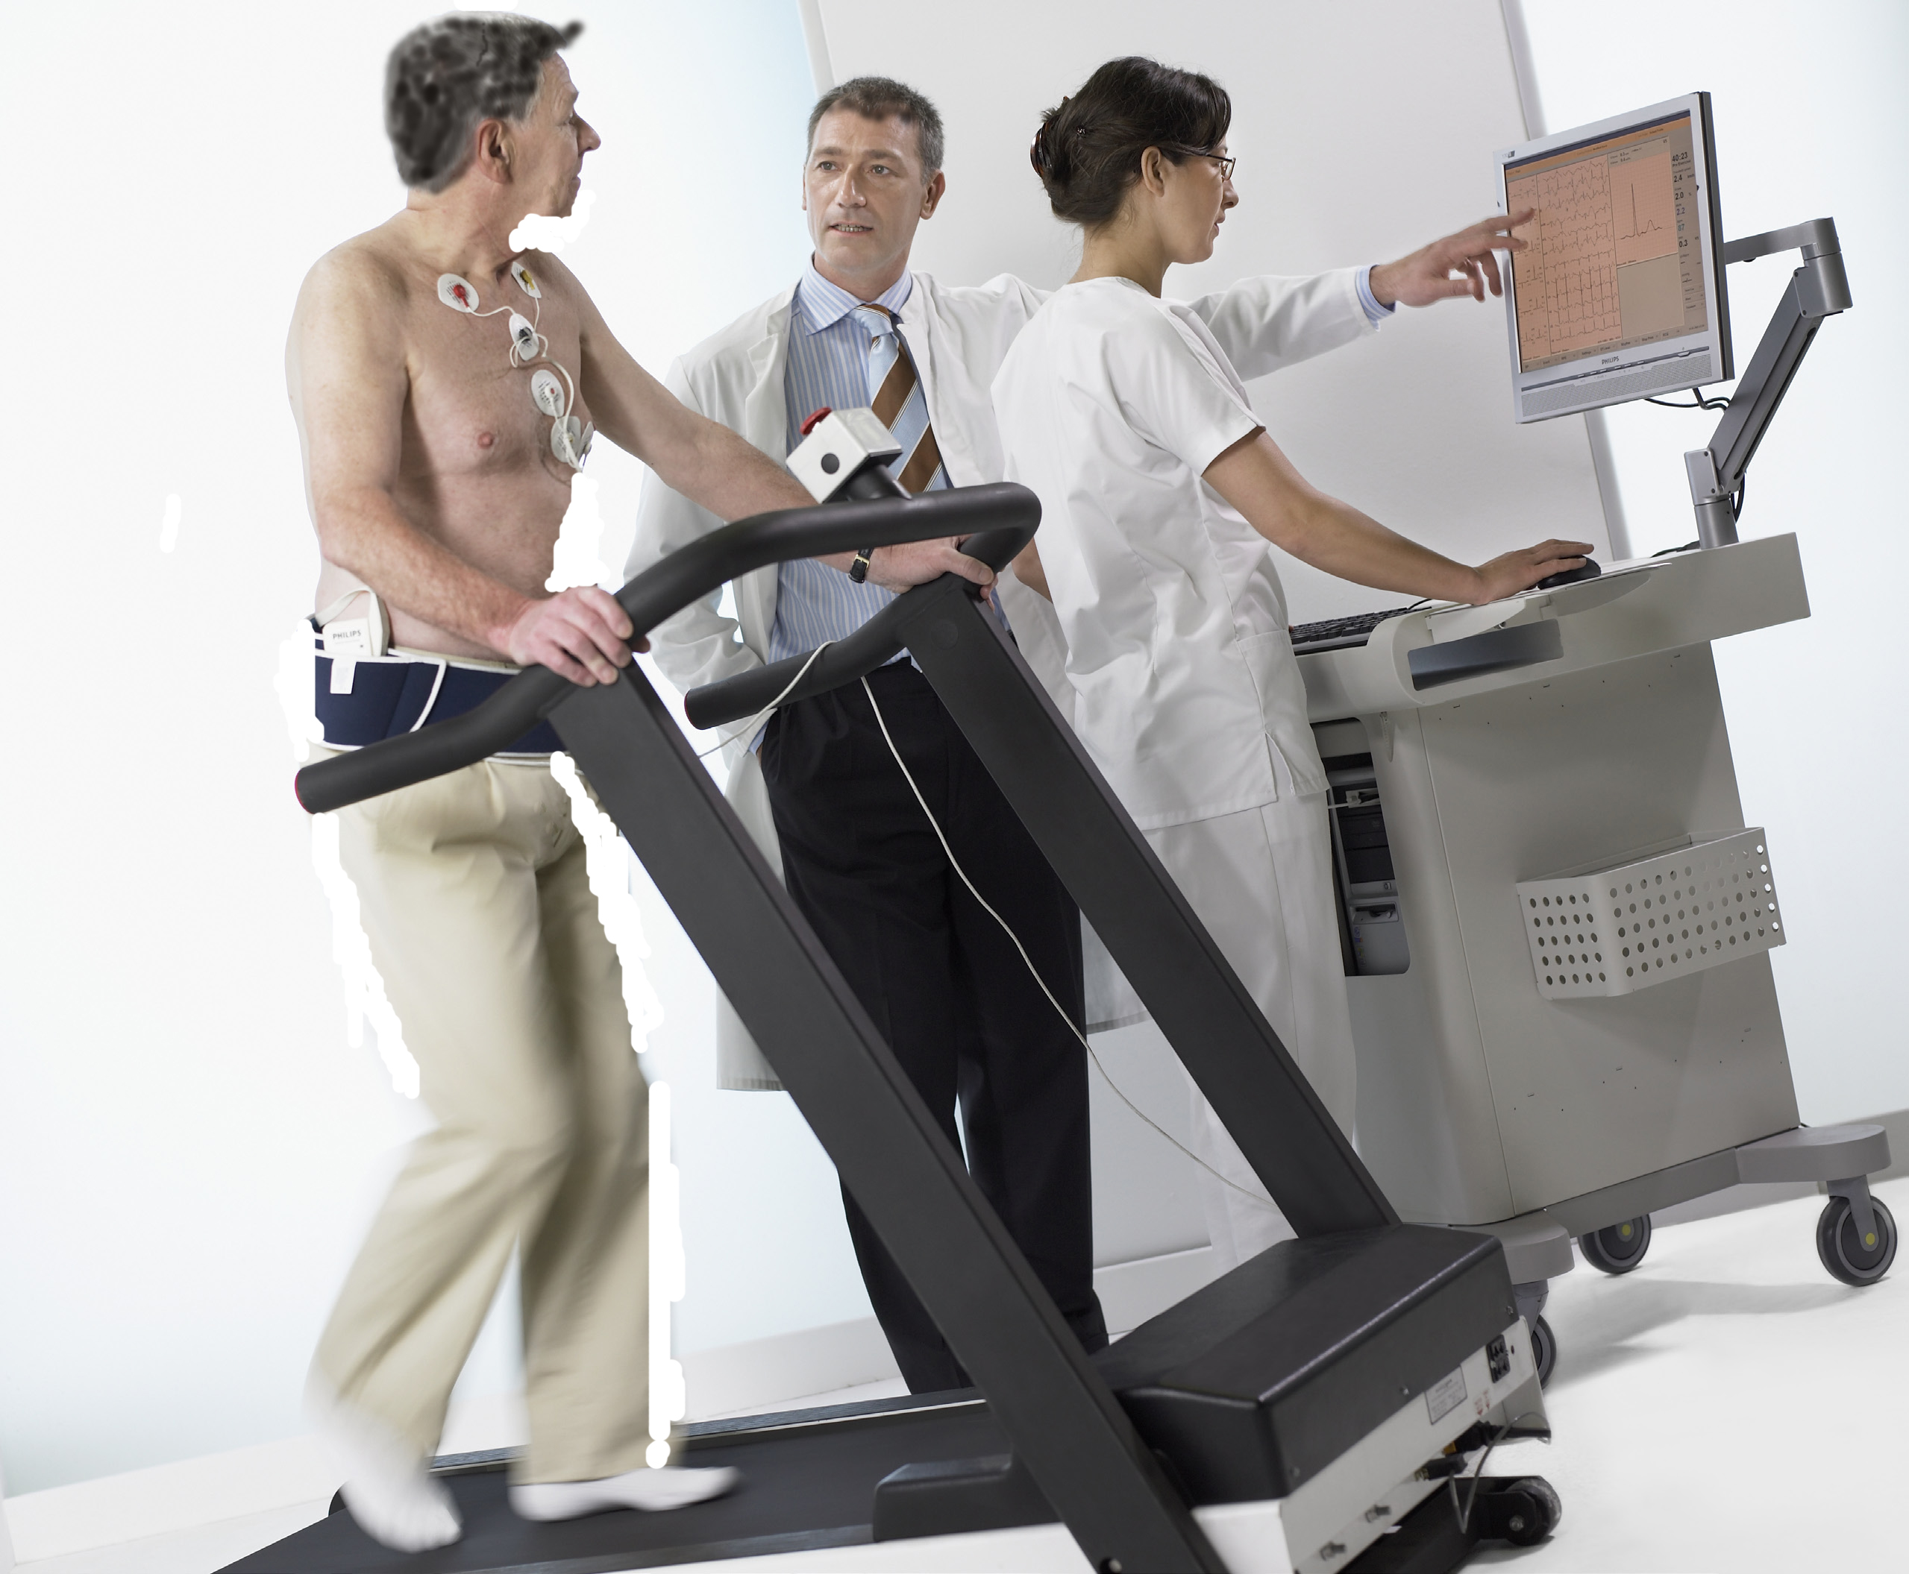

The level of physical exertion varies from low during sleep to a maximum during heavy physical Task. Different intensities during training will affect your condition differently. While playing sports your muscles produce waste products that are removed by the body. If more waste products are made than removed, your muscles will become more acidic, and you will suffer from cramp or stitches. This will happen later in someone with a relatively low heart rate than in someone with a relatively high heart rate. Training over a longer period can help to lower your heart rate slightly.

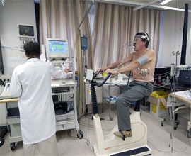

**Why does training result in a lower heart rate?**

Task makes the heart stronger, which means it can beat slower. A slower beating heart needs less energy to pump the same amount of blood per minute than a heart that beats faster. The **cardiac output** is the amount of blood that is pumped per minute. Generally a taller person will have a greater cardiac output than a smaller person, while people with a similar posture will have a similar cardiac output. The **resting heart rate** of a trained person will be lower the fitter they are. Therefore, the pulsatory volume (the amount of blood pumped per heartbeat) will have to increase to maintain the same cardiac output.

If you have a low resting heart rate through for instance endurance training, the heart will pump more blood per beat, i.e. the pulsatory volume is higher. As a result your heart rate will not have to go as high as in an untrained person for a given intensity of Task, so the result of endurance training is that you reach your maximum heart rate at a higher level of exertion.

At a given level of stress you can say that the lower the heart rate the higher the pulsatory volume and the fitter the person concerned. Therefore the resting heart rate can be used as a **general indication** for your condition.

**Resting heart rate**

During physical exertion, the nervous system and the hormonal glands that are close to the kidneys release a chemical message through adrenaline to regulate your **resting heart rate**.. Adrenaline stimulates the heart and raises the heart rate. So why does watching an exciting movie, which also releases adrenalin, not lead to an increase in physical fitness? The answer to that question is that during physical Task the raise in heart rate is directly related to an increased transport of oxygen to active muscles. The increase in oxygen use during exertion is related to a greater rate of oxygen absorption in the blood, i.e. the **aerobic** capacity. Despite the increase in heart rate during psychological stress, the increase in oxygen use is minimal, because the muscles do not use more oxygen during psychological stress than in rest.

**Cardiovascular training**

Cardiovascular training raises the sensitivity of the heart for signals from the parasympathetic nervous system, allowing the heart rate to drop even lower. Cardiovascular training is training in which you perform an activity that raises your heart rate, but in which you are still able to talk. So you are not supposed to be completely out of breath during your training. One thing cardiovascular training does is to strengthen your heart, which means it will not have to work as hard to provide oxygen-rich blood to your body. It lowers the risk of a heart attack, and lowers your blood pressure. It makes you feel better. It improves your sleep and lowers stress.

A fit athlete can have a resting heart rate (see the block of text above) between 30 and 50 beats per minute. Michael Boogerd (height 1,77 m, weight 63 kg), a professional cyclist had a resting heart rate of 33 at the age of 30.

Task 3a

Between what values were the resting heart rates of your fellow students (see Practicum A)? _____________

Task 3b

Why might it be relevant for a sports physiologist to know the data (measured data) of the whole group?

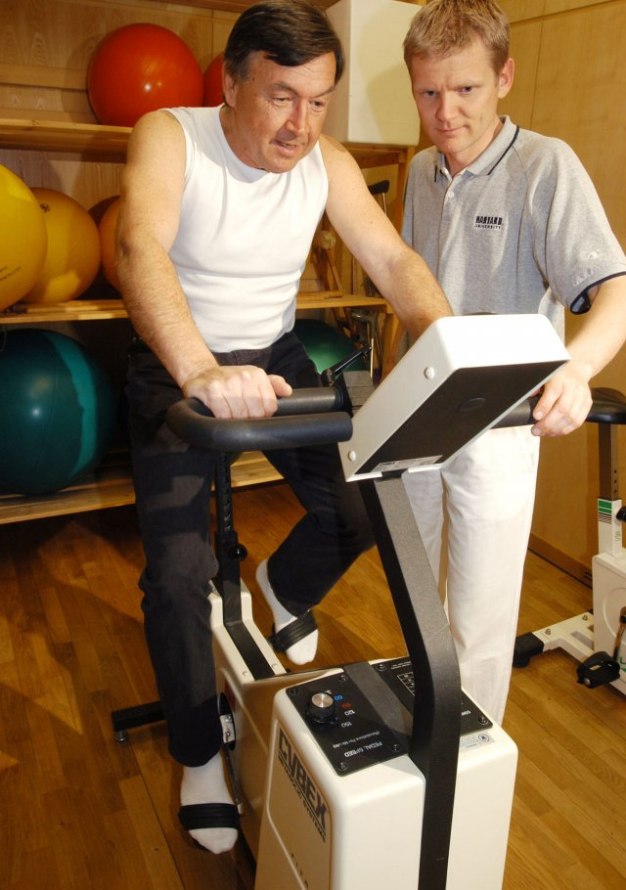If a sports physiologist guides a client’s training programme and for example takes weekly measurements of that person’s resting heart rate, then it will be an indication of an improvement in condition if that rate is lower. Older people also have a lower heart rate. Of course this does not mean older people have a better condition.

## 2.2 The threshold point

As you may have read above, measuring the heart rate is important in an intensive training programme. An important question is how high you can responsibly raise that rate.

To select a good training programme the sports physiologist, sport instructor or physiotherapist will first determine the maximum heart rate (MHR). The MHR is expressed in beats per minute, and is the highest number of times that the heart can contract (beat) per minute.

We call the heart rate where the production and removal of waste products in the muscles are only just still in balance the **threshold point**. The threshold point is the heart rate someone can maintain over a longer period of time without the muscles threshold acidic. In a test you can measure where the threshold point is, just like a sports physiologist. Exercising with a heart rate under the threshold point we call **aerobic** Task. If the heart rate is higher than the threshold point, we call it **anaerobic**.

You can improve someone’s condition by regularly having them practice in such a way that the heart rate stays within certain limits. These limits depends on the threshold point and the reason the client wants to improve their condition. For this purpose there are tables with so-called heart rate zones. These zones are necessary to set up a good training programme, because the effect of training depends on which zone the heart rate stays in. Top athletes may even profit from anaerobic Task.

Various different divisions of the heart rate zones exist. The one below is taken from the mini course heart rate zones by TACX, an organisation for sports cyclists. De percentages in the table concern the threshold point (the heart rate on the border between aerobic and anaerobic).

Table heart rate zones based on anaerobic threshold (threshold point).

|  |  |  |
| --- | --- | --- |
| **Heart rate zone** | Percentage of threshold point | Type of training |
| **1** | <73% | Recovery training |
| **2** | 73 – 86% | Gentle endurance training |
| **3** | 86 – 92% | Intermediate endurance training |
| **4** | 92 – 99% | Heavy endurance training |
| **5** | 1. – 102% | Extensive interval training |
| **6** | >102% | Intensive interval training |

Based on the goal, the sports physiologist will choose one of the heart rate zones for an Task programme.

Task 4

Suppose that someone with a threshold point of 156 wants to do heavy endurance training. The sports physiologist will choose based on this table and advised the client to keep his heart rate between two values.

Between which values should this client keep his heart rate during training to achieve an optimum result?

____________________________________________________________

## 2.3 General equations and variation

It is known that MHR is largely determined by genetic factors and age. Also it varies very little in one person. After twenty years of age, the MHR of people with a sedentary lifestyle will gradually decrease with about one beat per year. Generally, the MHR will not change much over the years for those who Task fairly intensely. It is important to know the MHR before determining the optimum training heart rate that can be used during training and competition and to gain the maximum health profit from training. Often it is unnecessary and inefficient to determine MHR. Sport instructors and coaches will therefore often estimate it. You will mostly encounter the following equation on internet (numbered because we will refer to it later on):

MHR = 220 - L (L is your age in years). [1]

As you might expect, there are other equations as well. Scientists at Oakland University, among them Ronald L. Gellish, have researched whether this equation is accurate enough. You can see their 908 observations in the scatter plot below.

MHR in beats per minute

Because we will make our own equations later on in this module, we will first look at these equations in greater detail.

Task 5a

Equation 1 assumes that a higher age results in a lower MHR. How can you find that in Gellish’s scatter plot above?

Task 5b

Draw the graph for equation 1 in the scatter plot above Task 5.a. Looking at age, there is variation, and the graph turns into a very rough model. What can cause that variation?

Based on his observations, Gellish came up with an equation that he believes fits better than the one mentioned before. He found:

MHR = 207 – 0,7 • L [2]

Task 5c

How do you think Gellish came up with equation 2?

Task 5d   
Add the graph from equation 2 to the scatter plot and research whether you also think it suits better than the previous one. Also try to indicate why you think so.

Task 5e

Use equation 2 to estimate the MHR for a 20 year old.

Task 5f

All these points in the scatter plot are confusing. Instead we will look at the models only. Draw the graphs for both models below in one set of axes.

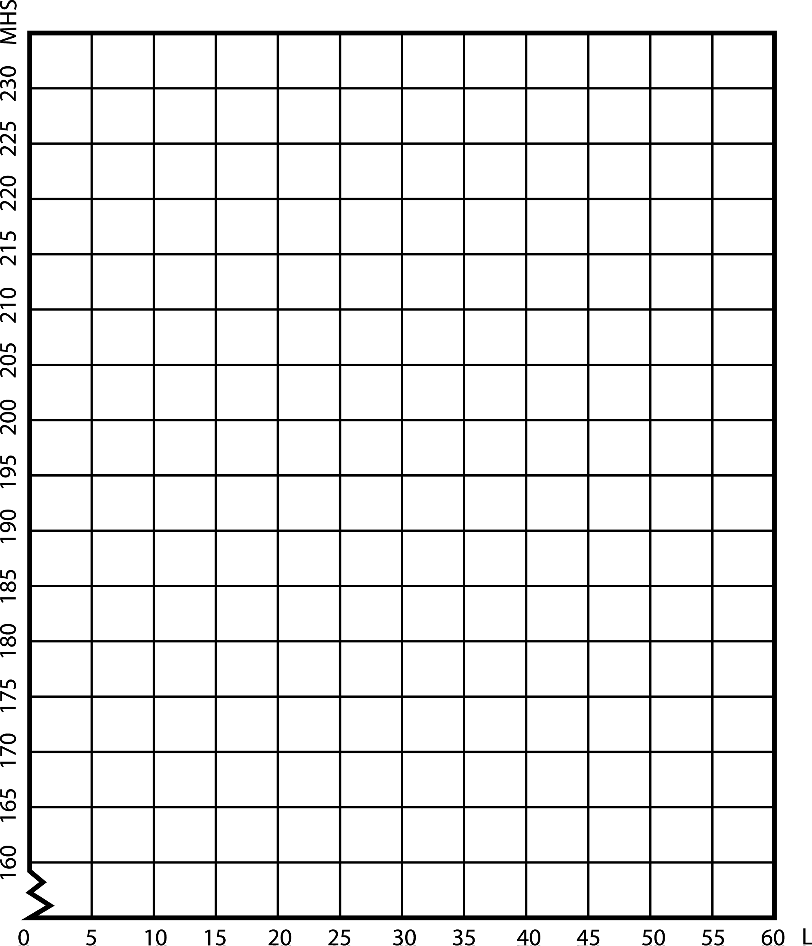

in years

Task 5g

Calculate for which age it does not matter whether you use equation 1 or equation 2.

Task 5h

What differences are there between equations 1 and 2 if you look at your own age group?

Task 5.i

The graph for equation 2 is also an approximation of reality. We saw that the values Gellish found are not exactly on the line of his graph. What would you have needed to prove the answer to 5.d?