|  |  |
| --- | --- |
| **Maths into Work Project**  **Emergency Calls** |  |

**Background**

|  |  |
| --- | --- |
| A Regional Police Force is divided into Four *Divisions* based on the geography of the Region. Within South Division there are five *Sections* based on the five major towns. Within each *Section* police officers work in teams.  **Immediate Response Incidents**  *Targets:*  10 minutes in urban areas  20 minutes in rural areas  National target 88% within target times  If you make an emergency call the operator first of all decides whether yours is an *immediate response incident*. If it is an *immediate response incident* the time taken for a Police Officer to arrive at the scene is recorded.  A key performance measure of how efficient the police are is whether these incidents are dealt with within target times.  A Police Inspector gets the data about his Division's response times and uses a spreadsheet to see how his teams are doing. | C:\WINDOWS\Desktop\Police103Kent.jpeg |

Task:

Read through all the information on this and the following two pages, so that you can explain:

1. the calculations that are carried out by the spreadsheet
2. the formulae you would use in columns F and G and row 40 in the spreadsheet
3. why the success rates of the different Teams and Sections may be different
4. Explain how you would calculate the average success rate for the whole division for one month.

**Data and interview**

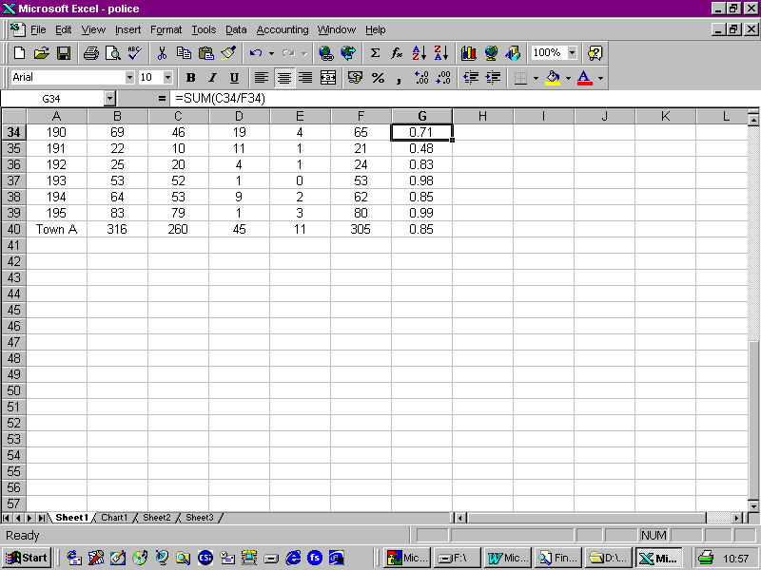

*Police Inspector*:

so we get the team [indicating column A the different teams are numbered 190, 191, 192 and so on in Town A],

How many calls were received [indicating column B], right?

How many were on time [indicating column C], yes?

How many were not on time [indicating column D],

and how many were discounted (maybe false alarms) [indicating column E].

**Display**

The Police Inspector displays the results using bar charts.



|  |  |
| --- | --- |
| **Maths into Work Project**  **Emergency Calls** |  |

**Background**

|  |  |
| --- | --- |
| A Regional Police Force is divided into Four *Divisions* based on the geography of the Region. Within South Division there are five *Sections* based on the five major towns. Within each *Section* police officers work in teams.  **Immediate Response Incidents**  *Targets:*  10 minutes in urban areas  20 minutes in rural areas  National target 88% within target times  If you make an emergency call the operator first of all decides whether yours is an *immediate response incident*. If it is an *immediate response incident* the time taken for a Police Officer to arrive at the scene is recorded.  A key performance measure of how efficient the police are is whether these incidents are dealt with within target times.  A Police Inspector gets the data about his Division's response times and uses a spreadsheet to see how his teams are doing. | C:\WINDOWS\Desktop\Police103Kent.jpeg |

Task:

Read through all the information on this and the following two pages, so that you can explain:

1. the calculations that are carried out by the spreadsheet
2. the formulae you would use in columns F and G and row 40 in the spreadsheet
3. why the success rates of the different Teams and Sections may be different
4. Explain how you would calculate the average success rate for the whole division for one month.

**Data and interview**



*Police Inspector*:

so we get the team [indicating column A the different teams are numbered 190, 191, 192 and so on in Town A],

How many calls were received [indicating column B], right?

How many were on time [indicating column C], yes?

How many were not on time [indicating column D],

and how many were discounted (maybe false alarms) [indicating column E].

**Display**

The Police Inspector displays the results using bar charts.



|  |  |
| --- | --- |
| **Maths into Work Project**  **Emergency Calls** |  |

**Background**

|  |  |
| --- | --- |
| A Regional Police Force is divided into Four *Divisions* based on the geography of the Region. Within South Division there are five *Sections* based on the five major towns. Within each *Section* police officers work in teams.  **Immediate Response Incidents**  *Targets:*  10 minutes in urban areas  20 minutes in rural areas  National target 88% within target times  If you make an emergency call the operator first of all decides whether yours is an *immediate response incident*. If it is an *immediate response incident* the time taken for a Police Officer to arrive at the scene is recorded.  A key performance measure of how efficient the police are is whether these incidents are dealt with within target times.  A Police Inspector gets the data about his Division's response times and uses a spreadsheet to see how his teams are doing. | C:\WINDOWS\Desktop\Police103Kent.jpeg |

Task:

Read through all the information on this and the following two pages, so that you can explain:

1. the calculations that are carried out by the spreadsheet
2. the formulae you would use in columns F and G and row 40 in the spreadsheet
3. why the success rates of the different Teams and Sections may be different
4. Explain how you would calculate the average success rate for the whole division for one month.

**Data and interview**



*Police Inspector*:

so we get the team [indicating column A the different teams are numbered 190, 191, 192 and so on in Town A],

How many calls were received [indicating column B], right?

How many were on time [indicating column C], yes?

How many were not on time [indicating column D],

and how many were discounted (maybe false alarms) [indicating column E].

**Display**

The Police Inspector displays the results using bar charts.



# Emergency Calls:

|  |  |
| --- | --- |
| **Maths into Work Project**  **Emergency Calls** |  |

**Background**

|  |  |
| --- | --- |
| A Regional Police Force is divided into Four *Divisions* based on the geography of the Region. Within South Division there are five *Sections* based on the five major towns. Within each *Section* police officers work in teams.  **Immediate Response Incidents**  *Targets:*  10 minutes in urban areas  20 minutes in rural areas  National target 88% within target times  If you make an emergency call the operator first of all decides whether yours is an *immediate response incident*. If it is an *immediate response incident* the time taken for a Police Officer to arrive at the scene is recorded.  A key performance measure of how efficient the police are is whether these incidents are dealt with within target times.  A Police Inspector gets the data about his Division's response times and uses a spreadsheet to see how his teams are doing. | C:\WINDOWS\Desktop\Police103Kent.jpeg |

Task:

Read through all the information on this and the following two pages, so that you can explain:

1. the calculations that are carried out by the spreadsheet
2. the formulae you would use in columns F and G and row 40 in the spreadsheet
3. why the success rates of the different Teams and Sections may be different
4. Explain how you would calculate the average success rate for the whole division for one month.

**Data and interview**



*Police Inspector*:

* so we get the team [indicating column A the different teams are numbered 190, 191, 192 and so on in Town A],
* How many calls were received [indicating column B], right?
* How many were on time [indicating column C], yes?
* How many were not on time [indicating column D],
* and how many were discounted (maybe false alarms) [indicating column E].

**Display**

The Police Inspector displays the results using bar charts.

