

Waterquality: Swim without risk?

**Abstract**

The quality of swimming water is checked annually according to guidelines that are the same for all EU countries. What are these guidelines? How are they determined and applied? Does the water near your school meetthe criteria? These are the questions that will be dealt with in this unit.

Students will investigate how water quality can be determined. Biology, chemistry and mathematics all play a role in this activity. Based on the testing of water samples, students will provide some advice for the local tourist office.

|  |  |
| --- | --- |
| **Aspect** | **Description** |
| **Mathematical content** | - Interpreting and drawing graphs - Calculations using percentages (reliability) - Making maps (scale factors) - Accuracy |
| **Scientific content** | - Experimental work  - Critically evaluate and justify norms  - Document results and reflect, evaluate and discuss  -Importance of acidic, alkaline and neutral solutions for living organisms, (chemistry) knowledge of abiotic factors that influence ecosystems (biology, chemistry) |
| **Age of students** | 14-16 |
| **Number of lessons in mathematics** | Approximately 1 |
| **Number of lessons in science** | Approximately 4 |

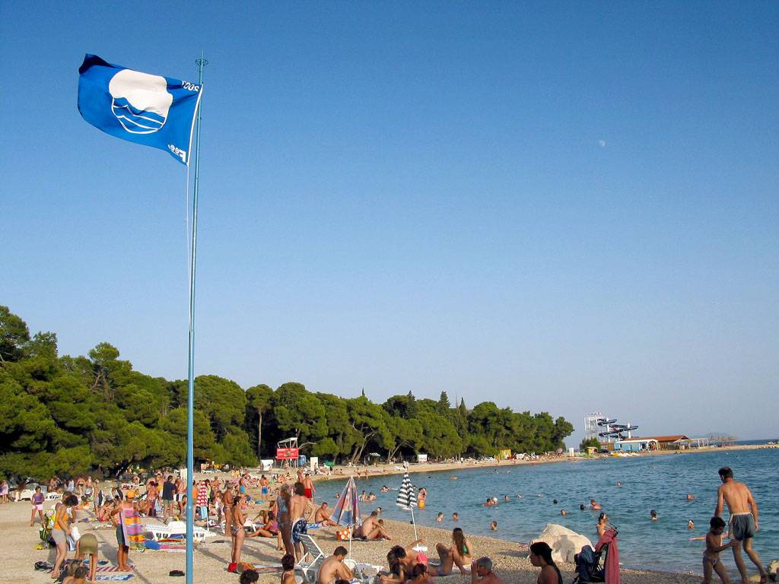**1. Overview of the teaching unit**

## 1.1 The situation

The quality of swimming water is checked annually, according to certain guidelines that are the same for all EU countries. What are the criteria by which water can be determined to be ´clean´? And how are these criteria determined and why no other criteria? How reliable are the results of the tests for the criteria?

These are the questions that will be dealt with and for which students will carry out research and formulate answers in this unit.

**1.2 Overarching questions**

* How can the purity of swimming water be tested?
* What exactly is the 'Blue Flag'?
* How reliable are the measurements and the criteria for the Blue Flag?
* What is the status of the quality of fresh and salt water for swimming in the Netherlands?
* Are there noticeable differences in water quality between EU countries?

## 1.3 Final product

Write a report for your local tourist office in which you explain why tourists should swim in this area or what should be improved. In this report you should refer to the experiments that you have carried out and to your findings from the tests.

## 1.4 Necessary materials

* Water samples from the local area. Students may collect these themselves after the first lesson.
* Testing equipment for identification of substances in the water (pH-value, nitrate-/nitrite- and phosphate-contents) (Activity 3)
* Testing equipment for copper sulphate solutions in various concentrations ( Activity 4)
* Optional for biology: Nets, small water containers, magnifying glasses, identification aids for invertebrates in waters and microscopes for the identification of algae.

## 1.5 The task plan

|  |  |  |  |
| --- | --- | --- | --- |
| Activity | **Biology** | **Chemistry** | **Mathematics** |
| 0 | **Task 1: Introduction to the topic**  Homework: bring water samples from your area | | |
| **1** |  | **Task 2: Is the water clean enough?**  Discuss samples: what are the criteria for swimming/drinking water and how can they be tested? |  |
| **2** |  | **Task 3: Are the criteria trustworthy?**  Norms of chemical and biological parameters: accuracy, advantages and disadvantages of methods | **Task 3: Are the criteria trustworthy?**  Calculations for Blue Flag criteria.  Optional: Logarithmic relationship between concentration and pH-value |
| **3** | **Task 4: What is allowed?**  Test samples for E-coli (bacteria) and other biological materials. | **Task 4: What is allowed?** Test samples for acid, chloride, nitrite |  |
| **4** |  | **Task 5: Are the measurement results reliable?**  Accuracy of test results |  |
| **5** |  |  | **Task 6: How can you make a comparison between the Netherlands and other countries?**  Comparison between countries, interpreting graphs |
| **6** | **Task 7: Discussion**  of results from each of the groups | | |

## 

**2. Description of the tasks**

**2.1 Task 1 – Introduction to the overarching question: Is the water clean enough?**

Students are confronted with the issue by means of an article from a newspaper on the pollution of swimming water (Summer 2010). Ideally, it would be helpful to invite a person who is involved in water treatment or testing to introduce the subject.

After reading, a group discussion should be held.

|  |  |
| --- | --- |
|  | *Potential issues for discussion:*   * Is our swimming water clean enough? * Why is purity an important consideration? * How is this purity checked? * How can the quality be maintained? * Who checks this? * Is approved swimming water potable (safe for drinking)? |

Humans, plants and animals depend on water. Everyday a person consumes two litres of water. It is important that the water is pure enough, not just for drinking, but also for swimming. Although you might not really be aware of this, the quality of the water is checked in many different situations.

In various laboratories at breweries, waterworks, sewage works, etc., water quality is measured constantly. The results are then usually published.

Polluted water may lead to disease (think of the E-coli bacteria, cyanobacteria or the presence of heavy metals).

In preparation of the next lesson, students should to bring in a water sample (0.5 - 1 litre). Experiments will be carried out during the lessons on this water sample.

This task allows for differentiation for different school levels. Students learn to collect and handle data and to create measures to maintain water quality and to protect the world in general.

Students will look at guidelines for water quality (in particular: the "Blue Flag"), will recognise the benefits of generally accepted criteria for guidelines, and will understand the reasons behind the selection of criteria and guidelines.

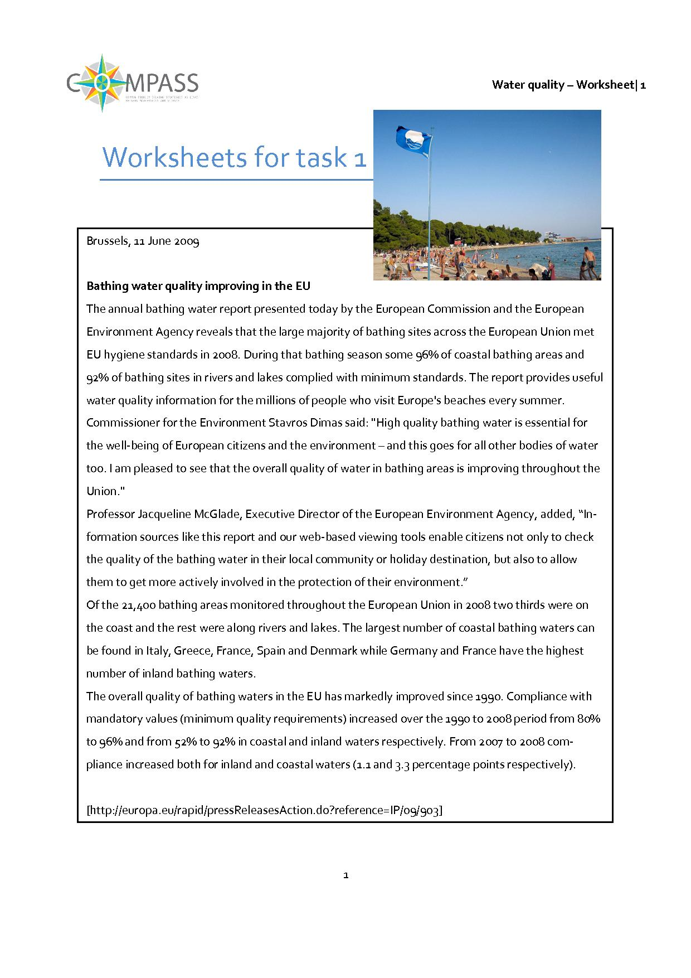

**2.2 Chemistry – Task 2: How can water be tested for quality?**

***The aim of this task***

* Students gain an understanding of the necessity for agreeing on common criteria to assess water quality.

***Contribution to the overall question***

Students gain an understanding that it is important and useful to apply objective and general criteria when checking the quality of swimming water. To achieve this, they test their own water samples using their own criteria. Discussion of these criteria should lead to general agreements on what these criteria should be. They can then be compared to the lawful demands that apply within the EU.

***Chemical contents***

* Testing the water samples using students’ own criteria
* Discussion of the various criteria that have been used
* Setting up a work plan for Blue Flag measurements (lesson 3)

Students’ water samples are tested for quality. Working in groups of 3 or 4, students should determine their criteria for quality. The results and opinions can be presented on posters, transparencies or in a PowerPoint presentation. These can then be used for a class discussion.

|  |  |
| --- | --- |
|  | *Activity 1 for students: Similarities and differences*  Take a look at the posters produced by each group.  Potential questions you might wish to consider:   * What similarities and differences have you found between groups when it comes to evaluating water quality? * Which samples are safe for swimming? * How certain are you of the choice for these criteria? * Have all risk factors been taken into account? Are you sure?   (see worksheet for task 2.2) |

In the discussion it is likely that different criteria have been used on each sample and that it is not possible to be sure if all important aspects have been considered. This should prompt students to consider searching for precise and well-defined criteria and measurement methods by which the quality of swimming water can be determined. In the next lesson students will learn to apply the criteria of the ‘Blue Flag’. Towards the end, they will set up a plan for the testing procedure. Optionally, a comparison with the directives for drinking water can be explored.

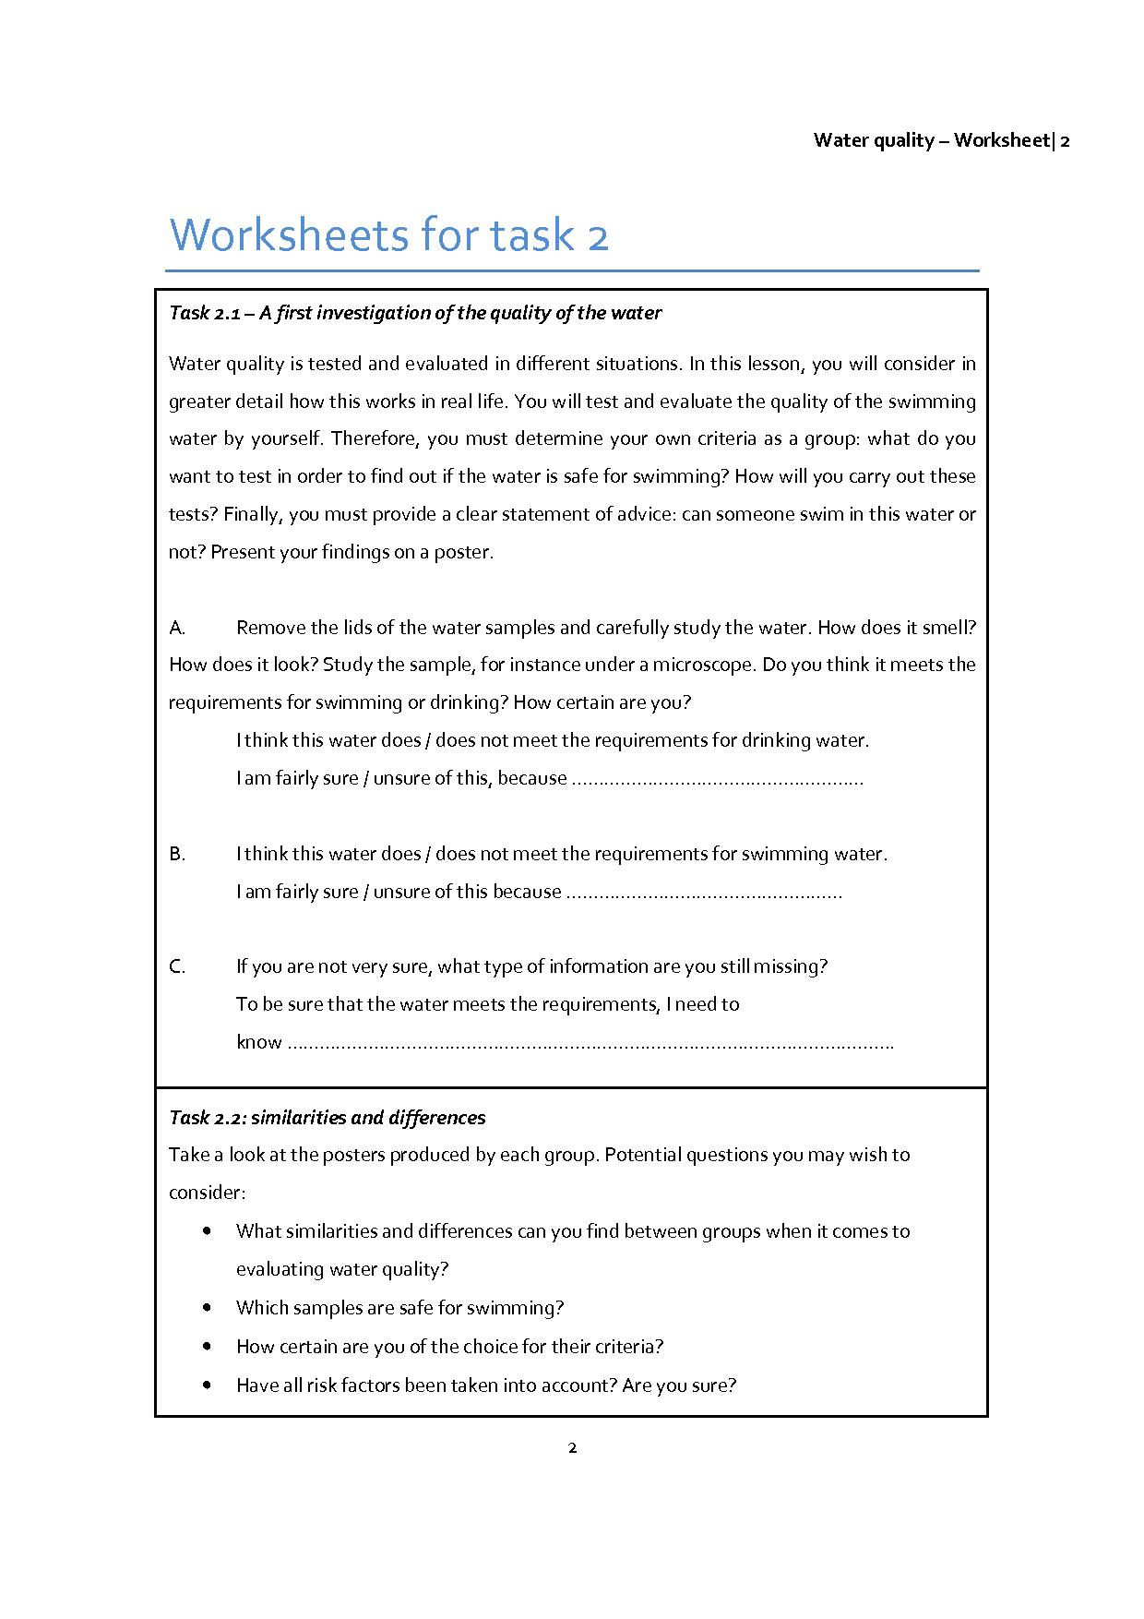

**2.3 Biology/Chemistry/Mathematics – Task 3: The Blue Flag criteria**

***The aim of this task***

* Students should become familiar with Blue Flag criteria.
* Students should critically reflect on the choice for Blue Flag criteria: why these and not different criteria?
* Students consider the mathematical background for the statistical measures.

***Contribution to the overall question***

* Development of understanding of the Blue Flag criteria

***Scientific contents***

* Knowledge and application of the criteria that can be used to check water quality: pH-value, numbers of bacteria (especially Escherichia coli and cyanobacteria), transparency (called turbidity), nitrite and (optionally) also for cyanobacteria (nitrate and phosphate).
* Advantages and disadvantages of colorimetric measurements in comparison with biological and phenomenological measurements.

***Mathematical content***

* Statistical methods, such as average, deviation, percentiles
* Logarithms (optional)

Students should investigate how the granting of a "Blue Flag" can be determined for swimming water. This information can be found on the Internet.

Task 3.4 focuses on the parameters that are used during testing and the reasons for their selection.

Next, other parameters that could be taken into account to evaluate the quality of swimming water are considered during a class discussion.

|  |  |
| --- | --- |
|  | *Activity 1 for students: Why are no other parameters tested?*  You have studied the Blue Flag requirements; why certain parameters and norms are reported in it and how the norms have been established. The question is: can we rely on these four criteria? Why are just these parameters chosen and no more? |

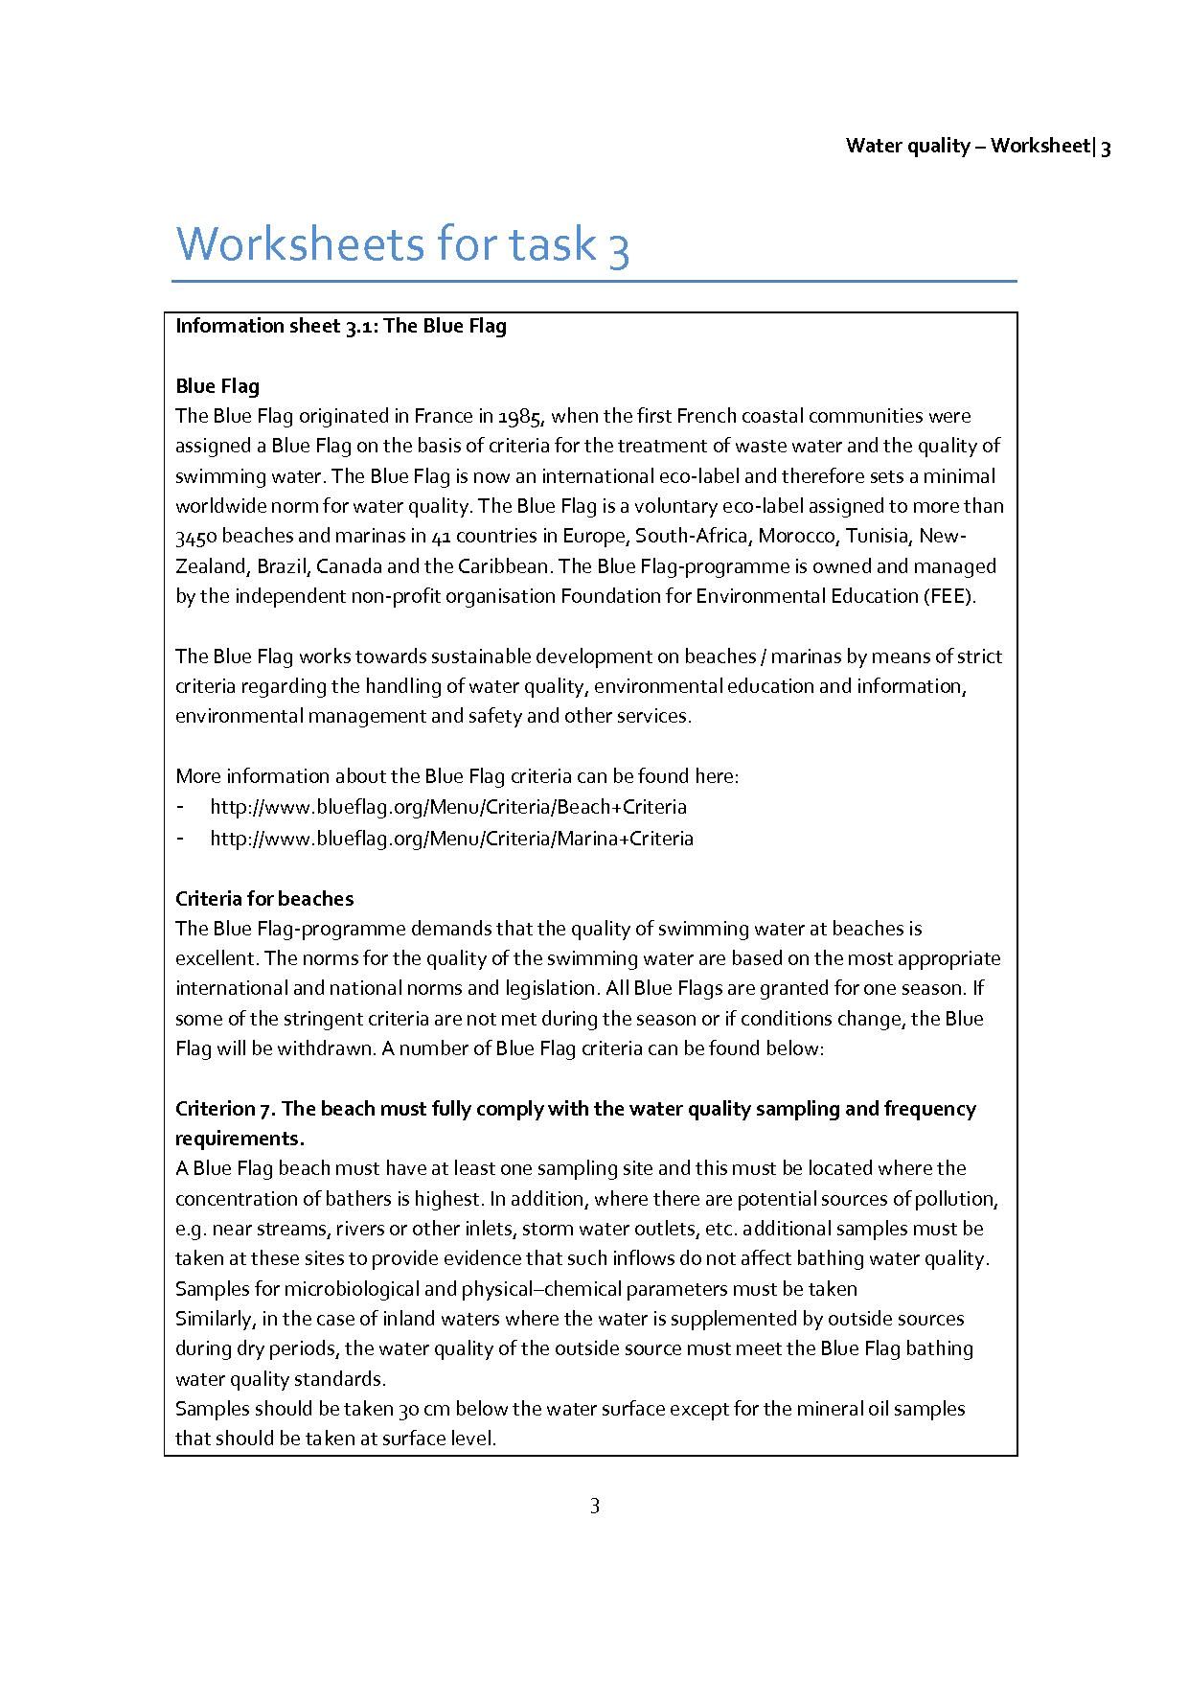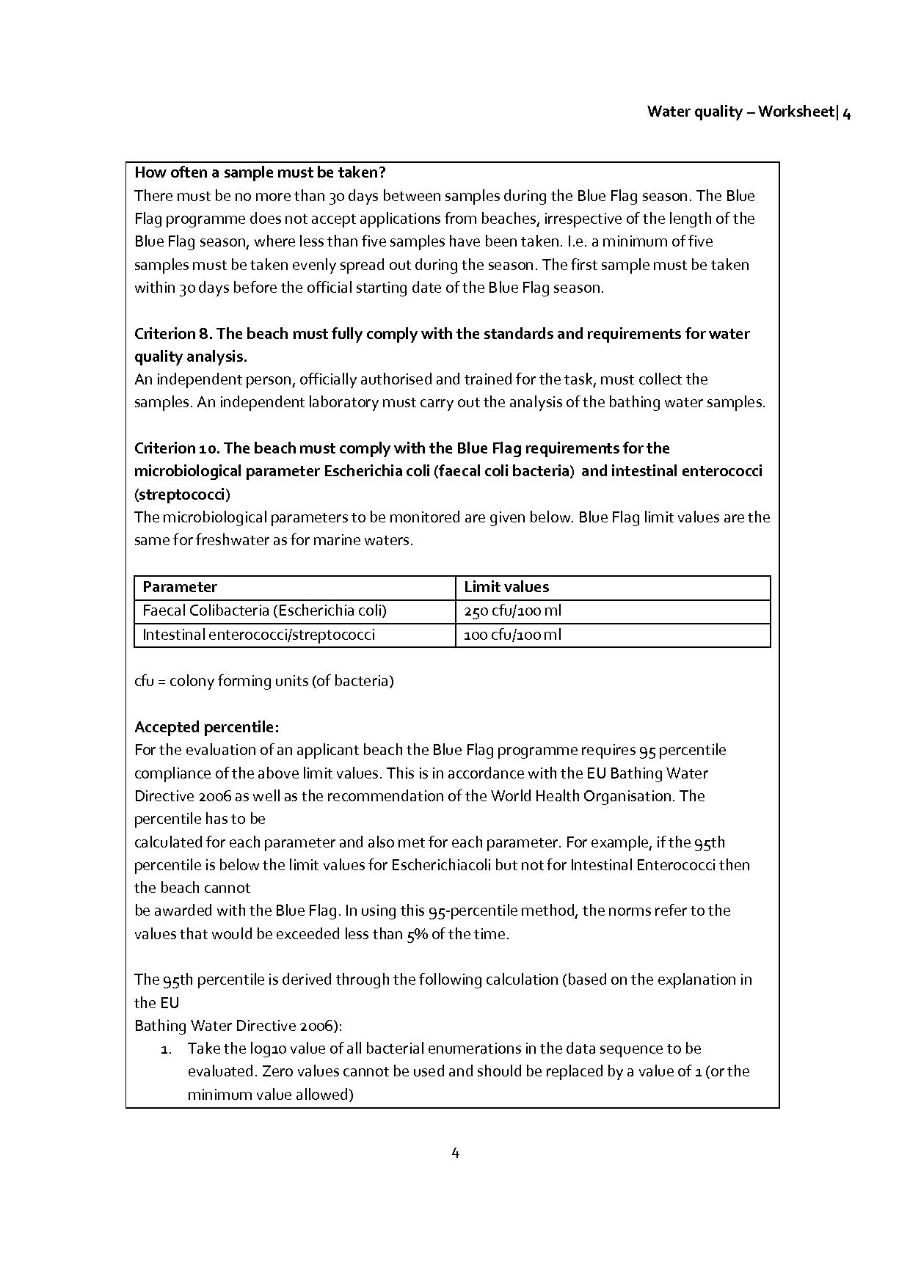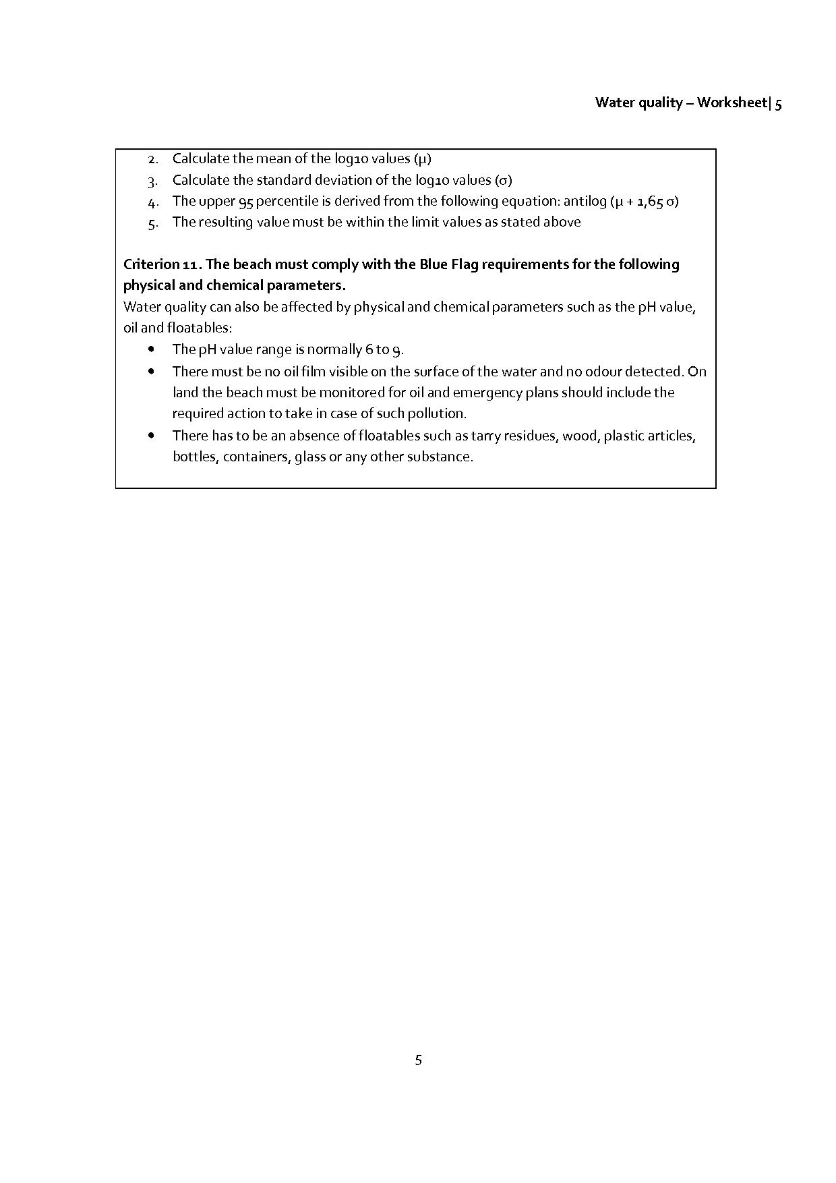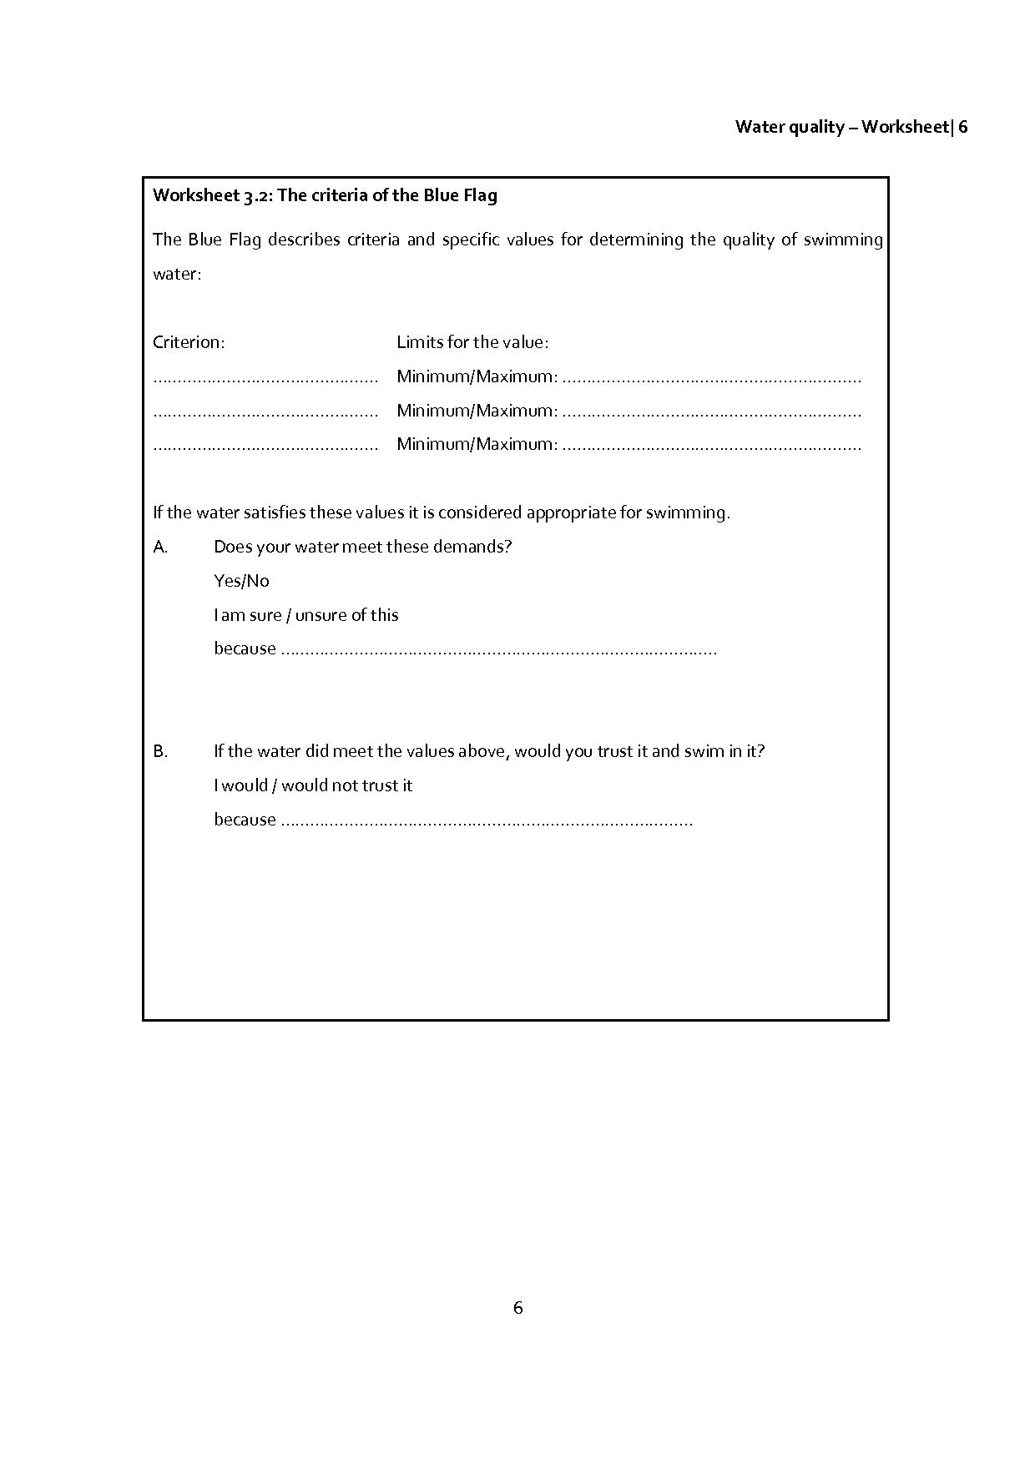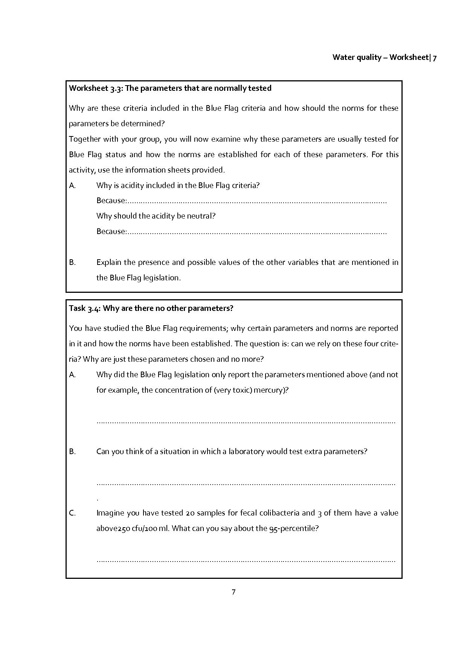

**2.4 Task 4 – Test the water quality of the samples**

***The aim of this task***

* Students test their own water samples to see if they meet the Blue Flag criteria and share their findings.
* Students will consider reliability with respect to taking and collecting samples.
* Other criteria selected by individuals or groups may be tested as well.

***Contribution to the overall question***

* Using the test results, students can later determine what advice to give to the local tourist office.

***Chemical contents***

* Application of the test kit to check water quality for pH-value, nitrite and (optionally) also for cyanobacteria (nitrate and phosphate).

***Biological content***

* Test for E-coli bacteria and (optionally)transparency (turbidity).Optionally, students could investigate the water sample using other biological parameters (like algae), and critically evaluate the usefulness of these investigations.

Note: The E-coli test takes time, because the culture needs to grow.

|  |  |
| --- | --- |
|  | *Activity 1 for students: Testing of your own samples with the test-kit*  The method for using the kit is explained in the manual.   * What results did you get? * Do they meet the Blue Flag requirements? * Compare your results with fellow students.   (see worksheet for task 4.1) |

Since the water samples have been collected at different locations, it should prove interesting to compare results and discuss how any differences may be explained.

The following tests are often used to determine water quality and are easily carried out with younger students. In particular, biological testing for indicator organisms (3) is easy to do. This method involves aspects from biology and promotes environmental awareness, not only of human health, but also aquatic life. These tests may be included in later considerations of the parameters determining water quality.

**(1) Visual depth measure**

Tie some string to a non-floating white / light-coloured object. Attach a plastic bottle to the string one metre from the object. Hold the other end of the string, and throw the “visual depth instrument” into the water. Does the object remain visible? If so, then the water quality is in order. If you want to determine the exact depth of visibility, remove the plastic bottle and let the object sink to a depth where it remains only just visible. Measure the length of the string which was submerged in the water.

**(2) Turbidity and odour of the water**

Water quality can also be assessed based on the turbidity and colour. Turbidity and colour can be caused by pollution from various substances, including iron, soil particles, sludge materials, or with numerous small organisms, such as green algae and diatoms, bacteria, and water fleas. It can be determined from the visual depth of a water sample.

**(3) Biological determination of water quality using indicator organisms**

Many water organisms are dependent of the available food, oxygen, pH and other factors. If these organisms are present, then a certain level of the above factors must be available. They are then representative of a specific condition of the water and are called indicator organisms. Before carrying out this test, students should investigate possible indicator organisms for their geographic area, or a table with indicators and conditions could be provided.

Criteria by which the testing process can be evaluated are:

- Accuracy

- Requirement of technical expertise

- Expense

- Benefit / importance to the people’s health

- Importance in maintaining the ecological balance

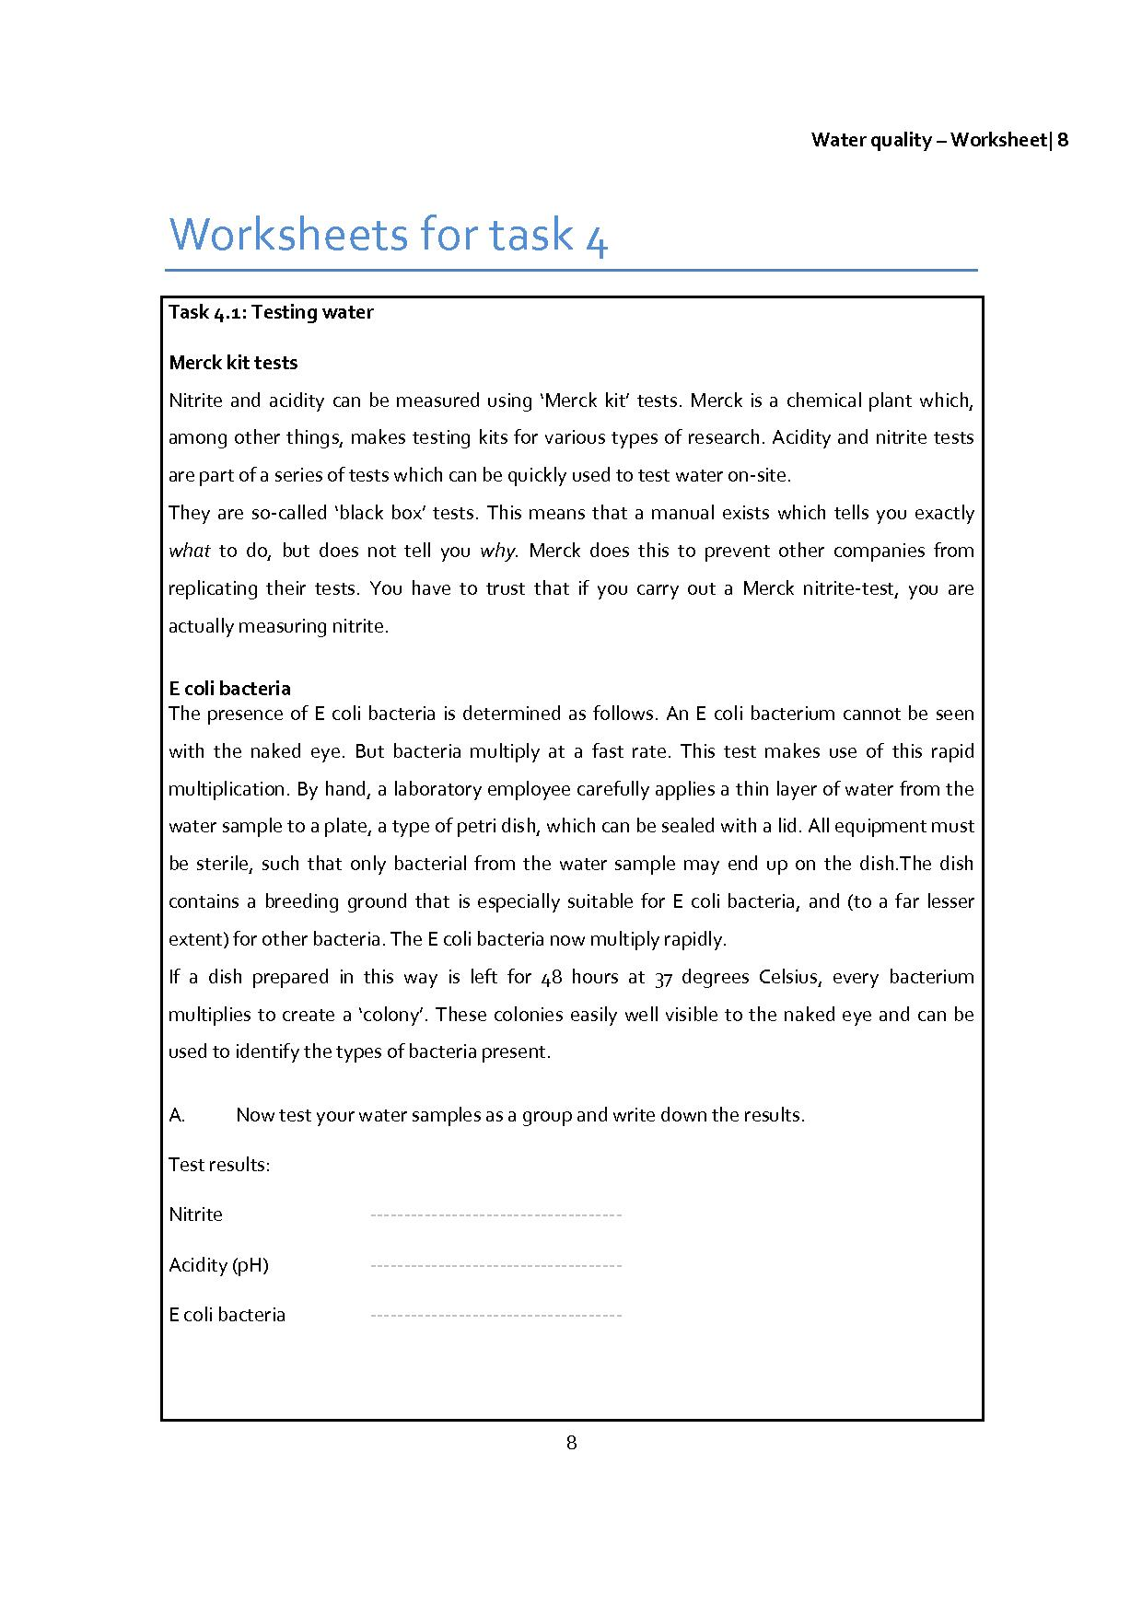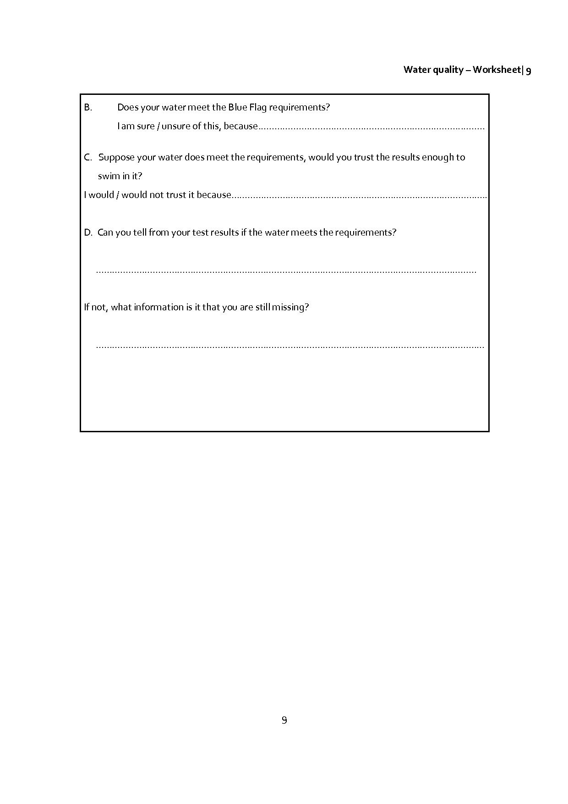**2.5 Task 5 – Can you trust your measurement results?**

***The aim of this task***

* Students reflect on the procedure followed during the testing process and to what extent it influences accuracy.
* Students consider the limited accuracy of the (colour) indicator test, using copper sulphate.

***Contribution to the overall question***

* This activity contributes to awareness of the fact that results may not be considered as very exact and that mention of this uncertainty should be included in any advice issued.

***Chemical contents***

* Accuracy of colorimetric analysis, using copper sulphate solution as an example.

The results of measurements are actually lists of numbers. To what extent can you be sure that the concentration of your sample really is representative for the water sample? In this activity we reflect on the testing procedure: what types of measurements did you carry out and how accurate were they?

|  |  |
| --- | --- |
|  | *Activity.1 for students: Did you measure properly?*  As you noticed, all tests from the Merck kit were so-called black box tests (which mean that you do not know exactly what happens in the tests but only carry them out). This was also the case for the E-coli-bacteria tests. All you had to do is to make sure that you tested what you wanted to test. Perhaps you did not always strictly follow the instructions.   * Do you think you carried the tests out well? * What does this means for the results of your measurements?   (see worksheet for task 5.1) |

Using a given series of 10 coloured copper sulphate solutions with given concentrations, two 'anonymous' solutions should be placed in their appropriate location within the series.

|  |  |
| --- | --- |
|  | *Activity 2 for students: Accuracy of the measurement results*  As you may have noticed, all tests from the Merck kit are based on the same principal: the higher the concentration of the solute, the more intense the colour of the solution. In some ways this also applies to the acidity test. For this reason, such measurements are called colorimetric determinations. To get an impression of the accuracy of a colorimetric determination you will be provided with a series of test tubes, numbered 1 to 10.   * Put them in the correct order * Where do the samples in numbers 11 and 12 fit in?   (see worksheet for task 5.2) |

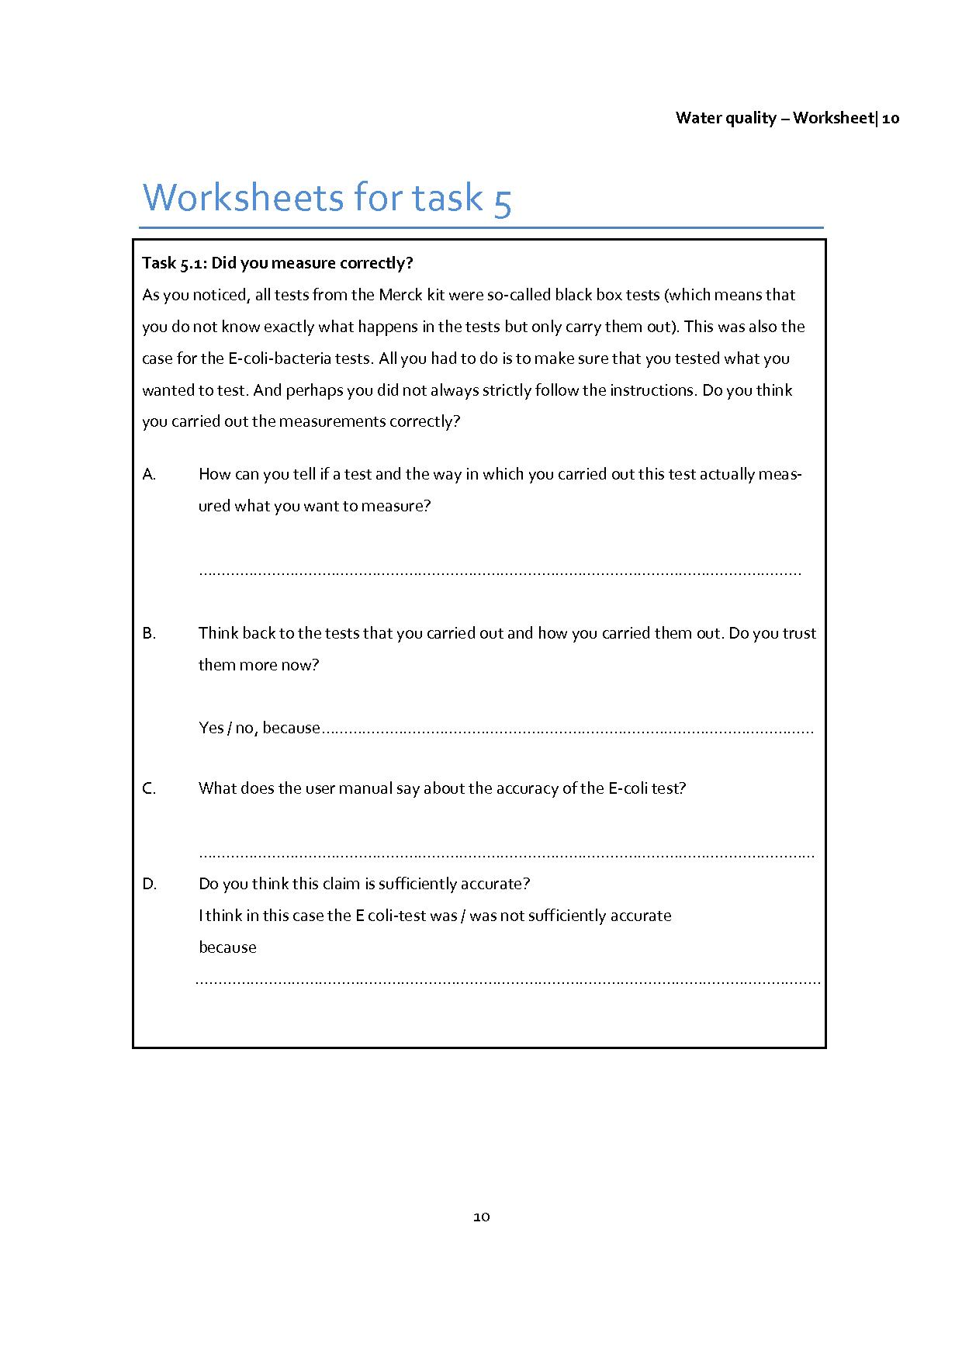

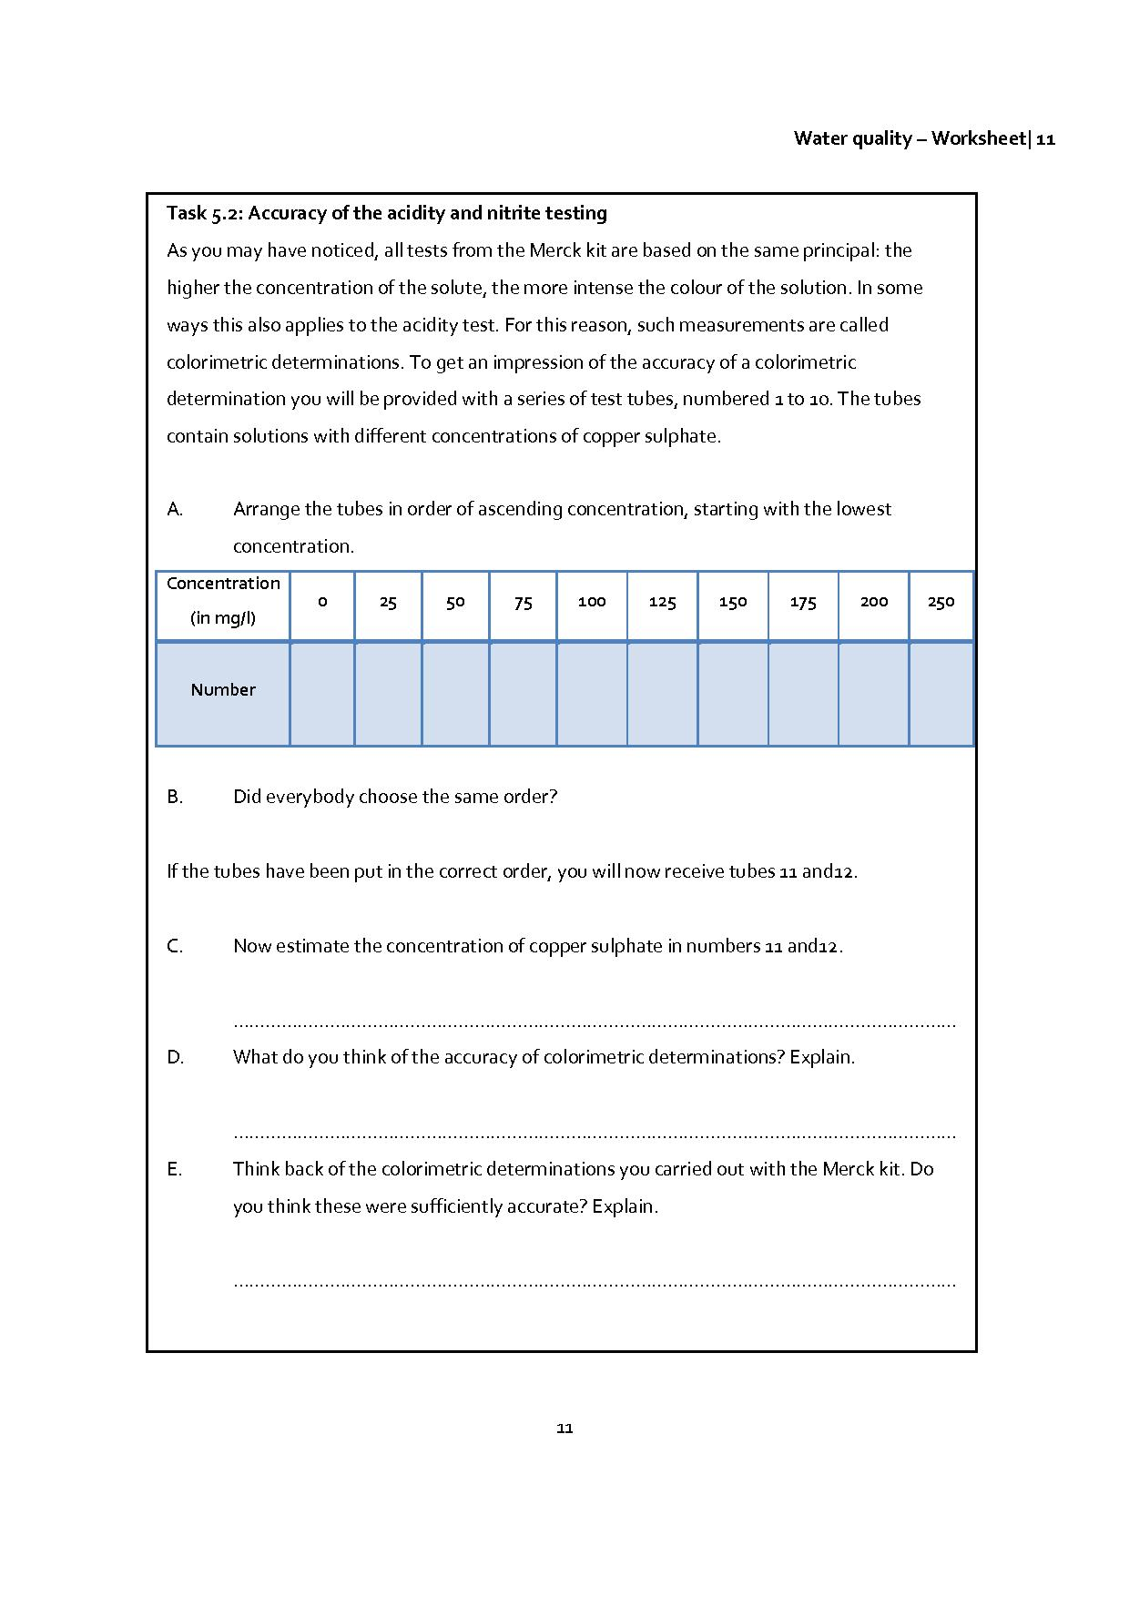**2.6 Task 6 – Comparison with other countries**

***The aim of this task***

* Students should compare the quality of swimming water in the Netherlands and Spain over a number of years.
* Students should identify differences in numbers, types and spread of swimming areas.

***Contribution to the overall question***

* By looking at quality in a broader sense, students can put their advice in an (inter)national context.

***Mathematical content***

* Compare and interpret diagrams.
* Interpret maps.

Heading for your favourite beach? Is the swimming water clean? Europeans have a diverse choice of beautiful beaches and bathing zones and many will look forward to cooling down in the sea water during long summer days. The quality of swimming water at your favourite beach or holiday destination can be an important factor in deciding where you will go. To help Europeans make their decisions between beaches, an annual report of the quality of coastal and bathing areas has been made, as reported by EU countries. The report assesses the quality of the swimming water in all 27 EU-countries during the swimming season of 2008 and thereby gives an indication of the areas where the quality of the swimming water is expected to be good in this year. Details of the swimming water quality in all EU countries for the 2008 season can be found in the national swimming water reports at [www.eea.europa.eu/themes/water/status-and-monitoring/state-of-bathing-water-1](http://www.eea.europa.eu/themes/water/status-and-monitoring/state-of-bathing-water-1)**.**

|  |  |
| --- | --- |
|  | *Activity 1 for students: Comparing graphs and maps*  The figures show compliance with Blue Flag standards in the Netherlands and Spain. Figure 1 shows a graph of swimming water and Figure 2 of bathing zones in coastal waters in the Netherlands. Figure 3 and 4 provide the same information for Spain.   * What can you find exactly in these graphs? * Compare how the data changes over time for the Netherlands and Spain. * Are there any notable years? Can you imagine why? * Which country appears to have the best quality swimming water?   (see worksheet for task 6.1) |

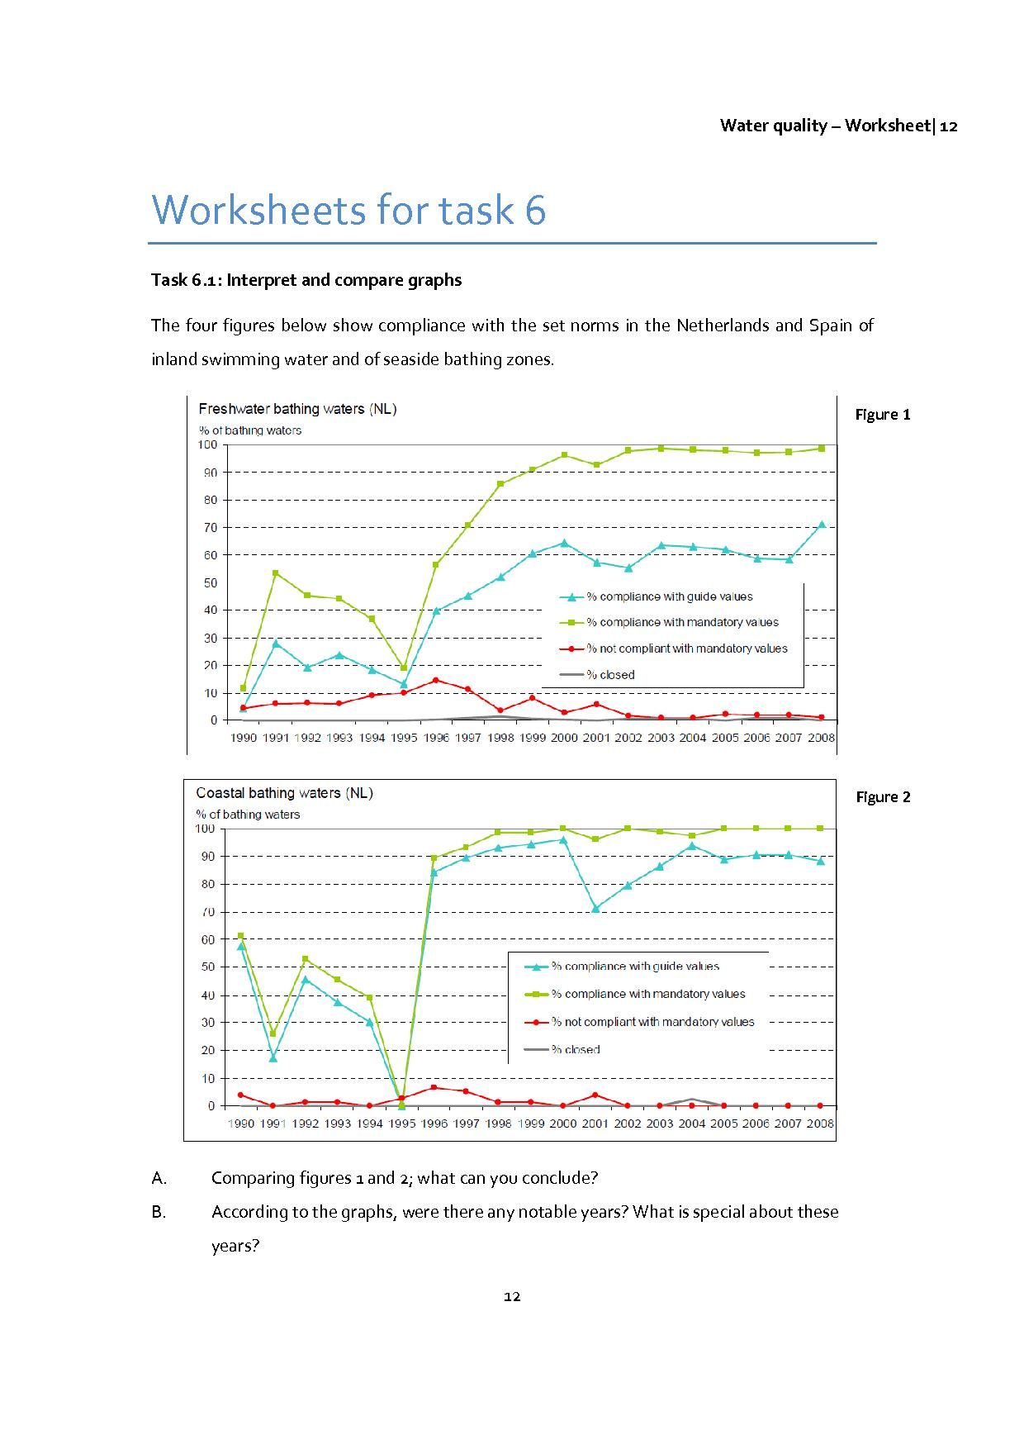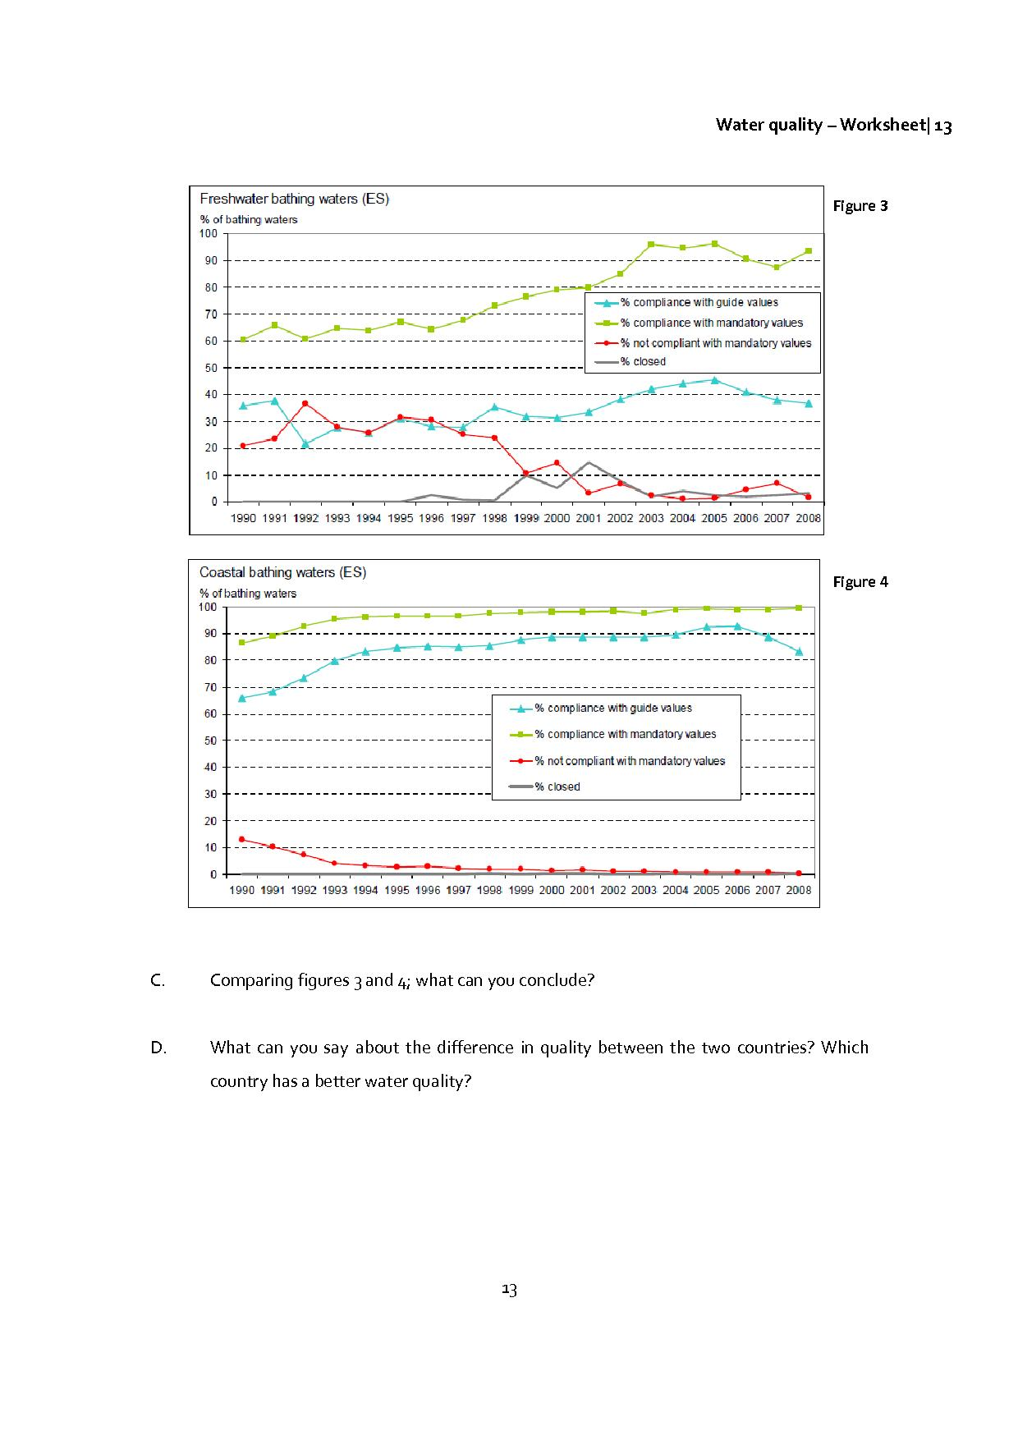

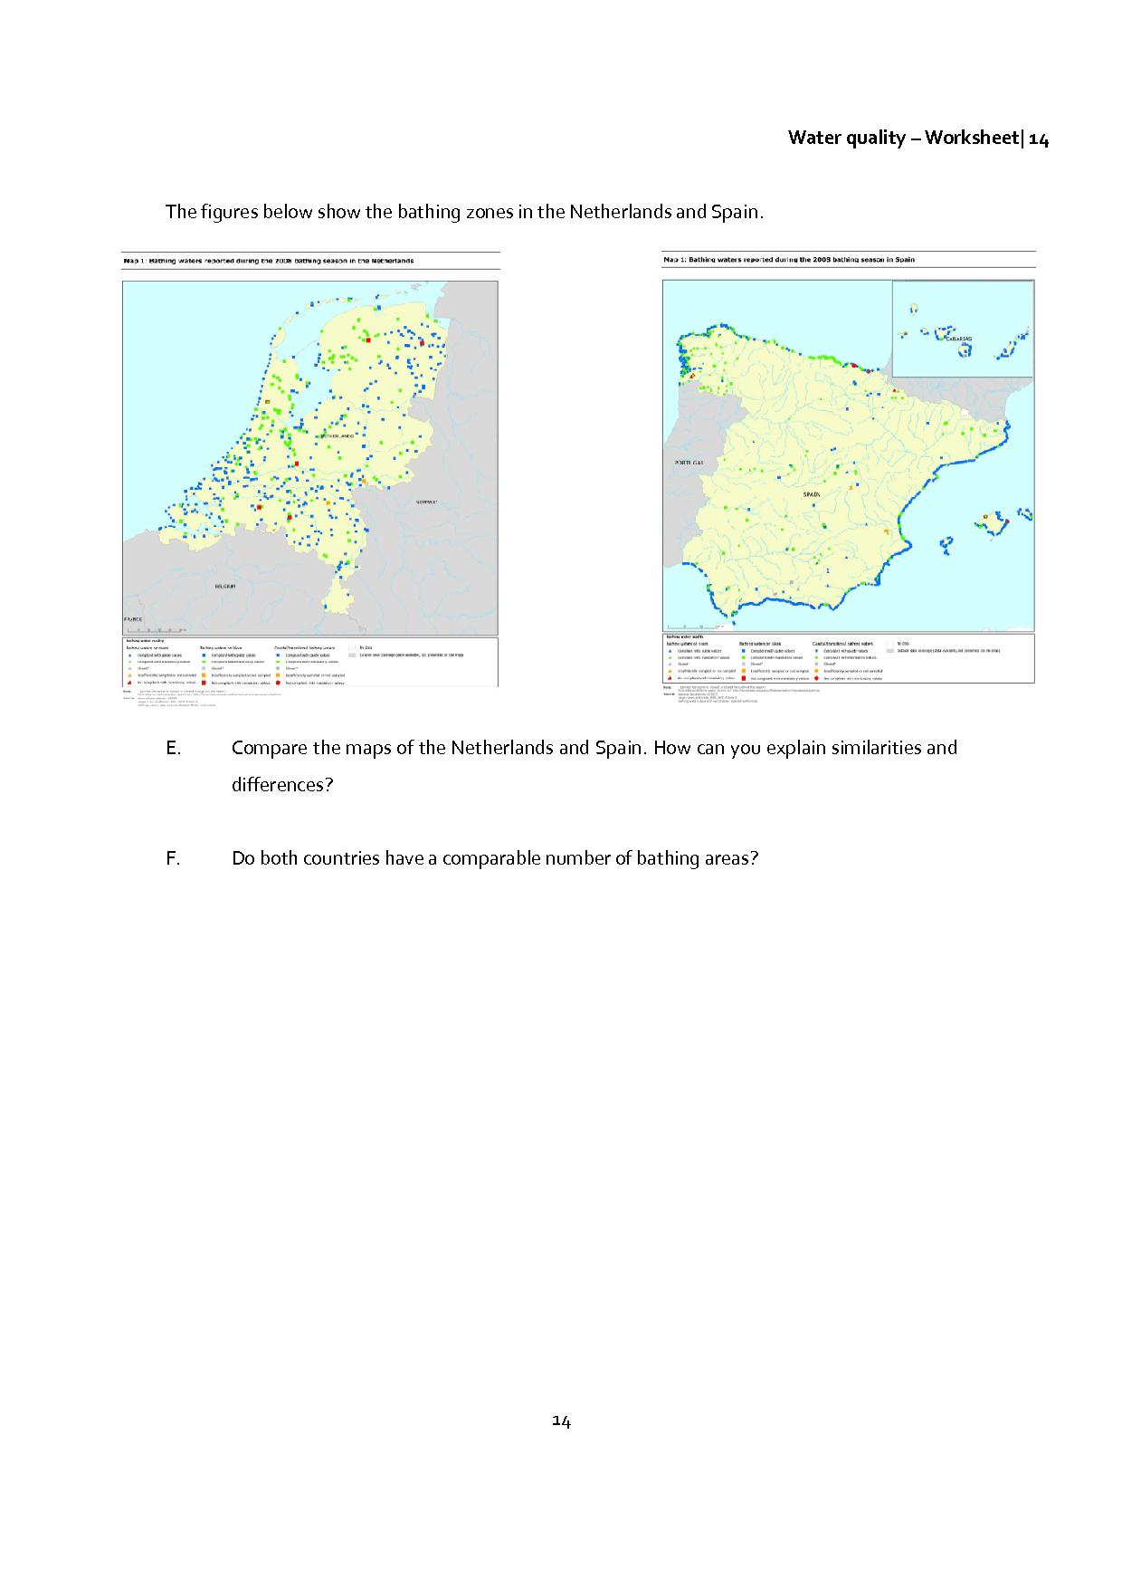

**2.7 Task 7 – Discussion and advice**

***The aim of this task***

The students summarise all the research they have carried out and provide advice for the local tourist office.

Now that all the steps in testing and determining water quality have been taken, you now need to give clear advice on whether the water is safe: is it safe to swim in it?

|  |  |
| --- | --- |
|  | *Final activity for students: provide advice for your local tourist office*  Formulate advice for your local tourist office in which you indicate why tourists should come and swim in your area. This report should refer to the sample tests that you carried out and their results. Also add a map of the swimming locations you tested in your area. |