Water Quality – teacher guide

Chemistry – Task: How can water be tested for quality?
Preparation
In preparation of the lesson, students should to bring in a water sample from the local area (0.5 - 1 litre).

Necessary materials
- Water samples
- Simple testing equipment like small tubes, microscope, …. .

Aim
- Students gain an understanding of the necessity for agreeing on common criteria to assess water quality.
- Students gain an understanding that it is important and useful to apply objective and general criteria when checking the quality of (swimming) water. To achieve this, they test their own water samples using their own criteria. Discussion of these criteria should lead to general agreements on what these criteria should be. They can then be compared to the lawful demands that apply within the EU.

Chemical contents
- Testing the water samples using students’ own criteria (like smell, color, etc)
- Discussion of the various criteria that have been used

Lesson plan

Introduction and discussion – 10 minutes

Introduce the problem of water quality using the text below or look for a report or an article on this issue (for example on the quality of swimming water).
Humans, plants and animals depend on water. Everyday a person consumes two litres of water. It is important that the water is pure enough, not just for drinking, but also for swimming. Although you might not really be aware of this, the quality of the water is checked in many different situations. In various laboratories at breweries, waterworks, sewage works, etc., water quality is measured constantly. The results are then usually published. Polluted water may lead to disease (think of the E-coli bacteria, cyanobacteria or the presence of heavy metals).

Potential issues for discussion:
- Is our (swimming) water clean enough?
- Why is purity an important consideration?
- How is this purity checked?
- How can the quality be maintained?
- Who checks this?
- Is approved (swimming) water potable (safe for drinking)?

Testing samples and produce poster - 20 minutes
Students’ water samples are tested for quality (see worksheet – part 1 ). Working in groups of 3 or 4, students should determine their criteria for quality. The results and opinions can be presented on posters, transparencies or in a PowerPoint presentation. These can then be used for a class discussion.

Class discussion – 15 minutes

Activity for students: Similarities and differences (see worksheet part 2)
Take a look at the posters produced by each group.
Potential questions you might wish to consider:
- What similarities and differences have you found between groups when it comes to evaluating water quality?
- Which samples are safe for swimming?
- How certain are you of the choice for these criteria?
- Have all risk factors been taken into account? Are you sure?
(see worksheet for task 2.2)

In the discussion it is likely that different criteria have been used on each sample and that it is not possible to be sure if all important aspects have been considered. This should prompt students to consider searching for precise and well-defined criteria and measurement methods by which the quality of swimming water can be determined.
Extra: you may want to discuss how the water samples have been taken: on the surface, deep down, close to the land etc. and what the effect will be on the water quality. This may also lead to collecting new/different samples.

Continuation
In a next lesson students can learn to apply the criteria of the ‘Blue Flag’ (see: http://www.blueflag.org/ ). They can set up a plan for the testing procedure. Optionally, a comparison with the directives for drinking water can be explored. See original Compass Module (on Mascil site) for more lessons/activities on this topic.

Appendix - Worksheet

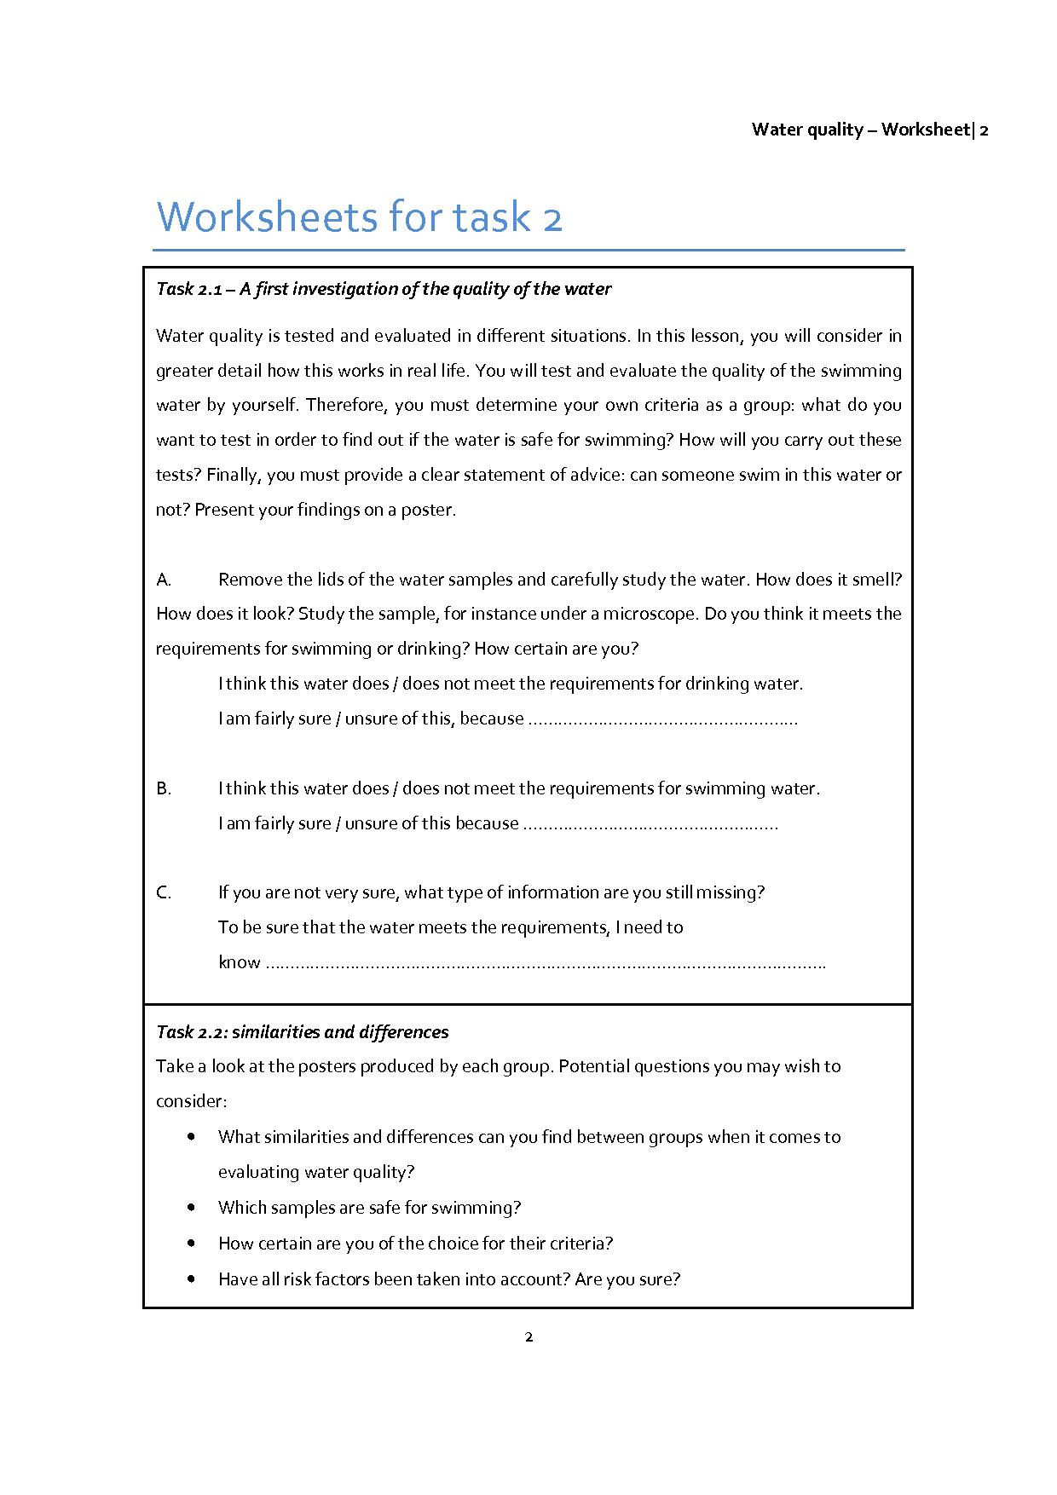

This worksheet is adapted from a similar worksheet from the Compass module Water Quality

