

Worksheets for task 1

Brussels, 11 June 2009

**Bathing water quality improving in the EU**

The annual bathing water report presented today by the European Commission and the European Environment Agency reveals that the large majority of bathing sites across the European Union met EU hygiene standards in 2008. During that bathing season some 96% of coastal bathing areas and 92% of bathing sites in rivers and lakes complied with minimum standards. The report provides useful water quality information for the millions of people who visit Europe's beaches every summer.

Commissioner for the Environment Stavros Dimas said: "High quality bathing water is essential for the well-being of European citizens and the environment – and this goes for all other bodies of water too. I am pleased to see that the overall quality of water in bathing areas is improving throughout the Union."

Professor Jacqueline McGlade, Executive Director of the European Environment Agency, added, “Information sources like this report and our web-based viewing tools enable citizens not only to check the quality of the bathing water in their local community or holiday destination, but also to allow them to get more actively involved in the protection of their environment.”

Of the 21,400 bathing areas monitored throughout the European Union in 2008 two thirds were on the coast and the rest were along rivers and lakes. The largest number of coastal bathing waters can be found in Italy, Greece, France, Spain and Denmark while Germany and France have the highest number of inland bathing waters.

The overall quality of bathing waters in the EU has markedly improved since 1990. Compliance with mandatory values (minimum quality requirements) increased over the 1990 to 2008 period from 80% to 96% and from 52% to 92% in coastal and inland waters respectively. From 2007 to 2008 compliance increased both for inland and coastal waters (1.1 and 3.3 percentage points respectively).

[http://europa.eu/rapid/pressReleasesAction.do?reference=IP/09/903]

Worksheets for task 2

***Task 2.1 – A first investigation of the quality of the water***

Water quality is tested and evaluated in different situations. In this lesson, you will consider in greater detail how this works in real life. You will test and evaluate the quality of the swimming water by yourself. Therefore, you must determine your own criteria as a group: what do you want to test in order to find out if the water is safe for swimming? How will you carry out these tests? Finally, you must provide a clear statement of advice: can someone swim in this water or not? Present your findings on a poster.

A. Remove the lids of the water samples and carefully study the water. How does it smell? How does it look? Study the sample, for instance under a microscope. Do you think it meets the requirements for swimming or drinking? How certain are you?

I think this water does / does not meet the requirements for drinking water.

I am fairly sure / unsure of this, because ………………………………………………

B. I think this water does / does not meet the requirements for swimming water.

I am fairly sure / unsure of this because ……………………………………………

C. If you are not very sure, what type of information are you still missing?  
To be sure that the water meets the requirements, I need to know ………………………………………………………………………………………………….

***Task 2.2: similarities and differences***

Take a look at the posters produced by each group. Potential questions you may wish to consider:

* What similarities and differences can you find between groups when it comes to evaluating water quality?
* Which samples are safe for swimming?
* How certain are you of the choice for their criteria?
* Have all risk factors been taken into account? Are you sure?

Worksheets for task 3

|  |  |  |  |  |  |  |
| --- | --- | --- | --- | --- | --- | --- |
| **Information sheet 3.1: The Blue Flag**  **Blue Flag**  The Blue Flag originated in France in 1985, when the first French coastal communities were assigned a Blue Flag on the basis of criteria for the treatment of waste water and the quality of swimming water. The Blue Flag is now an international eco-label and therefore sets a minimal worldwide norm for water quality. The Blue Flag is a voluntary eco-label assigned to more than 3450 beaches and marinas in 41 countries in Europe, South-Africa, Morocco, Tunisia, New-Zealand, Brazil, Canada and the Caribbean. The Blue Flag-programme is owned and managed by the independent non-profit organisation Foundation for Environmental Education (FEE).  The Blue Flag works towards sustainable development on beaches / marinas by means of strict criteria regarding the handling of water quality, environmental education and information, environmental management and safety and other services.  More information about the Blue Flag criteria can be found here:   * http://www.blueflag.org/Menu/Criteria/Beach+Criteria * http://www.blueflag.org/Menu/Criteria/Marina+Criteria   **Criteria for beaches**  The Blue Flag-programme demands that the quality of swimming water at beaches is excellent. The norms for the quality of the swimming water are based on the most appropriate international and national norms and legislation. All Blue Flags are granted for one season. If some of the stringent criteria are not met during the season or if conditions change, the Blue Flag will be withdrawn. A number of Blue Flag criteria can be found below:  **Criterion 7. The beach must fully comply with the water quality sampling and frequency requirements.** A Blue Flag beach must have at least one sampling site and this must be located where the concentration of bathers is highest. In addition, where there are potential sources of pollution, e.g. near streams, rivers or other inlets, storm water outlets, etc. additional samples must be taken at these sites to provide evidence that such inflows do not affect bathing water quality.  Samples for microbiological and physical–chemical parameters must be taken  Similarly, in the case of inland waters where the water is supplemented by outside sources during dry periods, the water quality of the outside source must meet the Blue Flag bathing water quality standards.  Samples should be taken 30 cm below the water surface except for the mineral oil samples that should be taken at surface level.  **How often a sample must be taken?**  There must be no more than 30 days between samples during the Blue Flag season. The Blue Flag programme does not accept applications from beaches, irrespective of the length of the Blue Flag season, where less than five samples have been taken. I.e. a minimum of five samples must be taken evenly spread out during the season. The first sample must be taken within 30 days before the official starting date of the Blue Flag season.  **Criterion 8. The beach must fully comply with the standards and requirements for water quality analysis.**  An independent person, officially authorised and trained for the task, must collect the samples. An independent laboratory must carry out the analysis of the bathing water samples.  **Criterion 10. The beach must comply with the Blue Flag requirements for the**  **microbiological parameter Escherichia coli (faecal coli bacteria) and intestinal enterococci**  **(streptococci)**  The microbiological parameters to be monitored are given below. Blue Flag limit values are the  same for freshwater as for marine waters.   |  |  | | --- | --- | | **Parameter** | **Limit values** | | Faecal Colibacteria (Escherichia coli) | 250 cfu/100 ml | | Intestinal enterococci/streptococci | 100 cfu/100 ml |   cfu = colony forming units (of bacteria)  **Accepted percentile:**  For the evaluation of an applicant beach the Blue Flag programme requires 95 percentile  compliance of the above limit values. This is in accordance with the EU Bathing Water Directive 2006 as well as the recommendation of the World Health Organisation. The percentile has to be  calculated for each parameter and also met for each parameter. For example, if the 95th percentile is below the limit values for Escherichiacoli but not for Intestinal Enterococci then the beach cannot  be awarded with the Blue Flag. In using this 95-percentile method, the norms refer to the values that would be exceeded less than 5% of the time.  The 95th percentile is derived through the following calculation (based on the explanation in the EU  Bathing Water Directive 2006):   1. Take the log10 value of all bacterial enumerations in the data sequence to be evaluated. Zero values cannot be used and should be replaced by a value of 1 (or the minimum value allowed) 2. Calculate the mean of the log10 values (μ) 3. Calculate the standard deviation of the log10 values (σ) 4. The upper 95 percentile is derived from the following equation: antilog (μ + 1,65 σ) 5. The resulting value must be within the limit values as stated above   **Criterion 11. The beach must comply with the Blue Flag requirements for the following**  **physical and chemical parameters.**  Water quality can also be affected by physical and chemical parameters such as the pH value, oil and floatables:   * The pH value range is normally 6 to 9. * There must be no oil film visible on the surface of the water and no odour detected. On land the beach must be monitored for oil and emergency plans should include the required action to take in case of such pollution. * There has to be an absence of floatables such as tarry residues, wood, plastic articles, bottles, containers, glass or any other substance. |

**Worksheet 3.2: The criteria of the Blue Flag**

The Blue Flag describes criteria and specific values for determining the quality of swimming water:

Criterion: Limits for the value:

………………………………………. Minimum/Maximum: …………………………………………………….

………………………………………. Minimum/Maximum: …………………………………………………….

………………………………………. Minimum/Maximum: …………………………………………………….

If the water satisfies these values it is considered appropriate for swimming.

A. Does your water meet these demands?

Yes/No

I am sure / unsure of this

because ……………………………………………………………………………..

B. If the water did meet the values above, would you trust it and swim in it?

I would / would not trust it

because …………………………………...……………………………………

**Worksheet 3.3: The parameters that are normally tested**

Why are these criteria included in the Blue Flag criteria and how should the norms for these parameters be determined?

Together with your group, you will now examine why these parameters are usually tested for Blue Flag status and how the norms are established for each of these parameters. For this activity, use the information sheets provided.

A. Why is acidity included in the Blue Flag criteria?

Because:………………………………………………………………………………………………………

Why should the acidity be neutral?

Because:...……………………………………………………………………………………………………

B. Explain the presence and possible values of the other variables that are mentioned in the Blue Flag legislation.

**Task 3.4: Why are there no other parameters?**

You have studied the Blue Flag requirements; why certain parameters and norms are reported in it and how the norms have been established. The question is: can we rely on these four criteria? Why are just these parameters chosen and no more?

A. Why did the Blue Flag legislation only report the parameters mentioned above (and not for example, the concentration of (very toxic) mercury)?

………………………………………………………………………………………………………………………

B. Can you think of a situation in which a laboratory would test extra parameters?

………………………………………………………………………………………………………………………

.

C. Imagine you have tested 20 samples for fecal colibacteria and 3 of them have a value above250 cfu/100 ml. What can you say about the 95-percentile?

………………………………………………………………………………………………………………………

Worksheets for task 4

**Task 4.1: Testing water**

**Merck kit tests**

Nitrite and acidity can be measured using ‘Merck kit’ tests. Merck is a chemical plant which, among other things, makes testing kits for various types of research. Acidity and nitrite tests are part of a series of tests which can be quickly used to test water on-site.

They are so-called ‘black box’ tests. This means that a manual exists which tells you exactly *what* to do, but does not tell you *why.* Merck does this to prevent other companies from replicating their tests. You have to trust that if you carry out a Merck nitrite-test, you are actually measuring nitrite.

**E coli bacteria**

The presence of E coli bacteria is determined as follows. An E coli bacterium cannot be seen with the naked eye. But bacteria multiply at a fast rate. This test makes use of this rapid multiplication. By hand, a laboratory employee carefully applies a thin layer of water from the water sample to a plate, a type of petri dish, which can be sealed with a lid. All equipment must be sterile, such that only bacterial from the water sample may end up on the dish.The dish contains a breeding ground that is especially suitable for E coli bacteria, and (to a far lesser extent) for other bacteria. The E coli bacteria now multiply rapidly.

If a dish prepared in this way is left for 48 hours at 37 degrees Celsius, every bacterium multiplies to create a ‘colony’. These colonies easily well visible to the naked eye and can be used to identify the types of bacteria present.

A. Now test your water samples as a group and write down the results.

Test results:

Nitrite -------------------------------------

Acidity (pH) -------------------------------------

E coli bacteria -------------------------------------

B. Does your water meet the Blue Flag requirements?

I am sure / unsure of this, because....................................................................................

C. Suppose your water does meet the requirements, would you trust the results enough to

swim in it?

I would / would not trust it because…………………………………………………………………………………..

D. Can you tell from your test results if the water meets the requirements?

……………………………………………………………………………………………………………………………

If not, what information is it that you are still missing?

………………………………………………………………………………………………………………………………

Worksheets for task 5

**Task 5.1: Did you measure correctly?**

As you noticed, all tests from the Merck kit were so-called black box tests (which means that you do not know exactly what happens in the tests but only carry them out). This was also the case for the E-coli-bacteria tests. All you had to do is to make sure that you tested what you wanted to test. And perhaps you did not always strictly follow the instructions. Do you think you carried out the measurements correctly?

A. How can you tell if a test and the way in which you carried out this test actually measured what you want to measure?

……………………………………………………………………………………………………………………

B. Think back to the tests that you carried out and how you carried them out. Do you trust them more now?

Yes / no, because………………………………………………………………………………………………

C. What does the user manual say about the accuracy of the E-coli test?

………………………………………………………………………………………………………………………

D. Do you think this claim is sufficiently accurate?

I think in this case the E coli-test was / was not sufficiently accurate  
 because  
 ………………………………………………………………………………………………………………………..

**Task 5.2: Accuracy of the acidity and nitrite testing**As you may have noticed, all tests from the Merck kit are based on the same principal: the higher the concentration of the solute, the more intense the colour of the solution. In some ways this also applies to the acidity test. For this reason, such measurements are called colorimetric determinations. To get an impression of the accuracy of a colorimetric determination you will be provided with a series of test tubes, numbered 1 to 10. The tubes contain solutions with different concentrations of copper sulphate.

A. Arrange the tubes in order of ascending concentration, starting with the lowest concentration.

|  |  |  |  |  |  |  |  |  |  |  |
| --- | --- | --- | --- | --- | --- | --- | --- | --- | --- | --- |
| **Concentration (in mg/l)** | **0** | **25** | **50** | **75** | **100** | **125** | **150** | **175** | **200** | **250** |
| **Number** |  |  |  |  |  |  |  |  |  |  |

B. Did everybody choose the same order?

If the tubes have been put in the correct order, you will now receive tubes 11 and12.

C. Now estimate the concentration of copper sulphate in numbers 11 and12.

………………………………………………………………………………………………………………………

D. What do you think of the accuracy of colorimetric determinations? Explain.

………………………………………………………………………………………………………………………

E. Think back of the colorimetric determinations you carried out with the Merck kit. Do you think these were sufficiently accurate? Explain.

………………………………………………………………………………………………………………………

Worksheets for task 6

**Task 6.1: Interpret and compare graphs**

The four figures below show compliance with the set norms in the Netherlands and Spain of inland swimming water and of seaside bathing zones.

**Figure 1**

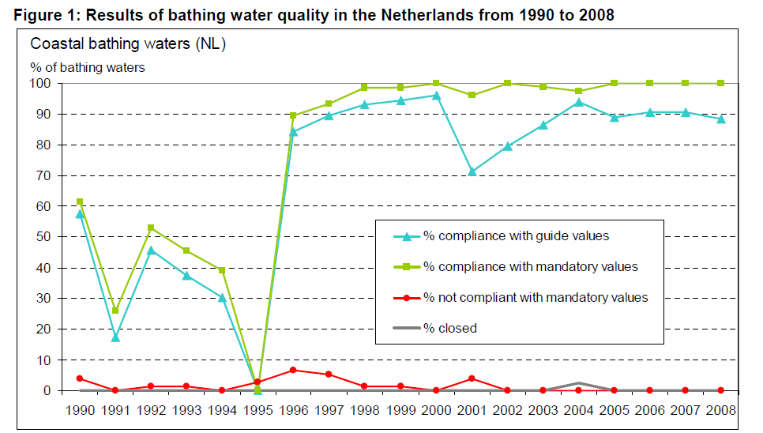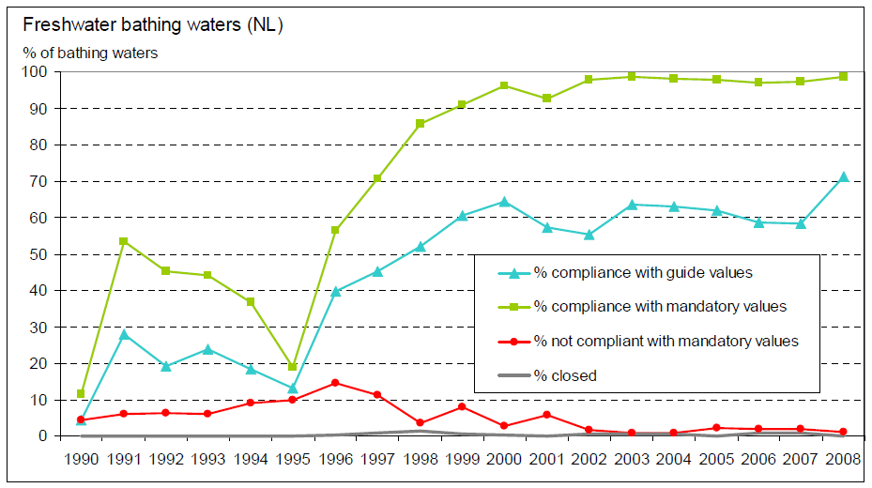

**Figure 2**

A. Comparing figures 1 and 2; what can you conclude?

B. According to the graphs, were there any notable years? What is special about these years?

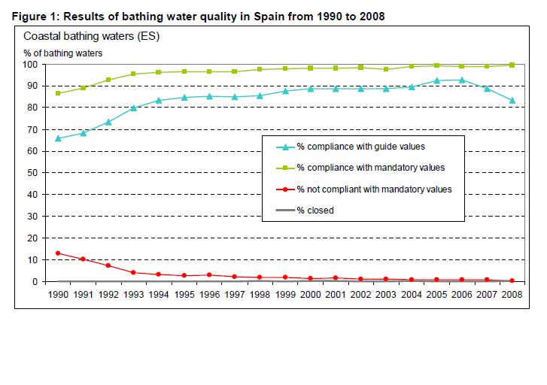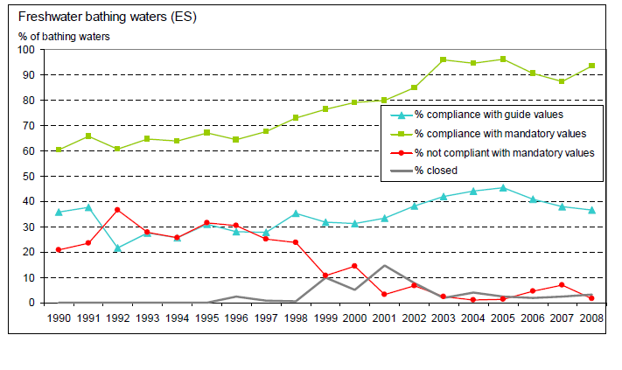

**Figure 4**

**Figure 3**

C. Comparing figures 3 and 4; what can you conclude?

D. What can you say about the difference in quality between the two countries? Which country has a better water quality?

The figures below show the bathing zones in the Netherlands and Spain.

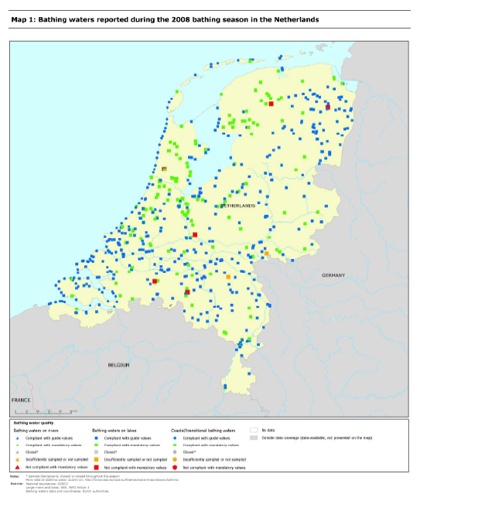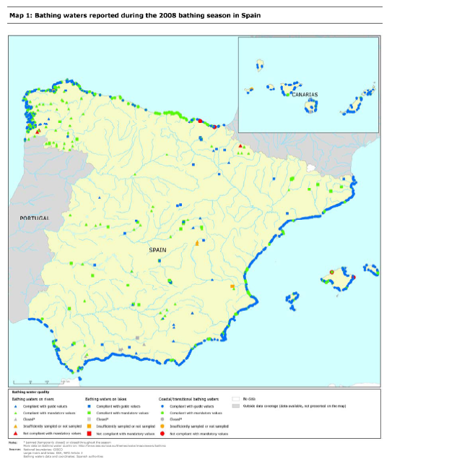

E.Compare the maps of the Netherlands and Spain. How can you explain similarities and differences?

1. Do both countries have a comparable number of bathing areas?