1

Sweet tooth

**Needed:**

Large bowl with 2 kg of sugar

Plastic bag

Ladle

**Task:**

Put a kilo of sugar in the plastic bag.

Let the jury weigh the result.

2

Fireworks

Here you see a standard box of matches. Not a single match has been taken out. Marjolein has an opened tabloid newspaper. She wants to enclose the area of the newspaper in matches (the matches in line around the paper).

Will she have enough matches in this box of matches or won’t it be enough?

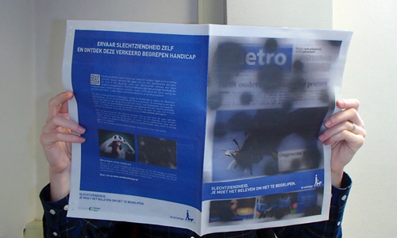

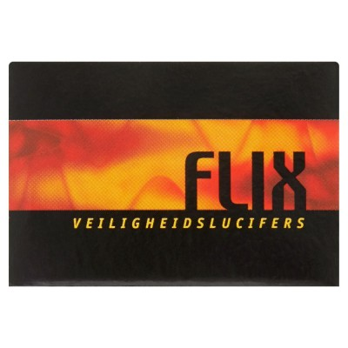

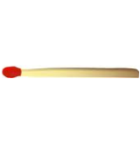

1. She will have more than 10 matches left over
2. She will have fewer than 10 matches left over
3. She will be short by less than 10 matches
4. She will be short by more than 10 matches.

Let the jury judge your answer. Be sure you can explain it.

3

Teenagers are work in progress

Needed: pen and paper

Dutch newspaper (6-1-2018):

**Teenagers are work in progress**

*About X youngsters will turn eighteen this year. They are suffering from stressing expectations, but still grade their life 8,4.*

What is X? Or put another way: how many youngsters turn eighteen this year?

Let the jury judge your answer. Be sure you can explain it.

4

Easy peasy

Needed: wine bottle and bowl/dish

If you were to completely fill the bottle with water, would that amount of water fit in the dish?

a. It’ll fit easily.

b. It’ll only just fit.

c. It’ll almost fit.

d. No way.

Let the jury judge your answer. Be sure you can explain it.

5

Loose tiles

Needed: Pen and paper

Ten standard concrete pavement tiles weigh about as much as …?

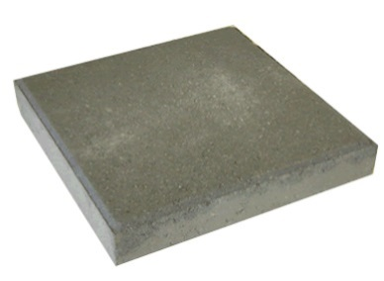

Think of an original answer. More than one original answer may be even better! The jury will give marks for the quality and originality of the answer and the explanation.

6

Fine-spun

Needed: Pen and paper

About how many kilometres of hair does this young lady have on her head?

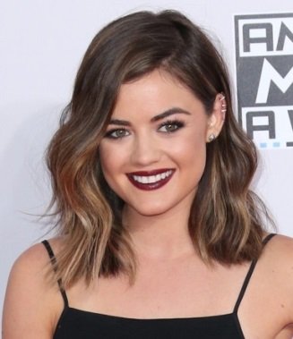

A. About the length of the average Tour de France stage

B. About the length of a marathon

C. About the length of the boulevard in Scheveningen

Let the jury judge your answer. Be sure you can explain it.

7

Max Maximum

Needed: Pen and paper

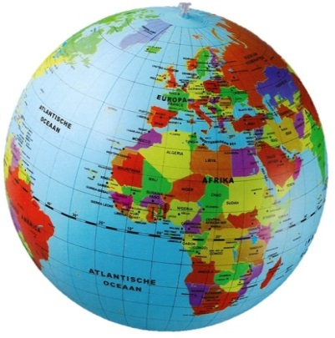

In how many days (24 hours) would Max Verstappen drive around the equator in his Formula 1 car without stopping? Assume there are no corners and take the average speed he reaches on the straight on an F1 racetrack. Be sure you can explain your answer, and let the jury judge it.

8

Making the distance

Needed: all kinds of objects and/or clothing

Using objects from the room (do not take them from the other assignments) and/or your own things, make a distance of 5 metres.

Let the jury judge your answer. The jury will give points for the quality and originality of the result.

9

Brommmers kiek’n

Needed: pen and paper

The documentary *Brommers kiek’n* shows the annual Easter bonfire competition between Espelo and Dijkerhoek. The below Dijkerhoek hill won second place in 2015. The volume of the hill determines the winner. What is the volume of this hill? Let the jury judge your answer and be sure you can explain it well.

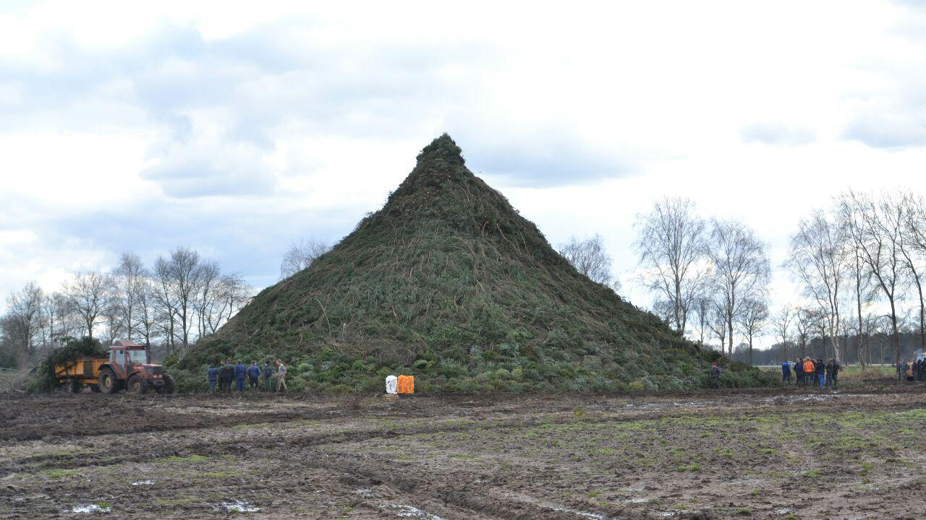

10

Growing

Needed: pen and paper



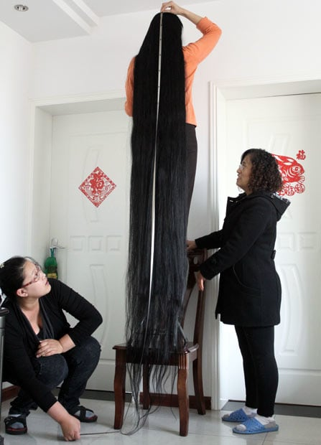

Which grows faster: your hair or your nails?

Provide an original and convincing explanation for the jury.

11

The world in a nutshell

Needed: pen and paper

*If you take all the water in the world as equal to one litre, the amount of available fresh water is equal to one tablespoon.*

Think of a similar comparison that reduces enormous amounts or distances to convenient proportions.

Give an explanation. Your comparison must be both correct and original (we already know the solar system to scale)

Let the jury judge your idea.

12

Sticky

Needed: pen and paper

Marjolein has a strange hobby. She wants to put sticky tape on all the doors in her house. “I like the way they shine,” she says.

How many standard rolls of sticky tape would she need to completely cover one side of an interior door in sticky tape?

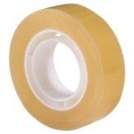

Let the jury judge your answer. Be sure you can explain it.

13

Racing beasts

Needed: pen and paper

The following animals are taking part in a sprint race. Predict the final result:

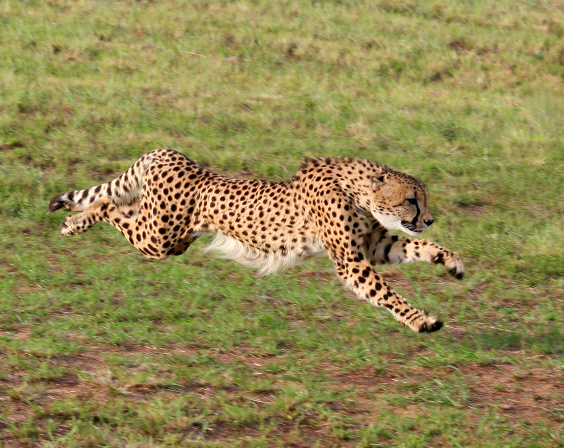

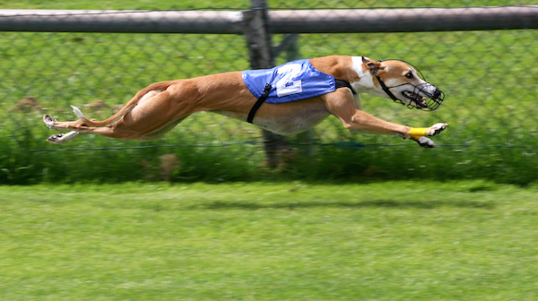

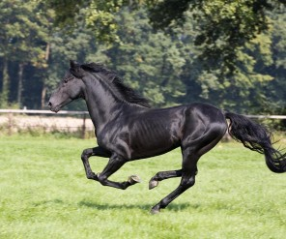

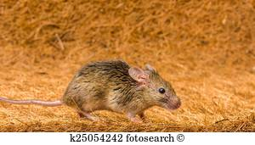

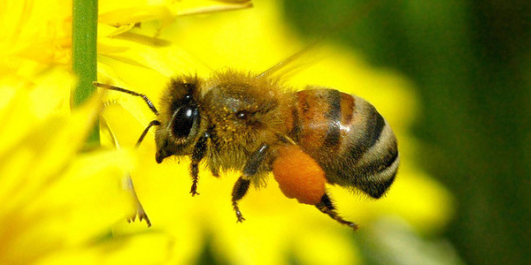

cheetah greyhound horse mouse bee

Write down the animals from slow to fast. How long they can keep up their top speed is not important. Be sure you can explain your order. Let the jury judge your answer.

14

Coffee bath

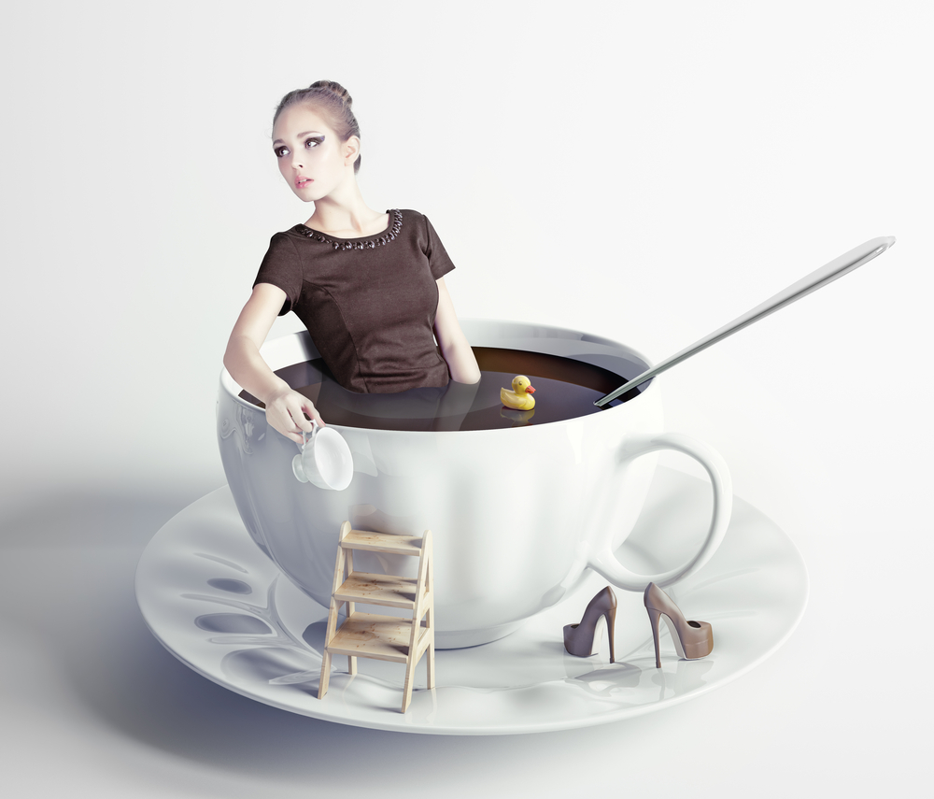

Needed: pen and paper

Could the amount of coffee and tea you drink annually fill the average bath tub?

Have a correct, clear and original explanation. Let the jury judge your answer.

15

Tater trouble

Needed: a large amount of potatoes and a plastic shopping bag

Put 5 kilos of potatoes in the bag.

Let the jury judge your answer.

16

Elephant mummy

Needed: pen and paper

How many rolls of toilet paper would you need to put an elephant in a mummy suit?

Let the jury judge your answer. Make sure to have an original and clear explanation.

17

Croquette fitness

Needed: pen and paper

Marjolein weighs 70 kg and she would like to keep it that way.

She eats a croquette which contains around 150 kcal.

To burn 150 kcal she can choose between:

- walking the stairs (up!)

- swimming (doing laps, breast stroke)

Which activity would be the quickest way to burn those 150 kilocalories? And how many minutes of time would she gain compared to the other activity?

Let the jury judge your answer. Make sure to have an original explanation.

18

Deafening

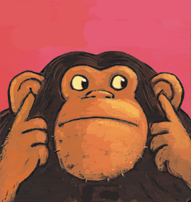

1. Health and safety regulations state that the sound level at pop gigs must not be louder than 103 decibels maximum.

That corresponds more or less to … ?

1. Think of a sound that is around 103 decibels.

The jury will give points for the quality and originality of the answer and the explanation.

19

Jeroen Dijsselbloem

In an interview with our former minister of Finances Jeroen Dijsselbloem was asked how he imagines the number 51.695. His answer: “Maybe the number of days that I was a member of parliament?”

1. Could he be right?
2. How would you represent/visualize 51.695?



The jury will recognize creativity and visuality.

20

Good measures

Needed: your own objects or something from the room (do not remove anything from the other assignments or the participants!)

Show the jury something, or make something for which you are pretty certain about the measurement(s) or the weight.

The jury must be able to check (flexible rule, people and kitchen scales are available).

Originality may get you bonus points.

21

Splash!

Needed: pen and paper

How long would it take before the Niagara waterfalls would have filled an Olympic swimming pool?

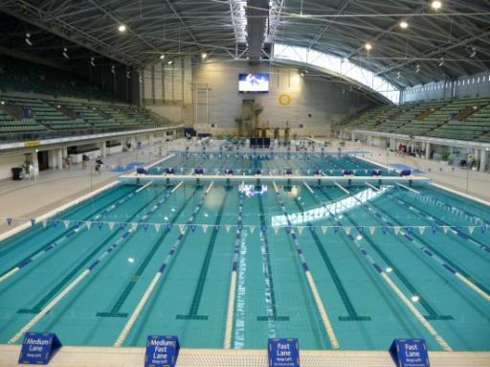

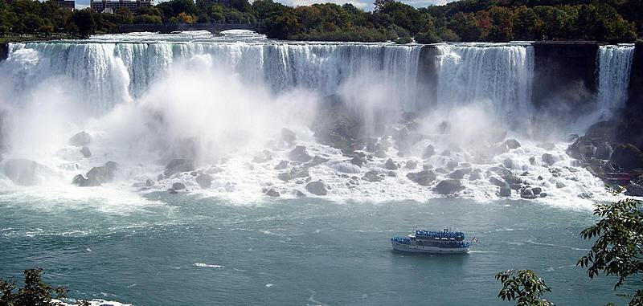

Be sure you can explain it.

Let the jury judge your answer.

22

Writers keepers

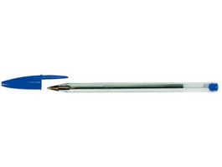

How many kilometres can you write with a Bic ballpoint pen?

The number of kilometres is the same as?

1. 1 mile
2. 6 laps on a long distance speed skating track
3. The height of the top of Mont Blanc
4. The distance between Noordwijkerhout and Leiden

23

Ready, measure!

Needed: pen and paper

Think of 5 objects that each have a 1 m2 surface area.

Explain your choice. Originality may get you bonus points.

Let the jury judge the result.

24

Tightly packed

Needed: pen and paper

If you place all the people in the world shoulder to shoulder, how large an area of land would you need?

The area should be similar to that of:

a. the province of Gelderland (in NL)

b. the Netherlands

c. France

d. Europe

Let the jury judge your answer. Be sure you can explain it.

25

Timely

Every member of the group will put his or her hands in front of their eyes for one minute.

You must be absolutely quiet to not influence each other.

Try to get as close as possible to one minute.

The scores of the team members will be averaged.

Practice first before you show it in front of the jury.

26

Ball pit

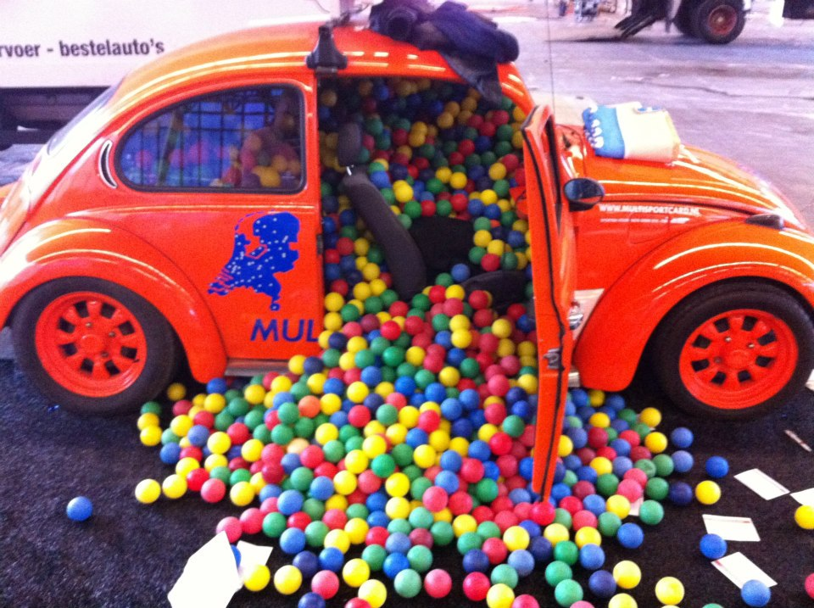

Needed: pen and paper

How many table tennis balls would fit in the boot of a medium sized car?

Let the jury judge your answer and show how you got it.